Artificial intelligence, machine learning, and data-driven algorithms are transforming industries. Meanwhile, modern healthcare struggles to improve its integration with information technologies.
With ever-escalating costs, care variability and 1 in 10 wrong medical diagnoses contributing to tens of thousands of deaths in the US alone, medicine should be the one place where the best use of our people, data, and tools is most important. Lives literally hang in the balance.
Whether we are ready for it or not, AI/ML/data-driven technologies are progressively becoming a part of medicine. Yet medicine must remain fundamentally an endeavor of humans caring for other humans. The symposium brought together a dynamic community of thought leaders to mature a conversation on the powerful potential of such engineering opportunities while mitigating the risks of unintended, but predictable, consequences.
Links to speaker videos (only for those who gave us permission to tape/share), event photos, and follow-up events can be found here: https://med.stanford.edu/presence/initiatives/hiai-symposium.html
9:15 AM John Hennessy, PhD-- Honoring John Hennessy for his recent Turing Award
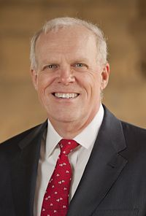
Former Stanford University President John Hennessy, Chairman of Alphabet Inc., and Director of the Knight-Hennessy Scholars Program, opened the symposium by describing the timeliness of the current artificial intelligence (AI) focus. In the 1960s, there were predictions that machines would beat humans in ten years. However, only recently has the availability of massive datasets and enhanced computing power enabled effective AI. Hennessy warned that, although there is much promise regarding AI applications in medicine, AI should not be conflated with human intelligence. He stressed that supervised learning AI algorithms are the epitome of “garbage in, garbage out,” cautioning trust of AI without human guidance. He also noted that although AI can outperform humans in certain tasks such as classifying dog and cat breeds, AI does not always yield interpretable insights. He pointed out that a 5 year old child can tell you understandable differences between dogs and cats (“cats are smaller,” “cats have prominent whiskers”), but today AI cannot. Hennessy concluded that AI should augment, rather than replace human intelligence.

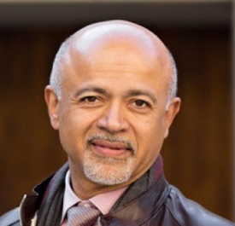
9:55 AM Abraham Verghese MD, MACP, FRCP-- What This Computer Needs is a Physician
Abraham Verghese, the Linda R. Meier and Joan F. Lane Provostial Professor, Vice Chair of the Theory & Practice of Medicine and founding Faculty Director of Stanford’s Presence Center, Department of Medicine, Stanford University. Presence focuses on leveraging technology for the human experience in medicine, reducing medical errors and protecting the patient-physician relationship. Dr. Verghese opened his session with an anecdote of a prominent scientist who, as a recent hospitalized patient, sadly observed that the only individual who behaved with the care and compassion we crave in our interpersonal interactions was the nursing assistant. The other care providers (physicians and nurses alike) were occupied by interacting with the computer at the expense of making a personal connection. This exemplifies the role that the electronic medical record plays in modern patient care. He introduced two components of clinical judgement: 1) data - which drives evidence-based medicine, and 2) human – the crucial physician-patient relationship. While much of the work of artificial intelligence in medicine will improve the data aspect of patient care, the human aspect must be front and center. Dr. Verghese quoted William Osler, one of the founding professors of Johns Hopkins Hospital: “The good physician treats the disease; the great physician treats the patient who has the disease.” Dr. Verghese concluded with a call to action to foster dialogue between the data-scientists and humanism.

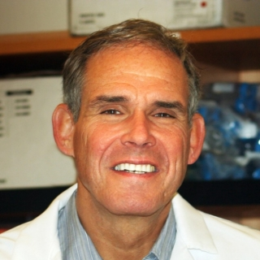
10:10 AM Eric Topol, MD-- Healthcare Ex Machina: How Artificial Intelligence Will Transform Medicine
Dr. Eric Topol, who founded and directs the Scripps Translational Science Institute, outlined a roadmap for the future of digital medicine. He began by noting that medicine has become “big business” in the United States. From 1975 to 2017, the number of US healthcare jobs has jumped from 4 to 16 million, and healthcare spending has increased from $550 to $11K per person per year. Alarmingly, the time allocated per patient visit has decreased from 60 to 7 minutes. Dr. Topol spoke about how data will transform healthcare and in particular, his vision for personalized medicine from pre-womb to tomb: a healthcare system in which multi-modal data on patients - genomic, transcriptomic, proteomic, metabolomic, and microbiota data - would be sampled at multiple points across a person’s lifetime. He discussed how AI can support patients by enabling them to collect and monitor their own data. Some examples include smart watches that collect EKG and potassium levels, machine-learning based mobile applications that detect and predict migraines, virtual medical coaches operating through AI-based, at-home virtual assistants such as Amazon’s Alexa. Dr. Topol emphasized the importance of patient-centric AI in the future and concluded by reflecting on the computer-driven culture of modern medicine that sacrifices patient facetime for computer time, leading to rising physician burnout. He shared an image of a country doctor in a 1948 Time Magazine publication, noting “endless work has its own rewards,” reminiscing of an era where burnout rates were presumably lower.

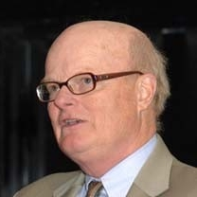
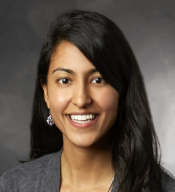
11:15 AM Larry Tierney, Jr, MD and Tanya Gupta, MD--Human Diagnostic Intelligence - A Live Demonstration
Dr. Larry Tierney, Professor of Clinical Medicine, UCSF, Associate Chief of Medical Service at the San Francisco VA Medical Center, renowned diagnostician and co-author of a textbook on medical history-taking for differential diagnosis, performed a live demonstration of the cognitive process required for a clinical diagnosis. Dr. Tierney was blinded to the case, and was guided through the case by Dr. Tanya Gupta, Chief Resident, Internal Medicine, Stanford. Dr. Tierney demonstrated the complicated process that diagnosing a patient entails, expertly navigating through medical history, intricacies of pain, physical exam, imaging, and lab results, while asking key questions and synthesizing his own experience, recent literature, and medical knowledge. The live demo showcased the complexity and difficulty A.I. would face if it were to replace doctors for diagnostics. However, it also highlighted some key areas where A.I. might augment clinician ability.

12:00 PM Mark L. Graber, MD, FACP--Diagnosis - The Beauty and the Beast
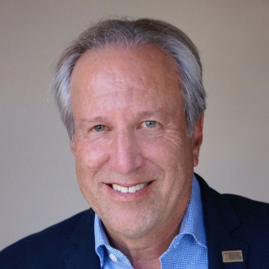
Dr. Mark Graber, Founder and President of the Society to Improve Diagnosis in Medicine, Senior Fellow at RTI International, and Professor Emeritus of Medicine at Stony Brook University, spoke on the importance of accurate diagnoses in medicine and how we can improve it using new technologies. He started off by framing the scope the problem: estimating the incidence of diagnostic errors to be 5-10% every year, resulting in approximately 250,000 deaths in the US per year. Dr. Graber believes the best ways to improve diagnostics is through patient access to care, patient engagement throughout the diagnosis process, and better communication between patients, colleagues, and consultants. In particular, technology could improve history collection, diagnostic testing, and clinical reasoning by learning risk, detecting errors, collecting feedback, and monitoring system and individual performance. He cited a successful technology, Isabel Healthcare, which improves differential diagnoses from 89.4 to 92.5 percent accuracy. He observed, because of human overconfidence and the time constraints physicians face, it is still not implemented widely in hospitals. Time must be a critical consideration when implementing new technologies into our clinics.
1:15 PM Lloyd B. Minor--Precision Health vs. Physician Burnout
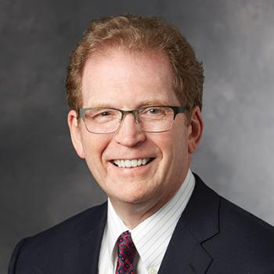
Stanford School of Medicine Dean and Professor of Head and Neck Surgery Lloyd Minor spoke of the importance of precision health and the challenge of physician burnout. Dean Minor remarked that in the recent past physicians served as great listeners and compassionate compatriots who worked alongside patients through the complexities and consequences of illness. He contrasted that with the current state of medicine in which 50% of the healthcare workforce experienced burnout. Dean Minor added that electronic health records (EHR) may be the fundamental problem, consuming physician time and attention that should be centered on the patient. He posed the question: why do physicians search for medical knowledge on Google rather than the EHR? He urged for design interventions that would ensure EHRs are an asset rather than a burden.

1:30 PM Art Papier, MD--20 Years Bringing Visual Diagnosis Decision Support Tools to Real-World Practice
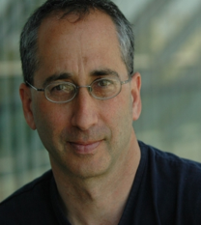
Dr. Art Papier, Associate Professor of Dermatology and Medical Informatics at the University of Rochester and Founder and CEO, VisualDx. VisualDX is the first widely used diagnostic clinical decision support system. Dr. Papier began with an analogy, comparing doctors to airplane guidance systems rather than oracles. Clinicians often misdiagnose due to overconfidence or anchoring bias. In particular, clinicians are at risk of representative bias because clinicians who frequently see archetypal representations of a disease are frequently fooled by variant presentations. Dr. Papier presented a second analogy: pilots do not use Google on their final approach, but clinicians do. He urged a cockpit design of finely tuned clinical decision support tools for clinicians with standardized medical terminology, a visual search process and interface, and a means of delivering a meaningful answer in seconds. Dr. Papier then described VisualDx, a mobile application that allows users to send images to a cloud server which in turn, analyzes the image and sends back results. Dr. Papier described the importance of engaging patients in the development in design of AI-based tools and described an instance when he shared the VisualDx application with a patient, walking her through the software process step by step. The patient noted she had increased trust in the application and how much she enjoyed the interaction. Moving forward, Dr. Papier noted a big hindrance to the adoption of AI-based clinical decision support systems is overconfidence.

2:00 PM Fei-Fei Li, PhD--Using AI to Illuminate the Dark Space of Healthcare
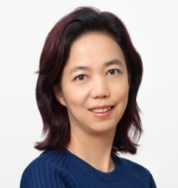
Associate Professor of Computer Science, Stanford University, and Chief Scientist of AI at Google Cloud, Fei-Fei Li introduced the novel field of ambient intelligence in AI-assisted healthcare. She said that while much of AI has been focused on treatment, diagnosis, and drug discovery, what is left ignored is the physical space of healthcare delivery. She painted a vision of a hospital in which the “intelligence is ambient, much like the light in this room.” Professor Li noted that due to the complexities of medical practice, preventable medical errors like immobility-induced ulcers, patient falls, and bloodstream infections are all too prevalent. To address this concern, Professor Li offered three key steps to assist with the adoption of ambient intelligence in clinics: 1) transform the physical space with sensing capability while preserving privacy, capturing information across both space and time, and storing video data efficiently, 2) develop human activity recognition capabilities, such as detecting clinician adherence to hand washing, and 3) integrating the ambient information with clinical data in the EHR. As Co-founder of Stanford’s renowned SAILORS outreach program for high school girls and the national non-profit AI4ALL, Professor Li also emphasized the importance of diversity in AI research. AI is fundamentally created by humans to serve humans and thus it is crucial that AI is developed by diverse people.

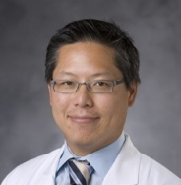
2:30 PM Erich Huang--Creating a Data Science Culture in Healthcare Research
Assistant Professor of Biostatistics and Bioinformatics at Duke University Erich Huang, who also serves as the faculty lead for informatics on Google Life Sciences Project Baseline Study, spoke about the reconciliation of data science culture with healthcare. Professor Huang focused on the need for clinical decision support models which continually learn over time, and require the interdisciplinary collaboration of people from engineering, medicine, and business, and other disciplines. His call to action: redesign the EHR ecosystem, putting patients in the center of care. Adding the hope of integrating data science tools such as Spark, Python, and R to run seamlessly on the EHR. The first step to integration is bridging the cultures of data science and healthcare.

3:00 PM Robert M. Califf, MD, MACC--Who's Responsible? Regulatory Guidance on Clinical Decision Support and Software as a Medical Device
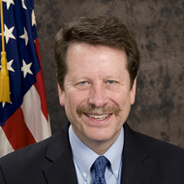
Dr. Robert M. Califf is the former commissioner of the US Food and Drug Administration (FDA) from February 2016 to January 2017. Dr. Califf noted a key challenge at the FDA is regulatory guidance on clinical decision systems and software as a medical device. In particular, he added AI and other software-based tools cannot be regulated the, “old-fashioned way” because they are developed and distributed relatively quickly (particularly when compared to the lengthy and rigorous development examination processes in place for drug and medical device safety and efficacy), have a great deal of complexity and have short latency. Software updates are can be rolled out significantly more cheaply, frequently and quickly than hardware or medical device modifications, necessitating a complete rethinking of the regulatory process for which the FDA is not yet prepared. Although the FDA has begun several initiatives in this arena, such as the Digital Health Innovation, Dr. Califf shared that the FDA is in need of a greater number of individuals who are knowledgeable about both medicine and technology, imploring the medical academic community to step forward as leaders in this effort. He concluded by recognizing the importance of reducing bias in AI-based decision support tools, particularly because marginalized communities are often not included in learning data sets.

3:45 PM Rich Caruana, PhD--Friends Don't Let Friends Release Black Box Models in Medicine
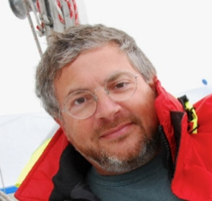
Dr. Rich Caruana is a Principal Researcher at Microsoft and a former faculty member at UCLA Medical School and CMU’s Center for Learning and Discovery. Dr. Caruana believes we grossly overestimate the power of deep learning, and there are potential harms in implementing a deep learning model if not cautious. Dr. Caruana urged attendees to understand the underlying errors and biases to which AI is prone. He noted high accuracy on test sets do not necessarily apply to the real world. While AI may be able to outperform children in classifying dogs versus cats, AI may not have any intuitive understanding of what distinguishes the two species. He reviewed a case study which used rule-based models for predicting pneumonia risk, and how being able to interpret the model was valuable in picking out correlations that were confounding. He explained the fundamental problem in current prediction problems is that they are not from randomized controlled trials (and it’s unethical and impossible to expect so) and, as such, we cannot infer causality. Additionally, there are always a large number of confounding variables simply because we will always have missing variables or features in our data. Finally, he introduced a new type of model his team has been working on, known as GA2Ms, that has greater accuracy, intelligence, and explain-ability.

4:15 PM Bob Kocher, MD--How to Make Our Crazy, Expensive, Amazing, and Uneven Health Care System Better Faster
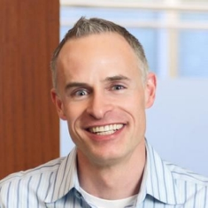
Dr. Bob Kocher is a Partner at Venrock and Adjunct Professor at Stanford University, having previously worked as a Special Assistant to President Obama for healthcare economic policy. Dr. Kocher provided a general overview of the healthcare industry, outlining the emerging opportunity for AI to improve outcomes in healthcare. He encouraged AI developers to think more creatively—for example, to apply AI to solve problems within the hospital instead of, “hot fields like precision medicine and clinical decision support.” According to Dr. Kocher, there are many business challenges, particularly of incentives as well as practical considerations such as reimbursement, integration, and customer acquisition. He called for attendees to learn from the success of technologies replacing HR such as chatbots, as well as voice recognition algorithms, which he thinks provide great promise to help save money and time for physicians in a more practical way. Looking forward, he is hopeful that new talent, liberation of data, new payment models, and stakeholder distress will help propel the implementation of artificial intelligence into clinics. Finally, he ended his talk predicting that technology and information will reduce healthcare costs over time, and new technologies will improve the standard of care for patients.

4:45 PM Margaret Levi--AI, Automation, and Society
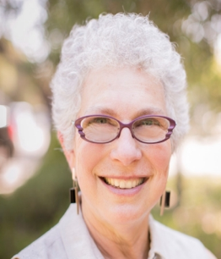
Dr. Margaret Levi, the Director of the Center for Advanced Study in the Behavioral Sciences and a professor of Political Science at Stanford University, closed the symposium with remarks about our ethical responsibility to build “machines of loving grace.” Dr. Levi encouraged attendees to ponder on how we will responsibly implement artificial intelligence in order to provide for those who are marginalized or displaced by new technologies. According to Dr. Levi, we have a responsibility as a society to ensure meaning and dignity for those who will lose work or whose work will be devalued, and those who may be discriminated against by these new technologies. She called for attendees to develop new moral framework and values to evaluate and discuss ethical questions centered on artificial intelligence. Ultimately, Dr. Levi posited, these can be achieved through a revised theory of behavior, value for the need for survival and dignity, and social infrastructure.
Additional Outreach/Social Media/Press
Before, during, and after the symposium, the community actively engaged in discussion through both in person and online engagement, including through the social media hashtag #HIAIWithPresence, yielding dozens of posts and thousands of impressions around the world.
https://twitter.com/search?q=%23HIAIwithPresence

This was further accompanied by multiple widely read online articles and external press:
https://www.medscape.com/viewarticle/897350
http://blogs.plos.org/speakingofmedicine/2018/04/24/human-intelligence-artificial-intelligence-in-medicine-a-day-with-the-stanford-presence-center/
http://blogs.plos.org/everyone/2018/04/11/interview-arthur-papier/
http://scopeblog.stanford.edu/2018/05/01/the-art-of-diagnosing-in-action/
http://scopeblog.stanford.edu/2018/04/19/symposium-discusses-promise-caution-of-technology-in-medicine/

Summary prepared by Jonathan X Wang, Jason K Wang, Sonoo Thadaney, Abraham Verghese, Jill Stanley, Kimberly Myers Hewlett, Robin Daines and Jonathan H Chen.

