Completing Assessment Measures over a Video* session

In this document:

How to use the PHQ-9/PCL/BAI measure during a phone session……………………..Page 1

How to complete baseline measures over the phone………………………………………..Page 2

How to complete Session 4 measures over the phone………………………………………Page 3

How to complete post-treatment measures………………………………………………………Page 4

How to bookmark a webpage…………………………………………………………………………….Page 5

Assessment Measure Links/QR codes………………………………………………………………..Page 7

*************************************************************************************

- How to use the PHQ-9/PCL/BAI measure during a phone session: (Completed every session except baseline, session 4, and post-treatment)
Important: Symptom measures are not dependent on the client’s study condition (app vs. paper) and can be done via any method. As always, we recommend choosing the best option to meet the needs of you and the client.
*Please note that video does not include Facetime calls, if you are using Facetime with a client, please refer to the recommendations on the phone session SOP.
For both App/Paper condition clients (i.e., For all clients):
Recommended option: A study team member/clinician (if clinician is using email to communicate with their client) can send the client a link/QR code of the symptom measure they will need to complete. Just before/at the start of each session the client can refer to the link/QR code to complete the survey. For future ease of access, the client should save the link in the notes of their phone or bookmark the survey webpage on their computer. If the client is completing the survey at the start of the session, they can share their screen with the clinician for review of their score. (Note: See page 7 for quick access to the symptom measure links/QR codes).
Tip: We recommend asking the client for the total score before beginning the session to confirm the client has completed the measure and as a check-in on how the client is doing.
Tip: You can also bookmark the symptom measures to enter them from your end, if needed (Please scroll to the last page if you’d like to learn how to bookmark/explain how to bookmark the page to your clients).
Alternative Options:
1) If access to the internet, but no time during session to complete the measure: The study team will send the client an email with the survey link before each session and the client can do it on their own time. For this option, the study team will need to know when the client’s appointment occurs. This option may useful for clients who need a reminder at each session to complete the measure and the clinician will not have time to address this each week while they are doing telehealth.
2) If client has difficulty pulling up the survey: If the client is not able to pull up the survey because of technology challenges/other reasons, the clinician can open the measure on their screen and share the screen with the client, so the client can read the items of the measure, while the clinician selects the responses on behalf of the client on their end. This option may be time intensive for some clinicians/clients. Note: If you are using Zoom, you may be able to give control of your screen to the client after sharing it, so that the client can complete the measure on their end and then release control of the screen back to you. (https://canvas.du.edu/courses/79407/pages/sharing-mouse-control-in-a-team-meeting).
3) If access to the internet and a printer: If there is no time available during the session/the client will not complete the measure outside of session, or the client prefers paper. A study team member can send the client an email with the appropriate symptom measure attached. The client can print multiple copies and fill one out at each session and share the score with the clinician at the start of each session. The client would hold onto these (dated) measures until they are able to get them to their clinician. Important: Make sure the client uses their client ID as an identifiable rather than their name.
- How to complete baseline measures over a video session:
What needs to be completed by the client (5 items):
- Client demographics form
- Baseline PCL-5 (PTSD Checklist)
- PHQ-9 (Patient Health Questionnaire- 9)
- BAI (Beck Anxiety Inventory)
- B-IPF (Brief Inventory of Psychosocial Functioning)
Recommended option: Study team will email client the baseline measures to be completed online after consenting them. Clinician should check in with client at next session to see if client has completed measures. If not, clinician can offer to allow client to complete them during session time and discuss together, while client shares their screen. (Note: See page 7 for quick access to the symptom measure links/QR codes).
Alternative option 1: If client cannot pull up the baseline measures online, the clinician can open the online baseline measures on their end. The clinician can then share their screen and fill each survey out on the client’s behalf, while the client verbally says their responses. This is only recommended for clients who otherwise cannot complete the baseline. Note: If you are using Zoom, you may be able to give control of your screen to the client after sharing it, so that the client can complete the baseline measures on their end and then release control of the screen back to you (https://canvas.du.edu/courses/79407/pages/sharing-mouse-control-in-a-team-meeting).
- How to complete session 4 measures over the phone
What needs to be completed (4 items):
- PCL
- PHQ-9
- BAI
- B-IPF
Recommended option: Study team will email client the session 4 measures to be completed after the clinician has completed session 3 with the client (If the clinician is not actively submitting materials, they may need to let the study team know when they have completed session 3 with their client). Clinician should check in with client at session 4 to see if client has completed measures. If not, clinician can offer to allow client to complete them during session time and discuss together, while the client shares their screen. (Note: See page 7 for quick access to the symptom measure links/QR codes).
Alternative option 1: If client cannot pull up the session 4 measures online, the clinician can open the online session 4 measures on their end. The clinician can then share their screen and fill each survey out on the client’s behalf, while the client verbally says their responses. This is only recommended for clients who otherwise cannot complete the session 4 measures. Note: If you are using Zoom, you may be able to give control of your screen to the client after sharing it, so that the client can complete the session 4 measures on their end and then release control of the screen back to you (https://canvas.du.edu/courses/79407/pages/sharing-mouse-control-in-a-team-meeting).

- How to complete post-treatment measures:
What needs to be completed (4 items):
- PCL
- PHQ-9
- BAI
- B-IPF
Recommended option: Study team will email client the post-treatment measures to be completed after clinician notifies the study team that the final session is coming up. Clinician should check in with client at the final session to see if client has completed measures. If not, clinician can offer to allow client to complete them during session time and discuss together, while the client shares their screen. (Note: See page 7 for quick access to the symptom measure links/QR codes).
*Reminder: After completing post-treatment measures and a brief phone interview, clients will be paid. Please remind clients at the final session to expect a call/email (depending on their preferences) from the study team to set up a time to complete the brief interview.
Alternative option 1: If client cannot pull up the post-treatment measures online, the clinician can open the online post-treatment measures on their end. The clinician can then share their screen and fill each survey out on the client’s behalf, while the client verbally says their responses. This is only recommended for clients who otherwise cannot complete the post-treatment measures. Note: If you are using Zoom, you may be able to give control of your screen to the client after sharing it, so that the client can complete the post-treatment measures on their end and then release control of the screen back to you (https://canvas.du.edu/courses/79407/pages/sharing-mouse-control-in-a-team-meeting)

- How to bookmark a webpage:
Step 1: Open the survey using the link provided to you by the study team (we recommend using Google Chrome as your browser to bookmark the webpage). Click the 3 vertical dots in the upper right-hand corner. Then select “Bookmarks” and then “Bookmark this tab”.
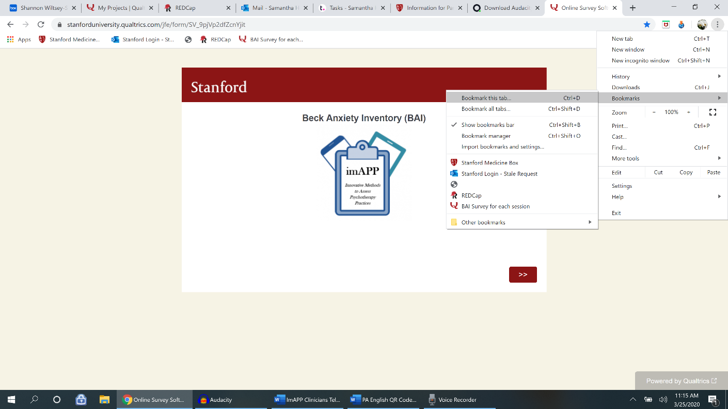
Step 2: After selecting “Bookmark this tab”, a pop up will appear showing you the default name of this tab. The default name is “Online survey software/Qualtrics”
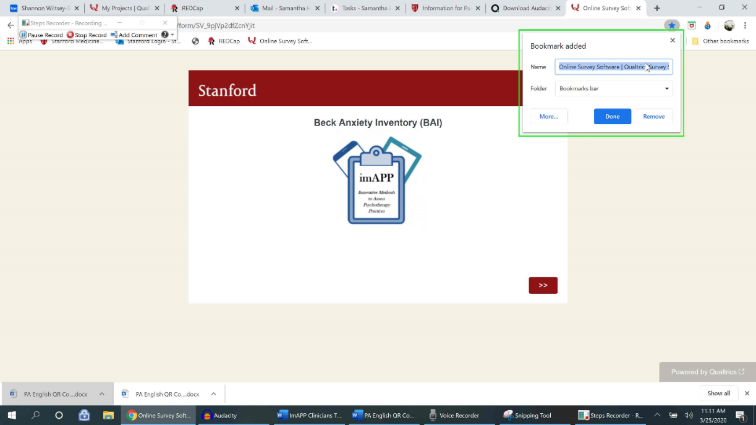

Step 3: You can rename webpage bookmark in the pop up window, if you like, and then hit “Done”. In the below example, I renamed the webpage bookmark: “BAI Survey for each session”.
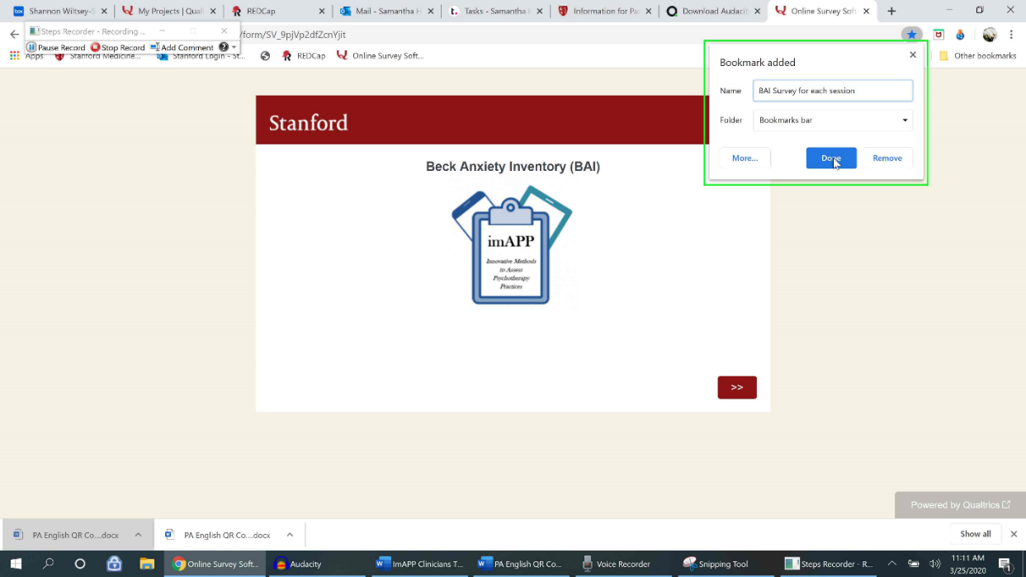

Thank you for all of your great work! If you have any questions or would like additional help/support, please contact the study team via email at sahern01@stanford.edu. Thanks!

- Links and QR codes for Qualtrics Symptom Measures (and Checklists):
*Note: Links/QR codes for Spanish measures begin on page 11
Stanford Medicine Box Link
Stanford Medicine Box link (for uploading worksheets and recordings):
https://stanfordmedicine.app.box.com/upload-widget/view/c1hzaqn4bth9lf5nqqimmaqhsarmuhk0/4886210141?height=385&instructions=&title=Submit+file+to+the+imAPP+study&isDescriptionFieldShown=1&isEmailRequired=0
Session Checklist to be completed after each session
CPT Session Checklist: https://stanforduniversity.qualtrics.com/jfe/form/SV_78JrdcqjdVl1LJb
CBT Session Checklist: https://stanforduniversity.qualtrics.com/jfe/form/SV_249BPBVrti1JXal

Baseline (Have client complete all of the below measures to complete study enrollment)
Client Demographics (to be completed by the clinician): https://stanforduniversity.qualtrics.com/jfe/form/SV_ehDrHDXZyKGk1X7
Client Demographics (to be completed by the client): https://stanforduniversity.qualtrics.com/jfe/form/SV_6m6J1UScRFECszX | 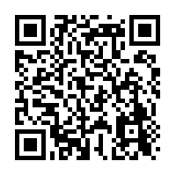
BASELINE: PCL LEC and Criterion A: https://stanforduniversity.qualtrics.com/jfe/form/SV_eIFxVVtELUJN0iN
BAI:  https://stanforduniversity.qualtrics.com/jfe/form/SV_9pjVp2dfZcnYjit | 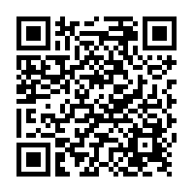
IPF: https://stanforduniversity.qualtrics.com/jfe/form/SV_b9qG4L1wDYkEQXX | 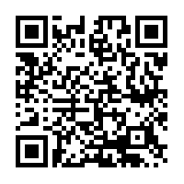
PHQ-9: https://stanforduniversity.qualtrics.com/jfe/form/SV_0DH0etT00pdwgHX | 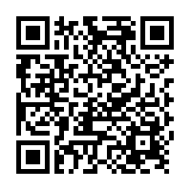

Session 1 (Have client do one of the below measures that corresponds to their diagnosis)
BAI:
https://stanforduniversity.qualtrics.com/jfe/form/SV_9pjVp2dfZcnYjit
PHQ-9:
https://stanforduniversity.qualtrics.com/jfe/form/SV_0DH0etT00pdwgHX
SESSION 1: PCL and Criterion A:
https://stanforduniversity.qualtrics.com/jfe/form/SV_e9ehAoGYq0JBLw1

Session 2 – 3 (Have client do one of the below measures that corresponds to their diagnosis)
BAI:
https://stanforduniversity.qualtrics.com/jfe/form/SV_9pjVp2dfZcnYjit
PHQ-9:
https://stanforduniversity.qualtrics.com/jfe/form/SV_0DH0etT00pdwgHX
SESSION 2-16: PCL and index event:
https://stanforduniversity.qualtrics.com/jfe/form/SV_554goMJkE7vbLh3

Session 4 (Have client do all of the below measures, they are paid $25 for completing them at Session 4)
BAI:
https://stanforduniversity.qualtrics.com/jfe/form/SV_9pjVp2dfZcnYjit
PHQ-9:
https://stanforduniversity.qualtrics.com/jfe/form/SV_0DH0etT00pdwgHX
SESSION 2-16: PCL and index event:
https://stanforduniversity.qualtrics.com/jfe/form/SV_554goMJkE7vbLh3
IPF:
https://stanforduniversity.qualtrics.com/jfe/form/SV_b9qG4L1wDYkEQXX

Session 5 – 16 (Have client do one of the below measures that corresponds to their diagnosis)
BAI:
https://stanforduniversity.qualtrics.com/jfe/form/SV_9pjVp2dfZcnYjit
PHQ-9:
https://stanforduniversity.qualtrics.com/jfe/form/SV_0DH0etT00pdwgHX
SESSION 2-16: PCL and index event:
https://stanforduniversity.qualtrics.com/jfe/form/SV_554goMJkE7vbLh3

Post-Treatment (Have client do all of the below measures, they are paid an additional $25 for completing the post-treatment measures and a brief exit interview)
BAI:
https://stanforduniversity.qualtrics.com/jfe/form/SV_9pjVp2dfZcnYjit
PHQ-9:
https://stanforduniversity.qualtrics.com/jfe/form/SV_0DH0etT00pdwgHX
SESSION 2-16: PCL and index event:
https://stanforduniversity.qualtrics.com/jfe/form/SV_554goMJkE7vbLh3
IPF:
https://stanforduniversity.qualtrics.com/jfe/form/SV_b9qG4L1wDYkEQXX

Symptom Measure Links/QR codes in Spanish:
Baseline (Have client complete all of the below measures to complete study enrollment)
Client Demographics (to be completed by the clinician): https://stanforduniversity.qualtrics.com/jfe/form/SV_ehDrHDXZyKGk1X7
Client Demographics Spanish (to be completed by Client. *Clinician will complete clinician section in English):
https://stanforduniversity.qualtrics.com/jfe/form/SV_5tnsd4b81P2yo9n
IPF Spanish:  https://stanforduniversity.qualtrics.com/jfe/form/SV_8AZgmFlWCQLEue9 | 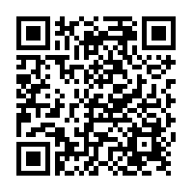
BAI- Spanish:
https://stanforduniversity.qualtrics.com/jfe/form/SV_1MiwUTdSDIXamQ5
PHQ-9 Spanish:  https://stanforduniversity.qualtrics.com/jfe/form/SV_becq1sxKqqn6xPT | 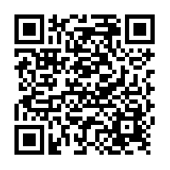
BASELINE: PCL-5 + LEC-5 + Criteria A Spanish  https://stanforduniversity.qualtrics.com/jfe/form/SV_0wePWiwQjFzyrXv | 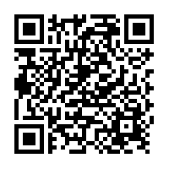

Session 1 (Have client do one of the below measures that corresponds to their diagnosis)
BAI- Spanish:
https://stanforduniversity.qualtrics.com/jfe/form/SV_1MiwUTdSDIXamQ5
PHQ-9 Spanish:
https://stanforduniversity.qualtrics.com/jfe/form/SV_becq1sxKqqn6xPT
SESSION 1: PCL-5 with Criterion A:  https://stanforduniversity.qualtrics.com/jfe/form/SV_8oFyl1GcpNddUtT | 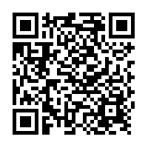

Session 2 – 3 (Have client do one of the below measures that corresponds to their diagnosis)
SESSION 2-16 PCL-5 with index trauma Spanish:
https://stanforduniversity.qualtrics.com/jfe/form/SV_bddTRO1hwYgCc6x
BAI- Spanish:
https://stanforduniversity.qualtrics.com/jfe/form/SV_1MiwUTdSDIXamQ5
PHQ-9 Spanish:
https://stanforduniversity.qualtrics.com/jfe/form/SV_becq1sxKqqn6xPT

Session 4 (Have client do all of the below measures, they are paid $25 for completing them at Session 4)
SESSION 2-16 PCL-5 with index trauma Spanish:
https://stanforduniversity.qualtrics.com/jfe/form/SV_bddTRO1hwYgCc6x
BAI- Spanish:
https://stanforduniversity.qualtrics.com/jfe/form/SV_1MiwUTdSDIXamQ5
PHQ-9 Spanish:
https://stanforduniversity.qualtrics.com/jfe/form/SV_becq1sxKqqn6xPT
IPF Spanish:
https://stanforduniversity.qualtrics.com/jfe/form/SV_8AZgmFlWCQLEue9

Session 5 – 16 (Have client do one of the below measures that corresponds to their diagnosis)
SESSION 2-16 PCL-5 with index trauma Spanish:
https://stanforduniversity.qualtrics.com/jfe/form/SV_bddTRO1hwYgCc6x
BAI- Spanish:
https://stanforduniversity.qualtrics.com/jfe/form/SV_1MiwUTdSDIXamQ5
PHQ-9 Spanish:
https://stanforduniversity.qualtrics.com/jfe/form/SV_becq1sxKqqn6xPT

Post-Treatment (Have client do all of the below measures, they are paid an additional $25 for completing the post-treatment measures and a brief exit interview)
SESSION 2-16 PCL-5 with index trauma Spanish:
https://stanforduniversity.qualtrics.com/jfe/form/SV_bddTRO1hwYgCc6x
BAI- Spanish:
https://stanforduniversity.qualtrics.com/jfe/form/SV_1MiwUTdSDIXamQ5
PHQ-9 Spanish:
https://stanforduniversity.qualtrics.com/jfe/form/SV_becq1sxKqqn6xPT
IPF Spanish:
https://stanforduniversity.qualtrics.com/jfe/form/SV_8AZgmFlWCQLEue9

