How to use worksheets during a phone session
Please note the below options are recommended based on the study condition the client is in, but you may use any option that is most feasible/beneficial to your client and yourself.
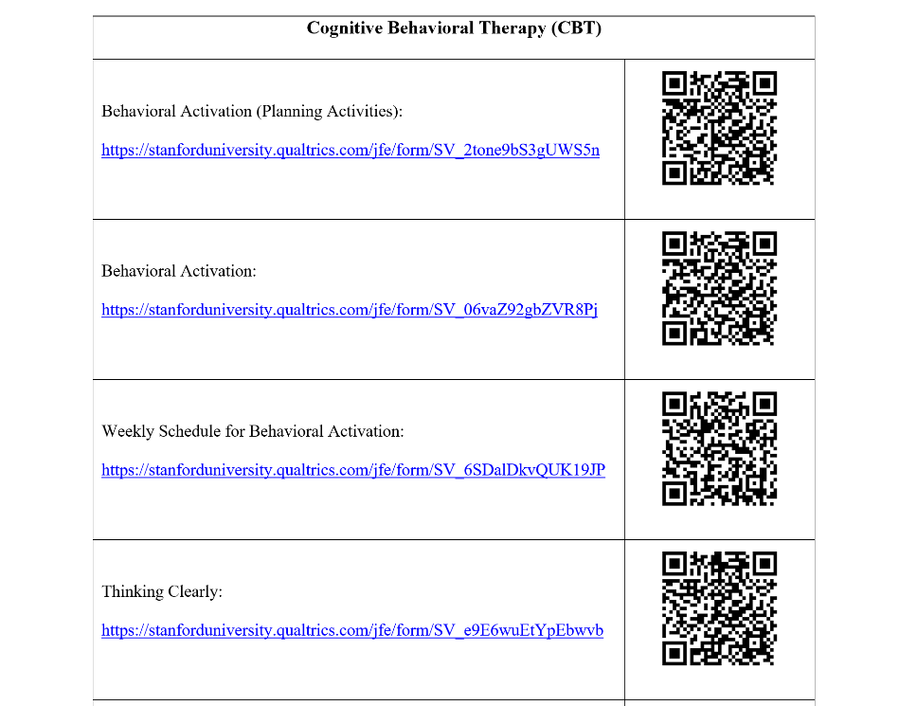
For clients in the APP condition:
The tablet does not need to be used during telehealth for clients in the app condition at this time.
Recommended option (if client has access to internet): Instead these clients can be given links/QR codes to complete the worksheets on Qualtrics online on their phone or computer during the session. We recommend the therapist and client both have a copy of the worksheet open and one/both can fill it out while they discuss it verbally over the phone. Note: The study team will send out a word document to all clinicians called “PA English QR codes Sheet”, which will have the links and QR codes available. Clients can also be sent the document/specific links at the clinician’s request. We recommend saving the document in an easily accessible folder on your computer. (Note: Please see page 3 for quick access to all the worksheet links/QR codes)
Alternative option 1: If you are discussing a worksheet with a client verbally during a phone session, you (the clinician) can complete the online worksheet online (based on the content discussed with the client).
Alternative option 2: If the client does not have access to online worksheets or they would prefer to do worksheets on paper copies they have, they are welcome to and encouraged to do so. They can verbally review these paper worksheets with you and, then, save them until they are able to get them to you in person. We recommend discussing with the client where they will store the worksheets. Ideally, they will all be saved in a folder and kept in the same place. Important: Please ensure that the client uses their client ID rather than their name as their identifier on worksheets.

For clients in the paper condition:
Recommended option: If the client has paper copies of the worksheet or access to a printer, you can continue to assign clients homework and have them verbally review the worksheets with you. During the session, you and the client can also each individually write on a paper worksheet while verbally discussing it. Alternatively, just one of you (you or the client) can write on a worksheet. Note: If the client has worksheets, we can collect them from you when in-person meetings are available again, and they are able to give them to you. Important: Please ensure that the client uses their client ID rather than their name as their identifier on worksheets.
Alternative option 1: You, as the clinician, can guide a discussion based on a worksheet verbally and record any main points of the discussion on a worksheet on your end. After the session, you can take a picture of the drawing board or paper worksheet with notes from your discussion (e.g., jotting down main points from verbally doing ABC sheet).
Alternative option 2: The study team or the clinician (if you are using email with clients at this time) can email the client copies of the worksheets (as word documents) that the client can type into during your phone session and send to you in a secure email.

Hi there! Did you try a method not listed above that works for you and your client? Please feel free to share it with the study team via email at sahern01@stanford.edu or with other clinician study participants during the consultation calls! We appreciate your creativity and flexibility!

Links and QR codes for Qualtrics Worksheets:
*Note: Links/QR codes for Spanish worksheets begin on page 6
Stanford Medicine Box Link
Stanford Medicine Box link (for uploading worksheets and recordings)
https://stanfordmedicine.app.box.com/upload-widget/view/c1hzaqn4bth9lf5nqqimmaqhsarmuhk0/4886210141?height=385&instructions=&title=Submit+file+to+the+imAPP+study&isDescriptionFieldShown=1&isEmailRequired=0

Cognitive Processing Therapy (CPT) English Full Worksheets
ABC- Full: https://stanforduniversity.qualtrics.com/jfe/form/SV_2bMbgeXWEl49OD3 | 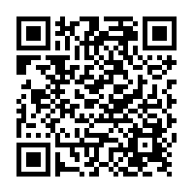
Challenging Questions Worksheet – Full: https://stanforduniversity.qualtrics.com/jfe/form/SV_0eQUg7Ej059ylN3 | 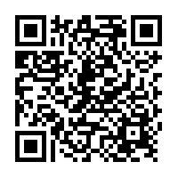
Challenging Beliefs Worksheet – Full: https://stanforduniversity.qualtrics.com/jfe/form/SV_9nqNnsevu6h4iO1 | 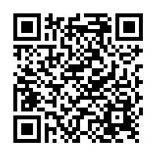
Patterns of Problematic Thinking – Full: https://stanforduniversity.qualtrics.com/jfe/form/SV_cDgJi9fvWUzymFL | 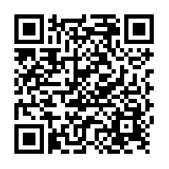
Stuck Point Log:  https://stanforduniversity.qualtrics.com/jfe/form/SV_bd87ZPmrlsjQeax | 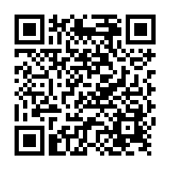

Cognitive Processing Therapy (CPT) English Short Form Worksheets
ABC- Short form:  https://stanforduniversity.qualtrics.com/jfe/form/SV_0GJLgQa4qKPWntj | 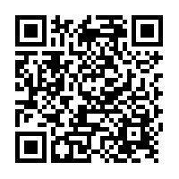
Thinking Questions Form (Simplified CQW): https://stanforduniversity.qualtrics.com/jfe/form/SV_9B1ZVQai4h9Fay9 | 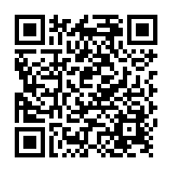
Changing Beliefs and Feelings (Simplified CBW):  https://stanforduniversity.qualtrics.com/jfe/form/SV_8G3KG2XzryLjuIt | 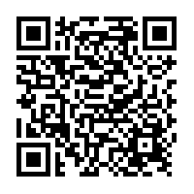

Cognitive Behavioral Therapy (CBT)
Behavioral Activation (Planning Activities):  https://stanforduniversity.qualtrics.com/jfe/form/SV_2tone9bS3gUWS5n | 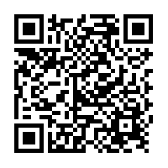
Behavioral Activation: https://stanforduniversity.qualtrics.com/jfe/form/SV_06vaZ92gbZVR8Pj | 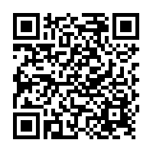
Weekly Schedule for Behavioral Activation: https://stanforduniversity.qualtrics.com/jfe/form/SV_6SDalDkvQUK19JP | 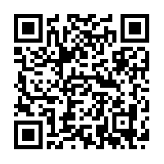
Thinking Clearly: https://stanforduniversity.qualtrics.com/jfe/form/SV_e9E6wuEtYpEbwvb | 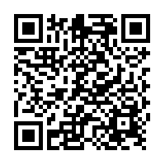
Cognitive Continuum:  https://stanforduniversity.qualtrics.com/jfe/form/SV_6l46t4hgSttw1Vj | 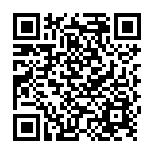
CBT Thought record:  https://stanforduniversity.qualtrics.com/jfe/form/SV_4UQnEvP54j3gD8V | 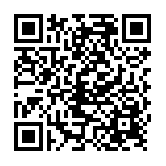
BRIGHT- Catch it, Check it, Change it:  https://stanforduniversity.qualtrics.com/jfe/form/SV_bCWuOuM852mIK3z | 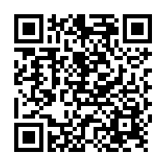
BRIGHT- Thoughts Check in:  https://stanforduniversity.qualtrics.com/jfe/form/SV_bvxZJUmIyM3V0zP | 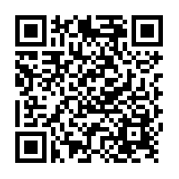
CBT Case Conceptualization:  https://stanforduniversity.qualtrics.com/jfe/form/SV_ctMp4dMyShclVeB | 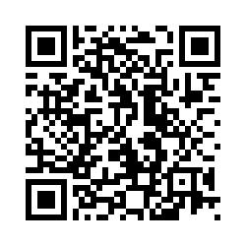

Worksheet Links/QR codes in Spanish
Cognitive Processing Therapy (CPT) Spanish Full Worksheets
ABC Full: https://stanforduniversity.qualtrics.com/jfe/form/SV_6mPnxNb4E7S8LeR | 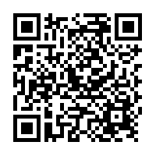
CQW Full: https://stanforduniversity.qualtrics.com/jfe/form/SV_dcz7h8pID1uijul | 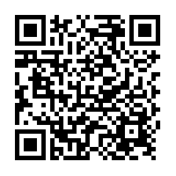
CBW Full:  https://stanforduniversity.qualtrics.com/jfe/form/SV_er1yRbphOZ17BAh | 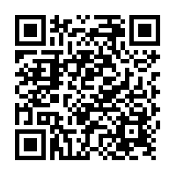
PPT Full: https://stanforduniversity.qualtrics.com/jfe/form/SV_3sfm69LFShL7zLf | 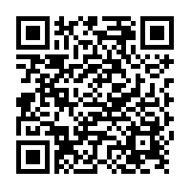

Cognitive Processing Therapy (CPT) Spanish Short Form Worksheets
Formulario de ABC short form:  https://stanforduniversity.qualtrics.com/jfe/form/SV_3ZWgeas4zL1JbAF | 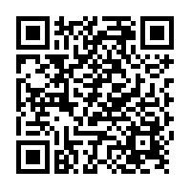
Desafiando puntos o pensamientos de bloqueo (simplified CQW):  https://stanforduniversity.qualtrics.com/jfe/form/SV_3vCVpquYdPTHHsF | 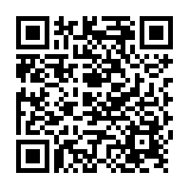
Cambiando creencias y sentimientos (simplified CBW):  https://stanforduniversity.qualtrics.com/jfe/form/SV_6YHJLYJEGgDXlpr | s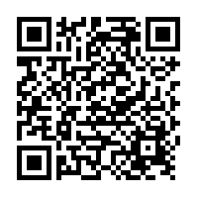

Cognitive Behavioral Therapy (CBT) Spanish Worksheets
CBT thought record in Spanish:  https://stanforduniversity.qualtrics.com/jfe/form/SV_eqyPRu1paWe9OqF | 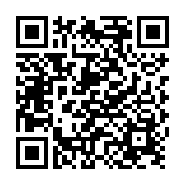
Pros and Cons in Spanish  https://stanforduniversity.qualtrics.com/jfe/form/SV_1HVVBRt9rD0TcoZ | 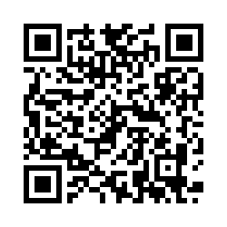
Thinking Clearly in Spanish  https://stanforduniversity.qualtrics.com/jfe/form/SV_bDGHTkXS5wpnUot | 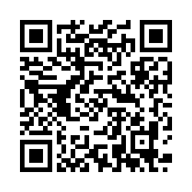
Cognitive Continuum in Spanish  https://stanforduniversity.qualtrics.com/jfe/form/SV_0rBWlV7GZmTQhyl | 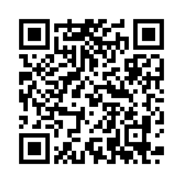
Weekly Schedule for Behavioral Activation in Spanish  https://stanforduniversity.qualtrics.com/jfe/form/SV_2ifrZSYSEPy8S2h | 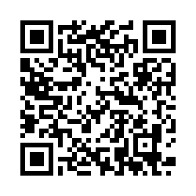
BRIGHT- Thoughts Check In in Spanish  https://stanforduniversity.qualtrics.com/jfe/form/SV_6n7gLXEwSBvyB2l | 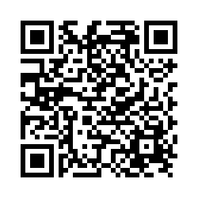
BRIGHT- Catch it, Check it, Change it in Spanish  https://stanforduniversity.qualtrics.com/jfe/form/SV_00we0JUTGEQjFHL | 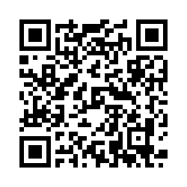
Behavioral Activation Worksheet in Spanish  https://stanforduniversity.qualtrics.com/jfe/form/SV_3qInOKrYSo7KLvD | 