Cognitive Processing Therapy (CPT) Spanish Full Worksheets
ABC Full: https://stanforduniversity.qualtrics.com/jfe/form/SV_6mPnxNb4E7S8LeR | 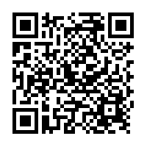
CQW Full: https://stanforduniversity.qualtrics.com/jfe/form/SV_dcz7h8pID1uijul | 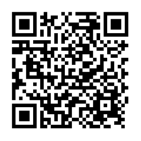
CBW Full:  https://stanforduniversity.qualtrics.com/jfe/form/SV_er1yRbphOZ17BAh | 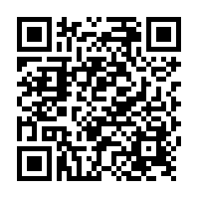
PPT Full: https://stanforduniversity.qualtrics.com/jfe/form/SV_3sfm69LFShL7zLf | 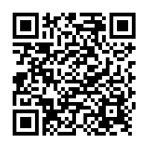

Cognitive Processing Therapy (CPT) Spanish Short Form Worksheets
Formulario de ABC short form:  https://stanforduniversity.qualtrics.com/jfe/form/SV_3ZWgeas4zL1JbAF | 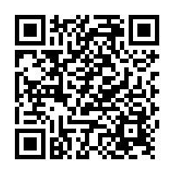
Desafiando puntos o pensamientos de bloqueo (simplified CQW):  https://stanforduniversity.qualtrics.com/jfe/form/SV_3vCVpquYdPTHHsF | 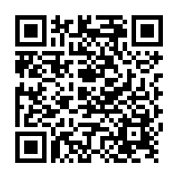
Cambiando creencias y sentimientos (simplified CBW):  https://stanforduniversity.qualtrics.com/jfe/form/SV_6YHJLYJEGgDXlpr | s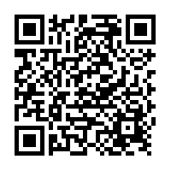

Cognitive Behavioral Therapy (CBT)
CBT thought record in Spanish:  https://stanforduniversity.qualtrics.com/jfe/form/SV_eqyPRu1paWe9OqF | 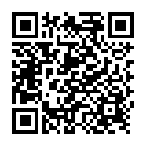
Pros and Cons in Spanish  https://stanforduniversity.qualtrics.com/jfe/form/SV_1HVVBRt9rD0TcoZ | 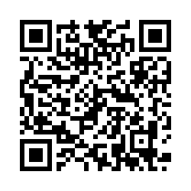
Thinking Clearly in Spanish  https://stanforduniversity.qualtrics.com/jfe/form/SV_bDGHTkXS5wpnUot | 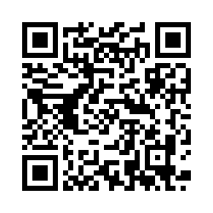
Cognitive Continuum in Spanish  https://stanforduniversity.qualtrics.com/jfe/form/SV_0rBWlV7GZmTQhyl | 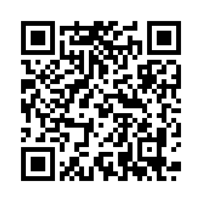
Weekly Schedule for Behavioral Activation in Spanish  https://stanforduniversity.qualtrics.com/jfe/form/SV_2ifrZSYSEPy8S2h | 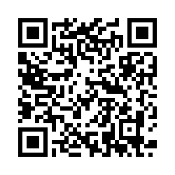
BRIGHT- Thoughts Check In in Spanish  https://stanforduniversity.qualtrics.com/jfe/form/SV_6n7gLXEwSBvyB2l | 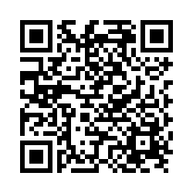
BRIGHT- Catch it, Check it, Change it in Spanish  https://stanforduniversity.qualtrics.com/jfe/form/SV_00we0JUTGEQjFHL | 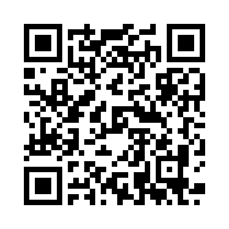
Behavioral Activation Worksheet in Spanish  https://stanforduniversity.qualtrics.com/jfe/form/SV_3qInOKrYSo7KLvD | 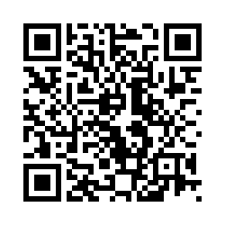

Session Checklists to be completed after each session
CPT Session Checklist: https://stanforduniversity.qualtrics.com/jfe/form/SV_78JrdcqjdVl1LJb | 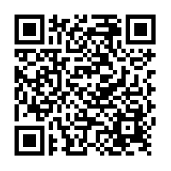
CBT Session Checklist: https://stanforduniversity.qualtrics.com/jfe/form/SV_249BPBVrti1JXal | 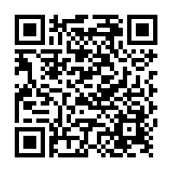

Measures (Both Conditions)
Clinician Baseline:  https://stanforduniversity.qualtrics.com/jfe/form/SV_8v88E707dCBux2R | 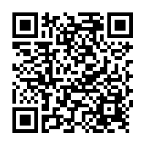

Baseline
Client Demographics (to be completed by the clinician): https://stanforduniversity.qualtrics.com/jfe/form/SV_ehDrHDXZyKGk1X7 | 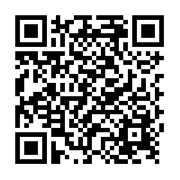
Client Demographics Spanish (to be completed by Client. *Clinician will complete clinician section in English):  https://stanforduniversity.qualtrics.com/jfe/form/SV_5tnsd4b81P2yo9n | 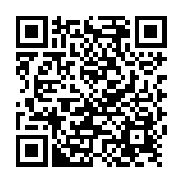
IPF Spanish:  https://stanforduniversity.qualtrics.com/jfe/form/SV_8AZgmFlWCQLEue9 | 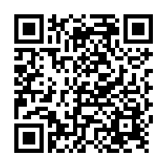
BAI- Spanish:  https://stanforduniversity.qualtrics.com/jfe/form/SV_1MiwUTdSDIXamQ5 | 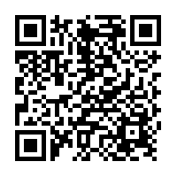
PHQ-9 Spanish:  https://stanforduniversity.qualtrics.com/jfe/form/SV_becq1sxKqqn6xPT | 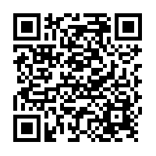
BASELINE: PCL-5 + LEC-5 + Criteria A Spanish  https://stanforduniversity.qualtrics.com/jfe/form/SV_0wePWiwQjFzyrXv | 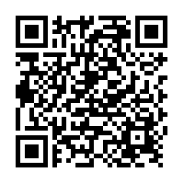

Session 1
BAI- Spanish:
https://stanforduniversity.qualtrics.com/jfe/form/SV_1MiwUTdSDIXamQ5
PHQ-9 Spanish:
https://stanforduniversity.qualtrics.com/jfe/form/SV_becq1sxKqqn6xPT
SESSION 1: PCL-5 with Criterion A:  https://stanforduniversity.qualtrics.com/jfe/form/SV_8oFyl1GcpNddUtT | 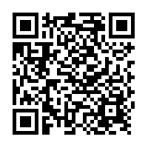

Session 2 – 3
SESSION 2-16 PCL-5 with index trauma Spanish:  https://stanforduniversity.qualtrics.com/jfe/form/SV_bddTRO1hwYgCc6x | 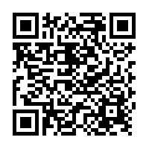
BAI- Spanish:
https://stanforduniversity.qualtrics.com/jfe/form/SV_1MiwUTdSDIXamQ5
PHQ-9 Spanish:
https://stanforduniversity.qualtrics.com/jfe/form/SV_becq1sxKqqn6xPT

Session 4
SESSION 2-16 PCL-5 with index trauma Spanish:
https://stanforduniversity.qualtrics.com/jfe/form/SV_bddTRO1hwYgCc6x
BAI- Spanish:
https://stanforduniversity.qualtrics.com/jfe/form/SV_1MiwUTdSDIXamQ5
PHQ-9 Spanish:
https://stanforduniversity.qualtrics.com/jfe/form/SV_becq1sxKqqn6xPT
IPF Spanish:
https://stanforduniversity.qualtrics.com/jfe/form/SV_8AZgmFlWCQLEue9

Session 5 – 16
SESSION 2-16 PCL-5 with index trauma Spanish:
https://stanforduniversity.qualtrics.com/jfe/form/SV_bddTRO1hwYgCc6x
BAI- Spanish:
https://stanforduniversity.qualtrics.com/jfe/form/SV_1MiwUTdSDIXamQ5
PHQ-9 Spanish:
https://stanforduniversity.qualtrics.com/jfe/form/SV_becq1sxKqqn6xPT

Post-Treatment
SESSION 2-16 PCL-5 with index trauma Spanish:
https://stanforduniversity.qualtrics.com/jfe/form/SV_bddTRO1hwYgCc6x
BAI- Spanish:
https://stanforduniversity.qualtrics.com/jfe/form/SV_1MiwUTdSDIXamQ5
PHQ-9 Spanish:
https://stanforduniversity.qualtrics.com/jfe/form/SV_becq1sxKqqn6xPT
IPF Spanish:
https://stanforduniversity.qualtrics.com/jfe/form/SV_8AZgmFlWCQLEue9

