Completing Assessment Measures over the Phone

In this document:

How to use the PHQ-9/PCL/BAI measure during a phone session……………………..Page 1

How to complete baseline measures over the phone………………………………………..Page 2

How to complete Session 4 measures over the phone………………………………………Page 3

How to complete post-treatment measures………………………………………………………Page3

How to bookmark a webpage…………………………………………………………………………….Page 4

Assessment Measure Links/QR codes………………………………………………………………..Page 6

*************************************************************************************

- How to use the PHQ-9/PCL/BAI measure during a phone session: (Completed every session except baseline, session 4, and post-treatment)
Important: Symptom measures are not dependent on the client’s study condition (app vs. paper) and can be completed with any method you choose. As always, we recommend using the method that best meets the needs of you and the client.
For both App/Paper condition clients (i.e., For all clients):
Recommended option (if client has access to internet): A study team member or you as the clinician (if you are using email to communicate with the client) can send the client a link/QR code to complete the measure prior to or just before the start of each session. We recommend asking the client to complete the measure the same day of the appointment prior to the start of each session. For future ease of access, the client should save the link in the notes of their phone or bookmark the survey webpage on their computer. (Note: See page 6 for quick access to the symptom measure links/QR codes).
Tip: We recommend asking the client for the total score before beginning the session to confirm the client has completed it and to check in on how the client is doing.
Tip: You can also bookmark the symptom measures to enter them from your end, if needed (Please scroll to the page 4 if you’d like to learn how to bookmark or how to easily explain to a client how to bookmark the page).
Alternative Options:
1) If access to the internet, but no time during session to complete the measure: The study team will send the client an email with the survey link before each session and the client can complete the assessment measure on their own time, prior to session. For this option, the study team will need to know when the client’s appointment occurs. This option may be useful for clients who need a reminder to complete the measure each session and the clinician does not have time to directly address this each week while they are doing telehealth.
2) If no access to the internet: If the client does not have access to internet, the clinician can read out the items of the measure and complete it on behalf of the client on their end. This option may be time intensive for some clinicians/clients.
3) If access to the internet and a printer: A study team member can send the client an email with the appropriate symptom measure attached. The client can print multiple copies and fill one out at each session and share the score with the clinician at the start of each session. The client would hold onto these (dated) measures, until they are able to get them to their clinician. Important: Make sure the client uses their client ID as an identifiable rather than their name.
- How to complete baseline measures over the phone:
What needs to be completed by the client (5 items):
- Client demographics form
- Baseline PCL-5 (PTSD Checklist)
- PHQ-9 (Patient Health Questionnaire- 9)
- BAI (Beck Anxiety Inventory)
- B-IPF (Brief Inventory of Psychosocial Functioning)
Recommended option: Study team will email client the baseline measures to be completed, after consenting them. You should check in with client at the next session to see if the client has completed all of the measures. If not, you can have the client complete them during the session and review the results together.
Alternative option 1: If a client does not have access to the internet to complete the measures online, or does not want to complete the baseline measures online, you can read the questions and response options to the client, while you fill out the survey online or on paper. This, however, would be very time intensive and only recommended for clients who otherwise cannot complete the baseline.
- How to complete session 4 measures over the phone
What needs to be completed (4 items):
- PCL
- PHQ-9
- BAI
- B-IPF
Recommended option: Study team will email client the session 4 measures to be completed after you complete session 3 with the client. You should check in with the client at session 4 to see if they have completed the measures. If not, you can have the client complete them during the session and discuss them together.
Alternative option 1: If a client does not have access to the internet to complete the measures online, or they do not want to complete the assessment measures online, you can read the client the questions and response options for each measure while you fill out the survey online or on paper. This, however, would be time intensive and only recommended for clients who otherwise cannot complete the baseline.

- How to complete post-treatment measures:
What needs to be completed (4 items):
- PCL
- PHQ-9
- BAI
- B-IPF
Recommended option: Study team will email client the post-treatment measures to be completed after you notify the study team that the final session is coming up. You should check in with the client at the final session to see if they have completed measures. If not, you can offer to allow client to complete them during session time and discuss together.
*Reminder: After completing the post-treatment measures and a brief phone interview, clients will be paid. Please remind clients at the final session to expect a call or email (depending on their preferences) from the study team to set up a time to complete the brief interview.
Alternative option 1: If client does not have access to the internet to complete the assessment measures online, or they do not want to complete the post-treatment measures online, you can read the client the questions and response options for each measure to the client, while you fill out the survey online or on paper. This, however, would be very time intensive and only recommended for clients who otherwise cannot complete the post-treatment measures.

- How to bookmark a webpage:
Step 1: Open the survey using the link provided to you by the study team (we recommend using Google Chrome as your browser). Click the 3 vertical dots in the upper right-hand corner. Then select “Bookmarks” and then “Bookmark this tab”.
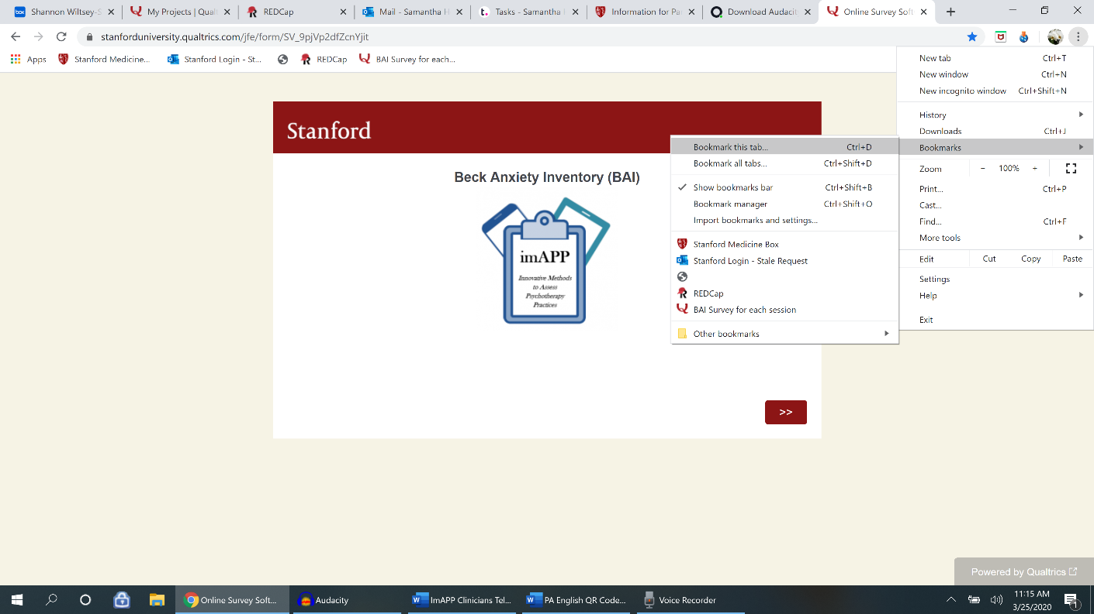
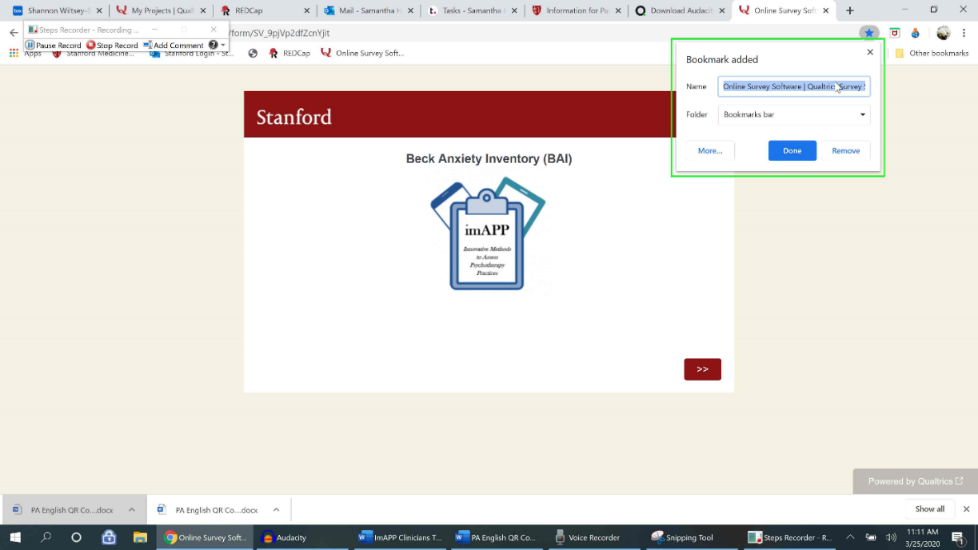
Step 2: After selecting “Bookmark this tab”, a pop up will appear showing you the default name of this tab. The default name is “Online survey software/Qualtrics”
Step 3: You can rename webpage bookmark in the pop up window, if you like, and then hit “Done”. In the below example, I renamed the webpage bookmark: “BAI Survey for each session”.
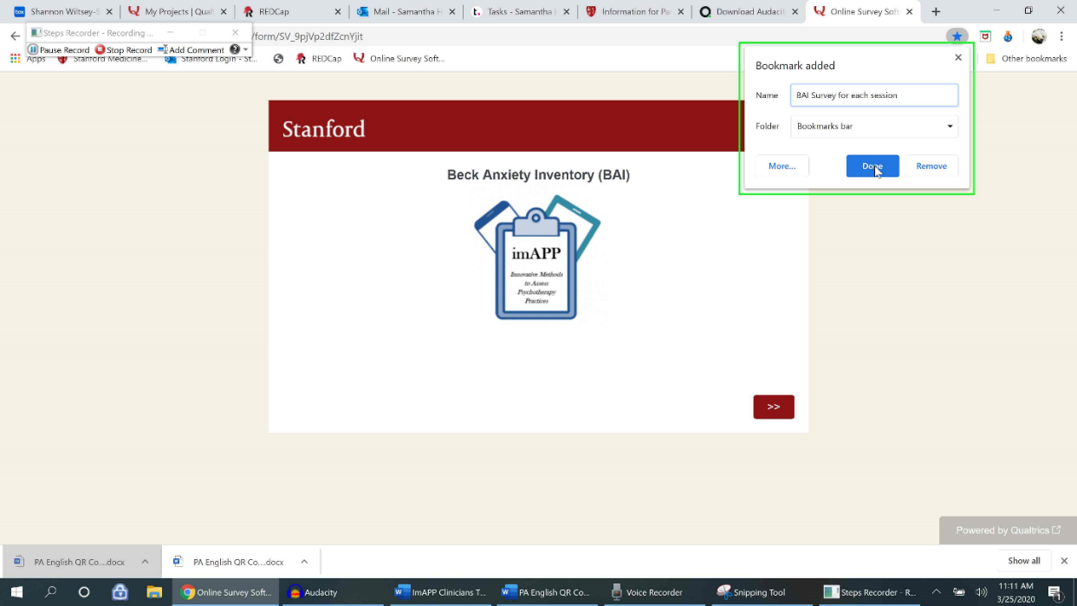

Thank you for all of your great work! If you have any questions or would like additional help/support, please contact the study team via email at sahern01@stanford.edu. Thanks!

- Links and QR codes for Qualtrics Symptom Measures (and Checklists):
*Note: Links/QR codes for Spanish measures begin on page 10
Stanford Medicine Box Link
Stanford Medicine Box link (for uploading worksheets and recordings):
https://stanfordmedicine.app.box.com/upload-widget/view/c1hzaqn4bth9lf5nqqimmaqhsarmuhk0/4886210141?height=385&instructions=&title=Submit+file+to+the+imAPP+study&isDescriptionFieldShown=1&isEmailRequired=0
Session Checklist to be completed after each session
CPT Session Checklist: https://stanforduniversity.qualtrics.com/jfe/form/SV_78JrdcqjdVl1LJb
CBT Session Checklist: https://stanforduniversity.qualtrics.com/jfe/form/SV_249BPBVrti1JXal

Baseline (Have client complete all of the below measures to complete study enrollment)
Client Demographics (to be completed by the clinician): https://stanforduniversity.qualtrics.com/jfe/form/SV_ehDrHDXZyKGk1X7
Client Demographics (to be completed by the client): https://stanforduniversity.qualtrics.com/jfe/form/SV_6m6J1UScRFECszX
BASELINE: PCL LEC and Criterion A: https://stanforduniversity.qualtrics.com/jfe/form/SV_eIFxVVtELUJN0iN
BAI:
https://stanforduniversity.qualtrics.com/jfe/form/SV_9pjVp2dfZcnYjit
IPF: https://stanforduniversity.qualtrics.com/jfe/form/SV_b9qG4L1wDYkEQXX
PHQ-9: https://stanforduniversity.qualtrics.com/jfe/form/SV_0DH0etT00pdwgHX

Session 1 (Have client do one of the below measures that corresponds to their diagnosis)
BAI:
https://stanforduniversity.qualtrics.com/jfe/form/SV_9pjVp2dfZcnYjit
PHQ-9:
https://stanforduniversity.qualtrics.com/jfe/form/SV_0DH0etT00pdwgHX
SESSION 1: PCL and Criterion A:
https://stanforduniversity.qualtrics.com/jfe/form/SV_e9ehAoGYq0JBLw1

Session 2 – 3 (Have client do one of the below measures that corresponds to their diagnosis)
BAI:
https://stanforduniversity.qualtrics.com/jfe/form/SV_9pjVp2dfZcnYjit
PHQ-9:
https://stanforduniversity.qualtrics.com/jfe/form/SV_0DH0etT00pdwgHX
SESSION 2-16: PCL and index event:
https://stanforduniversity.qualtrics.com/jfe/form/SV_554goMJkE7vbLh3

Session 4 (Have client do all of the below measures, they are paid $25 for completing them at Session 4)
BAI:
https://stanforduniversity.qualtrics.com/jfe/form/SV_9pjVp2dfZcnYjit
PHQ-9:
https://stanforduniversity.qualtrics.com/jfe/form/SV_0DH0etT00pdwgHX
SESSION 2-16: PCL and index event:
https://stanforduniversity.qualtrics.com/jfe/form/SV_554goMJkE7vbLh3
IPF:
https://stanforduniversity.qualtrics.com/jfe/form/SV_b9qG4L1wDYkEQXX

Session 5 – 16 (Have client do one of the below measures that corresponds to their diagnosis)
BAI:
https://stanforduniversity.qualtrics.com/jfe/form/SV_9pjVp2dfZcnYjit
PHQ-9:
https://stanforduniversity.qualtrics.com/jfe/form/SV_0DH0etT00pdwgHX
SESSION 2-16: PCL and index event:
https://stanforduniversity.qualtrics.com/jfe/form/SV_554goMJkE7vbLh3

Post-Treatment (Have client do all of the below measures, they are paid an additional $25 for completing the post-treatment measures and a brief exit interview)
BAI:
https://stanforduniversity.qualtrics.com/jfe/form/SV_9pjVp2dfZcnYjit
PHQ-9:
https://stanforduniversity.qualtrics.com/jfe/form/SV_0DH0etT00pdwgHX
SESSION 2-16: PCL and index event:
https://stanforduniversity.qualtrics.com/jfe/form/SV_554goMJkE7vbLh3
IPF:
https://stanforduniversity.qualtrics.com/jfe/form/SV_b9qG4L1wDYkEQXX

Symptom Measure Links/QR codes in Spanish:
Baseline (Have client complete all of the below measures to complete study enrollment)
Client Demographics (to be completed by the clinician): https://stanforduniversity.qualtrics.com/jfe/form/SV_ehDrHDXZyKGk1X7
Client Demographics Spanish (to be completed by Client. *Clinician will complete clinician section in English):
https://stanforduniversity.qualtrics.com/jfe/form/SV_5tnsd4b81P2yo9n
IPF Spanish:
https://stanforduniversity.qualtrics.com/jfe/form/SV_8AZgmFlWCQLEue9
BAI- Spanish:
https://stanforduniversity.qualtrics.com/jfe/form/SV_1MiwUTdSDIXamQ5
PHQ-9 Spanish:
https://stanforduniversity.qualtrics.com/jfe/form/SV_becq1sxKqqn6xPT
BASELINE: PCL-5 + LEC-5 + Criteria A Spanish
https://stanforduniversity.qualtrics.com/jfe/form/SV_0wePWiwQjFzyrXv

Session 1 (Have client do one of the below measures that corresponds to their diagnosis)
BAI- Spanish:
https://stanforduniversity.qualtrics.com/jfe/form/SV_1MiwUTdSDIXamQ5
PHQ-9 Spanish:
https://stanforduniversity.qualtrics.com/jfe/form/SV_becq1sxKqqn6xPT
SESSION 1: PCL-5 with Criterion A:
https://stanforduniversity.qualtrics.com/jfe/form/SV_8oFyl1GcpNddUtT

Session 2 – 3 (Have client do one of the below measures that corresponds to their diagnosis)
SESSION 2-16 PCL-5 with index trauma Spanish:
https://stanforduniversity.qualtrics.com/jfe/form/SV_bddTRO1hwYgCc6x
BAI- Spanish:
https://stanforduniversity.qualtrics.com/jfe/form/SV_1MiwUTdSDIXamQ5
PHQ-9 Spanish:
https://stanforduniversity.qualtrics.com/jfe/form/SV_becq1sxKqqn6xPT

Session 4 (Have client do all of the below measures, they are paid $25 for completing them at Session 4)
SESSION 2-16 PCL-5 with index trauma Spanish:
https://stanforduniversity.qualtrics.com/jfe/form/SV_bddTRO1hwYgCc6x
BAI- Spanish:
https://stanforduniversity.qualtrics.com/jfe/form/SV_1MiwUTdSDIXamQ5
PHQ-9 Spanish:
https://stanforduniversity.qualtrics.com/jfe/form/SV_becq1sxKqqn6xPT
IPF Spanish:
https://stanforduniversity.qualtrics.com/jfe/form/SV_8AZgmFlWCQLEue9

Session 5 – 16 (Have client do one of the below measures that corresponds to their diagnosis)
SESSION 2-16 PCL-5 with index trauma Spanish:
https://stanforduniversity.qualtrics.com/jfe/form/SV_bddTRO1hwYgCc6x
BAI- Spanish:
https://stanforduniversity.qualtrics.com/jfe/form/SV_1MiwUTdSDIXamQ5
PHQ-9 Spanish:
https://stanforduniversity.qualtrics.com/jfe/form/SV_becq1sxKqqn6xPT

Post-Treatment (Have client do all of the below measures, they are paid an additional $25 for completing the post-treatment measures and a brief exit interview)
SESSION 2-16 PCL-5 with index trauma Spanish:
https://stanforduniversity.qualtrics.com/jfe/form/SV_bddTRO1hwYgCc6x
BAI- Spanish:
https://stanforduniversity.qualtrics.com/jfe/form/SV_1MiwUTdSDIXamQ5
PHQ-9 Spanish:
https://stanforduniversity.qualtrics.com/jfe/form/SV_becq1sxKqqn6xPT
IPF Spanish:
https://stanforduniversity.qualtrics.com/jfe/form/SV_8AZgmFlWCQLEue9

