How to Submit your Phone Session Recording on Stanford Medicine Box
Note: The exact steps may change depending on the recording software you use, but the options of drag and drop or browse should be consistent across software applications. These steps can also be applied when uploading worksheet files to Stanford Medicine Box. For help specific to the application you’re using, please contact Samantha at sahern01@stanford.edu. The following example is done on a PC using the Voice Recorder software.

**Please remember to delete all recordings after submitting them and receiving confirmation from the upload page!**

Summary of the skills you can find in this SOP:

(Each skill is hyperlinked to take you to the exact section if you’d like to skip to what you need)
- Drag and Drop Files
- Browse and Upload a File
- Pin your recording folder to Quick Access
- Delete a Recording and Clear your Recycle Bin

Step 1: Open the FAST lab webpage in a separate window to access Stanford Medicine Box at: http://med.stanford.edu/fastlab/research/imapp/infoimapp.html. If you use this link, you will see at the the bottom of the page a section entitled “Submit file to the imAPP study”. If you instead pull up the FAST lab home page, go to “imAPP study” and then “Information for participating clinicians”. Now you should see at the bottom of the page the same section to submit a file.
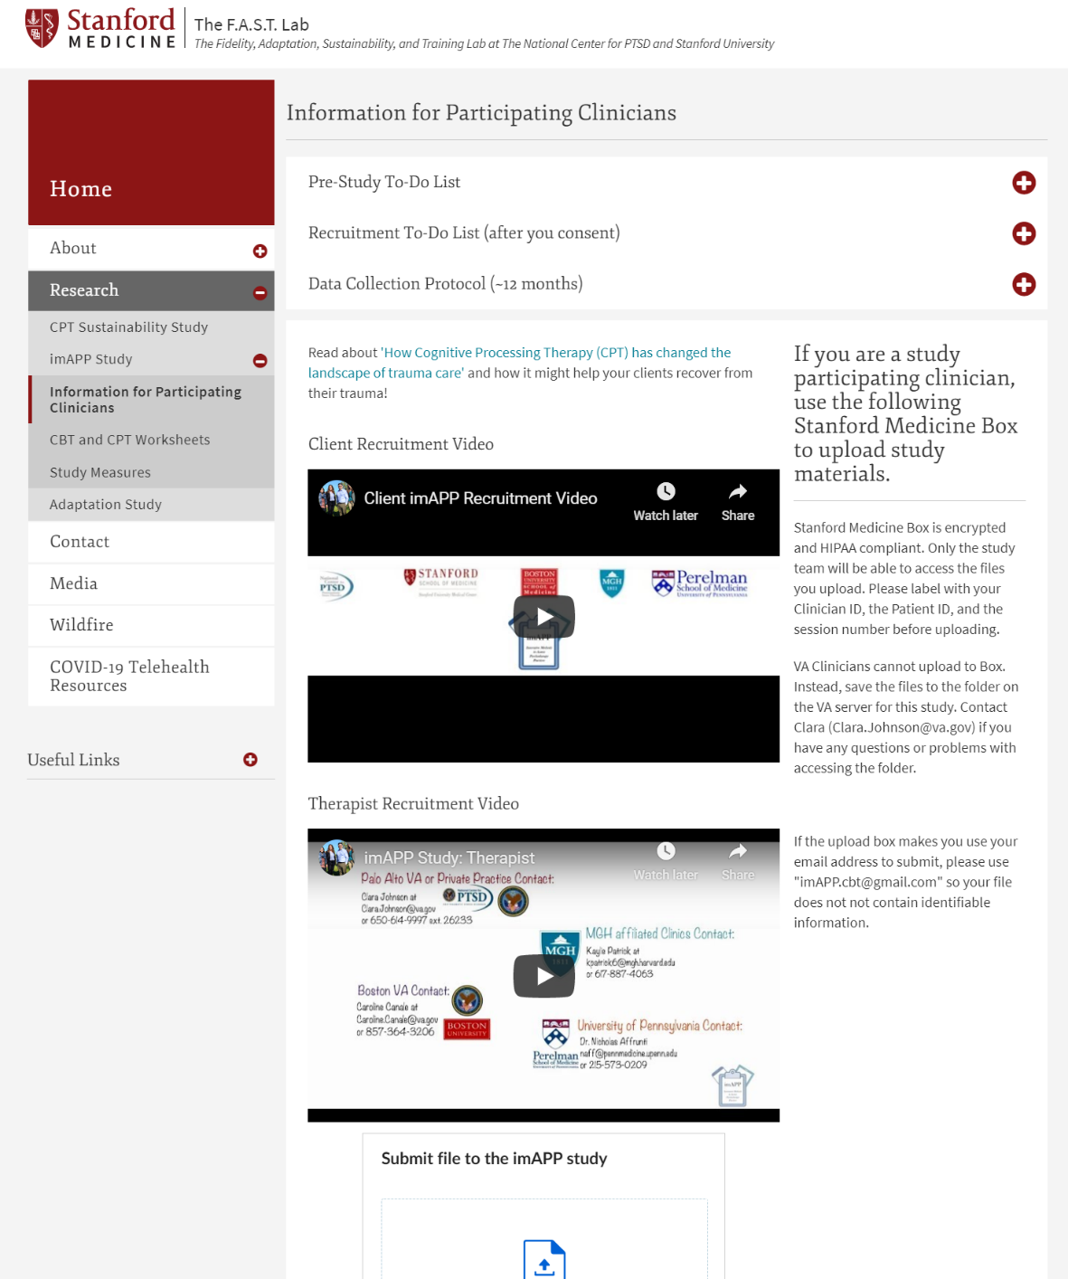

Step 2: You will have two choices to submit the recording into the section entitled “Submit a file to the imAPP study”. You can drag and drop a file into the section or you can browse your computer files and select and upload the recording. We suggest using the drag and drop method, but will include instruction for the browse and select option below in Step 8.
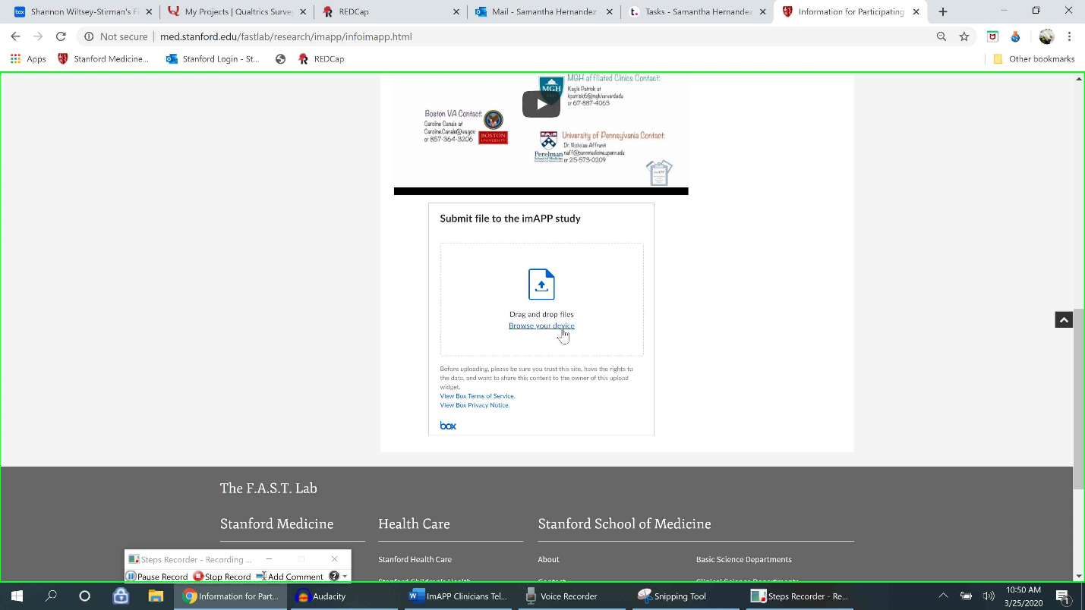
Note: The recording app “Voice Recorder” does not have a drag and drop function for moving files of recordings within the software itself. If the default recording application you use includes a drag and drop function (like Voice Memos does), we recommend using it. Otherwise, you can drag and drop the recording file from the file folder location instead, as we will be doing in this demonstration below.
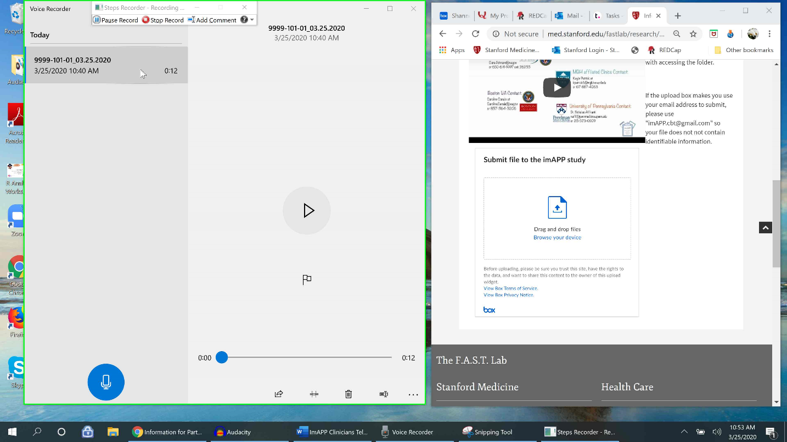
Step 3: Before dragging and dropping a file, be sure to pull up both the recording screen and the imAPP study page with the function to submit a file to the imAPP team in minimized mode, side-by-side, as seen below. We are going to use drag and drop with the recording file in the file location folder. Right click the recording (the same way you would to rename a recording). Select “Open file location” from the drop-down menu. This will take you to the audio file location. From which you can drag and drop the recording file into Stanford Medicine Box.
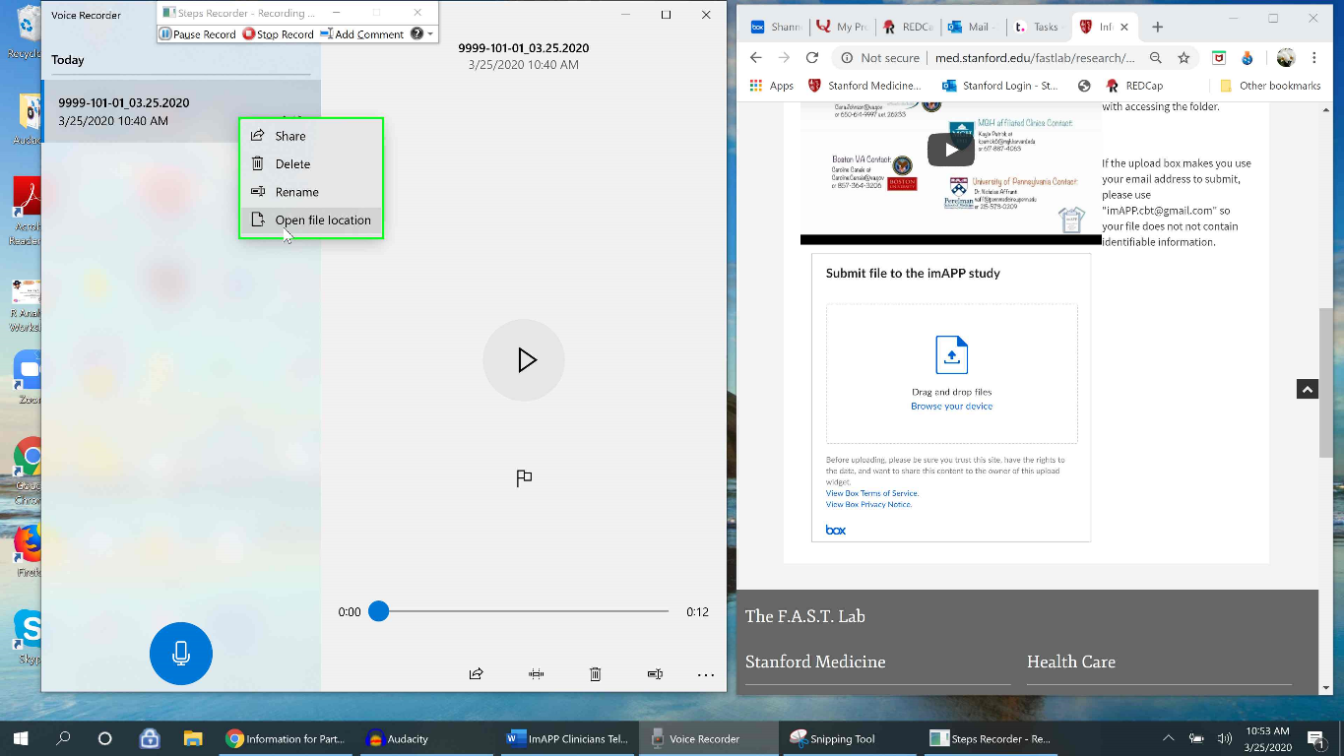
Step 4: This should open another file explorer window called “Sound recordings”. Select the recording you’d like to upload. Tip: You can also rename the recording here if needed!
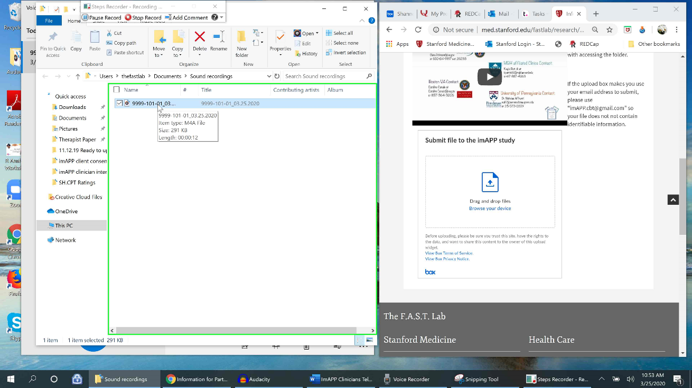
Step 5: Holding down the chosen file, drag and drop it into Stanford Medicine Box.
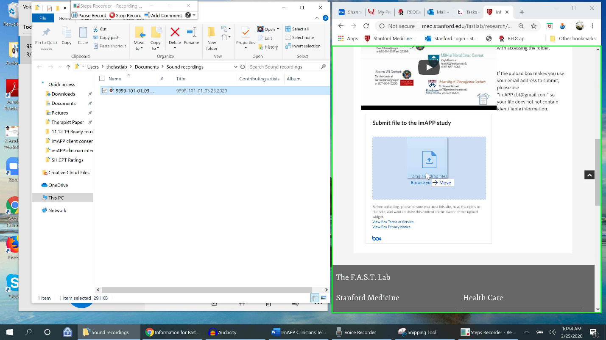
Step 6: You should see a green check mark next to your file name in the box, indicating the file was successfully uploaded. Add a description or change the name of the recording to include your ID number, your client’s ID number, the session number, and the date (e.g., 1099-101-04_03.25.2020). In the description, you can also include other helpful information (e.g., audio stopped after 10 min, session was only 10 min long).
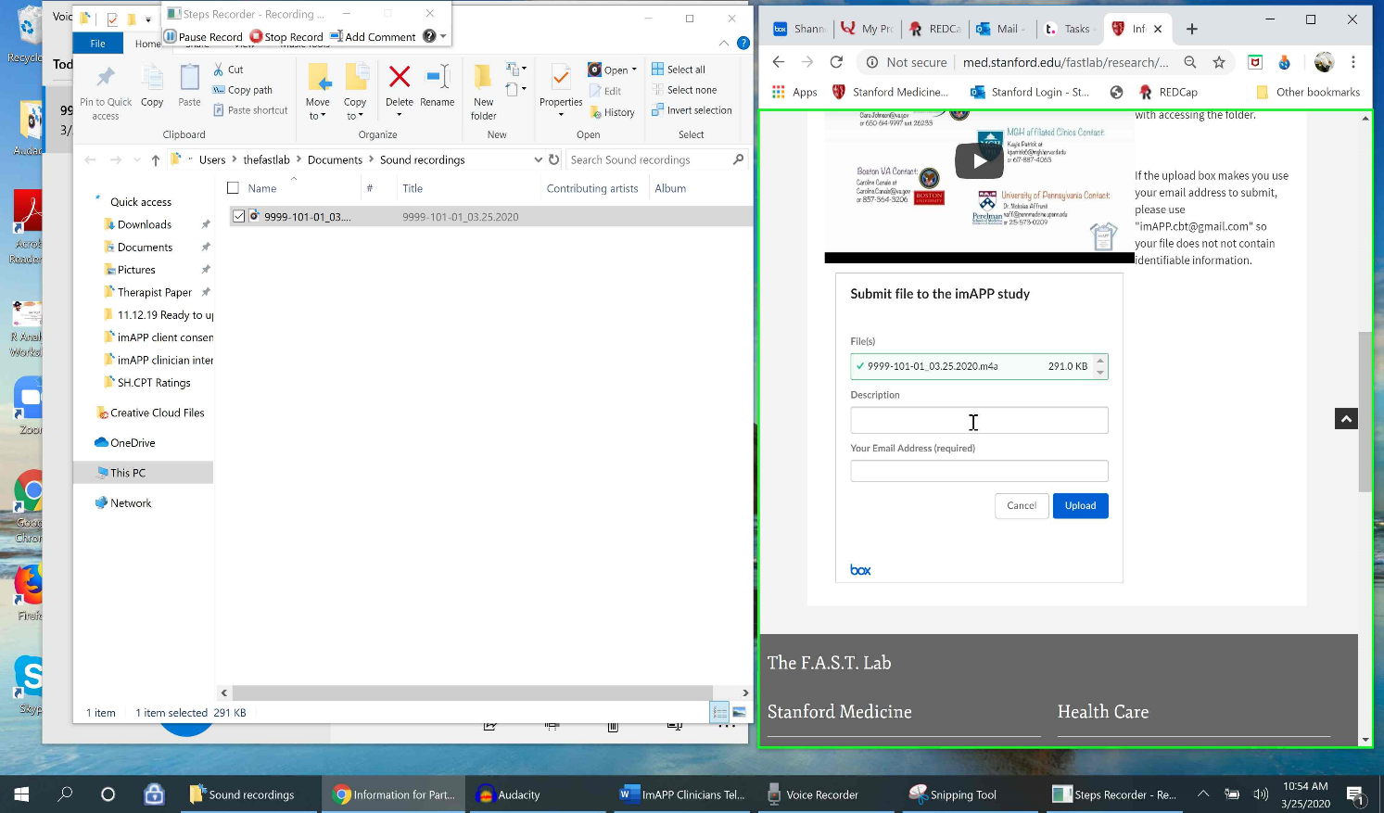
Step 7: Click “upload” to upload your attachment and description into Stanford Medicine Box. You should see a “Success! Your file has been uploaded” message as confirmation that your file was successfully uploaded. Skip to Step 21 to see how to delete the recordings, if drag and drop worked for you.
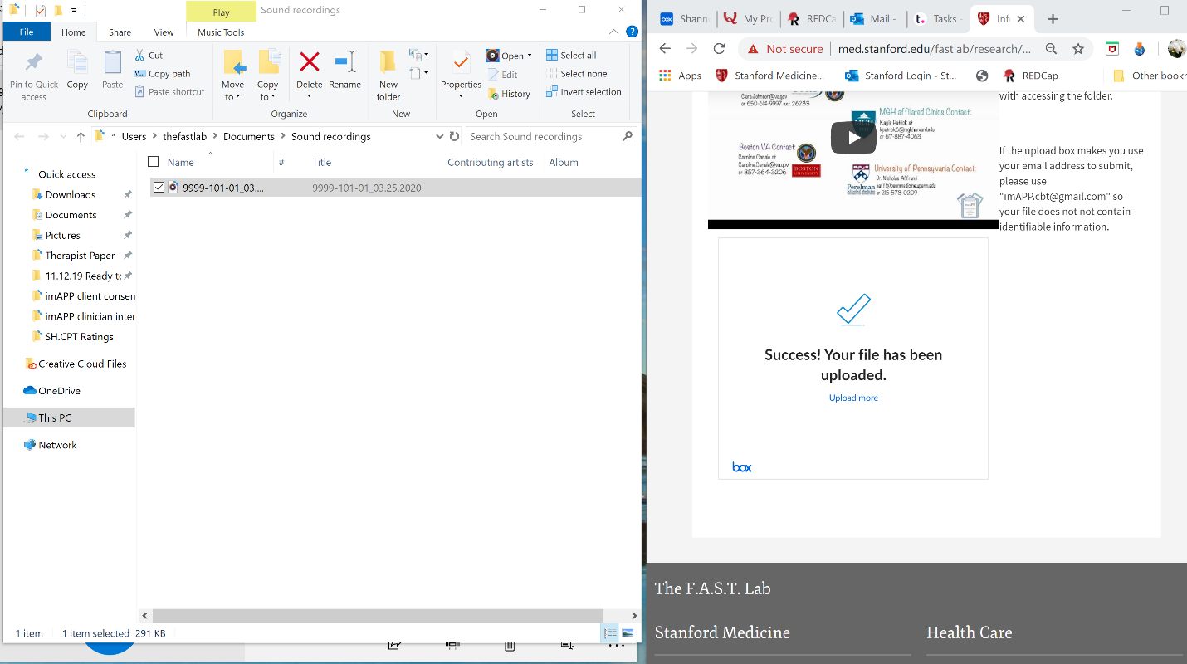

How to Use the Browse Function:
Note: If drag and drop does not work as an option for you, we recommend using the browse function as an alternative method. In order to use the browse function and to upload your recording, you first need to know the file location of where your files are being saved. For example, in Audacity you can choose where to save your files and can then select that folder when using browse and upload. In Voice Recorder, the program automatically saves your file in the software’s default folder called “Sound Recordings”. We will review how to access this folder below.
Step 8: For an alternative to the above drag and drop option, you can use the browse function. To use this option, click on the “browse your device” blue underlined text in the Stanford Medicine Box section on the imAPP webpage (See link above in Step 1).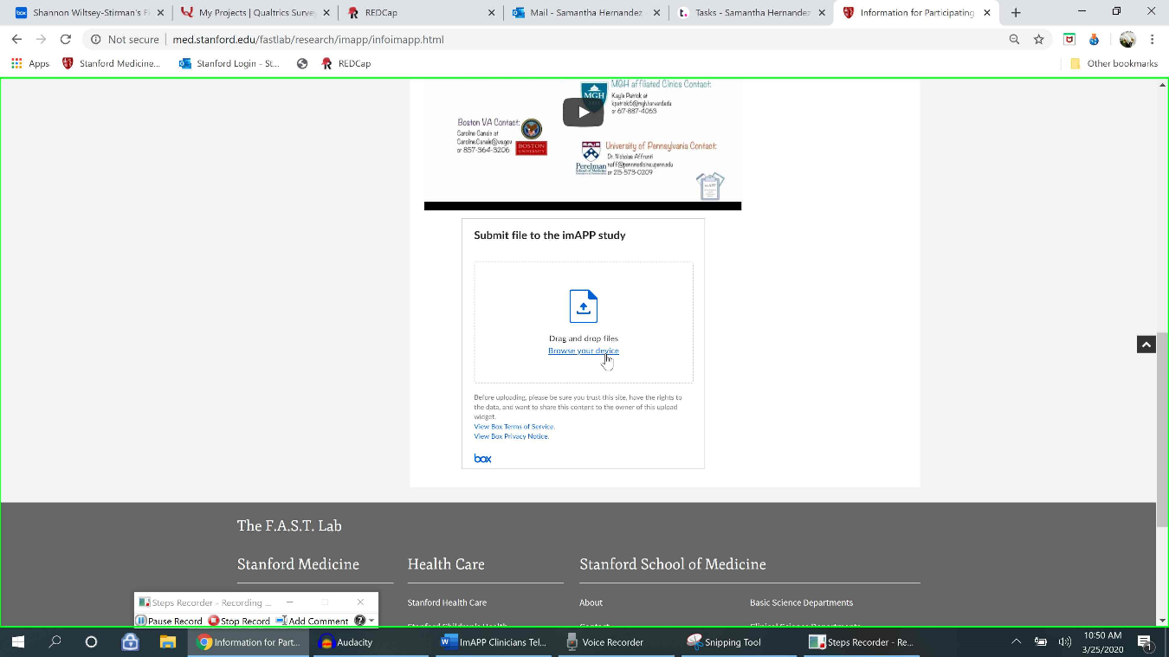

This should automatically open a file explorer window that shows the last folder you had open. In this example, it opens to the pictures’ folder. Select “cancel” to learn how to access your recordings folder when you select “Browse”.
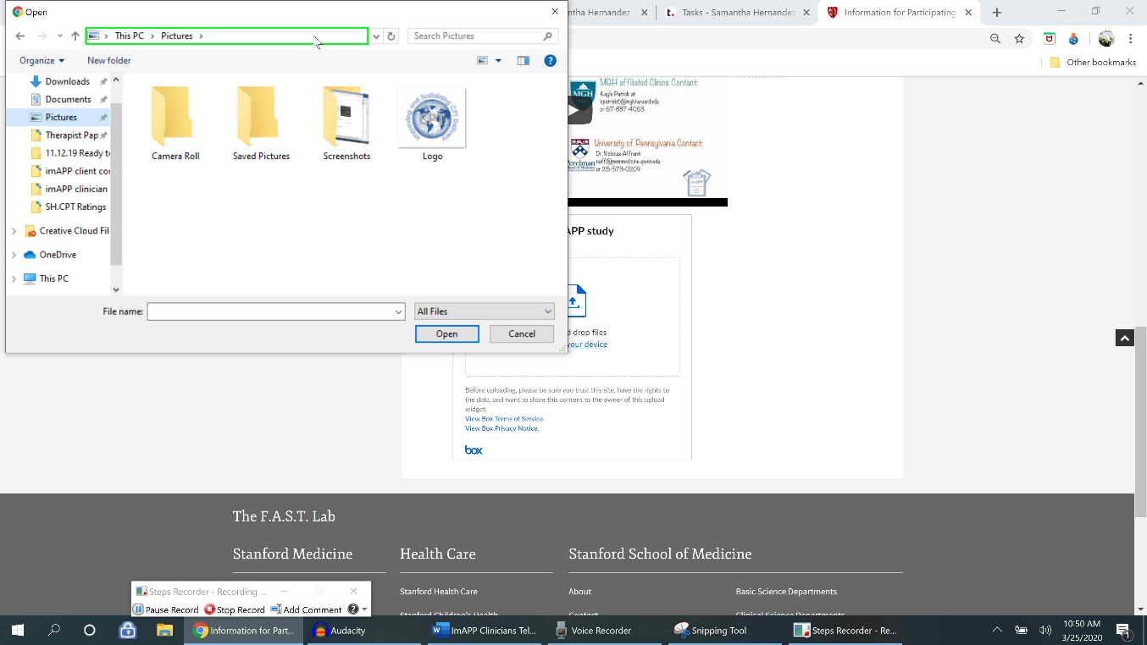
Step 10: In this example, we want our recordings folder, not our pictures’ folder to appear when we open the file explorer window. If you don’t know where your recording is saved, you can find its location by going to the recording in Voice Recorder and right clicking on it. Then select “open file location” from the drop down menu that will appear. 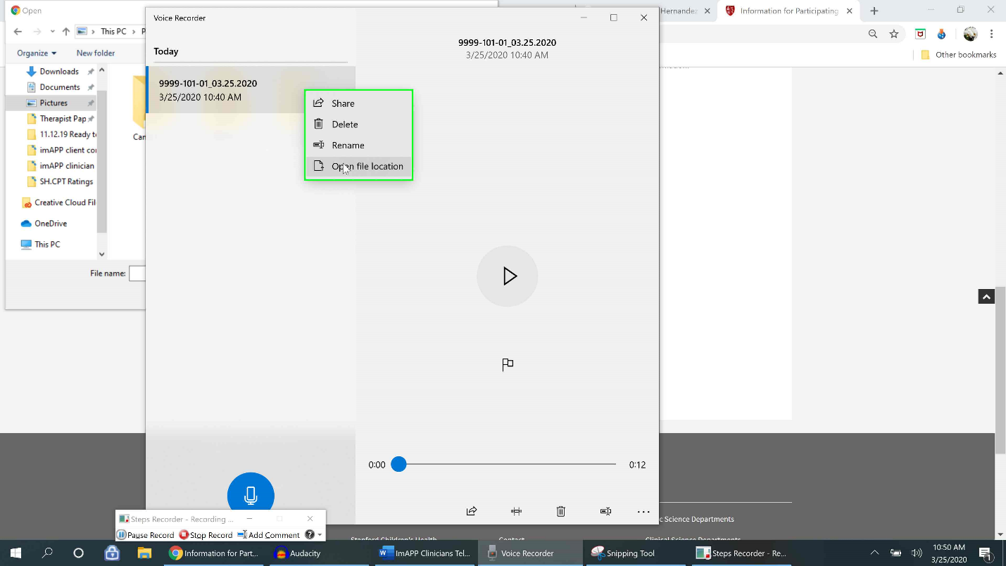
Step 11: This will open the file explorer window for where the recordings are located. The “file pathway” is located in the upper bar (see green bar in the below screen shot). The file pathway tells us which folder the recordings are located in. In this case it’s “This PC -> Documents -> Sound Recordings”. Make note of your file pathway, to follow along on your device.
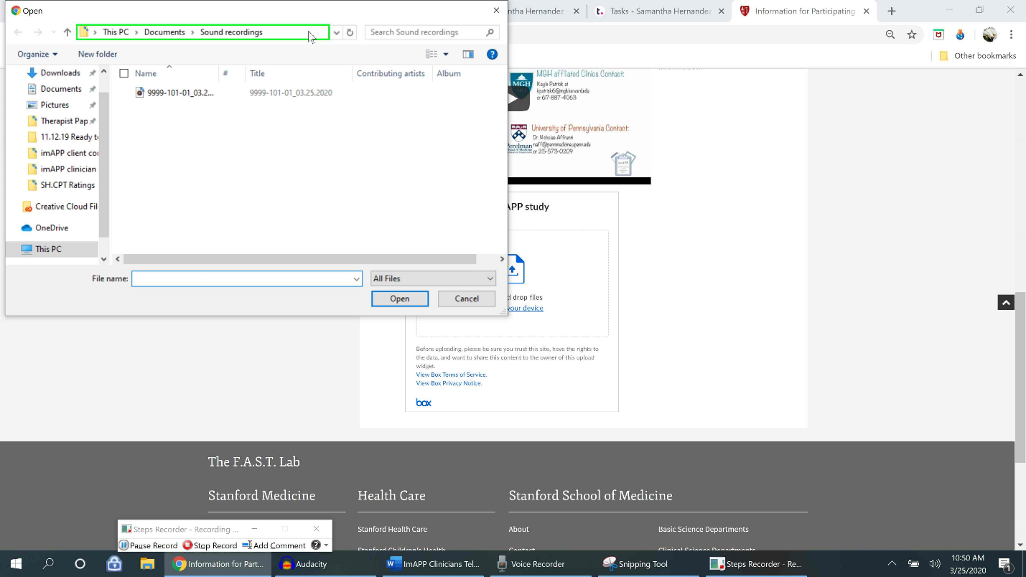
Step 12: Next, open a separate file explorer window to follow this pathway and eventually pin the folder to quick access, so it always appears on the left panel of readily available folders when you select “Browse” on the imAPP Stanford Medicine Box.
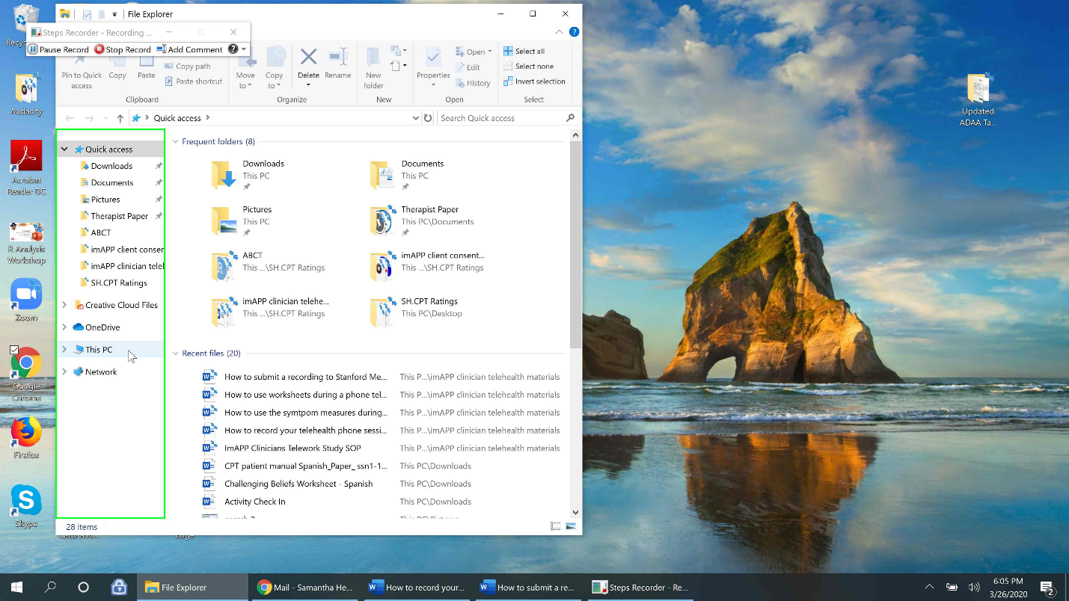
Step 13: In this example, the above pathway for me is to go to “This PC”, then “Documents” and then “Sound Recordings”. This is where my audio recordings are being saved. First, I go to “This PC”. Then I select “documents” because that was the second item listed in the pathway. On your device, select the first item in your pathway and then the second folder.
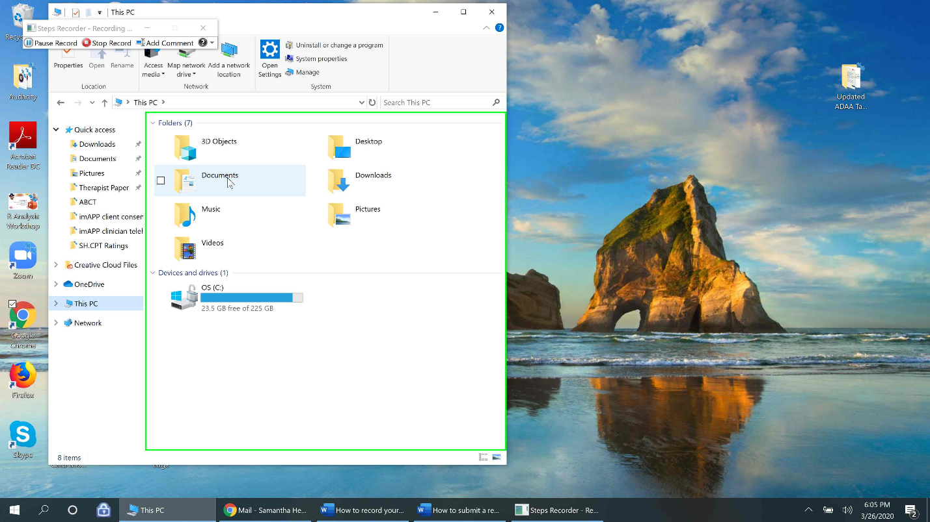
Step 14: In “Documents”, I see the folder “Sound Recordings”. You should also see “Sound Recordings” in your folder (following the pathway). Right click the “Sound Recordings” folder.
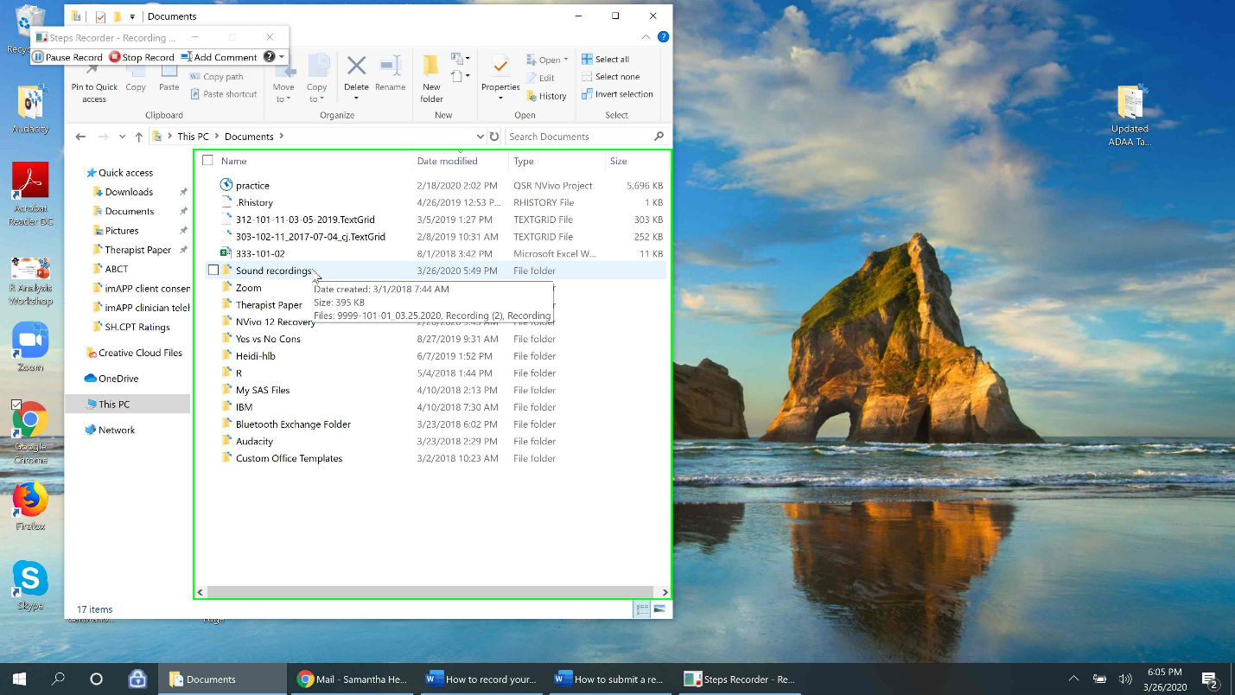
Step 15: A menu of options will appear. Select “Pin to Quick Access”.
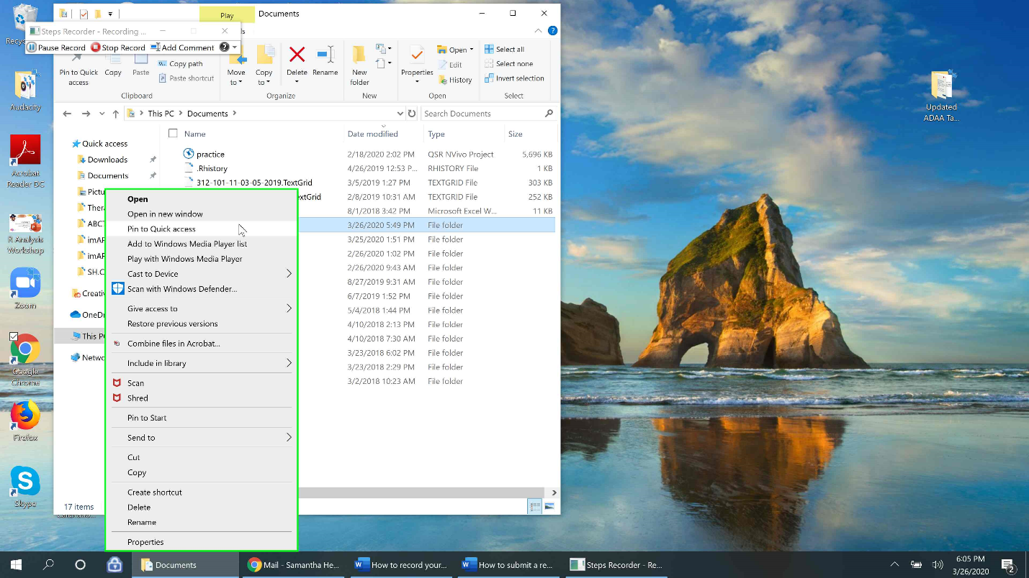
Step 16: Now my “Sound Recordings” folder is always pinned in my readily available folders in the left-hand panel, so I will always have easy access to the folder when I select browse. 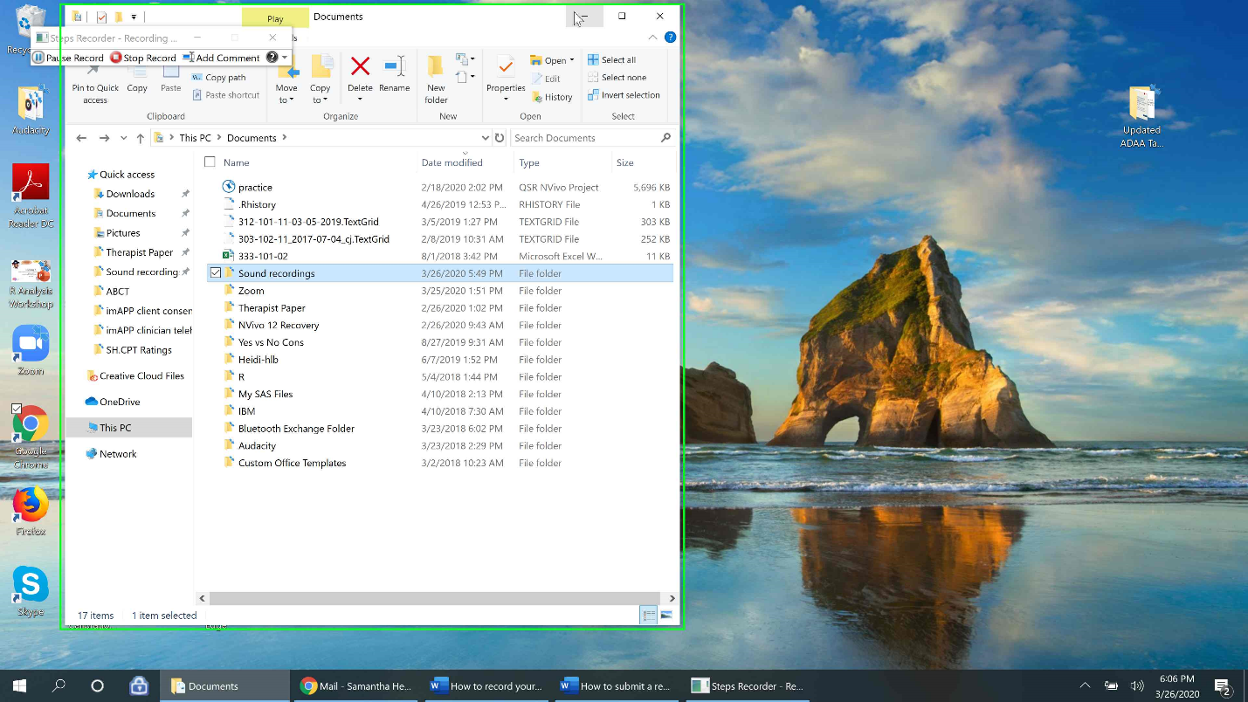

Step 17: Next, open Stanford Medicine Box and select “Browse your device”.
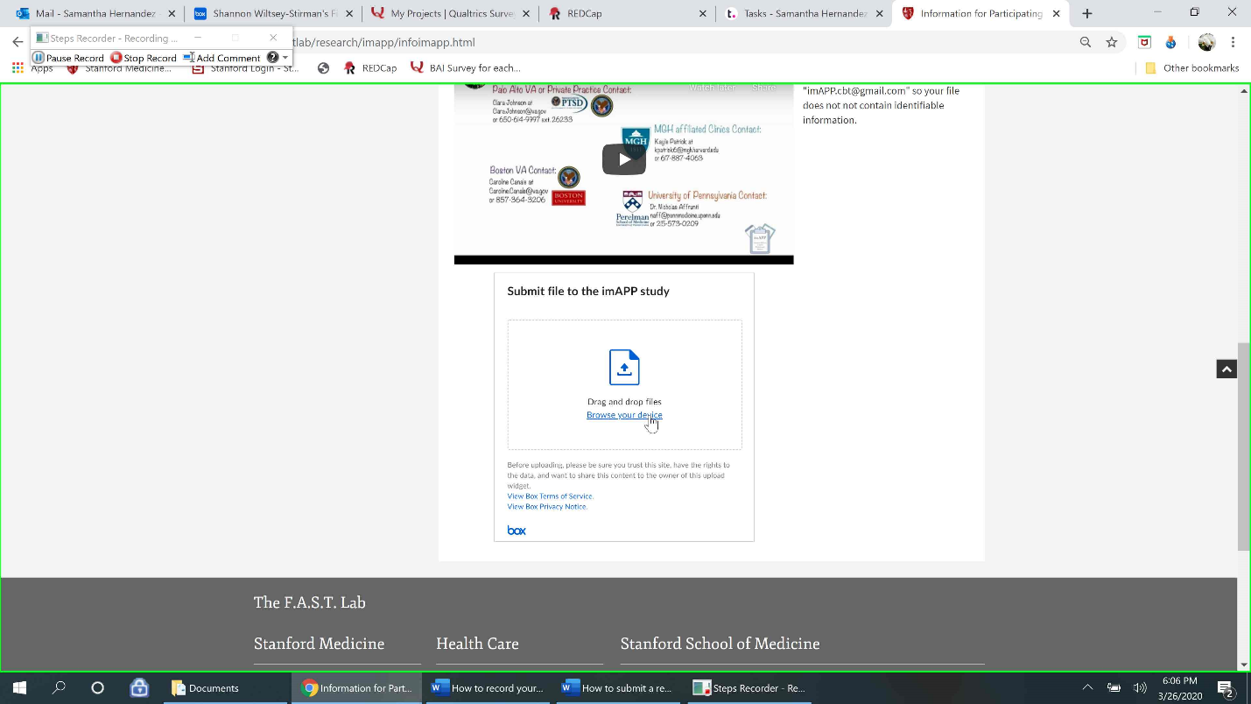
Step 18: In the file explorer window that opens, you should now see the “Sound recordings” folder in the left-hand dropdown of folders. Click “Sound recordings” to open the folder of available recordings. Your “Sound Recordings” folder will always be available on the left hand panel of folders when you select browse because we “Pinned to Quick Access”.
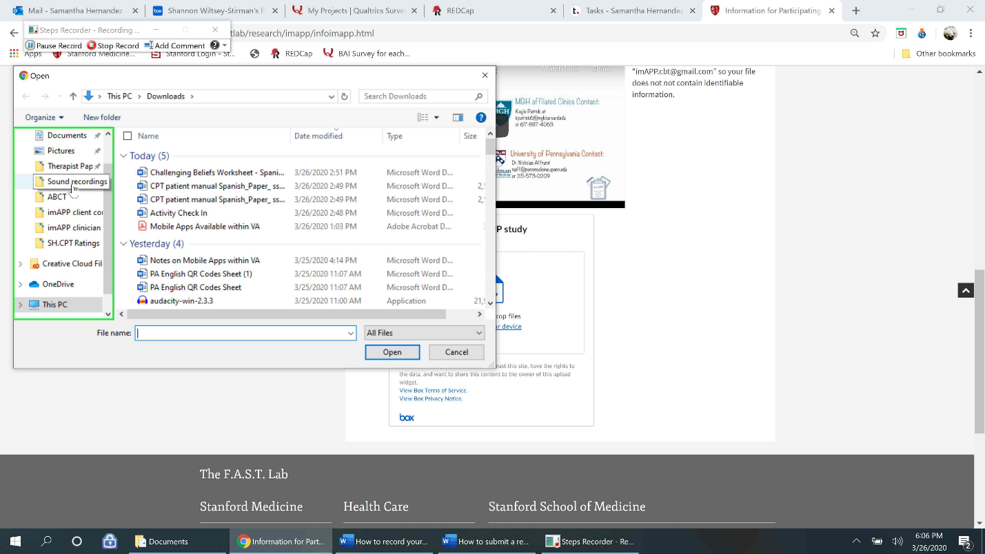
Step 19: Select the recording you wish to upload and then select “Open”.
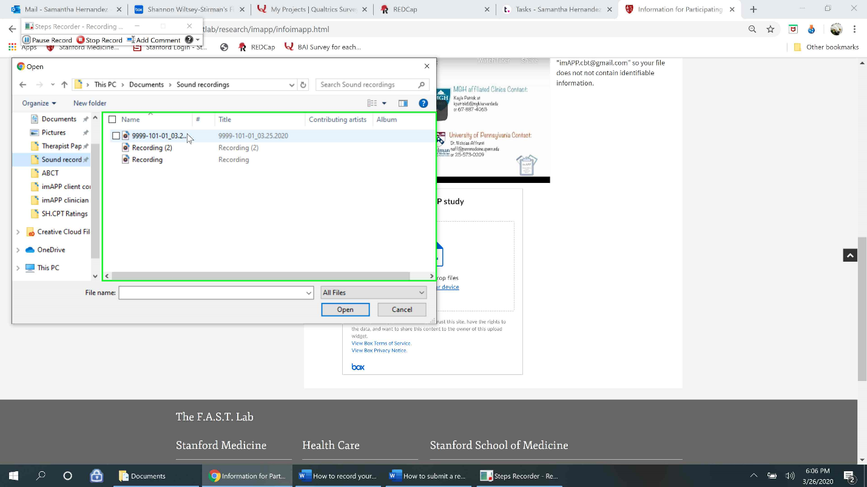
Step 20: You should see the recording appear in the box with a green check mark. You can then fill in any description, the imAPP email (imapp.cbt@gmail.com), and select “Upload” to upload it to Stanford Medicine Box.
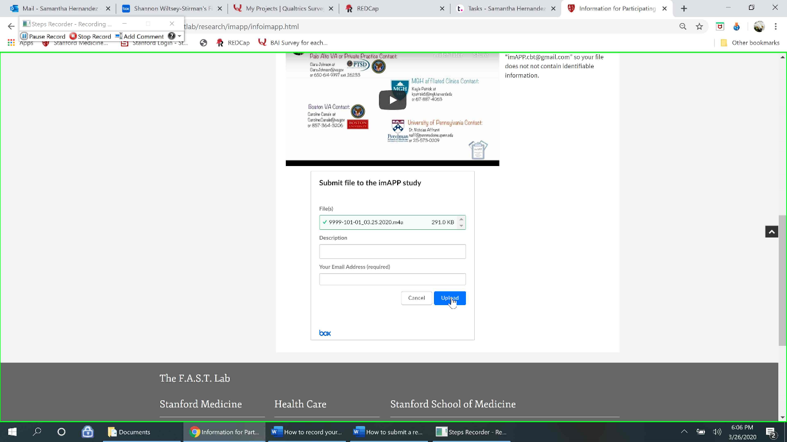

You should then see the confirmation page appear after selecting “Upload”.
After this, your sound recording folder will always be pinned to Quick Access and easily accessible when you select browse to upload a recording.

Please remember to delete recordings from the folder after uploading them and receving confirmation from the upload page. See below for instructions on how to delete.

Deleting a Recording
Step 21: To delete the recording, right click the audio file and select “delete” from the dropdown menu. Warning: When you delete a file this way, it sends the file to the “Recycle Bin” on your computer and the file is only permanently deleted after 30 days of being in the recycle bin. For directions on how to clear contents from your recycle bin, please see below.
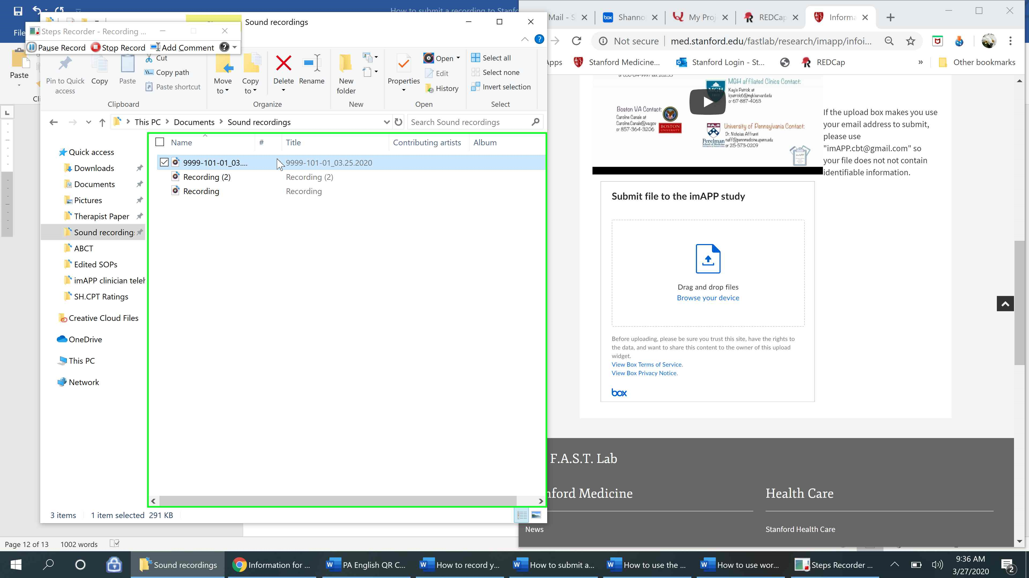
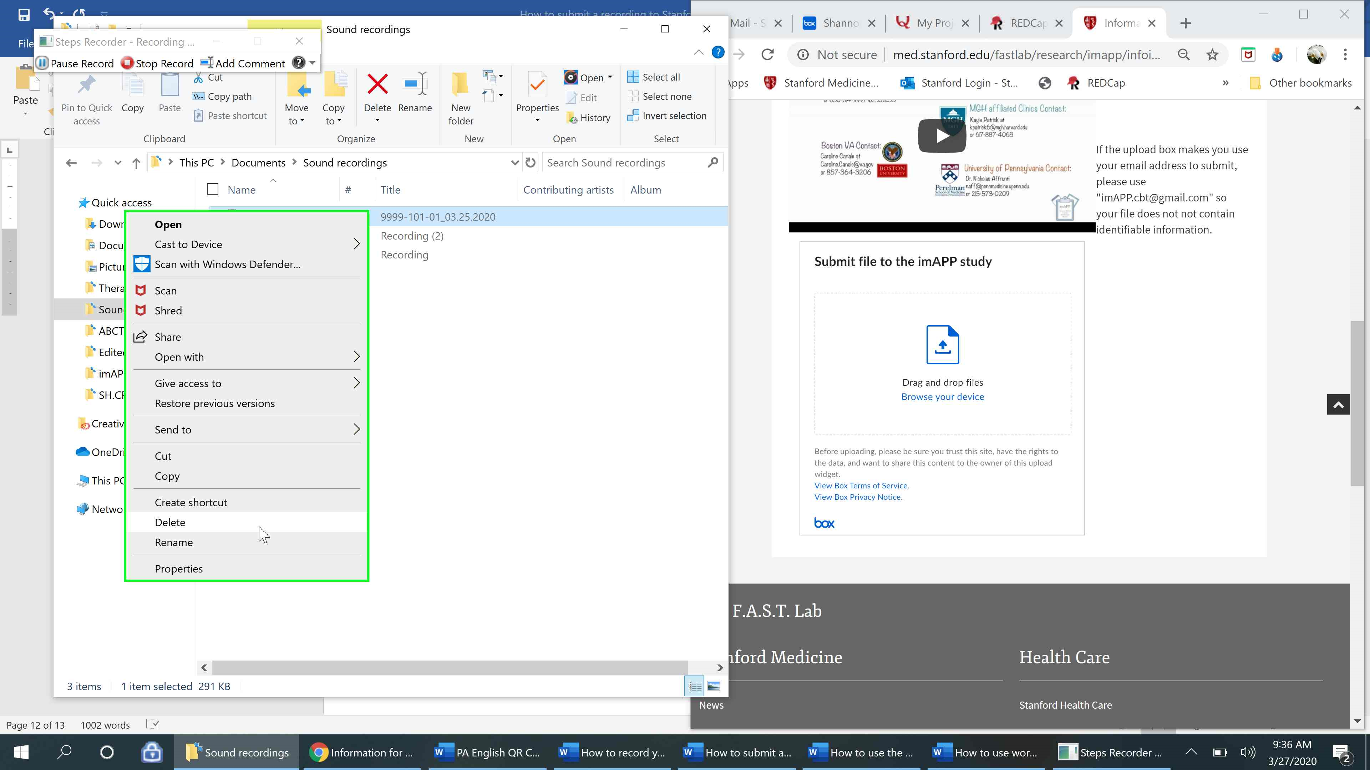
Emptying the Recycle Bin (Permanently Deleting Items)
Step 22: Click the search microscope icon to pull up the search bar that says “Type here to Search”. If you have the Recycle Bin icon on your desktop, see step 26.
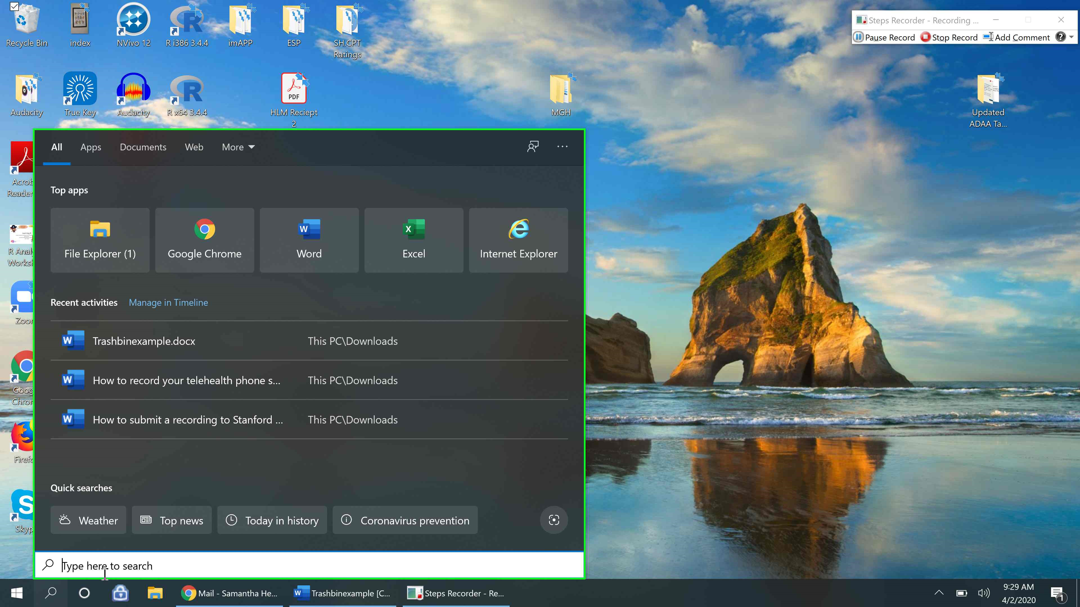
Step 23: Type “Recycle” into the search bar. Click on the “Recycle Bin” app with the icon of a recycling bin. 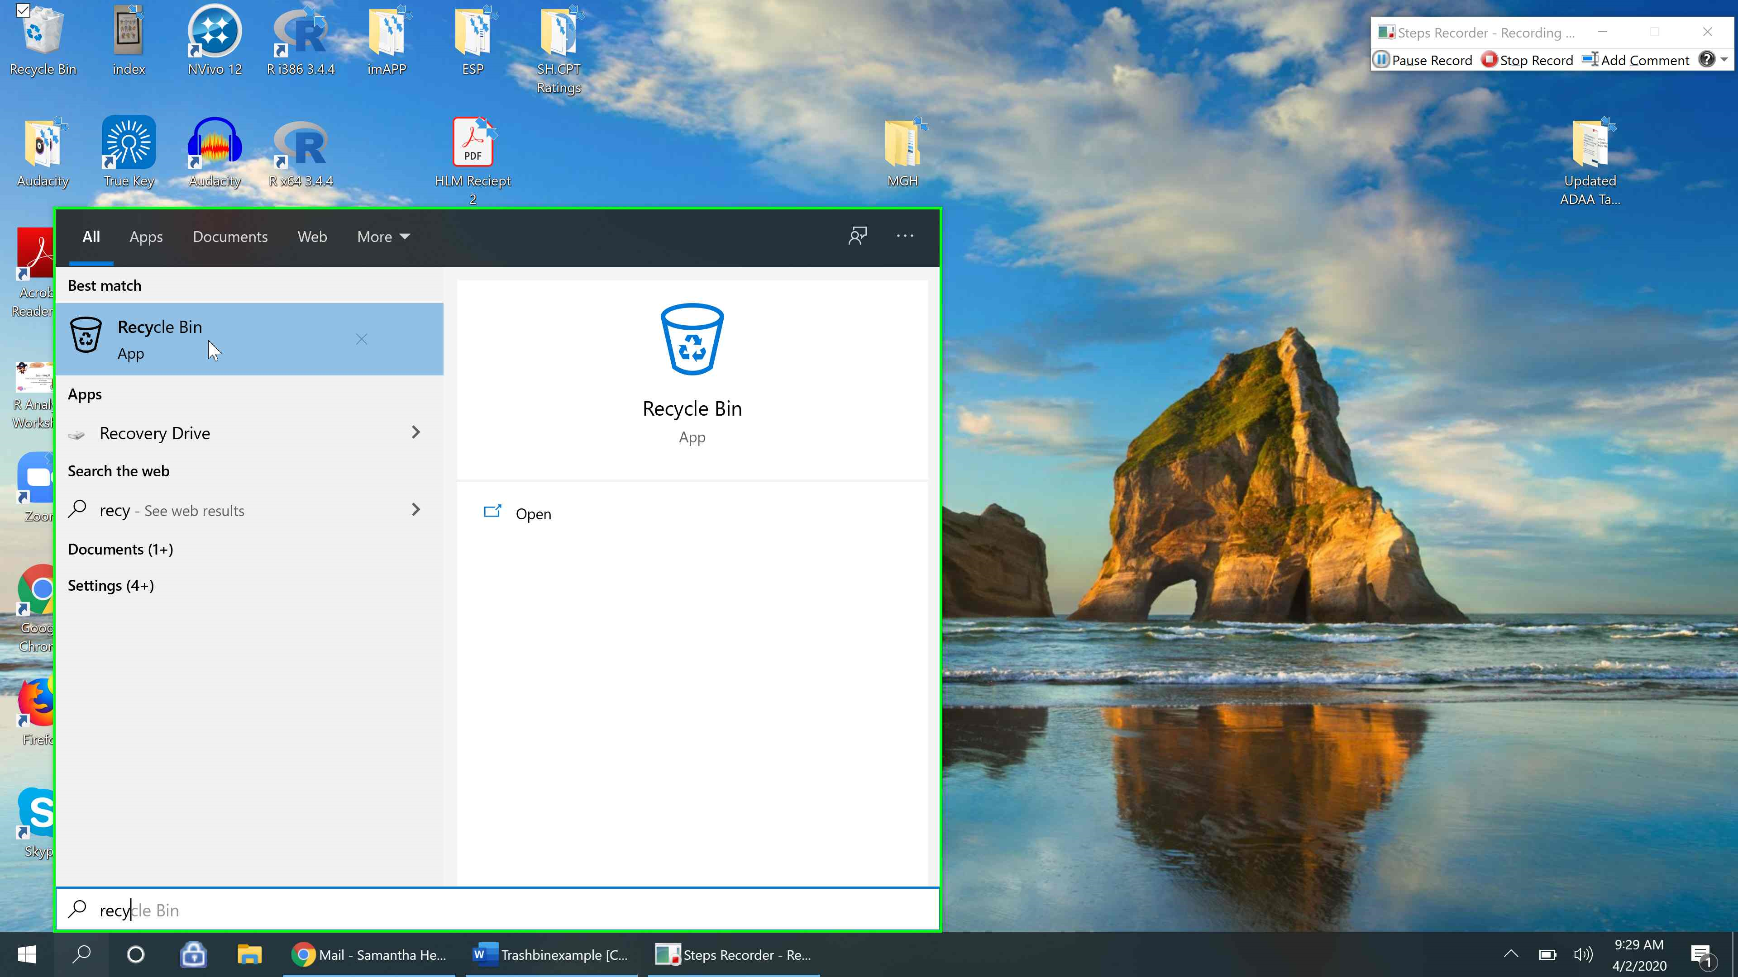
This will open a file folder of all of your recently deleted items (from the last 30 days).
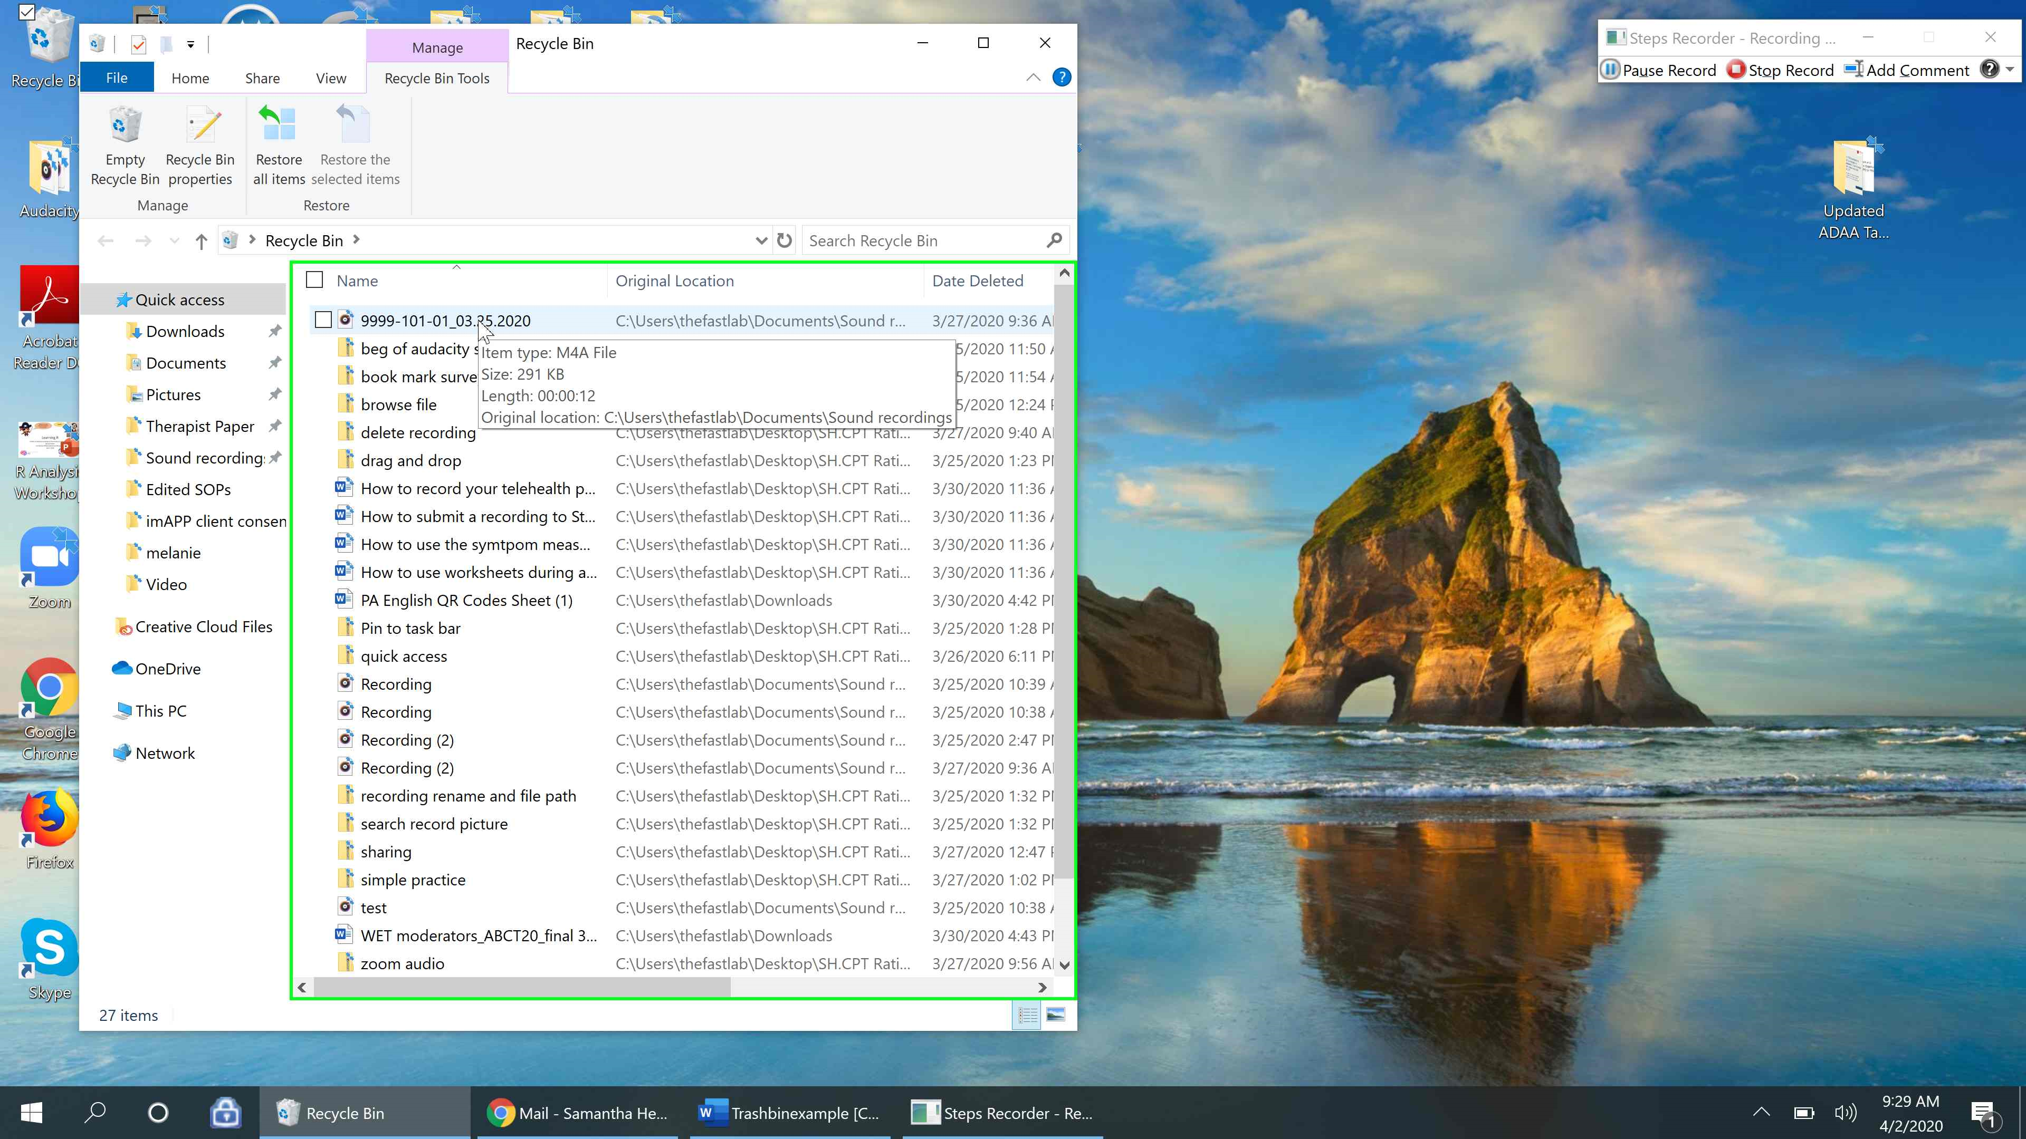
Step 24: Select the file you’d like to permanently delete and right click that file. A dropdown menu of options should appear. Select “Delete”.
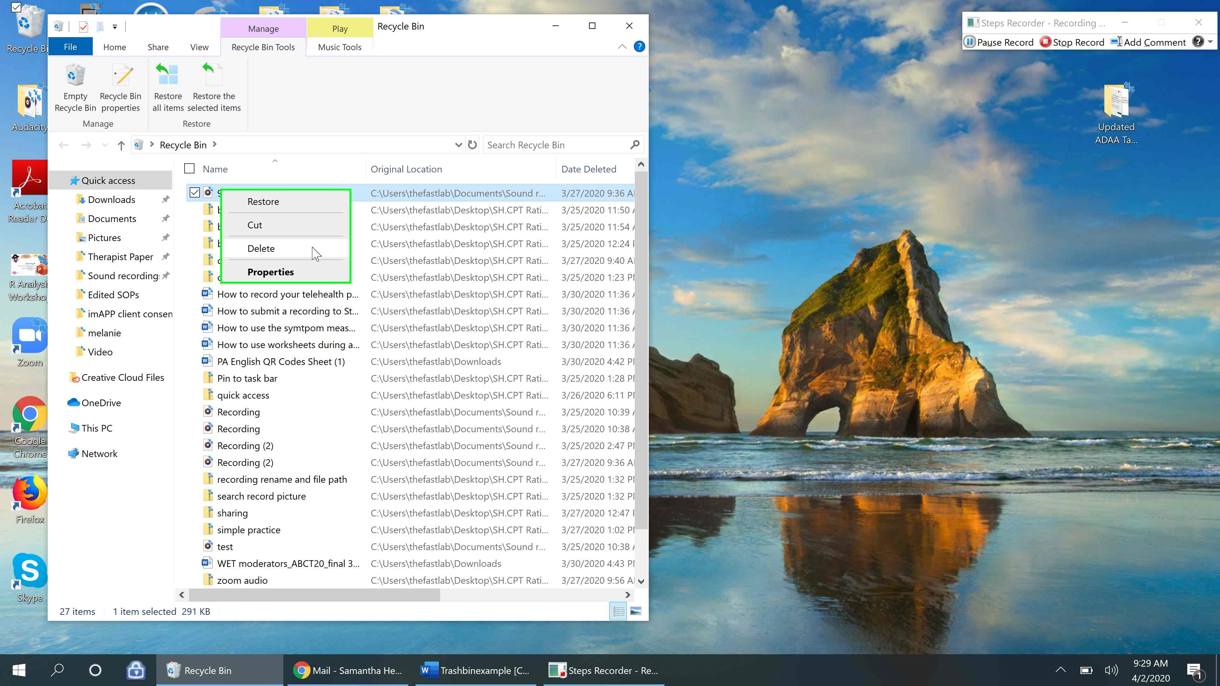
Step 25: A pop up will appear asking if you’re sure you want to permanently delete the file. Select “Yes”. The file is now permanently deleted.
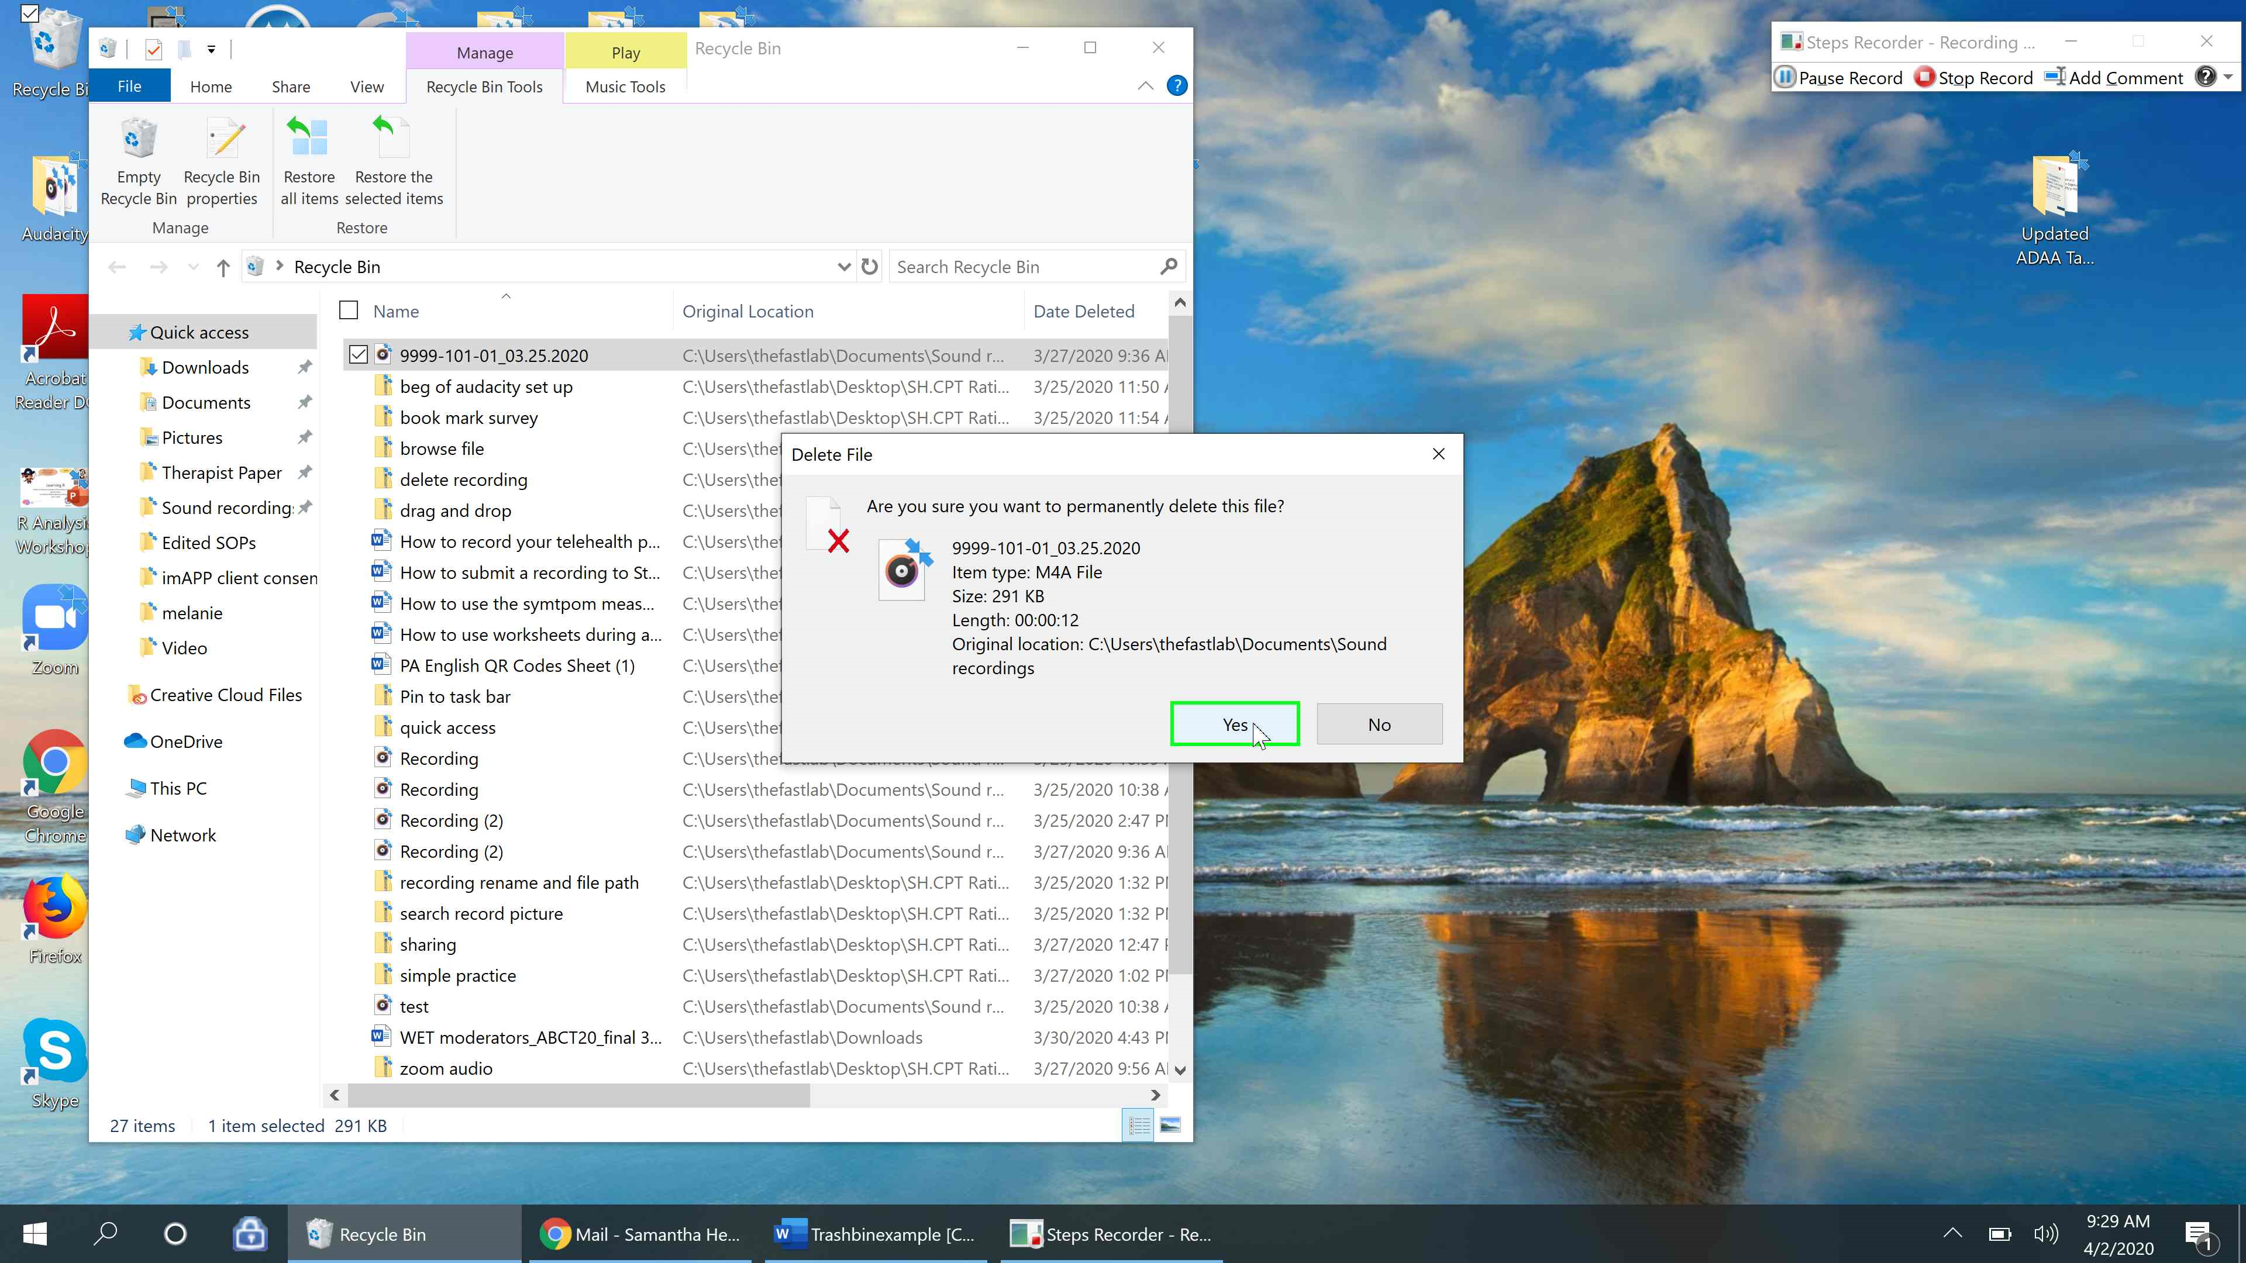

Tip: You can also permanently delete all the items in your recycle bin at once by clicking the “Empty Recycle Bin” icon in the upper left had corner.
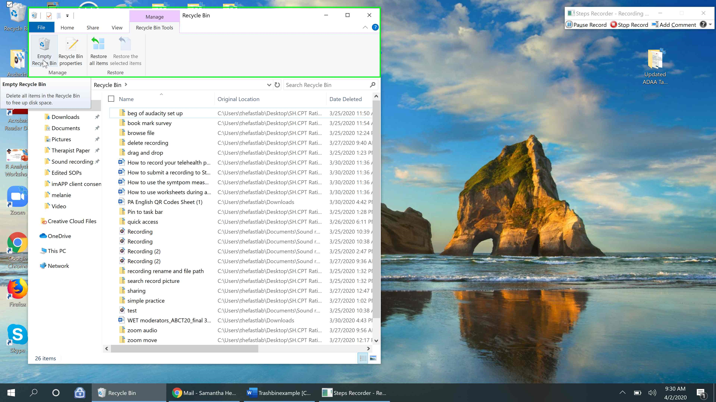

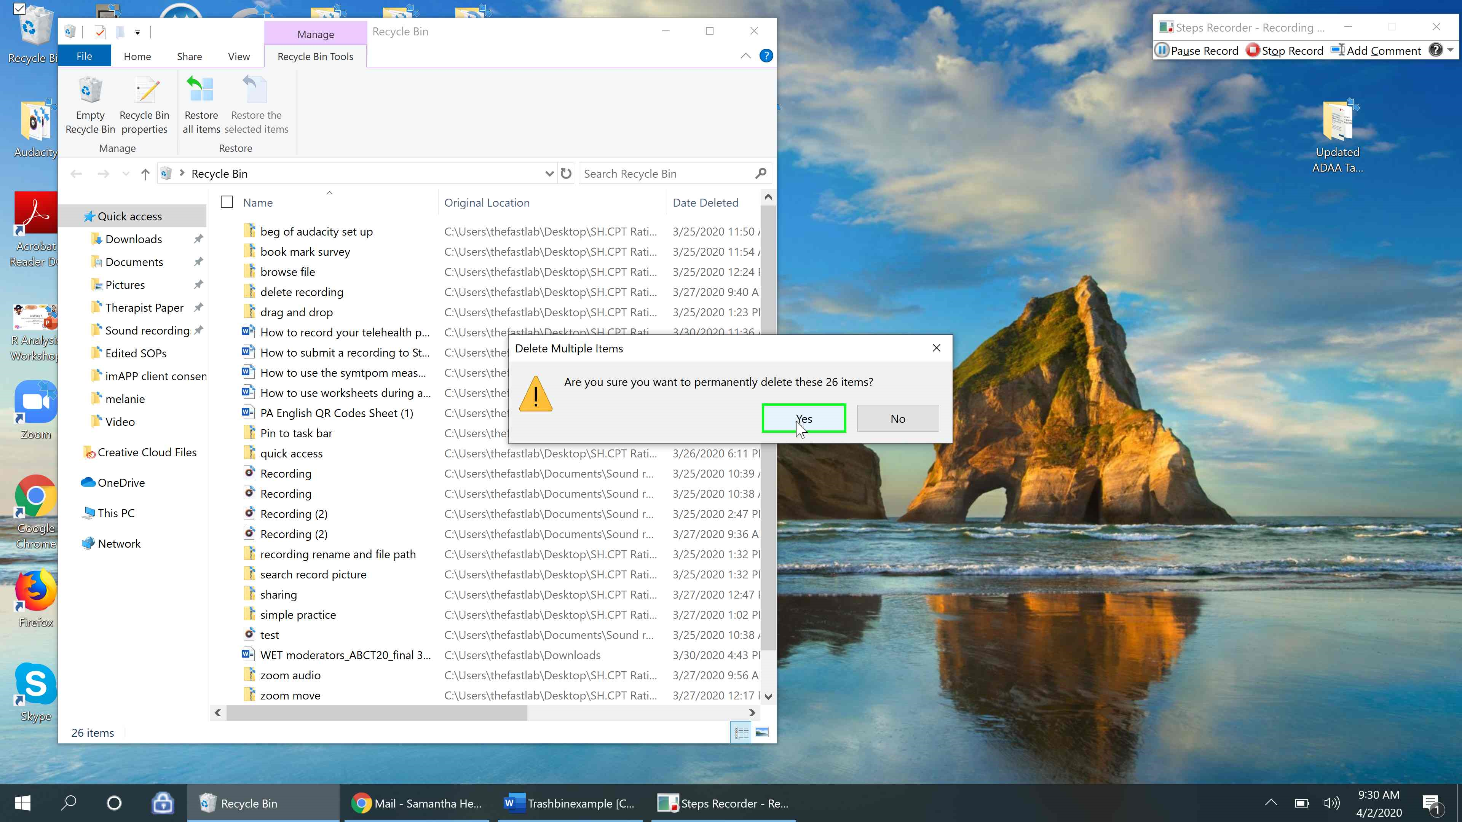

Alternative Directions for those with the Recycle Bin Icon on their Desktop
Step 26: Go to the “Recycle Bin” icon on your desktop and click it twice to open the Recycle Bin.
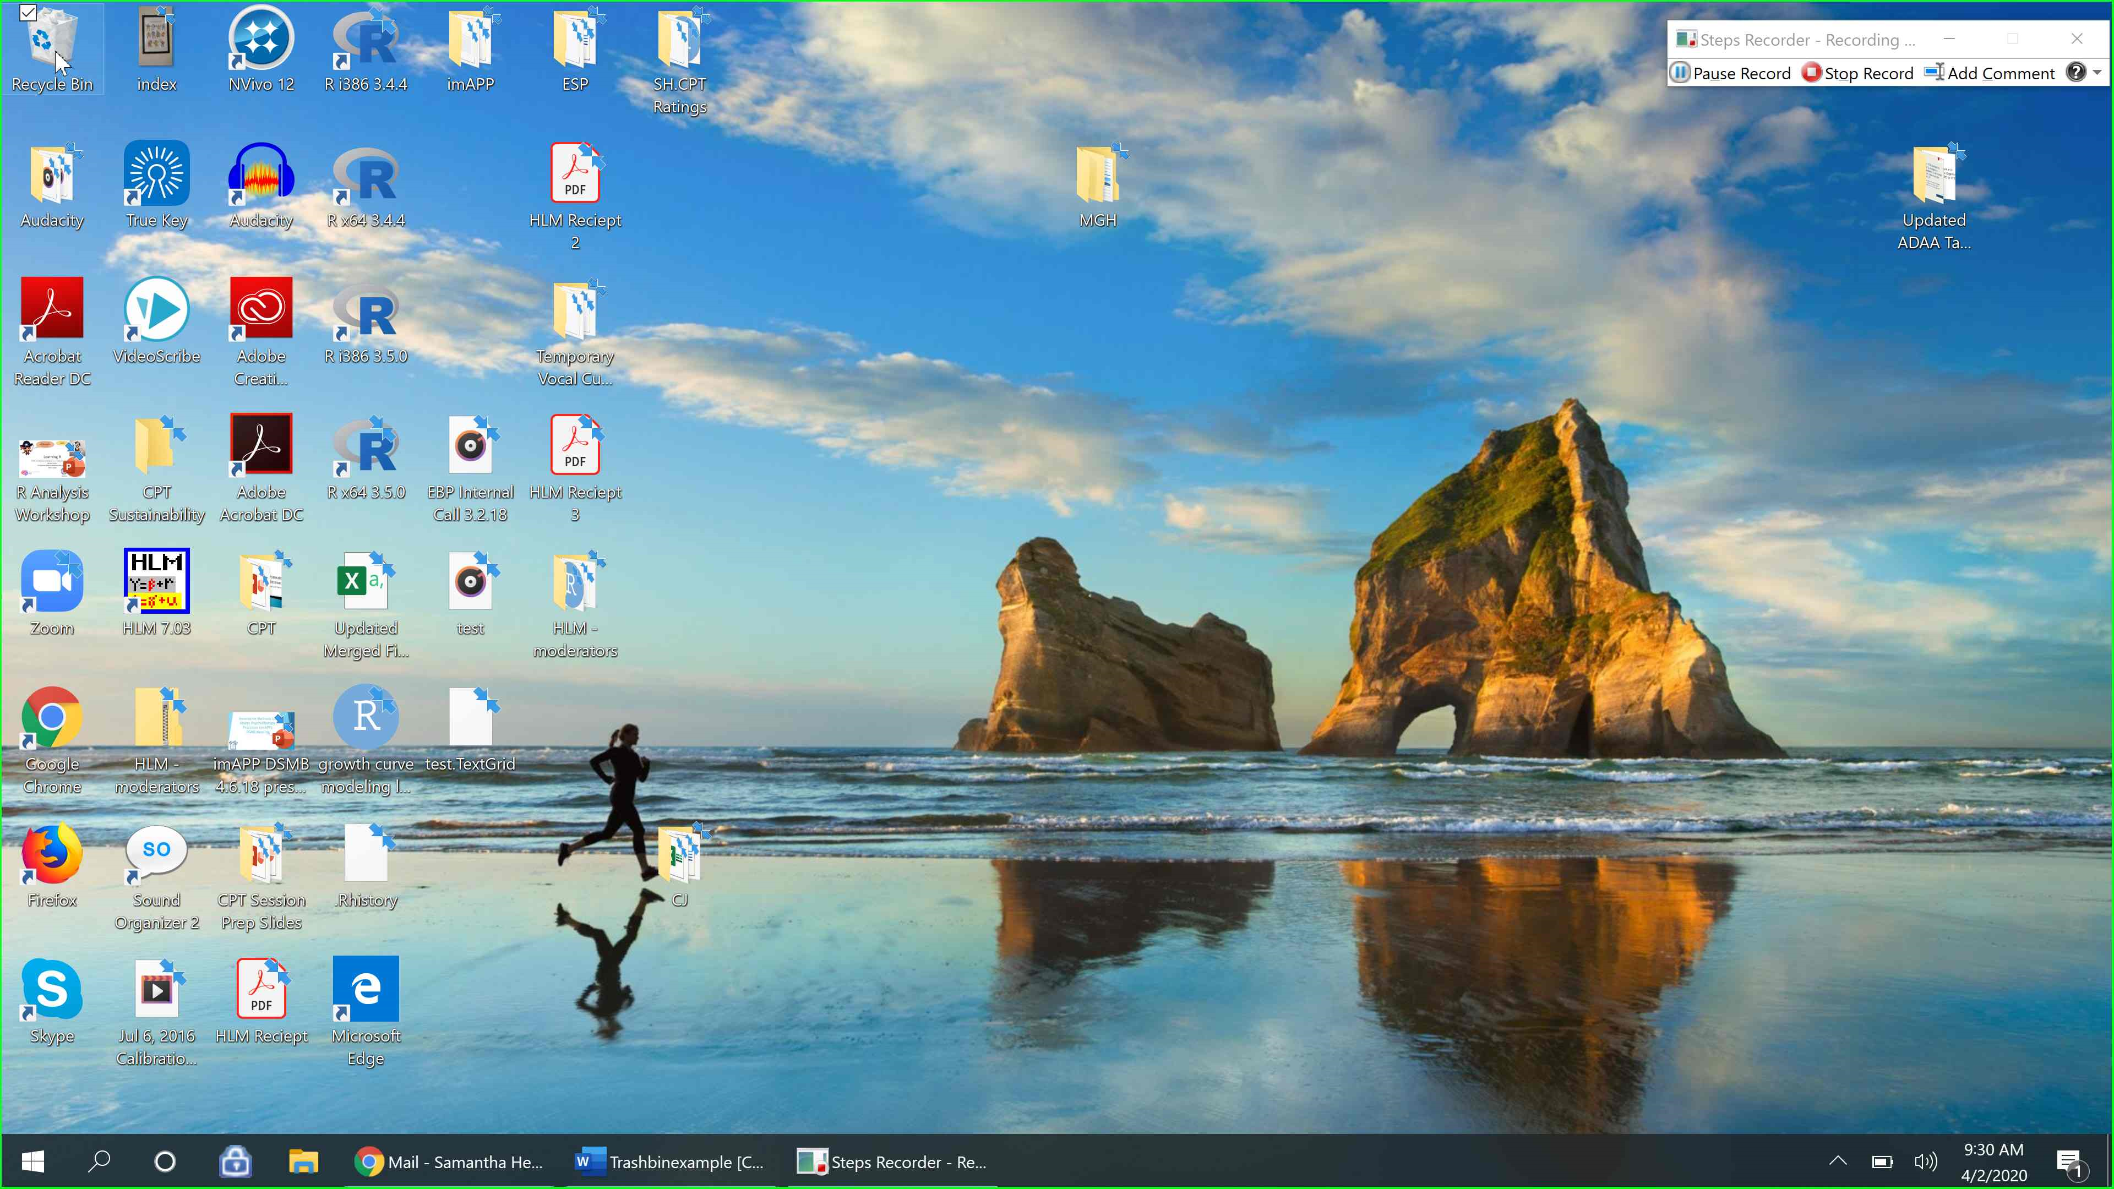
You should see all of the items in your recycle bin and can select an item individually to delete it (as explained in step 24) or you can use the Empty Recycle Bin function to permanently delete all of the items (as explained in the tip after step 25).
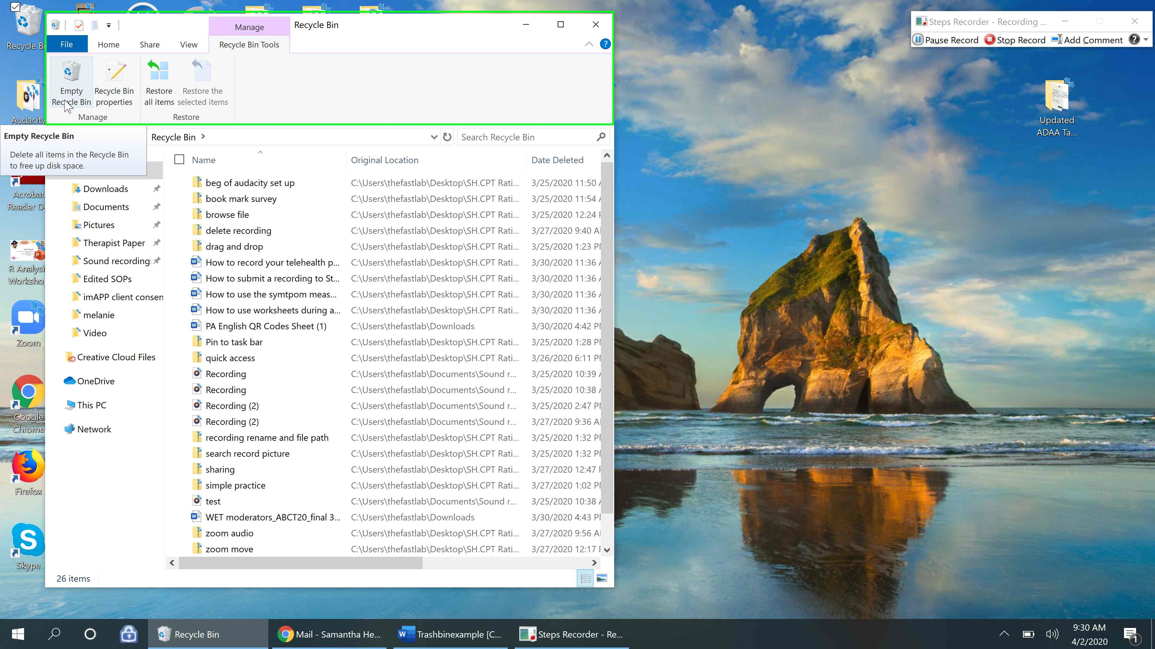
Tip: You can also delete a file in the Voice Recorder application by right clicking the recording and selecting “delete” and then “Ok” (The process is similar to the step we used to rename the recording). This process permanently deletes the recording and you do not need to also empty the trash can.
