How to record your telehealth video session
If you have any additional questions this SOP does not answer, please reach out to Samantha at sahern01@stanford.edu. The following example is done with Zoom on a PC.
Note: The following steps are done on Zoom, but can also be applied to other platforms, such as Simple Practice.

Summary of the skills you can find in this SOP:

(Each skill is hyperlinked to take you to the exact section, if you’d like to skip to what you need)
- How to adjust your audio settings on Zoom for the microphone
- How to record via Zoom
- How to screen share on Zoom
- How to rename your Zoom Recording
- How to upload your Zoom recording to Stanford Medicine Box
- How to delete a file and clear your recycle bin
- How to screen share on Simple Practice
Question: Are the steps below for Zoom (done on a PC) the same on a Mac? Yes, the interface of Zoom will look the same on a Mac and the steps like “to rename a file”, “choose a folder”, and “drag and drop” are the same.
Question: What do I do if my telemental health platform does not have a recording function built in like Zoom does? If you can’t record directly on your platform, you can open the recording application you have previously used to record your sessions (ex. Voice Recorder, Voice Memo, Quick Time Recorder) and turn it on in the background of your session on the computer to record the audio only. For more help with this, please see the “How to record your phone session” SOP.
Step 1: Before beginning your session, please plug in your microphone.
Warning: the microphone will not work with all platforms; unfortunately, it does not work with Simple Practice for instance. You should not plug in your microphone in this case and instead use the computer speakers.

Step 2: When you plug your microphone in and begin your zoom session for the first time you should see a pop up appear asking you if you’d like to join audio by phone or computer.
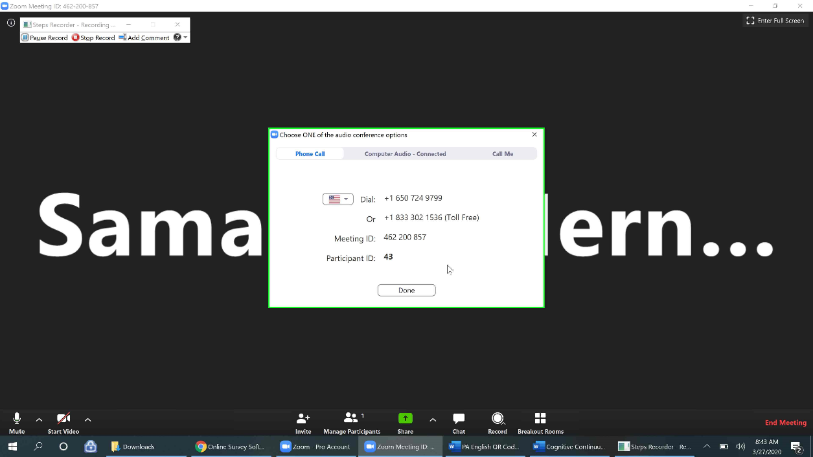
Note: If you choose to join the audio by phone, Zoom can still capture this audio in the recording.
Step 3: Select Computer Audio and then click the blue underlined text saying “Test speaker and microphone”. You will want to test your audio regardless of the platform you are using, to ensure you can hear the play back volume and that it is at its maximum volume.
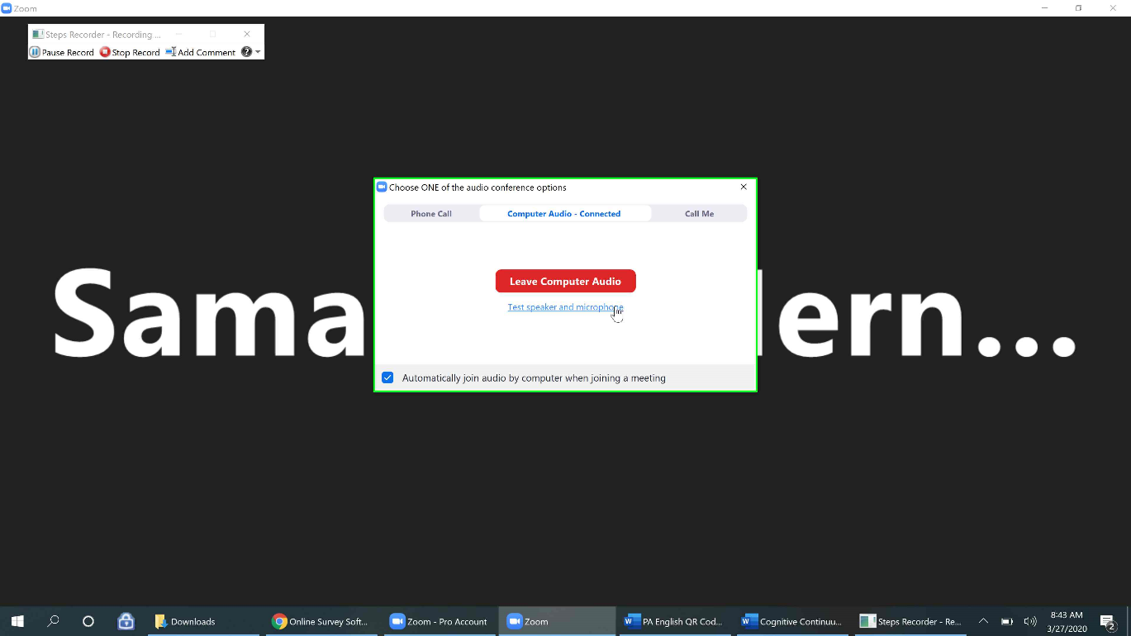
Step 4: When you select “test speaker and microphone”, it will prompt a series of tests. First your computer speakers might be tested. If you hear the ringtone playing, select “yes”. If not try adjusting your volume or select “no”
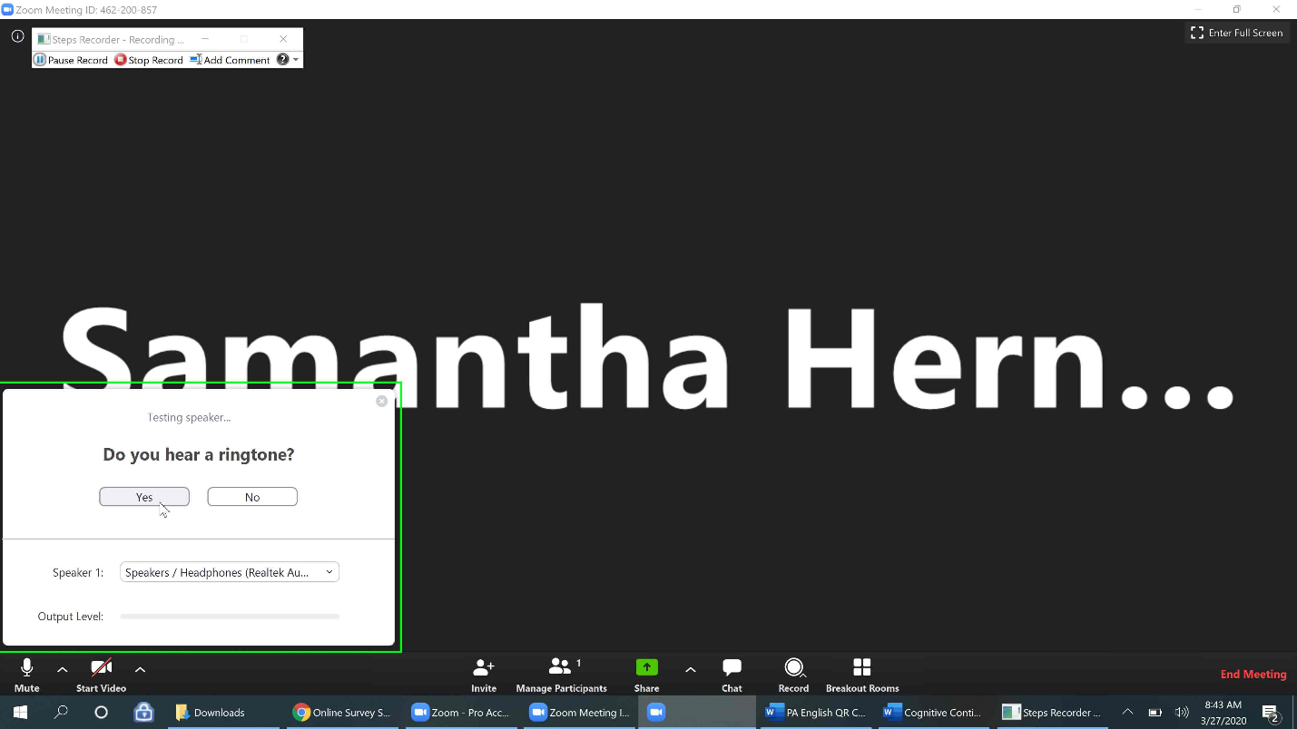
Step 5: The next test will be for your microphone and it will ask you to speak and if you hear the replay of yourself. Select “yes” if you do hear the replay. If you do not and are using a different platform, the microphone may not work for that particular platform.
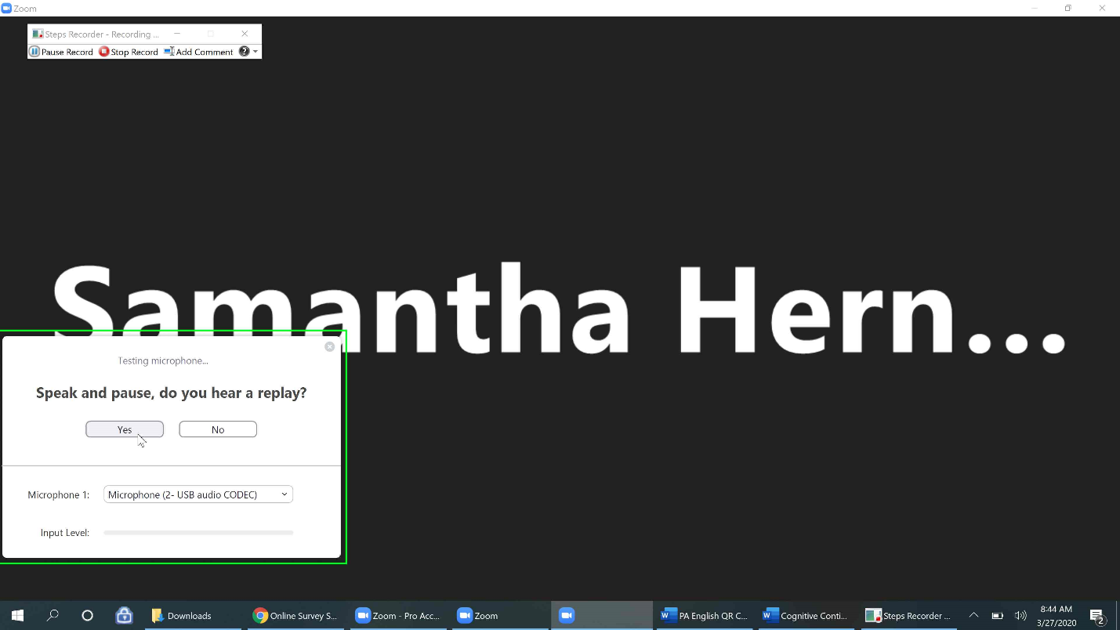
Step 6: Once both tests are successful, you should see a pop up saying your speakers and microphone look good. Select “finish”.
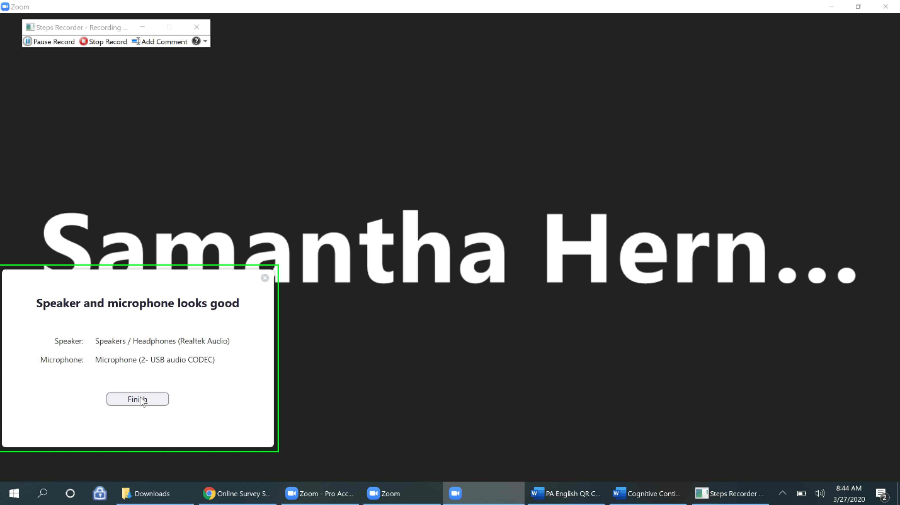
Step 7: It is important to ensure the volume settings of your microphone and speakers in Zoom are at the maximum setting. To check this go to the bottom left hand corner and select the icon to the right of the microphone. The icon is usually referred to as a caret or the symbol above the number 6 key (^).
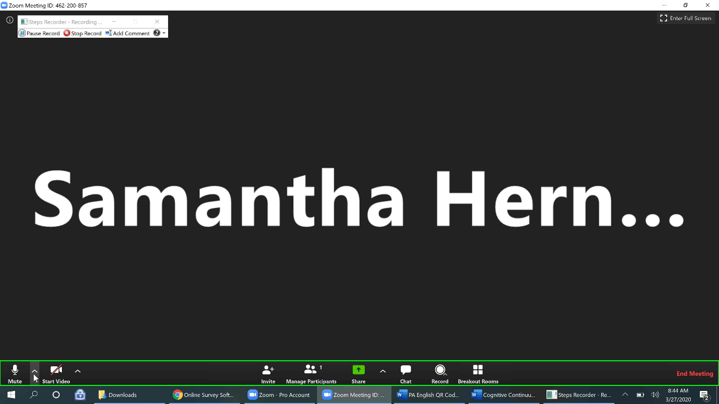
Step 8: This should pull up a list of audio options, please select “Audio settings” at the bottom of the list.
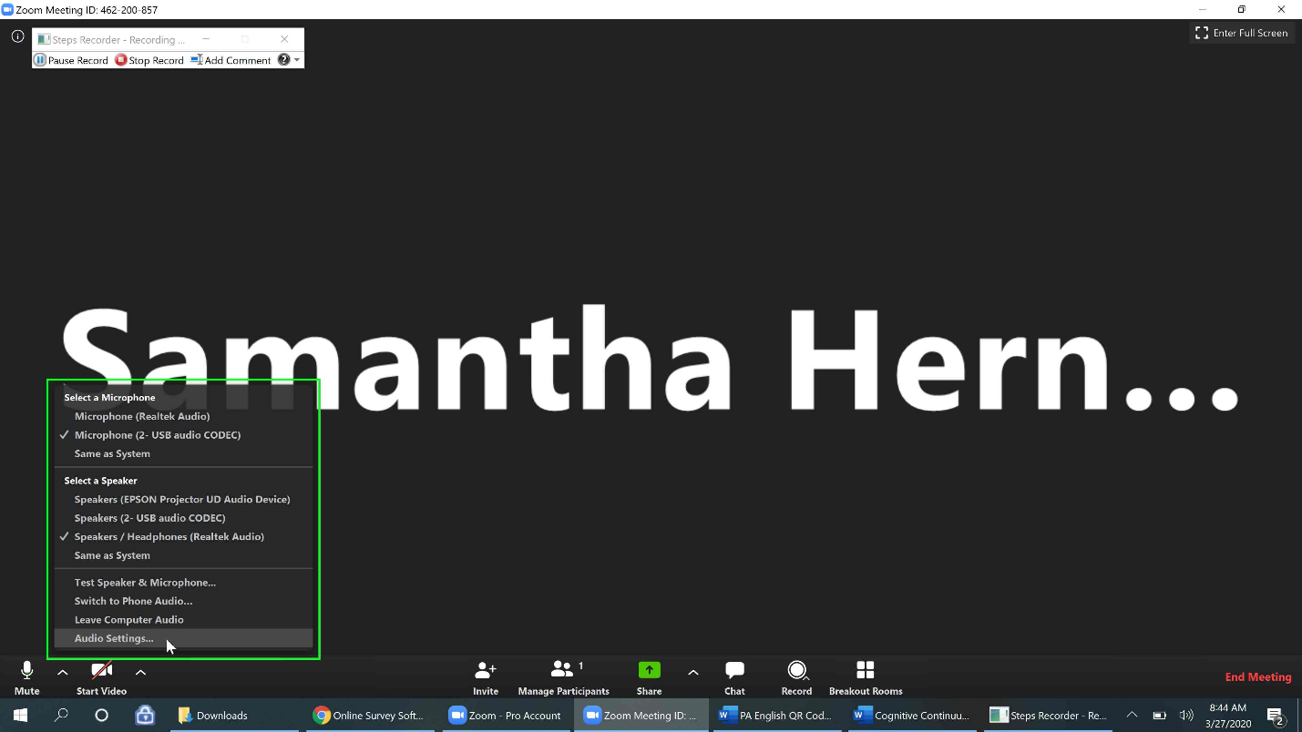
Step 9: You should see the following audio settings window pop up, which shows you the volume setting for both your speakers and microphone. In this example, my speaker settings are at maximum, but my microphone settings are not.
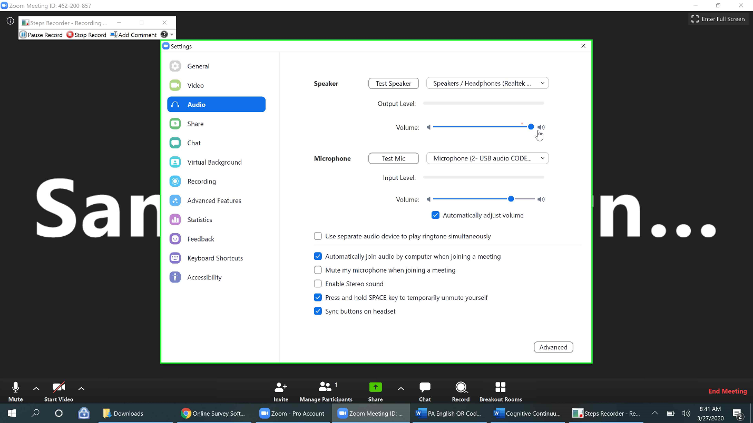
Step 10: Drag the blue end point icon of the microphone settings to the end, as seen below. You may need to uncheck the “automatically adjust volume” button in order to do this.
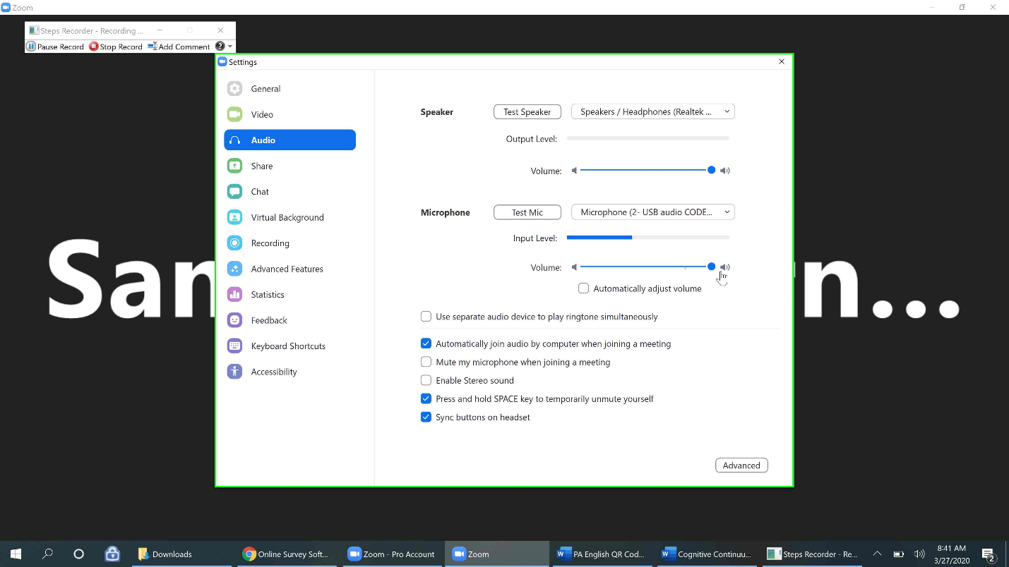
Step 11: In this same settings area, you can click “Recording” (we were previously in the “Audio” section). In the Recording section, you can see where your recordings are being saved when they are saved to your computer. Select “change” to change the folder.
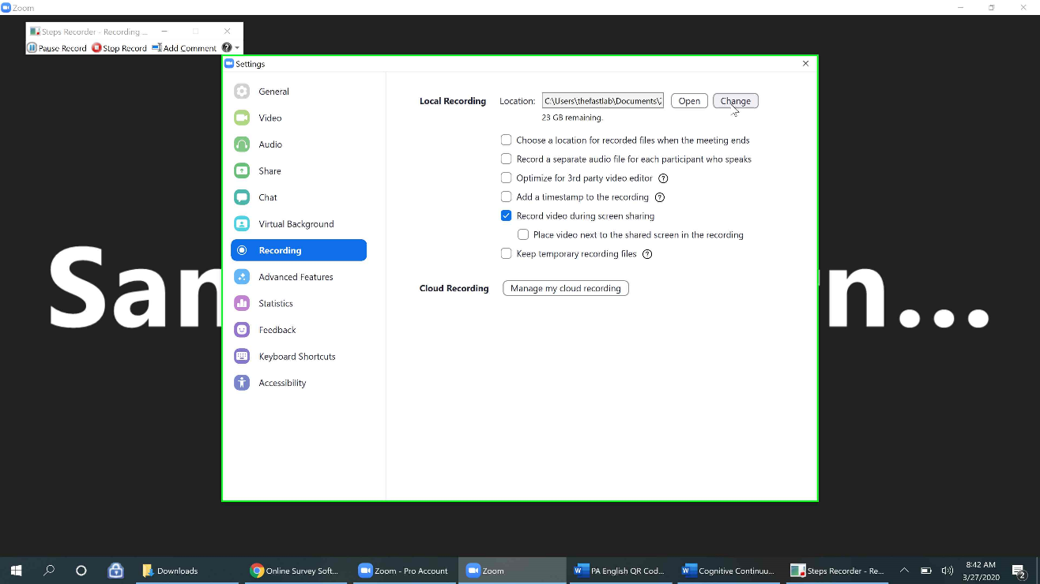
Step 12: By clicking change, a pop up menu will appear allowing you to browse through the folders on your computer. If you have a folder created for your imAPP recordings, you can scroll down and select it from the menu (to learn how to create a folder please see the instructions in how to record your phone session, step 8).
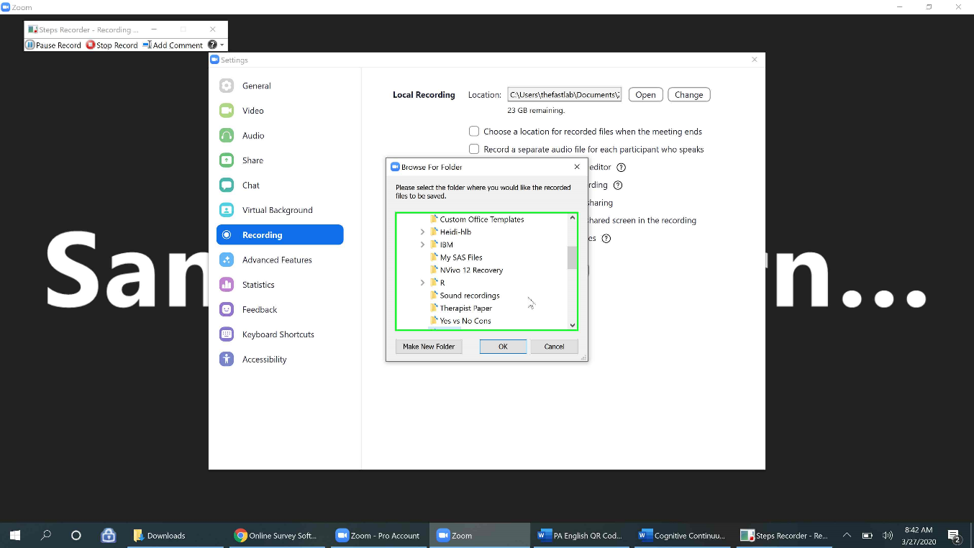
Step 13: In this example, the recordings folder I created is called “sound recordings”, I will select that folder and then click “Ok”. My default recording folder is now chosen and I can close this settings browser.
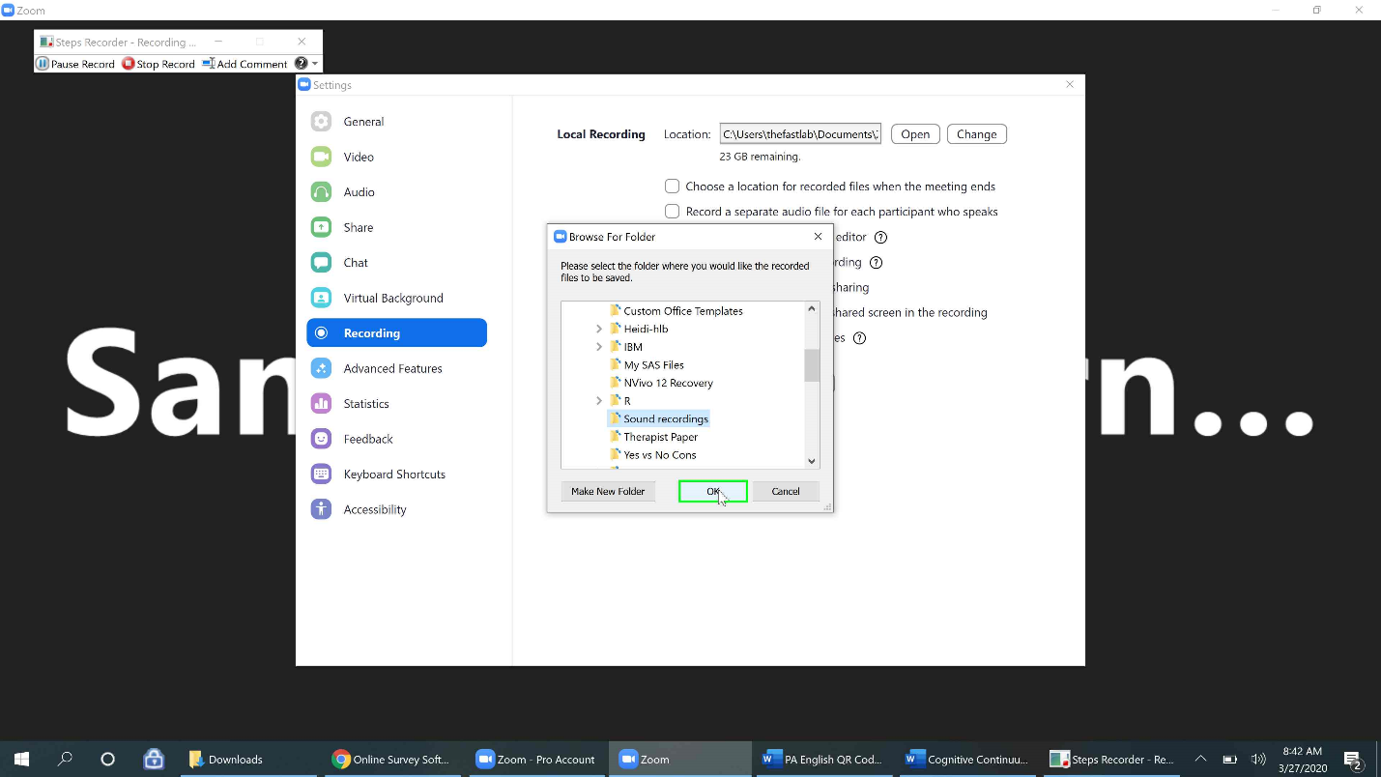
Step 14: Now that the audio settings are set up, you can begin to record your session (after setting up the audio setting for the first time, zoom should remember so you can automatically join audio and begin recording from now on). To begin recording the session, select the record icon. 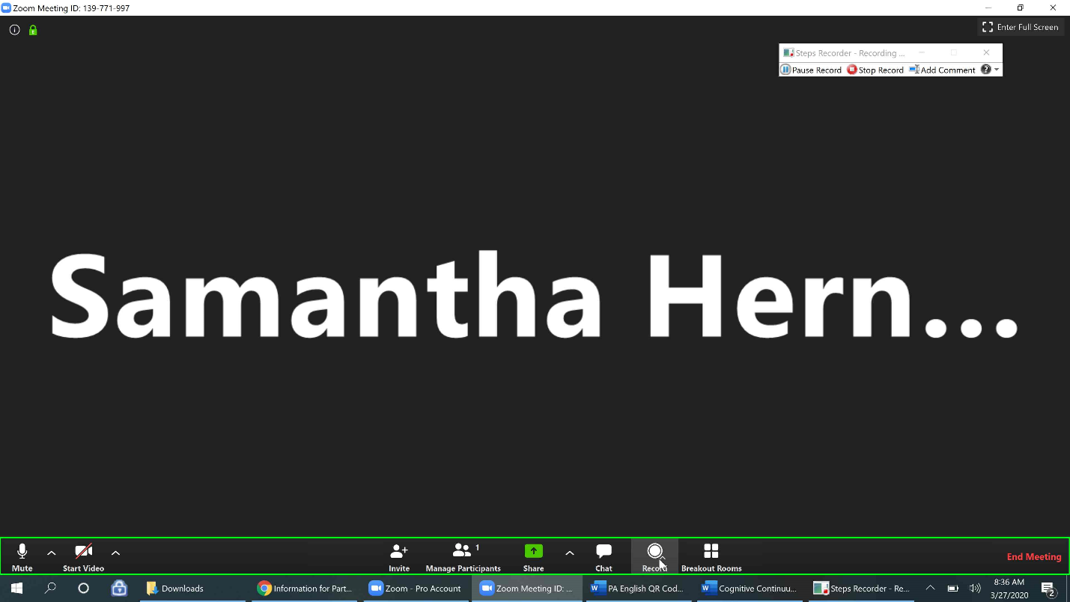
Question: What do I do if my telemental health platform does not have a recording function built in like Zoom does?
Answer: If you can’t record directly on your platform, you can open the recording application you have previously used to record your sessions (ex. Voice Recorder, Voice Memo, Quick Time Recorder) and turn it on in the background of your session on the computer to record the audio only.
Note: If you are using Simple Practice, you cannot have the microphone plugged in while doing telemental health and recording. You will need to use your computer speakers. We recommend doing a practice session to ensure the volume and quality of your computer speakers are captured well in the recording.

Step 15: After selecting the record icon, you should see the recording icon appear in the upper left-hand corner, along with a pause and stop icon. You can use these to pause or stop the recording during a session.
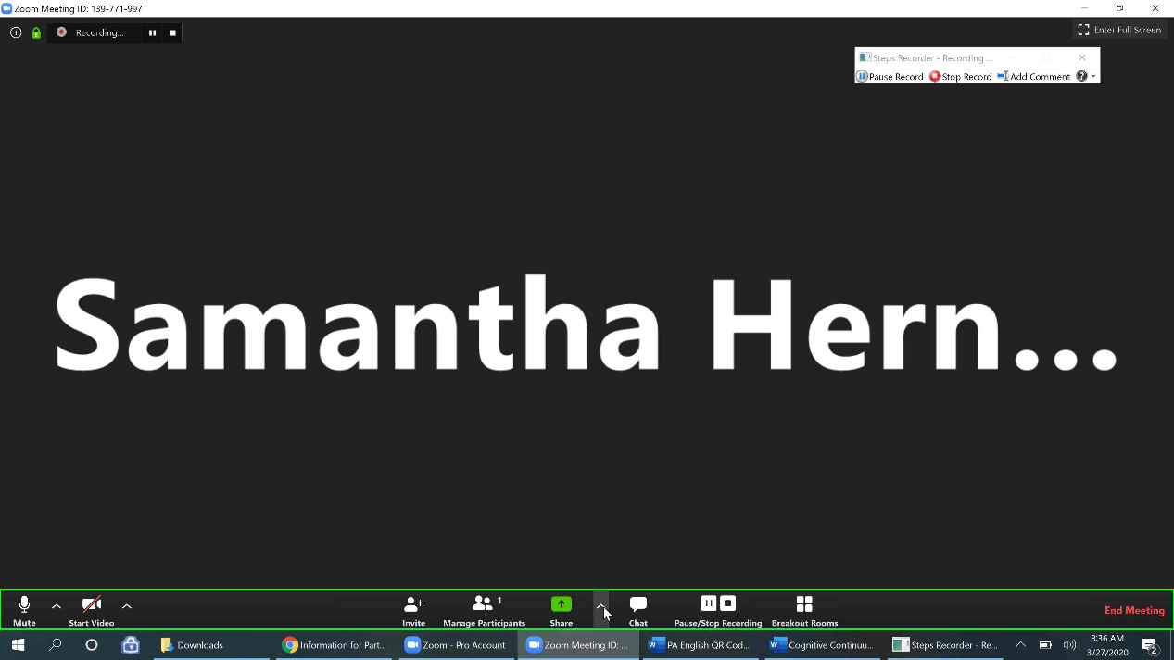

Step 16: Now that you are recording you can turn on your video and begin your session with your client. If you would like to do a worksheet with the client or review their symptom measure in session, it might be useful to use the “Share screen function”. Hover over the green box with an arrow that says “Share” beneath it. You should see 3 options pop up. In this example we will use the default of one participant sharing at a time, but note that both participants can share simultaneously if needed.
Note: Did you know that most video conferencing tools have a share function? If you’re not using Zoom, check to see if your platform allows for screensharing. Simple Practice does have a Share screen function. Scroll down to page 23 to see how to share on the Simple Practice platform, if you use Simple Practice.
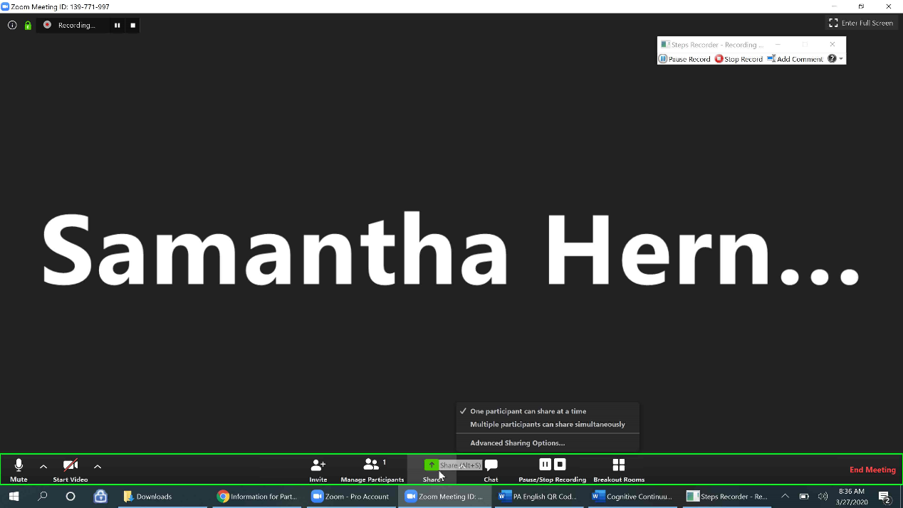
Step 17: Once you select the “Share” icon you should see a list of screen options appear. Select the upper left-hand screen option so that it becomes highlighted in blue and then select the blue “Share” button.
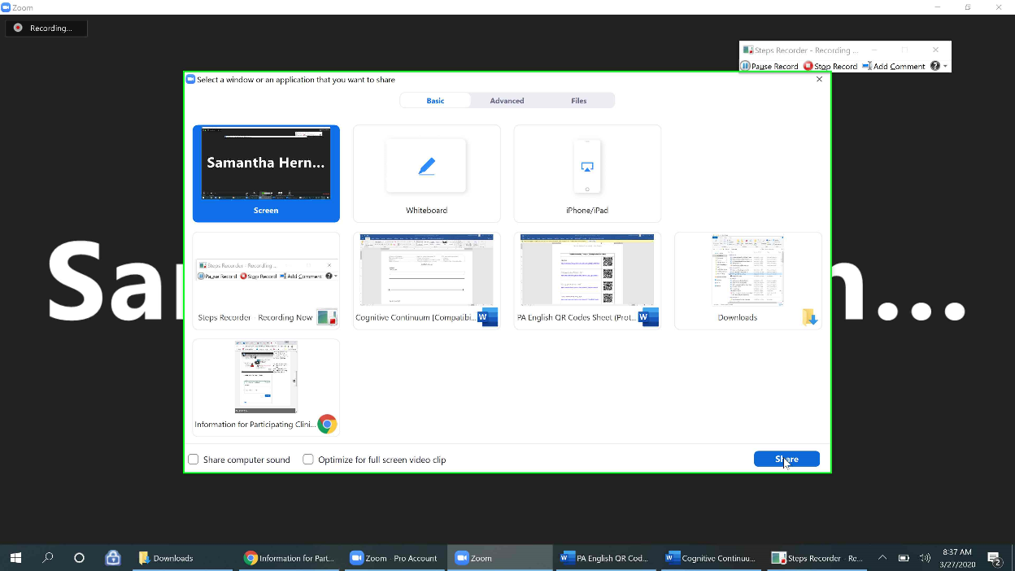

Step 18: You are now sharing your screen. You can see confirmation of this in the upper middle bar which should be green and red. You can select the red bar saying “Stop Share” at anytime to stop sharing your screen. In the example below I pulled up an online ABC worksheet on my screen to share with the client. This is useful to go through a worksheet together, while you or the client types into the online worksheet and shares their screen.
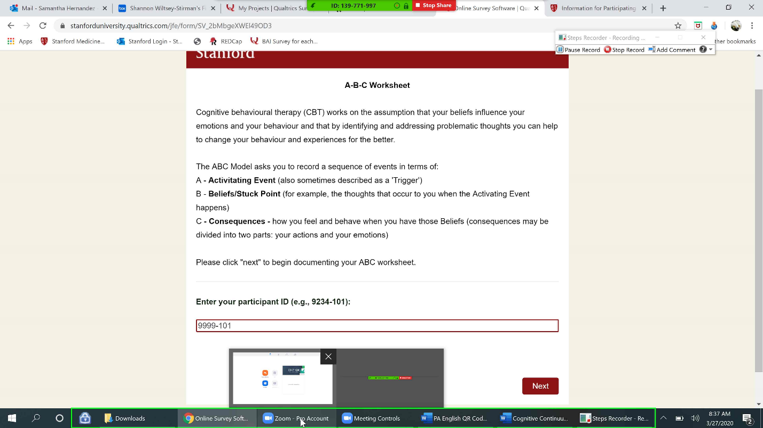
Step 19: If your session is coming to an end and you would like to end screen share, click the red bar that says “Stop Share”.
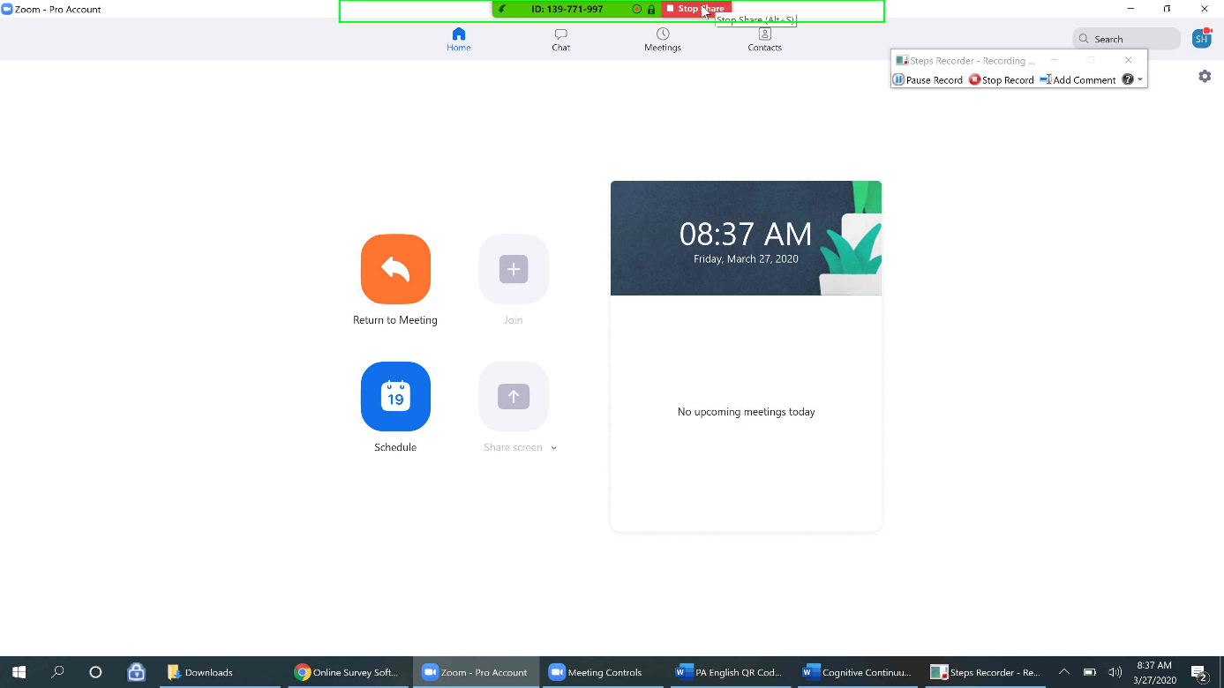
Step 20: You should see that the red and green top bar have disappeared now that I’m no longer sharing my screen. But the recording icon is still on in the upper left-hand corner. I can now click “end meeting” in the bottom right-hand corner to end the meeting and by default, also end the recording of the session.
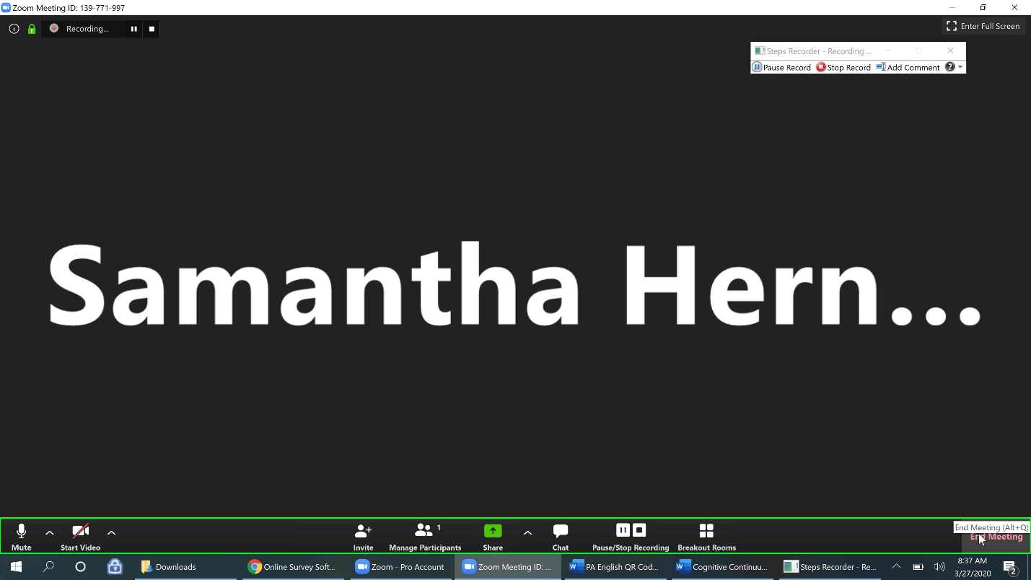
Step 21: You should see a pop up appear (if you were the creator of the meeting) asking if you’d like to end the meeting for all participants or just leave the meeting yourself. If this is a session between you and your client, we recommend selecting “End Meeting for All”.
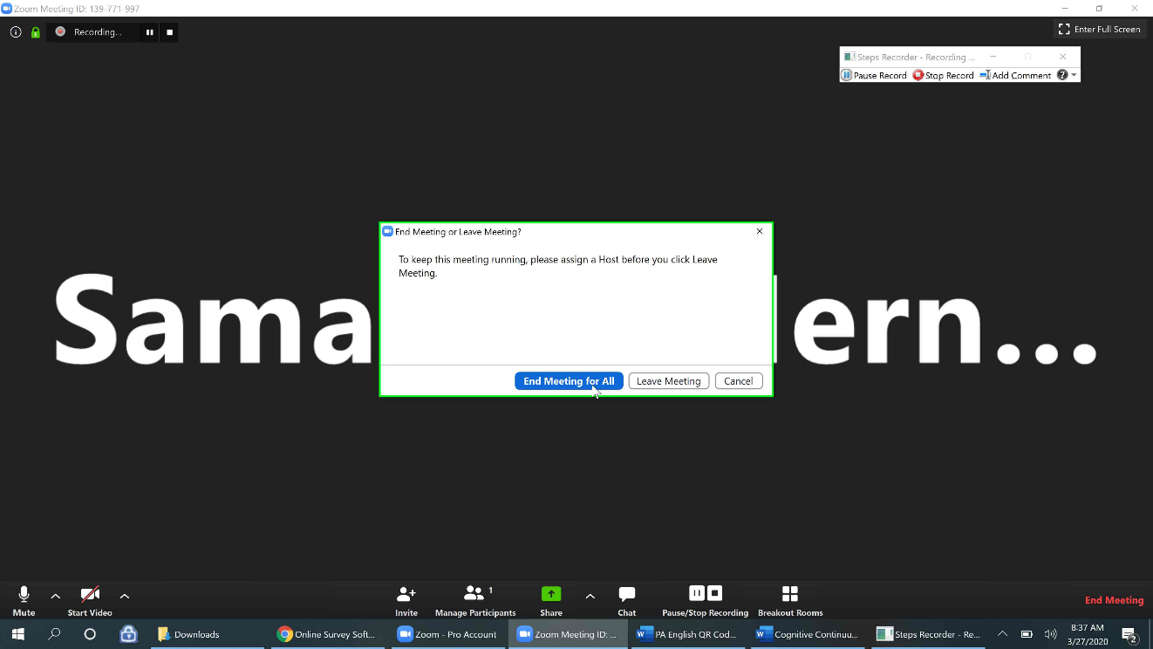
Step 22: Next you should see two windows appear, the first will show your recording being converted (this may take a few moments depending on the size of the recording) and another pop up asking how the meeting went (this feedback goes to Zoom), which you can respond to or exit out of.
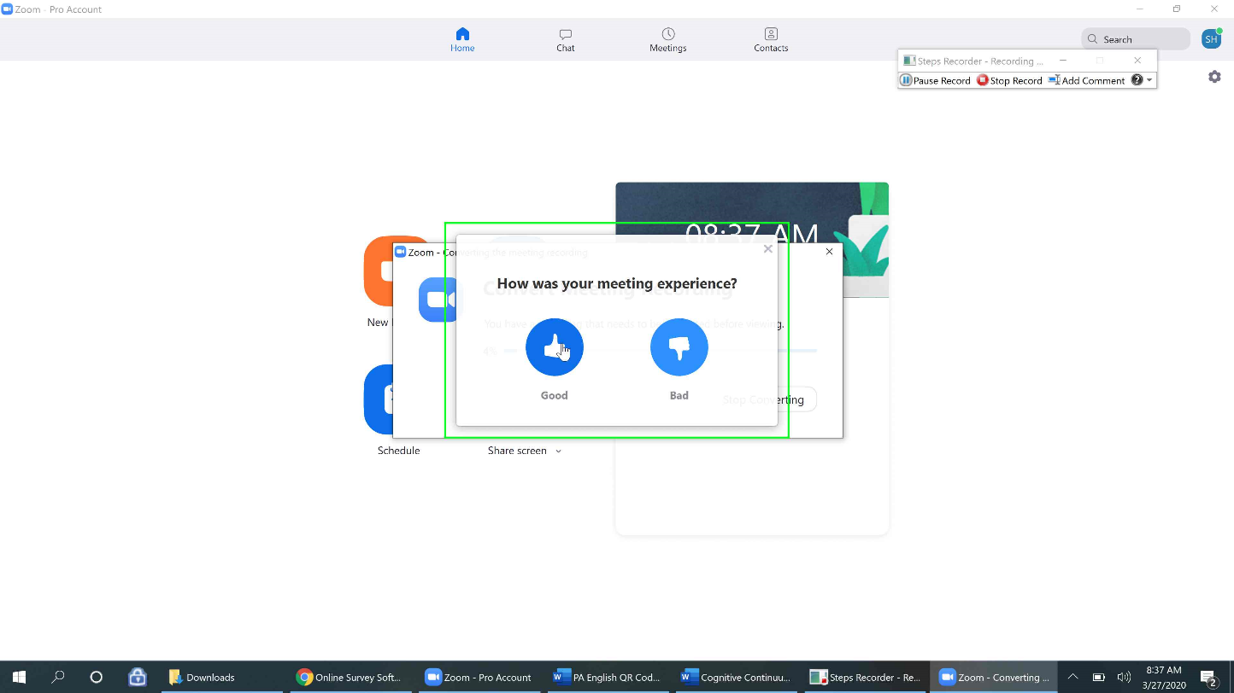
Step 23: Once the recording has finished converting, you should see three files appear. You will only need the “audio.only” one to submit to the study. We do not need the video component. At this time you can rename the “audio.only” file (ex. 1099-101-04_03.26.2020). Right click the file name “audio.only”.
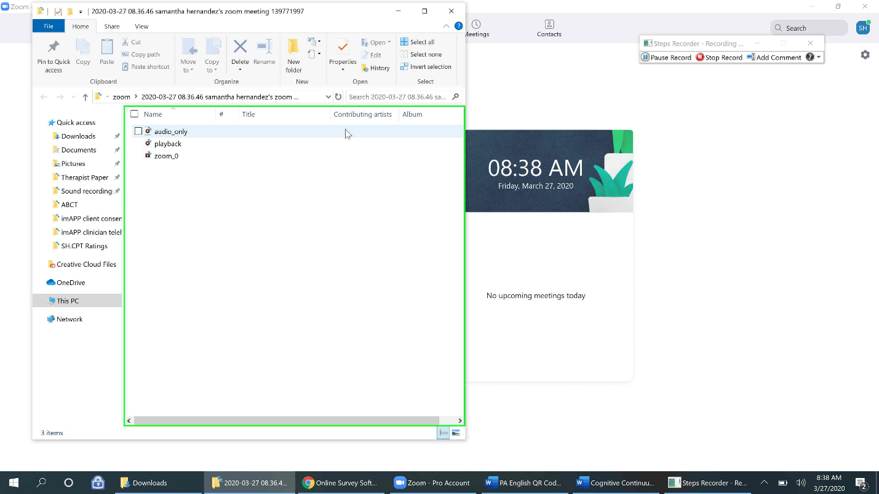
Step 24: A menu of options should then appear, please select “Rename”.
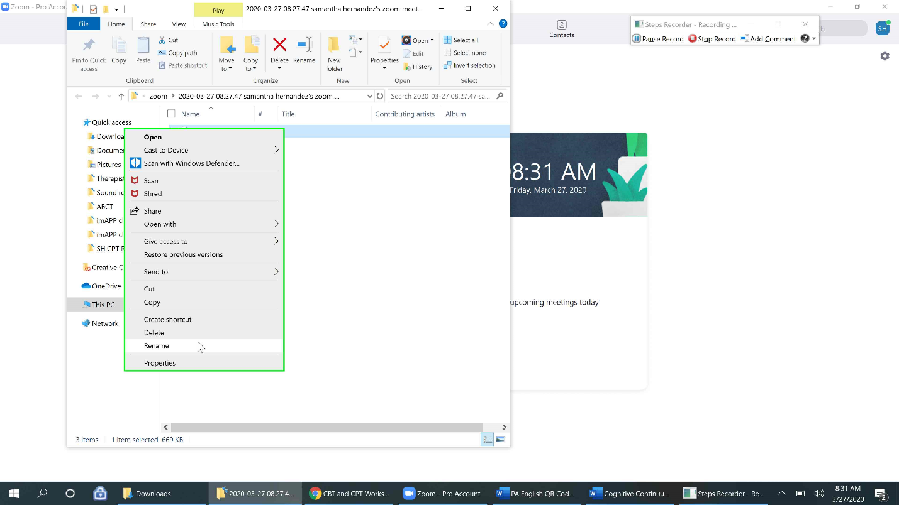
Step 25: You can then remove the previous name and rename the file (ex. 1099-101-04_03.26.2020).
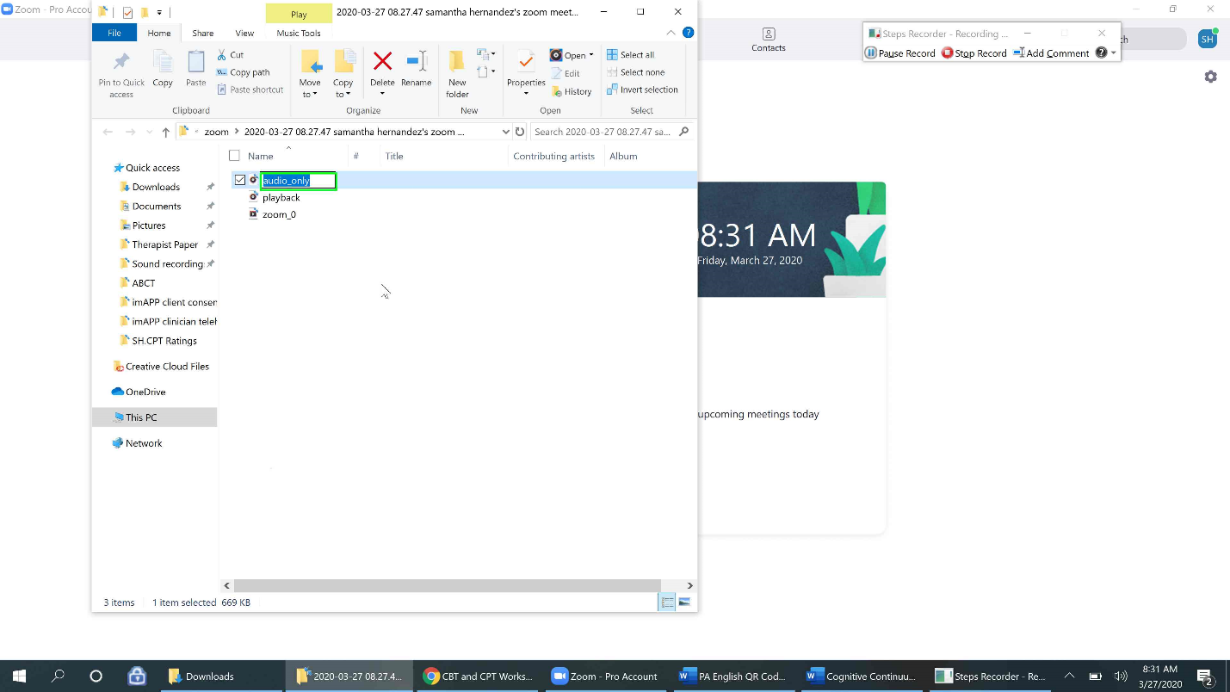
Step 26: To double check the sound quality of the recording, double click your newly renamed audio file.
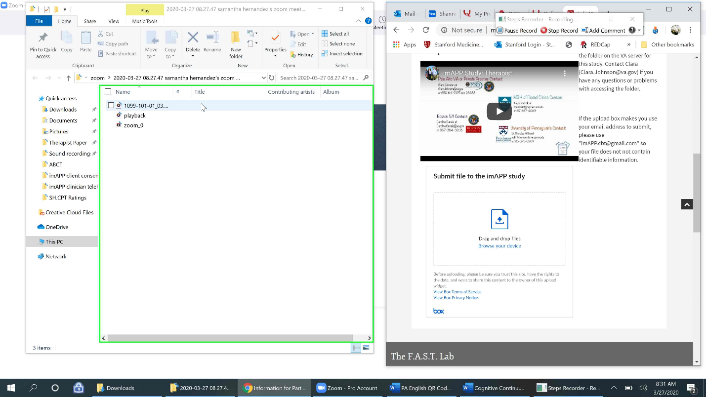
Step 27: This should open a sound player, like “Groove Music” to play the audio. Turn your volume up and listen to the audio quality of yourself and your client. If you notice the quality is too low and adjusting the settings does not help, try using/not using the microphone in another test session. If you are worried the quality might not be very good, please still submit it to the study so that we can make a determination and troubleshoot with you. Note: On a Mac, iTunes music player may open instead of “Groove Music” to play the audio recording.
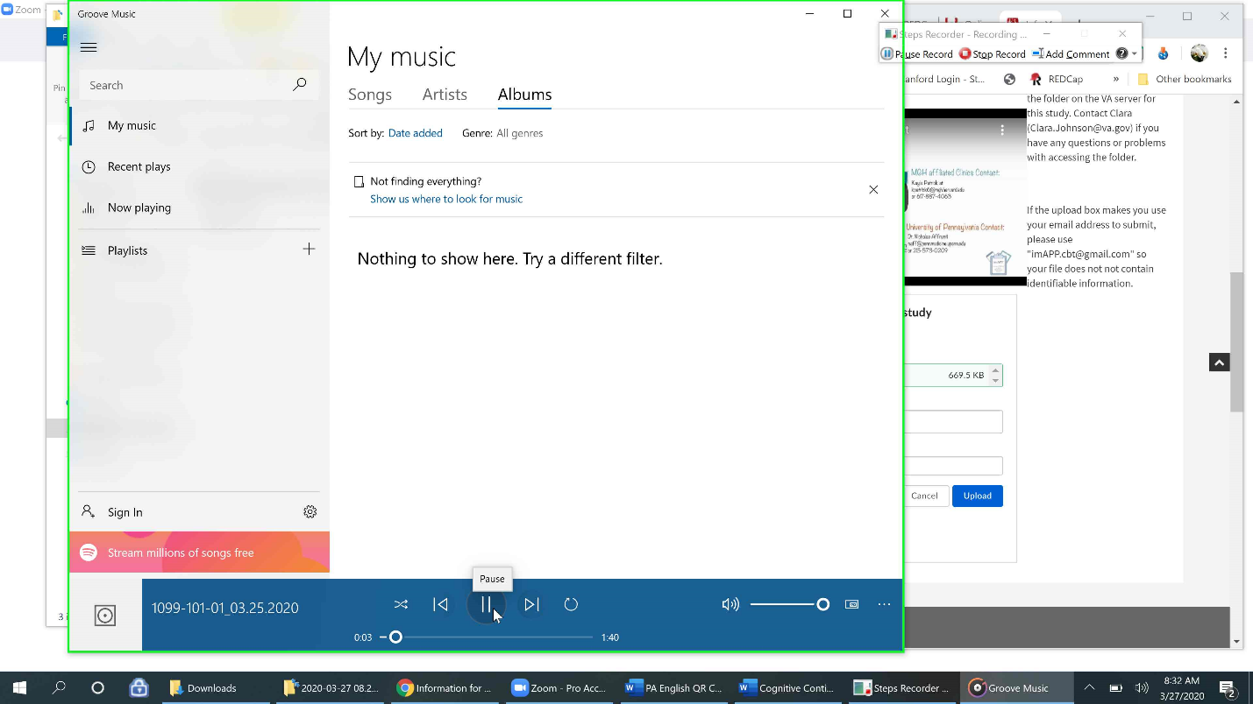
You can now submit your recording to Stanford Medicine Box (see the SOP entitled, “How to Submit a Recording to Stanford Medicine Box”, for further in- depth directions). For abbreviated instructions on how to submit a Zoom recording and delete it, see below.
**Please remember to delete the recording after uploading it.**

How to Submit your Zoom Recording to Stanford Medicine Box (abbreviated)
Step 1: I will be using drag and drop method below. Select the file to be uploaded. Hold down on the file and drag it over to the Stanford Medicine dropbox, so that the box becomes blue and then release the file. You will need to have both webpages open simultaneously (in minimized form).
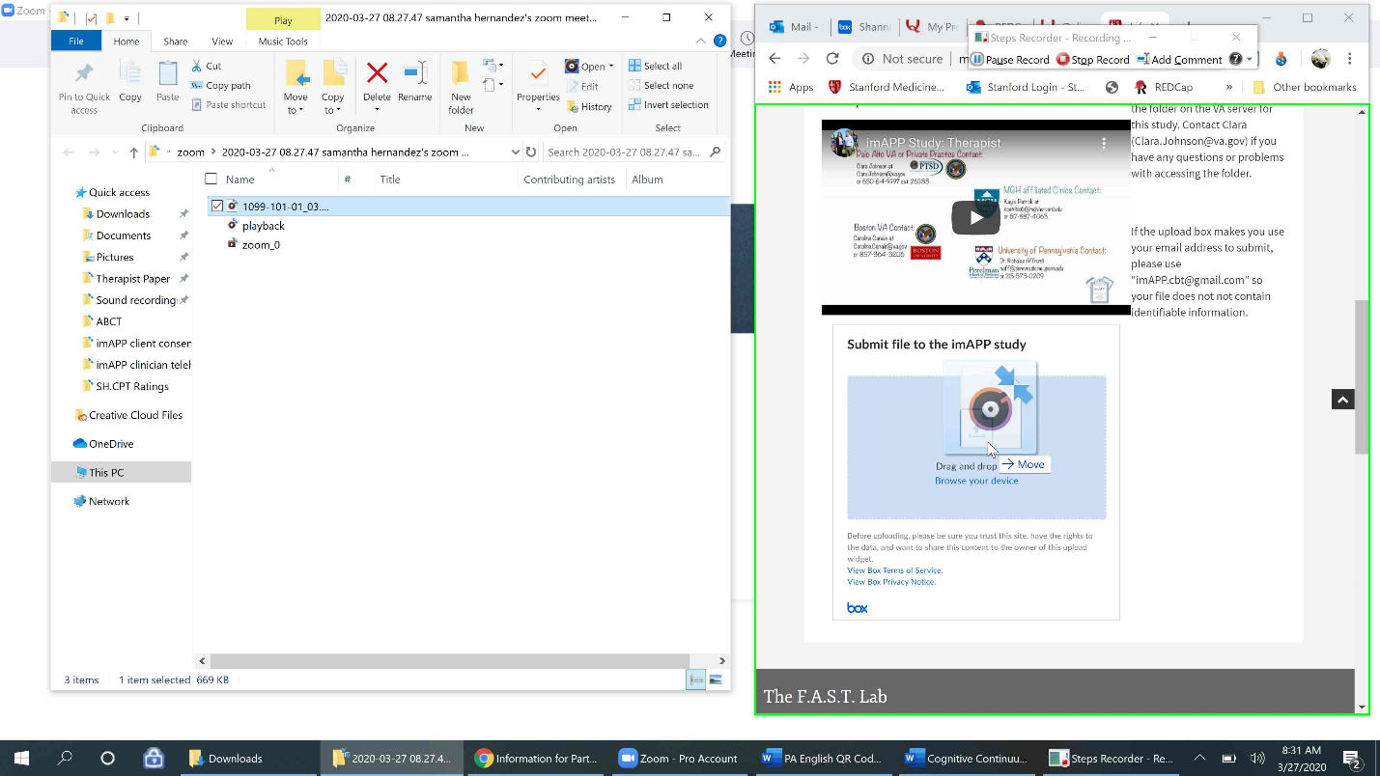

Step 2: You should get a confirmation of the file being uploaded in the dropbox via a green checkmark next to the file name. You may now fill in any description and use the imAPP email for the email box (imapp.cbt@gmail.com) and select “upload” to upload. You should see a confirmation page letting you know you have successfully uploaded the files.
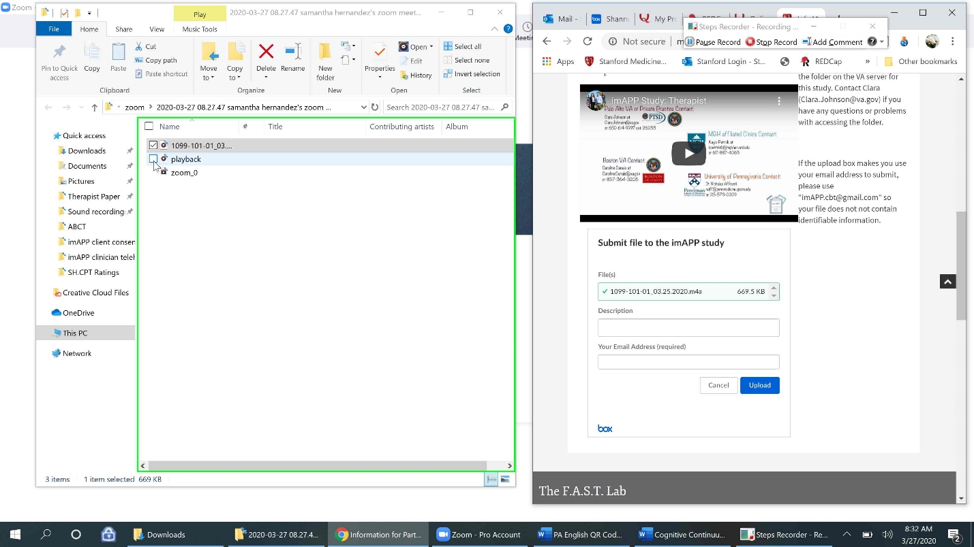
Step 3: After completing the upload, remember to delete all the Zoom files created from your recording. You can do this by selecting each of the files, so they are all highlighted in blue. Note: On a Mac you may need to select and right click one file at a time.
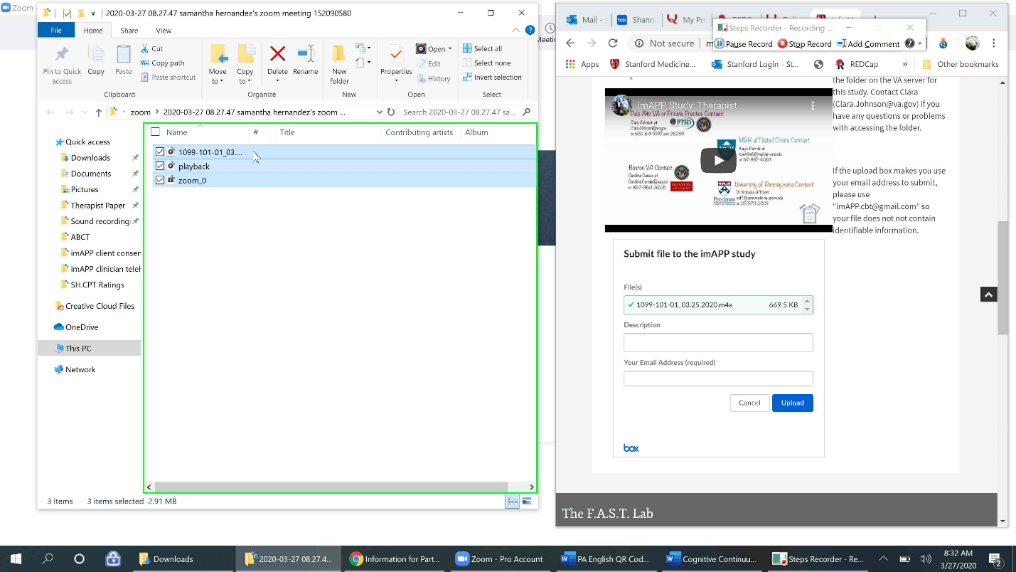

Deleting a Recording
Step 4: Then proceed to right click and choose “Delete” from the dropdown menu. The files are now in the “Recycle Bin”. Note: On a Mac, you should select “Move to trash”, because “delete” is not an option. Warning: When you delete a file this way, it sends the file to the “Recycle Bin” on your computer and the file is only permanently deleted after 30 days of being in the recycle bin. For directions on how to clear contents from your recycle bin, please see below.
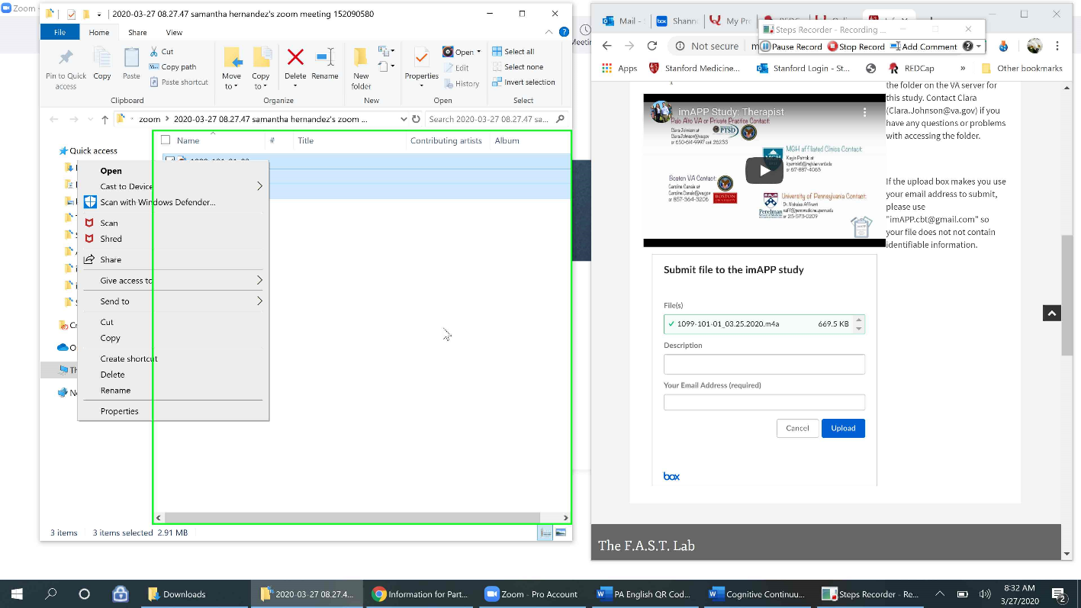
Emptying the Recycle Bin (Permanently Deleting Items)
Step 5: Click the search microscope icon to pull up the search bar that says “Type here to Search”. If you have the Recycle Bin icon on your desktop, see step 9.
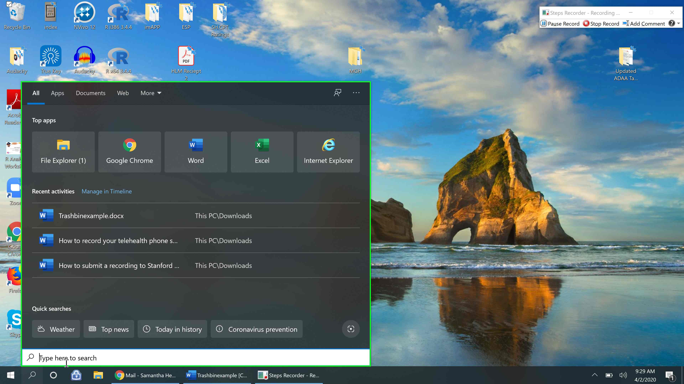
Step 6: Type “Recycle” into the search bar. Click on the “Recycle Bin” app with the icon of a recycling bin. 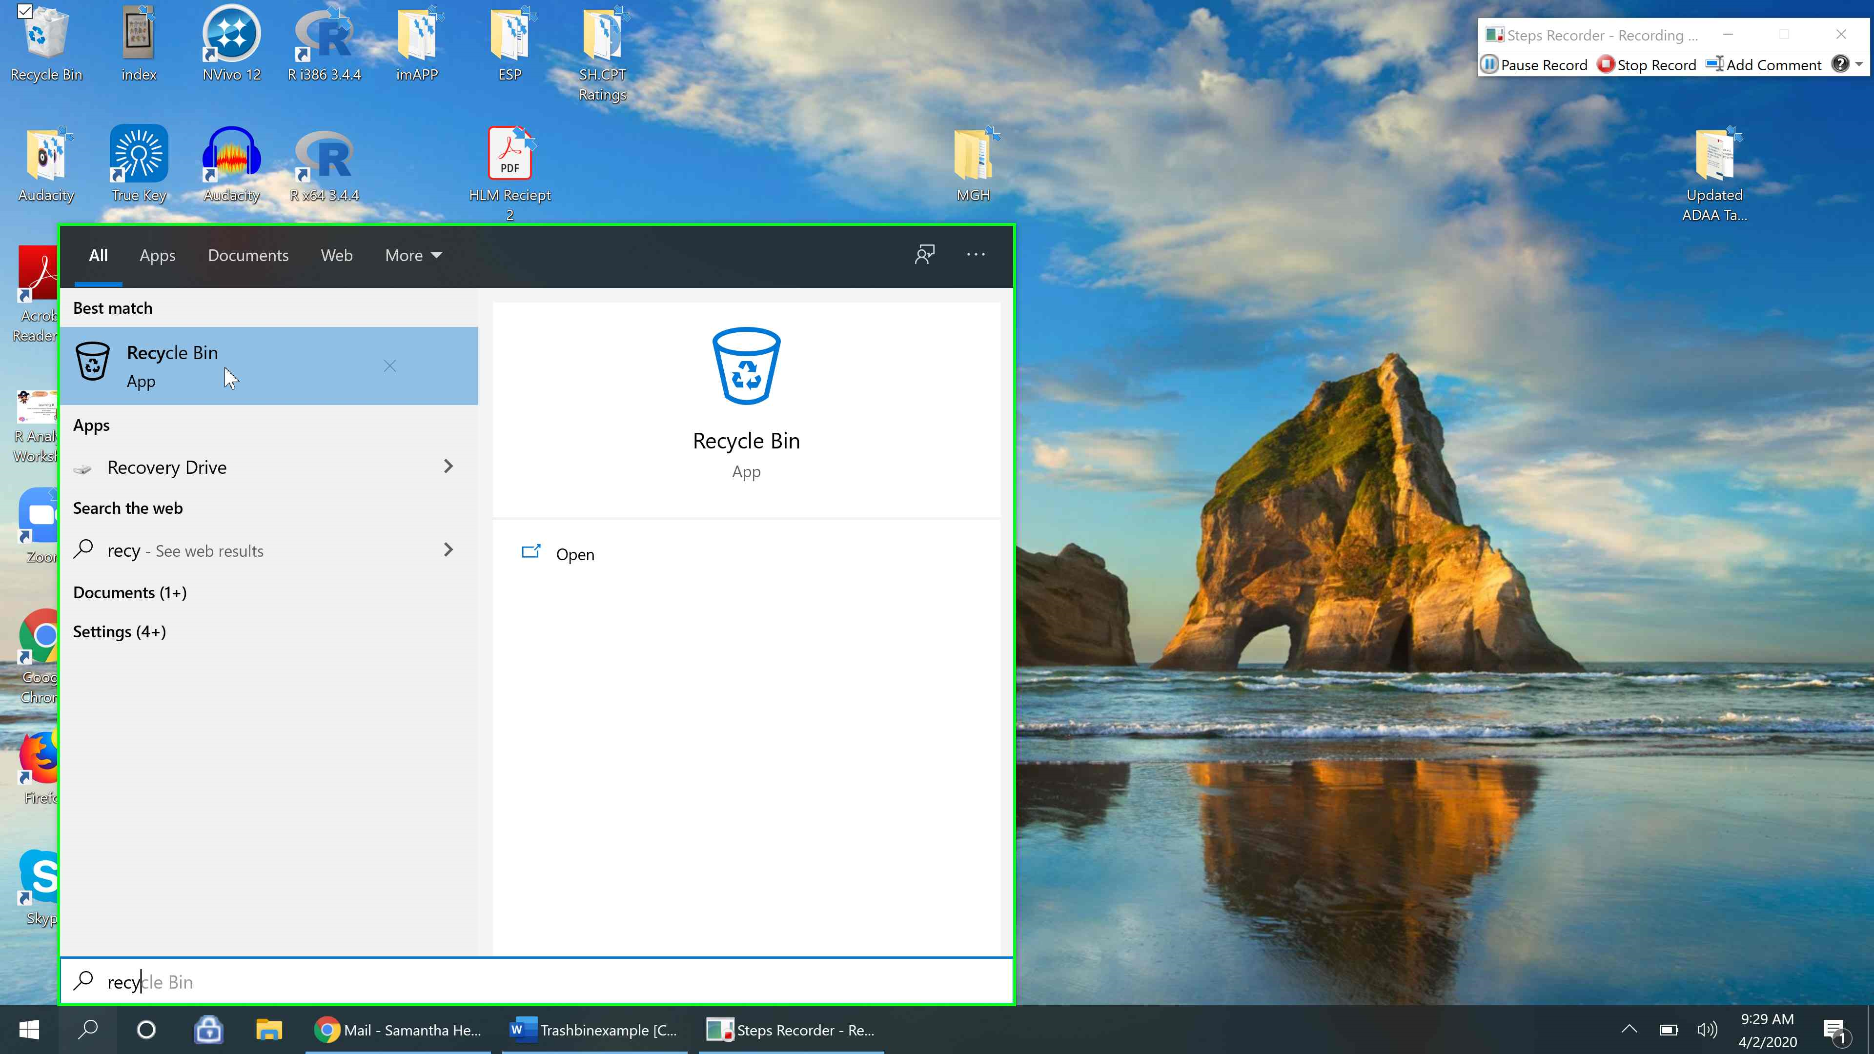
This will open a file folder of all of your recently deleted items (from the last 30 days).
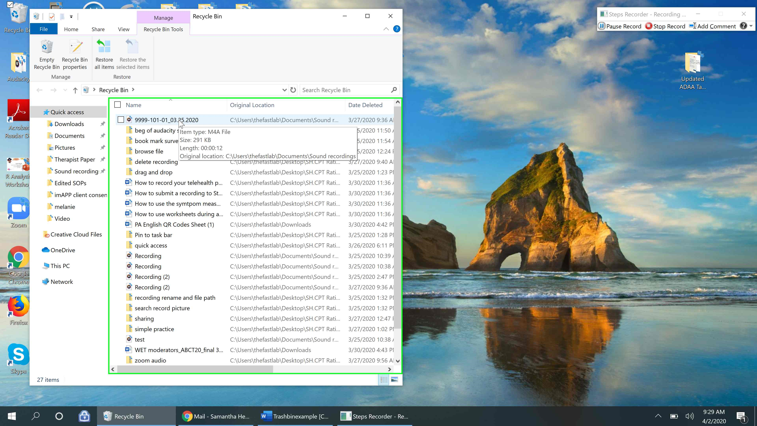
Step 7: Select the file you’d like to permanently delete and right click that file. A dropdown menu of options should appear. Select “Delete”.
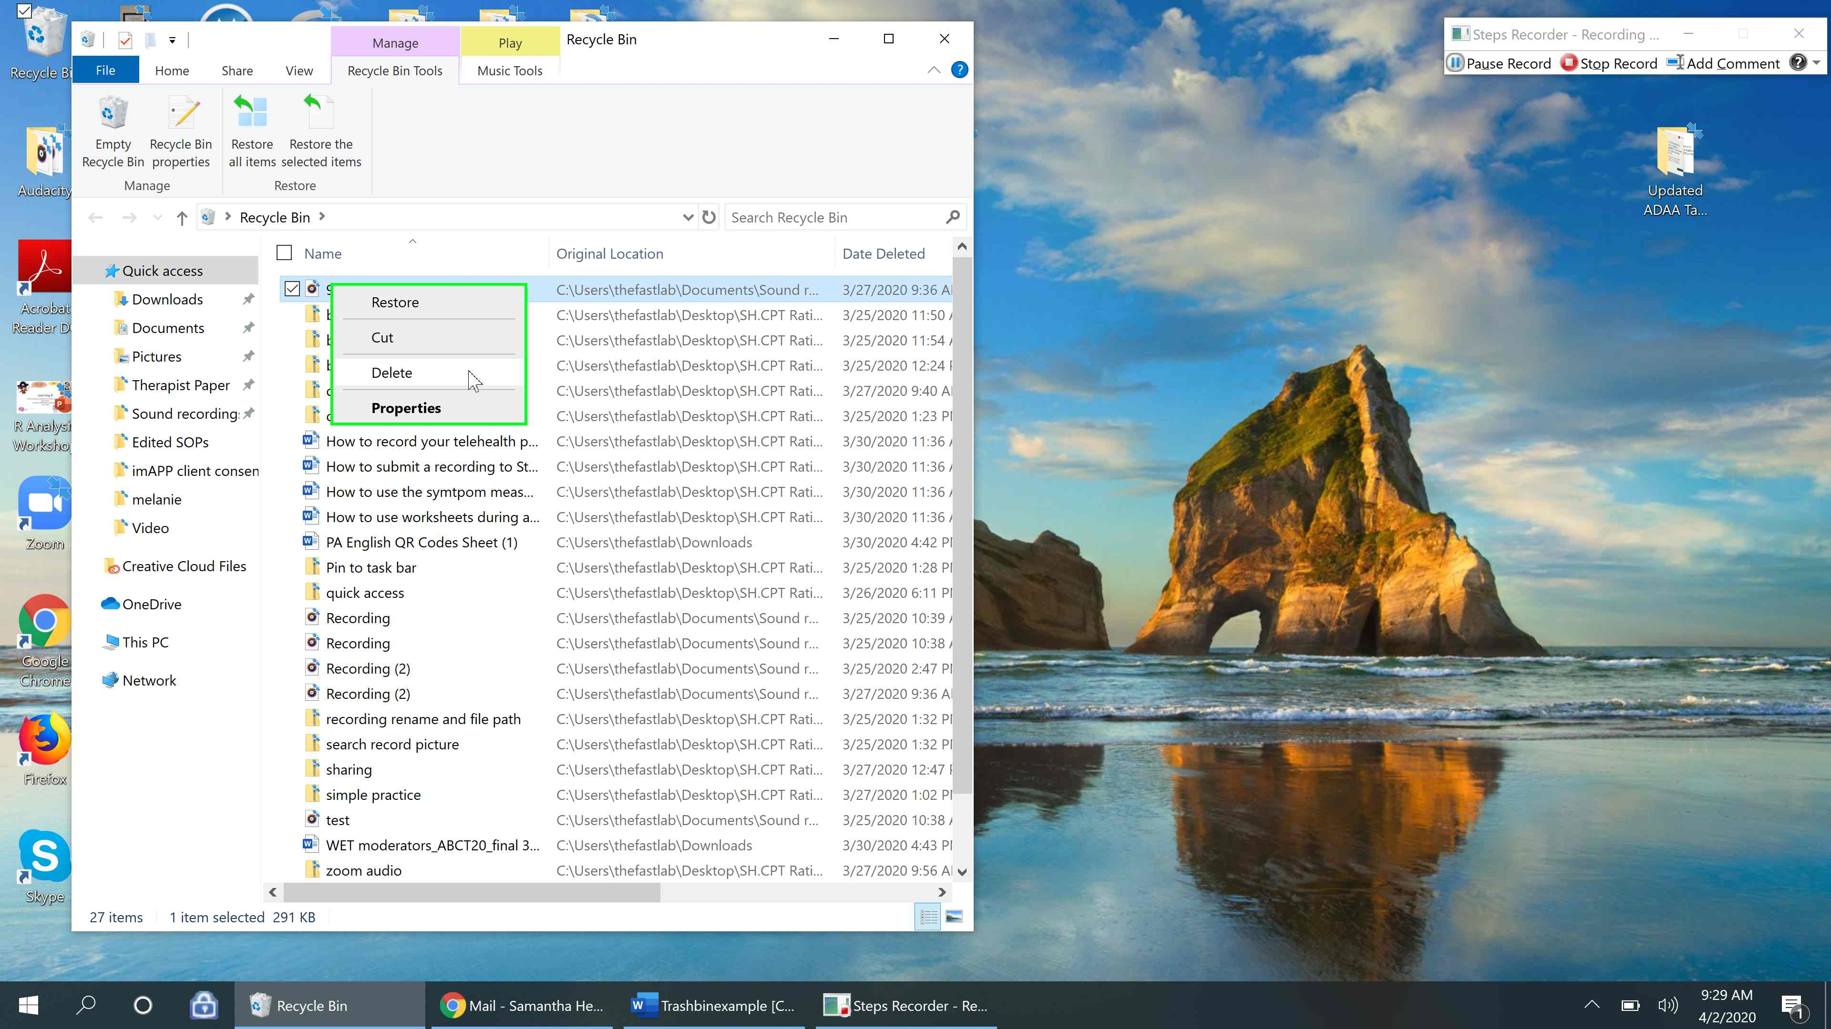
Step 8: A pop up will appear asking if you’re sure you want to permanently delete the file. Select “Yes”. The file is now permanently deleted.
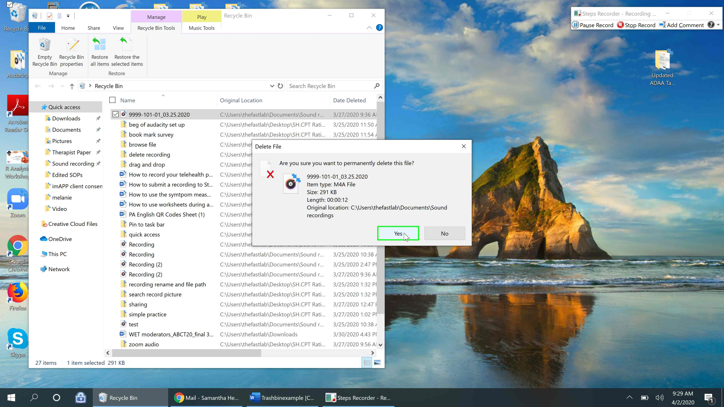

Tip: You can also permanently delete all the items in your recycle bin at once by clicking the “Empty Recycle Bin” icon in the upper left had corner.
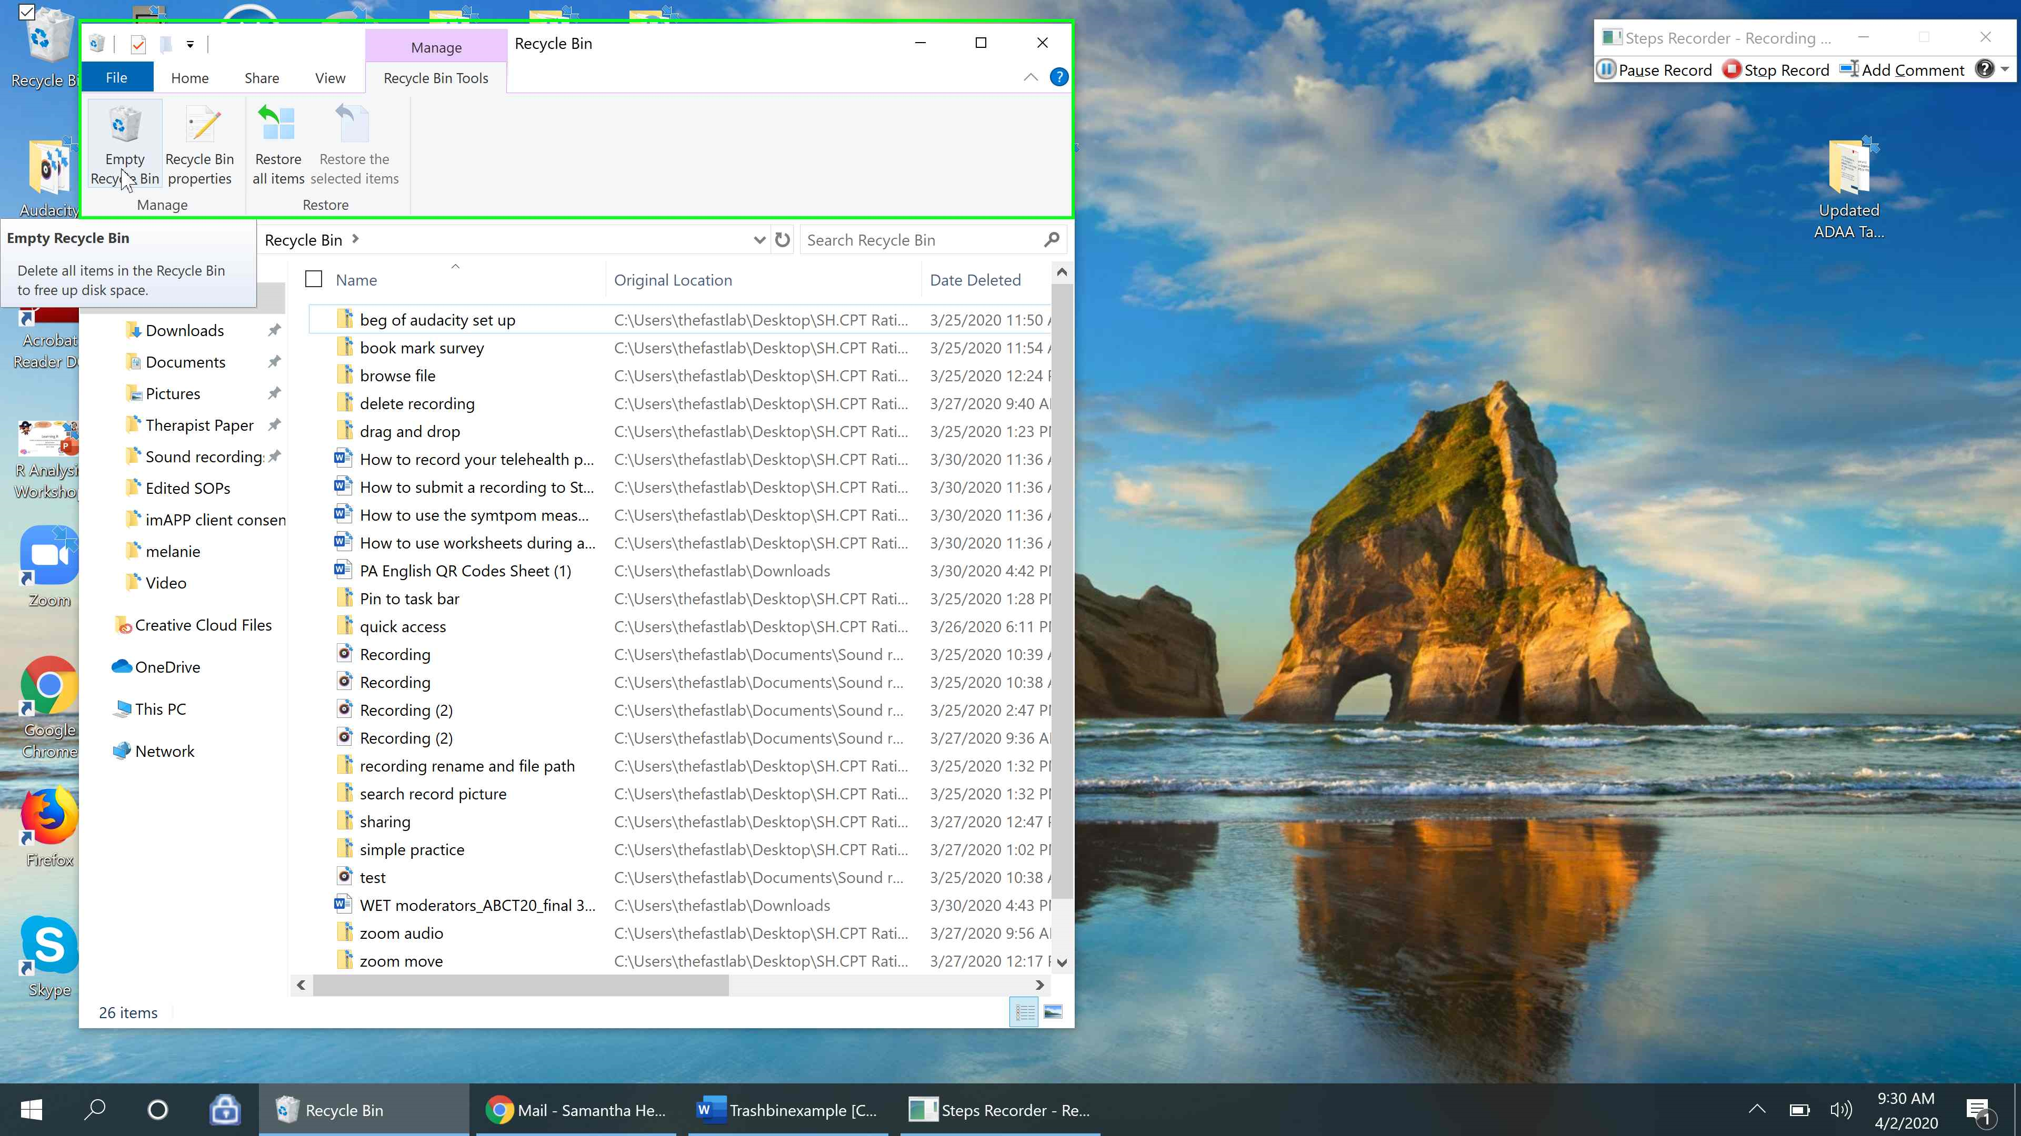

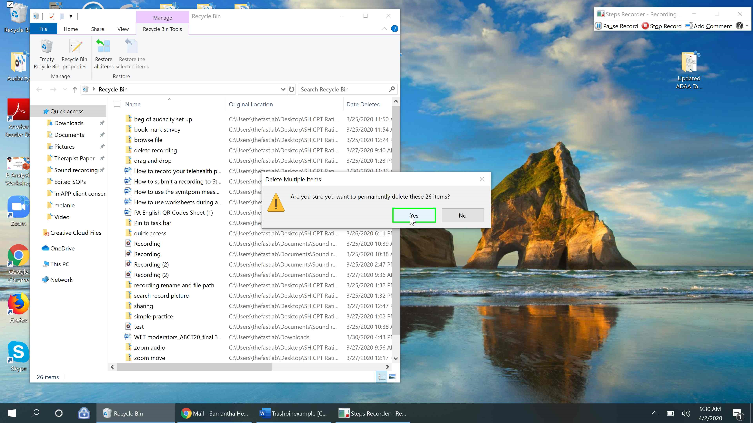

Alternative Directions for those with the Recycle Bin Icon on their Desktop
Step 9: Go to the “Recycle Bin” icon on your desktop and click it twice to open the Recycle Bin.
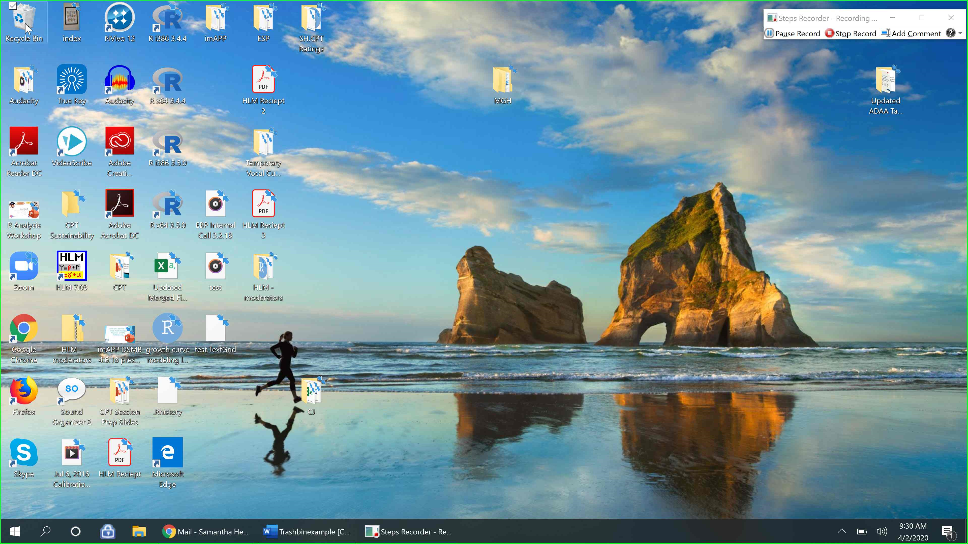
You should see all of the items in your recycle bin and can select an item individually to delete it (as explained in step 7) or you can use the Empty Recycle Bin function to permanently delete all of the items (as explained in the tip after step 8).
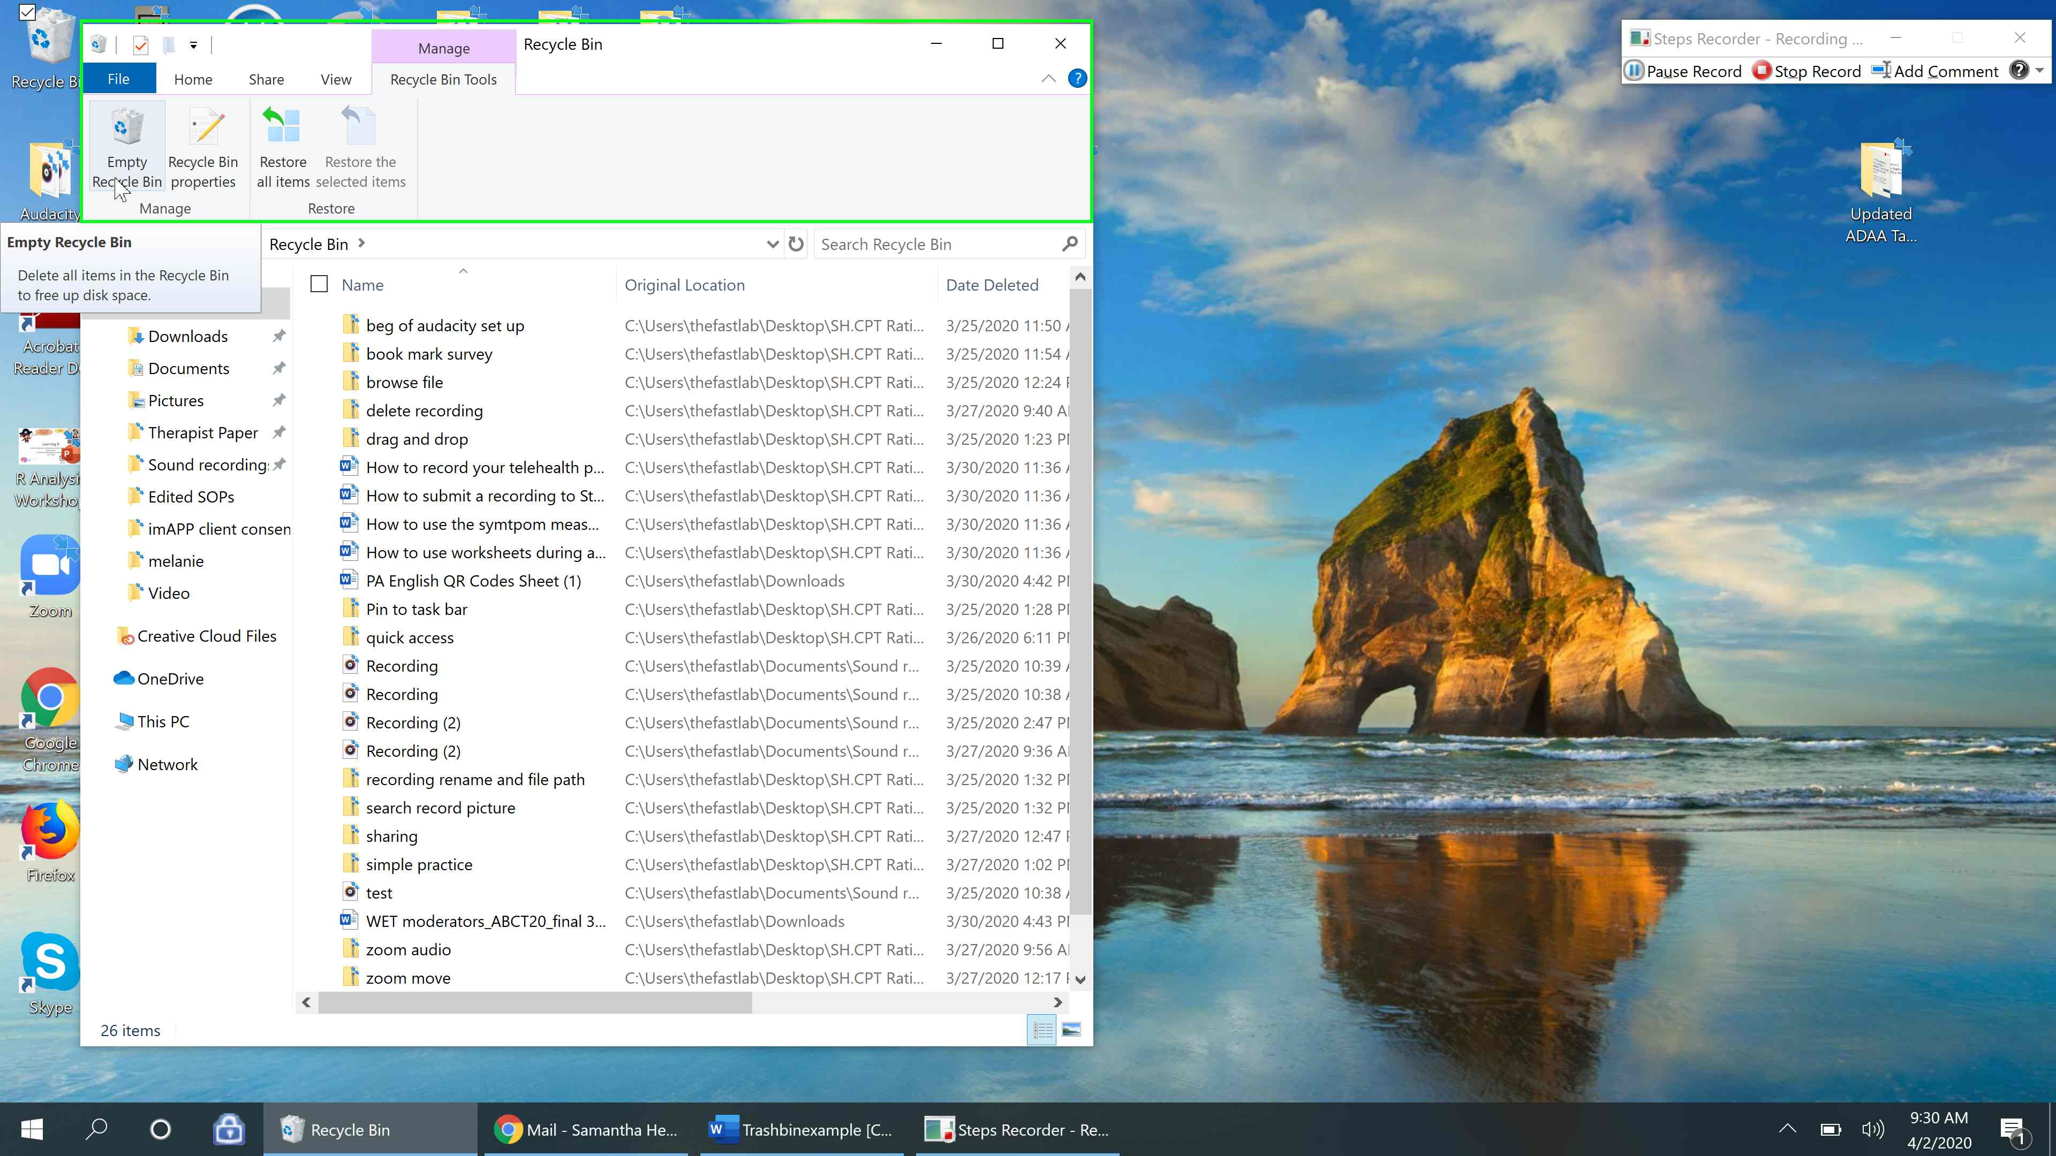
Sharing screens on Simple Practice:
The share screen function is consistent across most platforms and using it is almost the same as in Zoom.
Step 1: In the bottom left hand bar of options, you should see an icon with a box and arrow that says “Share”. Select that icon to begin sharing your screen.
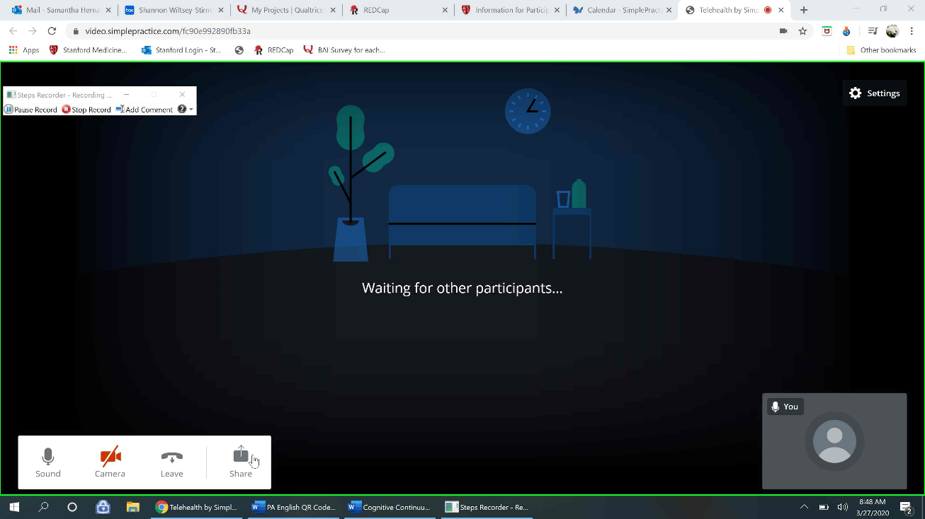
Step 2: A pop up should appear asking if you’d like to share your screen now. Select “Share now”.
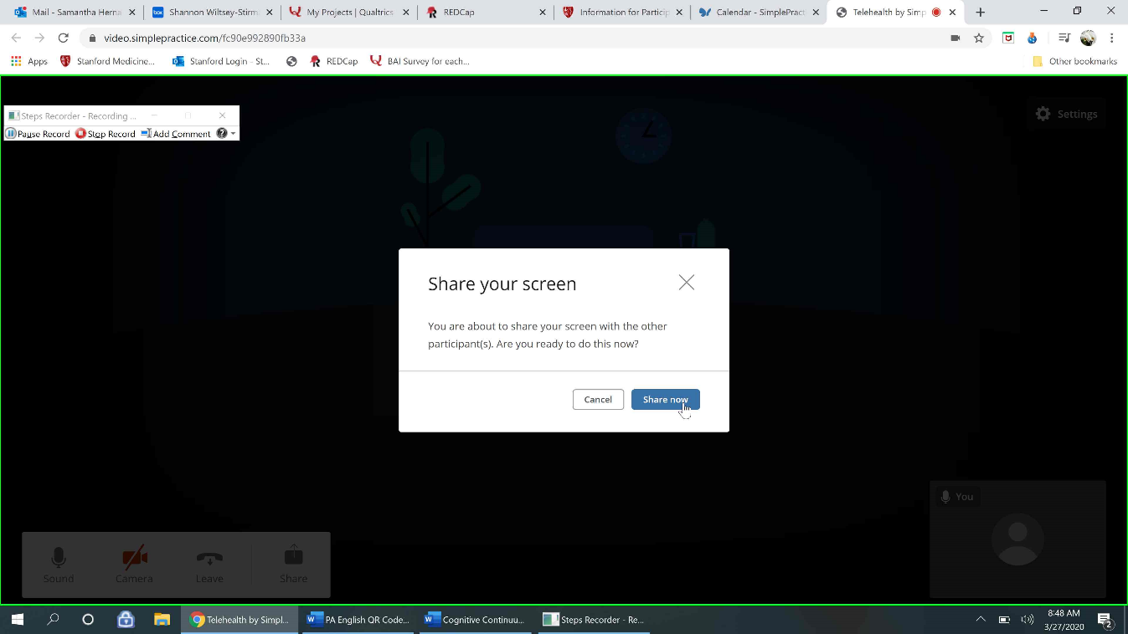
Step 3: It should then ask which screen you’d like to share. The default will be “Your Entire Screen”, but we recommend selecting “Application Window” instead so the client does not see other windows you may have open. In the “Application Window” section, select the screen and select “Share”.
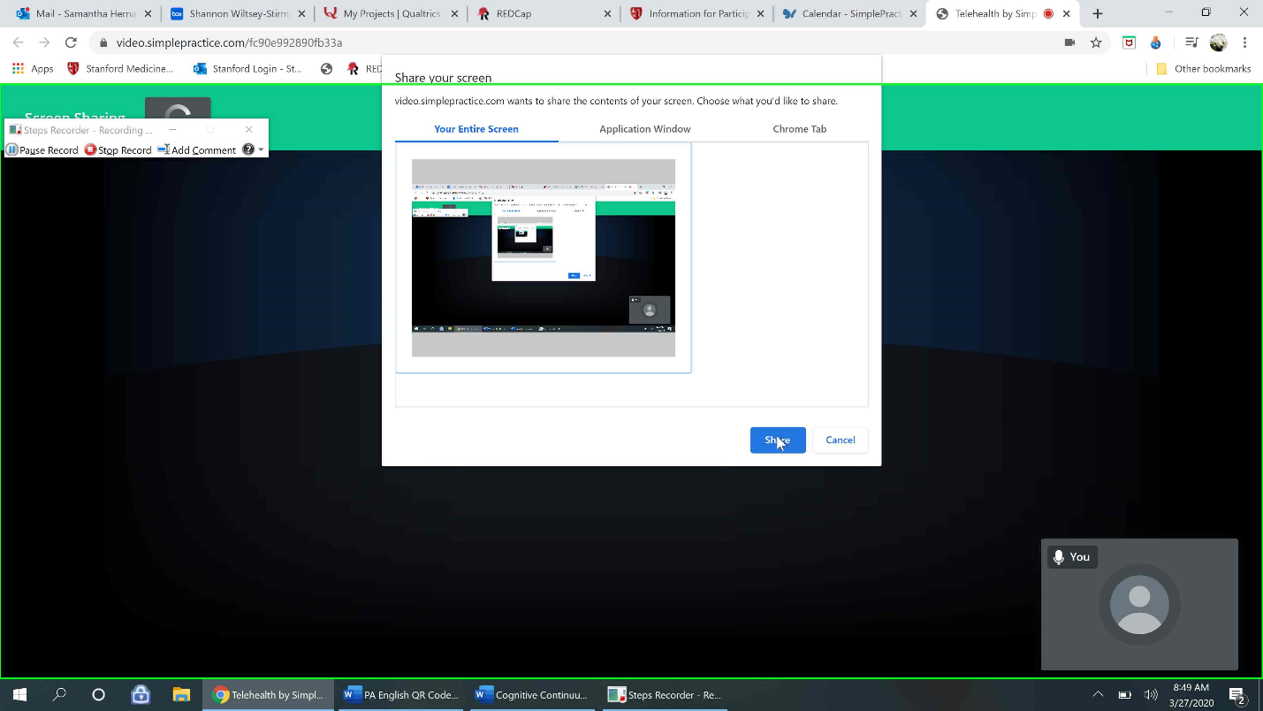
Step 4: A red bar should appear in the top middle of your screen, indicating that you are now sharing your screen with your client. You can now open an online worksheet or download a worksheet from the imAPP website to do a worksheet with your client via telehealth. For more information of options for screen sharing, please go to the “How to use worksheets on a Video session” SOP.
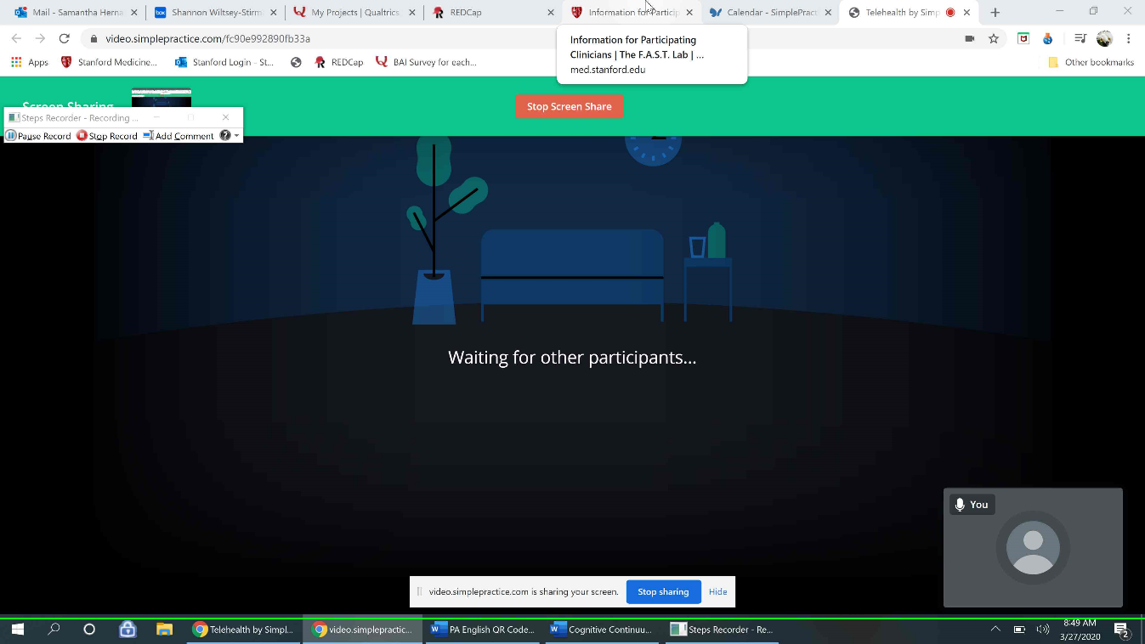
Step 5: Once you are done sharing screen and nearing the end of the session, you can select the red bar “Stop Screen Share” to return to your video screen.
