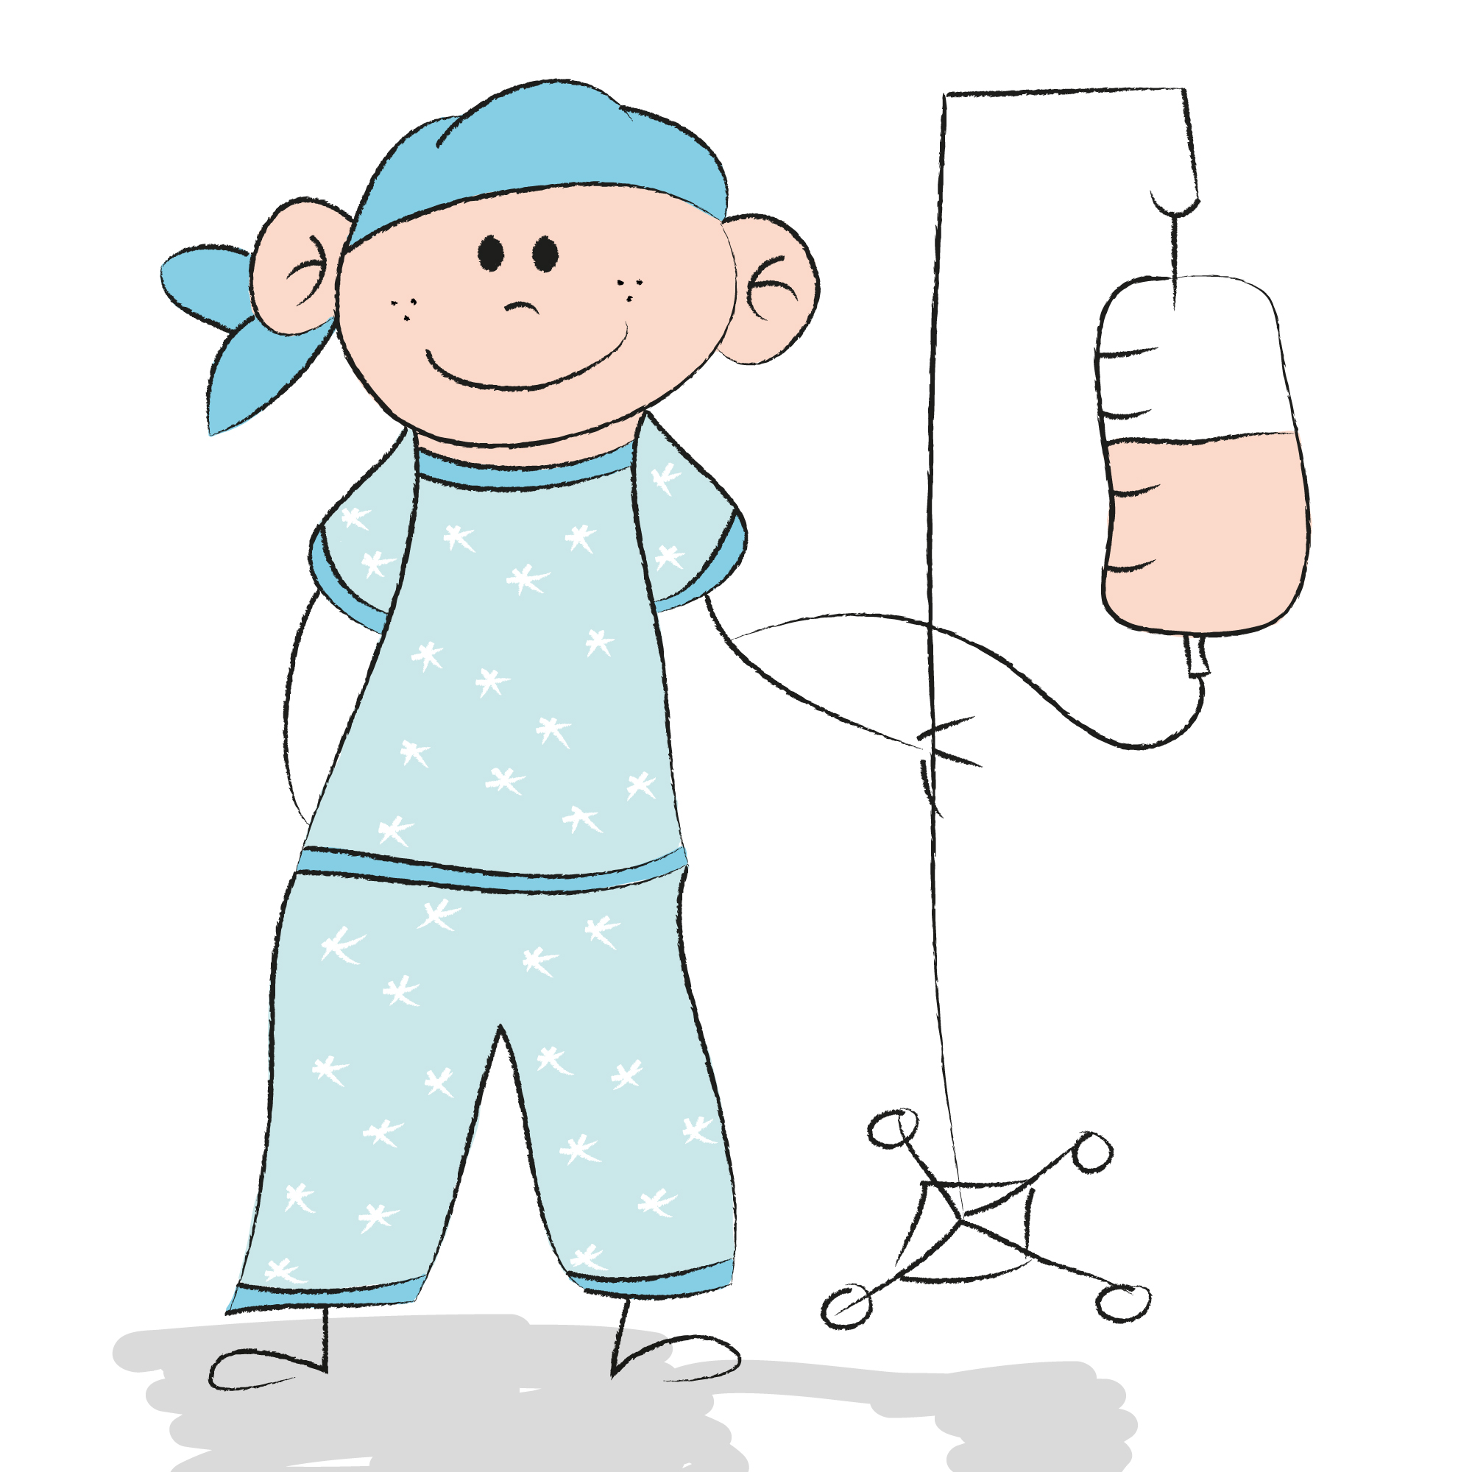

Cancer is hard.
We are hoping to learn what could make it a little easier for families living with pediatric cancer.

If your child has cancer, we know your whole family is impacted. We invite you and your family participate in a research study to better understand psychosocial stress facing families impacted by pediatric cancer who are being treated at the Bass Center.

What does it involve?
- Meeting with us once when your child is at the Bass Center for appointments or treatment
- Answering questions about the stresses of living with pediatric cancer, health and wellness, and use of mental health services
- Getting paid for participating.

If you are interested or would like more information, please contact
Dr. Victoria Cosgrove at veileen@stanford.edu or 650-723-9392.
Participant's rights questions, contact 1-866-680-2906
Family Cancer Study
650-723-9392 veileen@stanford.edu

Family Cancer Study
650-723-9392 veileen@stanford.edu

Family Cancer Study
650-723-9392 veileen@stanford.edu

Family Cancer Study
650-723-9392 veileen@stanford.edu

Family Cancer Study
650-723-9392 veileen@stanford.edu

Family Cancer Study
650-723-9392 veileen@stanford.edu

Family Cancer Study
650-723-9392 veileen@stanford.edu

Family Cancer Study
650-723-9392 veileen@stanford.edu

Family Cancer Study
650-723-9392 veileen@stanford.edu

Family Cancer Study
650-723-9392 veileen@stanford.edu

