High calorie shake ideas
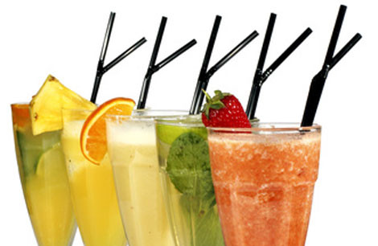

High calorie shakes are a great way to take in extra calories during the day.
All you need are the ingredients and a blender.
Include one or two of these shake recipes each day with breakfast, as an in-between meal snack, or after dinner treat!

Recipes
Before getting started:
1. Wash all of the fruit you'll be using.
2. Prepare ingredients and place in blender.
3. Blend ingredients together to desired consistency, adding additional liquid if needed.
Frozen fruit can be used for a thicker smoothie or shake.

Gone Bananas (530 calories)
- 2 bananas
- 1 envelope Carnation Instant Breakfast ©, vanilla flavor
- 1 cup whole milk
- 2 tablespoons orange juice concentrate

Blueberry Bonanza (450 calories)
- 3 to 4 ounces of tofu
- 1 banana
- 1/2 cup frozen blueberries
- 1 cup whole milk

Berries Galore (560 calories)
- 1/2 cup uncooked oats
- 1 banana
- 8 strawberries, fresh or frozen
- 1/2 cup frozen blueberries
- 1/2 cup frozen raspberries
- 1 cup whole milk

Lemon Delight (450 calories)
- 1 cup full fat lemon yogurt
- 1 cup whole milk
- 1 banana
- 1 teaspoon vanilla extract

Orange Whip (400 calories)
- 1 cup orange juice
- 1/2 cup pineapple juice
- 1/2 cup full fat cottage cheese
- 1/2 cup whole milk

Sherbet Shake (450 calories)
- 1 cup any flavor sherbet
- 1/2 cup whole milk

Caramel Dream (300 calories)
- 1/2 cup half and half
- 1/2 cup whole milk
- 2 T caramel sauce
- ¼ tsp salt (or to taste)

Tropical Banana Shake (480 calories)
- 2 ripe bananas
- 1/2 cup canned peaches
- 1 cup mango or guava nectar
- 1/2 cup whole milk
- 3 ice cubes

Tutti-Fruity Shake (570 calories)
- 1/2 cup vanilla ice cream
- 1 package Instant Breakfast, vanilla flavor
- 1/2 cup canned fruit
- 1/2 cup half and half cream
Peanut Butter Shake (350 calories)
- ½ cup whole milk
- 2 T dry milk powder
- 1 T smooth peanut butter
- ½ cup vanilla ice cream

OJ and Cinnamon Smoothie (490 calories)
- 1 envelope vanilla Carnation Instant Breakfast ©
- 1 cup whole milk
- ¼ cup dry milk powder
- 3T thawed orange juice concentrate
- 1/8 tsp ground cinnamon
- 6 ice cubes

Peach Perfect (260 calories)
- 1 medium peach cut into chunks
- ¼ cup dry milk powder
- ½ cup lemon or peach full fat yogurt
- 4 ice cubes

Peppermint Milkshake (560 calories)
- 1 cup vanilla ice cream
- 1 envelope vanilla Carnation Instant Breakfast ©
- ½ cup half and half
- ½ to 1 capful of peppermint extract

Triple Threat Chocolate Milkshake (350 calories)
- ½ cup chocolate ice cream
- ½ cup whole chocolate milk
- 1 T dry milk powder or malted milk powder
- 1 T chocolate syrup

Enjoy!

