AEM Touch Components 101

Components are the literal building blocks for AEM pages. Simply insert them into designated zones to construct page layouts and add content to your site. Basic functionality is intuitive, though it takes some familiarity to know when to use what, and how to best leverage each. For accelerating this applied knowledge, turn to our Design Demonstration Site and the specific component tutorials listed below.

Instructions Workflow

Search

- From the far upper-left, click the Side Panel menu.
- Click the Components list. The list of components is displayed.
- Locate the desired component. Use the filter or category tools to assist.
  - Filter: Enter text to search.
  - Category: Open the menu to sort by the classic categories (Layout, Form, Image, Text, etc…)
- Click the (i) information icon next to the component tile for descriptions.

Insert
There are two methods to insert a component onto a page: (1) From the Components list or (2) directly from the component zone on the page.

- Component list:
  - Click and drag the desired component from the list into a component zone on the page (where it says “Drag components here”)
  - Release the mouse when the blue arrow indicates a satisfactory position for the component.
- Component zone:
  - Click a component zone directly from the page.
  - Click the (+) Insert component button from the toolbar.
  - From the popup window, click to select the desired component. Components are listed first in categories, then alphabetically.

Configure
Once on the page, click any component once to open the toolbar. A full list of functions listed below.
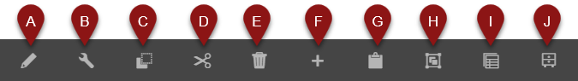
Note: Not all components have the following functions

- Edit: A quick edit option that allows text and/or image adjustments.
- Configure: Open the full configuration window.
- Copy: Clone the component onto the clipboard.
- Cut: Lift the component onto the clipboard.
- Delete: Remove the component from the page.
- Insert: Add a new component onto the page.
- Paste: Lay copied/cut component from the clipboard
- Group: Select multiple components (CTRL + Click).
- Parent: Select the component housing the current (this is usually a Panel Builder).
- Convert to experience fragment variation: ??

