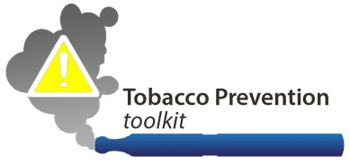
[School Name]
INSERT YOUR SCHOOL LOGO HERE
[Street Address, City, ST ZIP Code] | [Phone Number] | [Email Address]

August 10, 2016

Good [Morning, Afternoon Evening] all. Welcome to [School Name/Event]. We are excited to have you all here. We wanted to remind you all about our tobacco free policies here at our school. Use of any and all tobacco products, including e-cigs/vapes/vape pens/personal vaporizers is not allowed anywhere on our school campus, anywhere, including in the parking lots, restrooms, and within [Insert Number of Feet Here] feet of our campus [Insert Any Other Relevant Policy Information Here]. These policies not only applies to students, but to staff, parents/caregivers, and all visitors.
It is important to remember that over 400,000 people die each year from using tobacco, and many more are living with disease from their own or someone else’s tobacco use. Since 9 out of 10 adult smokers started using tobacco during their adolescent years, we as a school community can work together to prevent our young people from such terrible health consequences. Let’s be a good role model for our students.
We hope we have your support in communicating and reinforcing these critical school policies.
Together, we can help keep our loved ones safe!

