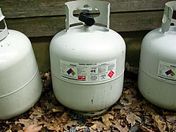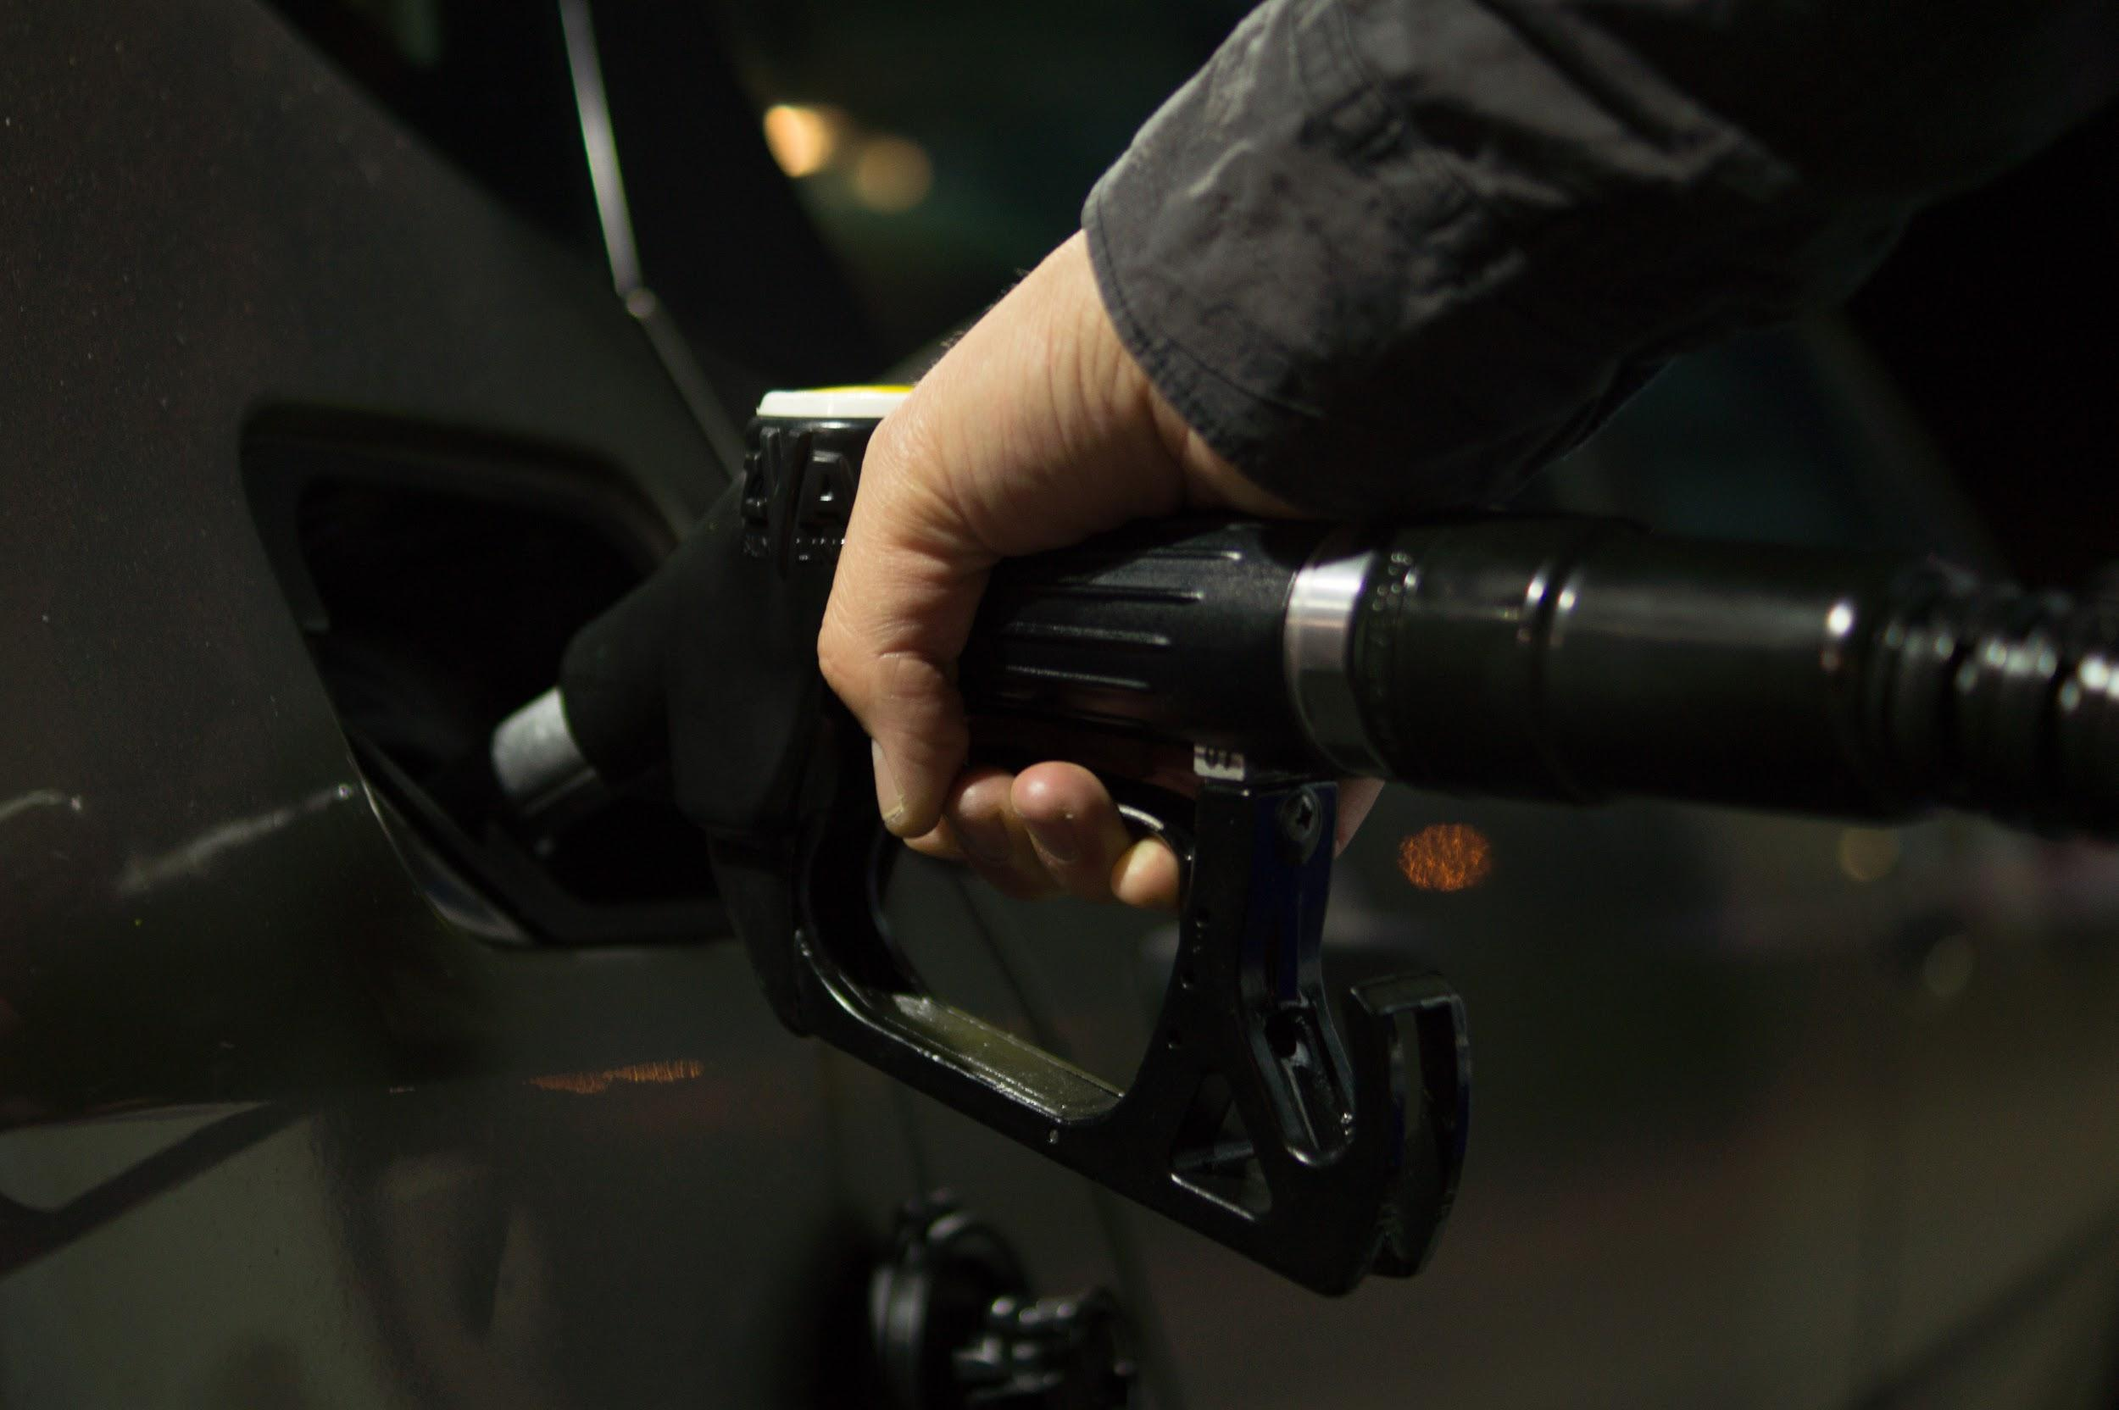

**Define: GAS**

In your own words:

Dictionary Definition:

Examples: