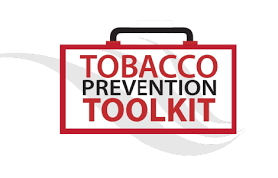
Vaping Prevention: A Remote Learning Curriculum Student Worksheet

Instructions: Use these questions along with the slideshow presentation to explore the risks of vaping and smoking, as well as the benefits of staying vape- and smoke-free.

Introduction
- Write down at least 2 things you think young people like about using e-cigarettes/vapes/ JUUL/Puff bar.

- Type answer here

2. Type answer here

- Write down at least 2 things you think young people DO NOT like or are concerned about using e-cigarettes/vapes/JUUL/Puff bar.

- Type answer here

- Type answer here

Check-in #1
- I am most concerned about the fact that e-cigarettes/vapes/JUUL/Puff bar ____________. (Check all that apply)

Have nicotine, which is really addictive for young people
Create clouds of aerosol rather than water vapor and can damage the lungs
Create plastic and toxic environmental pollution
Other: ________________________________________________

- What makes you concerned about the fact/facts that you picked in question 3?

Type answer here

- Which of the following is NOT true about pod-based e-cigarettes/vapes (like JUUL, Puff bar, and Eon Stik) that contain salt-based nicotine? (Check the correct box. There is only one correct answer.)

They create an aerosol, not a water vapor
They contain nicotine
They feel less harsh on the throat compared to cigarettes, making it easy for young people to use them
Each pod has less nicotine than a pack of cigarettes
- Which of these increase the addictiveness of a cigarette and an e-cigarette/vape? (Check the correct box. There is only one correct answer.)
Sugar
Increased nicotine
Flavors
All of the above

Check-in #2
- JUUL Labs company listed 7 ingredients in their products. Scientific studies showed at least 59 chemicals were actually present. Why do you think the JUUL company wouldn't want people to know about the other ingredients?

Type answer here

- Why do you think young people should avoid contact with e-cigarettes/vapes and all of the toxic chemicals they contain? (Check all that apply)
The human body isn't designed to have anything other than oxygen in the lungs
Toxic chemicals can weaken the body's ability to breathe and fight infection
"Secondhand Aerosol" is the aerosol that an e-cigarette/vape user breathes out, and it is NOT dangerous
Babies and pets are especially at risk for "thirdhand aerosol"
The human body isn't designed to have anything other than oxygen in the lungs

- What are some reasons small children and pets are especially at risk for "thirdhand aerosol" exposure?

Type answer here

- Which of the following is NOT true of how vaping affects your body? (Check the correct box. There is only one correct answer.)
Flavors and other chemicals impair lung function
The aerosol increases your risk for developing heart or lung disease later in life
They are healthy for adults
Nicotine tricks the brain into thinking it needs more nicotine

Check-in #3
- What is the main job of the lungs? (Check the correct box. There is only one correct answer.)
They pump blood throughout the body
They bring in fresh oxygen, and push out unnecessary carbon dioxide
They are the control center of the body
They digest food

- Why would it be dangerous if the lungs could not do their main job?

Type answer here

- How is smoking/vaping related to coronavirus/COVID-19? (Check all that apply)
Smoking/vaping can make a coronavirus infection worse
Smoking/vaping leads to coronavirus infection
Smoking/vaping makes the lungs more prepared to fight the infection
Smoking/Vaping makes it easier to become infected by the coronavirus

- How do the lungs and heart work together? (Check the correct box. There is only one correct answer.)
The heart fills the lungs with blood
The lungs fill the heart with air
The heart brings in fresh oxygen to the bloodstream and the lungs pump it all through the body
The lungs bring in fresh oxygen to the bloodstream and the heart pumps it all through the body

- What would you say to someone who's been smoking/vaping for a long time who said they want to quit but there's no point because the damage has already been done to their body?

Type answer here

- Why might someone start feeling intense "withdrawal" symptoms after using a JUUL for a short period of time? (Check the correct box. There is only one correct answer.)
The nicotine in 1 pod is close to 2 packs of cigs
Because they are craving the flavors
Their pleasure pathway is weaker than others
The person may just be anxious in general

- Nicotine is one of many ingredients e-cigarette/vape companies put into their products. Why do you think companies like JUUL and Puff bar add nicotine into their products if it is so dangerous and addictive?
Type answer here

Check-in #4
- Which of the following effects of nicotine is the most dangerous, in your opinion? (Check the correct box. There is only one correct answer.)
Nicotine causes addiction by rewiring and changing the brain.
Nicotine can make the heart beat faster because it activates the “fight or flight response.”
Nicotine can cause trouble breathing and damage to the lungs.
Nicotine can cause increased acid reflux.
Nicotine can negatively impact your reproductive organs.

- Please explain your answer to question 18.

Type answer here

- Outside of youth, what other vulnerable group has been targeted by big tobacco with the use of menthol in their tobacco/nicotine products? (Check the correct box. There is only one correct answer.)
Women
African Americans
Elderly people
Athletes

- How did tobacco companies promote menthol cigarettes to the African-American community?

Type answer here

Check-in #5
- Which of the following facts is the most surprising to you? (Check all that apply)
Flavors attract kids to use e-cigarettes/vapes.
Flavors can cause lung damage.
Flavors can cause heart damage.
Flavors make it easier for some people to start smoking/vaping.
Flavors make it easier for some people to keep smoking/vaping.

- Please explain your answer to question 22.

Type answer here

- What are some reasons e-cigarette/vape companies target younger customers? Give at least 2 reasons.

Type answer here

- Choose one social media post related to e-cigarettes/vapes/JUUL/Puff bar to answer the following questions.
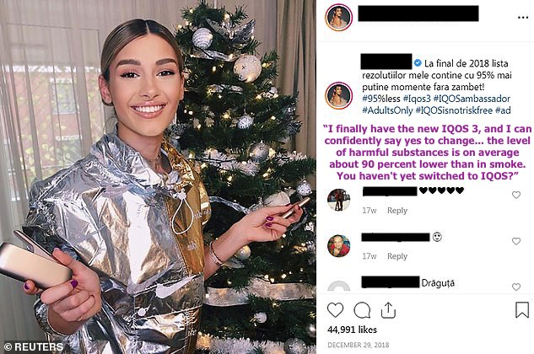
1.
3.
2.

- Which post did you choose and who created the post you chose in question 25?

Type answer here

- Who is meant to see the post you chose in question 25?

Type answer here

- What is the message the post's creator is trying to make with this post?

Type answer here

- Do you agree with the message the post's creator is trying to make? Why or why not?

Type answer here

- If I take time to plan when to vape, how to pay for it, where to get it, do it first thing in the morning, leave class to do it – my brain might be: (Check the correct box. There is only one correct answer.)
Good at planning
Addicted
Manipulated by big tobacco
Aerosolized
Check-in #6

- Imagine a close friend started to use e-cigarettes/vapes and offered one to you to try. What are 3 or more reasons you personally wouldn't want to try it? What might you say to them to explain why you aren't interested?

Type answer here

