Highlights – AAP Clinical Practice Guideline for Screening and Management of High Blood Pressure in Children and Adolescents

Pediatrics, September 2017, VOLUME 140 / ISSUE 3
http://pediatrics.aappublications.org/content/pediatrics/140/3/e20171904.full.pdf

Screening

BP should be measured in children/adolescents > 3 years old:
- Annually if otherwise healthy
- At every health care encounter if they have obesity, are taking medications known to elevate BP, have renal disease, h/o aortic arch obstruction or coarctation, or diabetes.

The initial BP may be oscillometric or auscultatory.

Quick screener: BP requiring further evaluation
(Based on 90% for children @ 5% height)

Age, y | BP, mm Hg
 | Boys |  | Girls
 | Systolic | DBP | Systolic | DBP
1 | 98 | 52 | 98 | 54
2 | 100 | 55 | 101 | 58
3 | 101 | 58 | 102 | 60
4 | 102 | 60 | 103 | 62
5 | 103 | 63 | 104 | 64
6 | 105 | 66 | 105 | 67
7 | 106 | 68 | 106 | 68
8 | 107 | 69 | 107 | 69
9 | 107 | 70 | 108 | 71
10 | 108 | 72 | 109 | 72
11 | 110 | 74 | 111 | 74
12 | 113 | 75 | 114 | 75
≥13 | 120 | 80 | 120 | 80

Algorithm for screening

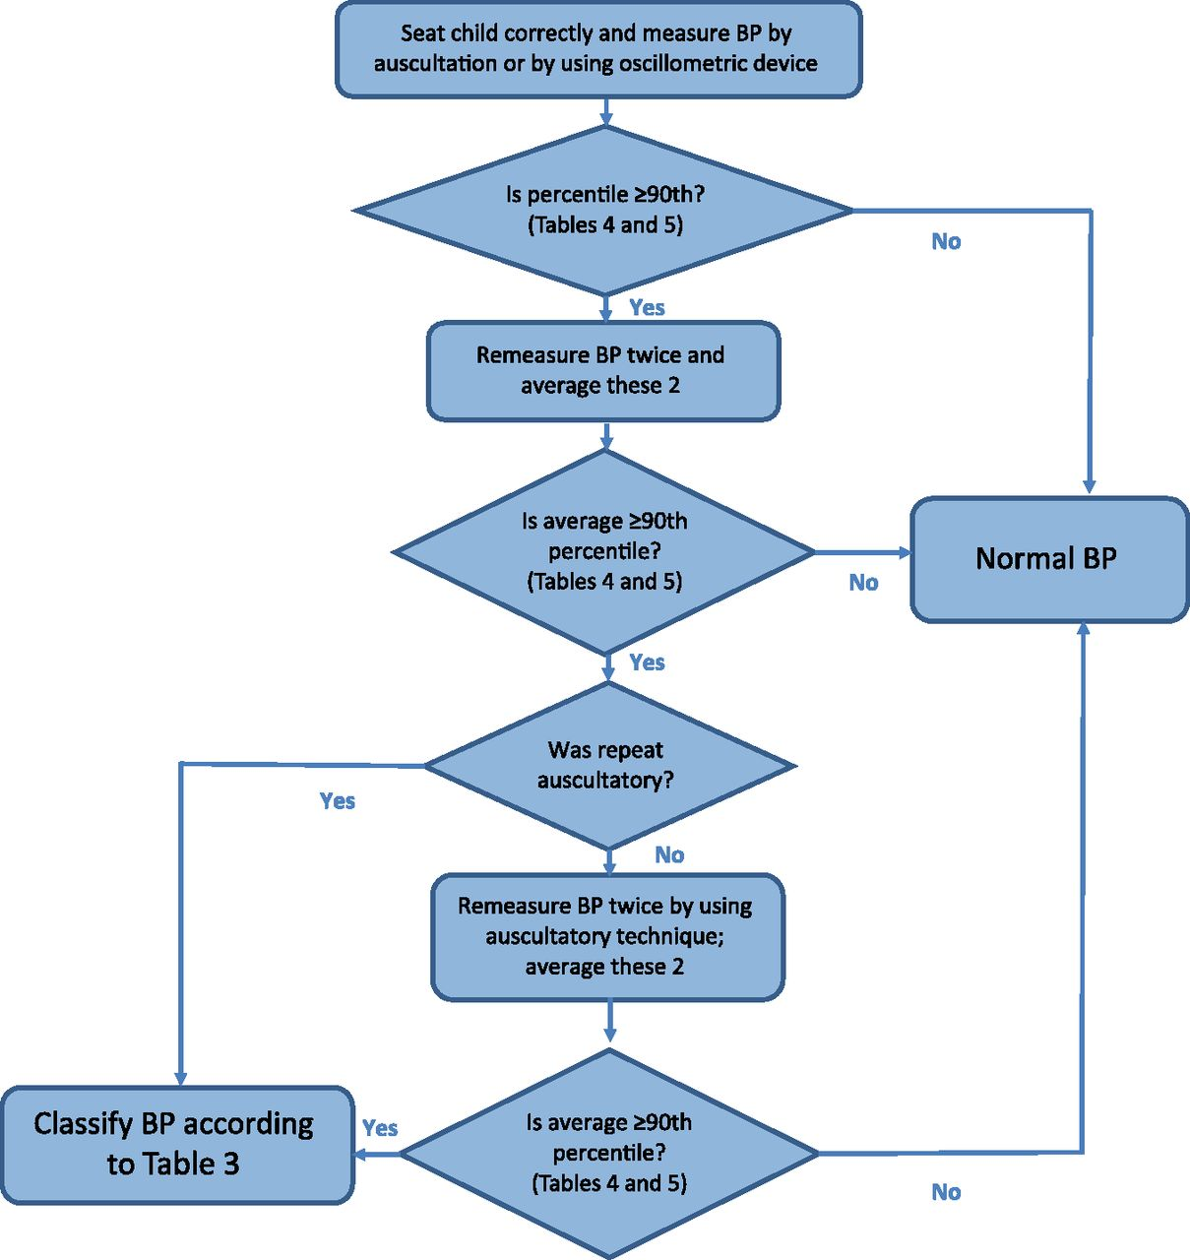

The updated Clinical Practice

Updated Definitions of BP Categories and Stages
For Children Aged 1–<13 y | For Children Aged ≥13 y
Normal BP: <90th percentile | Normal BP: <120/<80 mm Hg
Elevated BP: ≥90th percentile to <95th percentile or 120/80 mm Hg to <95th percentile (whichever is lower) | Elevated BP: 120/<80 to 129/<80 mm Hg
Stage 1 HTN: ≥95th percentile to <95th percentile + 12 mmHg, or 130/80 to 139/89 mm Hg (whichever is lower) | Stage 1 HTN: 130/80 to 139/89 mm Hg
Stage 2 HTN: ≥95th percentile + 12 mm Hg, or ≥140/90 mm Hg (whichever is lower) | Stage 2 HTN: ≥140/90 mm Hg

Patient Evaluation and Management According to BP Level
BP Category (See Table 3) | BP Screening Schedule | Lifestyle Counseling (Weight and Nutrition) | Check Upper and Lower Extremity BP | ABPMª | Diagnostic Evaluation^{b} | Initiate Treatment^{c} | Consider Subspecialty Referral
Normal | Annual | X | — | — | — | — | —
Elevated BP | Initial measurement | X | — | — | — | — | —
 | Second measurement: repeat in 6 mo | X | X | — | — | — | —
 | Third measurement: repeat in 6 mo | X | — | X | X | — | X
Stage 1 HTN | Initial measurement | X | — | — | — | — | —
 | Second measurement: repeat in 1–2 wk | X | X | — | — | — | —
 | Third measurement: repeat in 3 mo | X | — | X | X | X | X
Stage 2 HTN^{d} | Initial measurement | X | X | — | — | — | —
 | Second measurement: repeat, refer to specialty care within 1 wk | X | — | X | X | X | X
- X, recommended intervention; —, not applicable.
- ↵a ABPM is done to confirm HTN before initiating a diagnostic evaluation.
- ↵b See Table 15 for recommended studies.
- ↵c Treatment may be initiated by a primary care provider or subspecialist.
- ↵d If the patient is symptomatic or BP is >30 mm Hg above the 95th percentile (or >180/120 mm Hg in an adolescent), send to an ED.

More detailed review of 2017 Guideline:

30 Key Action Statements.
Some are noted in this summary, for the rest see the original article.

Pediatric hypertension
- 2%–5% of all pediatric patients
- one of the top five chronic diseases in children and adolescents.
- diagnosis is missed in up to 75% of pediatric patients in primary care settings

Highlights of the new pediatric hypertension guideline include:
- development based on a strict evidence-based approach as recommended by the National Academy of Medicine and the NHLBI National Heart, Lung, and Blood Institute;
- replacement of the term “prehypertension” with “elevated blood pressure”;
- new normative blood pressure tables based on children with normal weight;
- simplified screening table for identifying blood pressures needing further evaluation;
- simplified blood pressure classification in adolescents 13 years of age and older that aligns with forthcoming American Heart Association/American College of Cardiology adult blood pressure guidelines;
- a more limited recommendation to perform screening blood pressure measurement only at preventive care visits;
- streamlined recommendations on initial evaluation and management of abnormal blood pressures;
- expanded role for ambulatory blood pressure monitoring in both diagnosis and ongoing management of pediatric hypertension;
- more limited recommendation on when to perform an echocardiogram in the evaluation of newly diagnosed hypertensive pediatric patients (generally only before medication initiation);
- revised definition of left ventricular hypertrophy;
- revised treatment goals based on published evidence; and
- 30 evidence-based key action statements and an additional 27 clinical recommendations based on expert opinion.

How to take a BP properly

-Patient should be seated comfortably with feet flat on the floor, with back supported, legs uncrossed for 5 minutes. The upper arm bare should be bare to the shoulder

-Patient’s arm should be supported at heart level.

-Length: Cuff bladder should encircle 80%-100% of the patient’s arm circumference.
Width: Cuff bladder should cover ~50% of the upper arm (between the acromion and the olecranon)

-The midline of the bladder should be over the brachial artery and 2-3cm above the elbow crease.

-Inflate the cuff while palpating the radial artery. Note the mm/Hg when you can no longer feel the pulse. Wait 15-30 secs , Add 20 mm/Hg to prior reading and inflate.

-Use the bell of the stethoscope. The cuff should not touch the bell (do not tuck it under the cuff).

-Neither the patient nor the person taking the measurement should talk during the procedure.

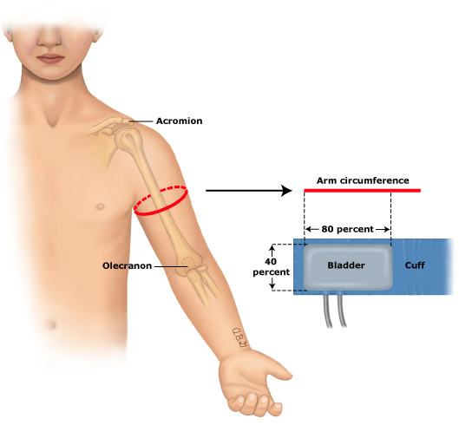

Evaluation
-if the initial BP is elevated (>/= 90%) repeat 2 auscultatory BP at the same visit and average them*

-BP normal or normalizes after repeat (<90%)
--recheck at next WCC

-Elevated BP (>/= 90% to < 95% or 120/80 whichever is lower)
--Recommend lifestyle interventions and consider nutrition or weight
management referral if appropriate
--Repeat in 6 months

-Second visit (in 6 months_
-BP still elevated
--upper and lower BP check (right and left arm and 1 leg)
--repeat lifestyle counseling
--recheck BP in 6 months

-Third visit
-BP still elevated 12 months after initial visit
--Order ABPM if available (ambulatory BP monitoring)
--Consider subspecialty referral
--All patients: (table 10, page 19)
UA
Chem panel (including BUN, Cr)
Lipid profile (fasting or non-fasting)
Renal U/S in < 6yo or abnormal U/A or renal fx
--Obese patients (BMI >/=95%)
add the following:
HA1c
AST/ALT
Lipid panel, fasting

--Consider the following in certain circumstances
fasting serum glucose (if high risk of DM)
TSH
Drug screen
Sleep study
CBC (especially in growth delay or abnormal renal fx

-If BP normalizes at any point return to routine annual BP checks at WCC

-Stage 1 htn (>/=95% to <95% +12 mmHg or 130/80 to 139/89, whichever is lower)
--Asymptomatic
lifestyle counseling
recheck BP in 1-2 weeks by auscultation

Second visit (1-2 weeks)
If still elevated to stage 1:
Upper and lower exp BPs (right and left arm and one leg)
Nutrition or weight management referral if appropriate
Recheck BP in 3 months by auscultation

Third visit
Still stage 1 htn
Consider subspecialty referral
Order ABPM (if available)
Diagnostic evaluation (table 15 pages 27-28)
Initiate Treatment (Primary care provider or Specialist)

-Stage 2 htn (>/= 95% + 12mmHg or >/= 140/90, whichever is lower)
Asymptomatic
Upper and lower BP check (right and left arm and 1 leg)
Lifestyle recommendations given
Repeat BP in 1 week or alternatively
Refer to subspecialty care w/i 1 week

Second Visit (1 week)
Diagnostic evaluation (table 15 pages 27-28)
ABPM
Treatment initiated
Or patient should be seen by subspecialist w/i 1 week

Symptomatic or BP > 30 mmHg > 95%, or >180/120
Immediate ED care

Diagnosis of HTN: should be made by trained health care professionals in the office setting if the patient has auscultatory confirmed BP reading >/= 95% at 3 different visits (KAS 3)

Treatment
Overall Goals
- Achieving a BP that reduces risk for target organ damage in childhood
- Reduce risk of htn and related CVD in adulthood

At the time of Dx of elevated BP or HTN, Offer patients the following (KAS 20)
- Advice on the DASH diet
- Moderate to vigorous aerobic physical activity at least 3-5 X/ wk (30-60 mins/session)

Treatment goal nonpharmacologic and pharmacologic (KAS 19)
- Children <90% SBP and DBP
- Adolescents >/= 13 yo < 130/80

Pharmacologic Treatment

In hypertensive children/adolescents who have failed lifestyle modifications (particularly those with LV hypertrophy on echo, symptomatic htn, stage 2 htn without a clearly modifiable factor (ie obesity), clinicians should initiate pharmacologic treatment

In Children/Adolescents:
- Antihypertensive meds decrease BP with few adverse effects
- Few studies compare different agents, and those studies that have been done show little difference
- No clinical trials in children that have CV end points as outcome
- Long-term studies on the safety of antihypertensive meds in children and their
- impact on future CVD are limited
- Physician should initiate treatment with one of the following
  - ACE inhibitors
  - ARB (Angiotensin II receptor blockers)
  - Long-acting Ca channel blockers
  - Thiazides

Considerations
- African American children may need a higher starting dose of ACE inhibitor. Alternatively may start with thiazide or long-acting Ca-blocker

- B-blockers are no longer recommended as initial treatment in children (due to data in adults: expanded adverse effect profile and lack of improved outcomes compared to other agents)

- Contraindicated in pregnancy: ACE inhibitors and ARBs

Extra tidbits:

ABPM: (KAS 6-7)
- should be performed for confirmation of HTN with office BP measurements in the elevated BP category for 1 year or more or with state 1 HTN over 3 clinic visits.
- Routine ABPM should be strongly considered in those withhigh-risk conditions (table 12, pg 21)

White Coat Hypertension (KAS 9)
- ABPM should be used in patients with suspected WCH
- Diagnosis: mean SBP and DBP < 95%, and SBP and DBP Load < 25% (load= % of valid ambulatory BP measurements > 95%)
- data in adults WCH compared to normotensive adults shows only slight increased risk of adverse outcomes, but at a much lower risk compared with those with established htn.

Primary htn is now the predominant dx for hypertensive children and adolescents seen in referral centers in the US.
->/= 6yo
-+ fm hx (parent or grandparent)
-overweight or obese

(KAS 11)
Children >/=6 yo do not need an extensive evaluation for secondary causes if they have +fm hx, are overweight or obese, and/or do not have a hx or PE findings suggestive of a secondary cause of htn

ECG (KAS 14)
Not indicated in children with htn as a way to assess LVH

Echo: (KAS 15)
Recommended to assess for cardiac target organ damage at the time of consideration of pharmacologic treatment of HTN.

Uric Acid: 2 studies (NHANES 1999-2000; and a small Italian study) found higher UA levels associated with higher BP in adolescents; Findings suggest that an elevated UA may best be viewed as 1 component of CV risk assessment especially in the obese.
There is currently insufficient evidence to support routine testing of UA for evaluation and management of elevated BP.

