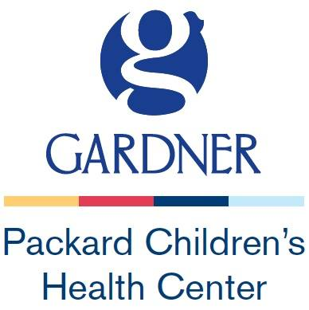

Gardner Packard Children’s Health Center
3351 El Camino Real, Suite 100
Atherton, CA 94027
(650) 362-2500-Phone
(650) 362-2584-Fax

facsimile transmittal sheet

To:

BHRS ACCESS Call Center

Fax Number: 650-596-8065

Total number of pages including cover:

CONFIDENTIALITY STATEMENT

The information contained in this facsimile transmission is privileged and confidential information, exempt for disclosure under applicable law. If the reader of this message is not the intended recipient, you are hereby advised that any review, dissemination, distribution or copying of the information in this transmission is prohibited. If you receive this facsimile in error, please notify us by telephone immediately upon receipt at the number from which this facsimile originated so that we may arrange for the return of this document to us at no charge to you.

