TN27 Participant Handbook 22JAN2021

Diabetes_TrialNet

**PARTICIPANT HANDBOOK**

**TOPPLE T1D Study**-**To**lerance Using **Pl**asmid T1D: A Phase 1 Study

**[A Phase 1 multiple ascending dose trial investigating safety, tolerability and pharmacokinetics of NNC0361-0041 administered subcutaneously to patients with type 1 diabetes mellitus]**

**(Protocol TN-27)**

VERSION 3.0

|  |
| --- |
| **Type 1 Diabetes TrialNet**  Researchers in this study are part of a larger group called Type 1 Diabetes TrialNet. TrialNet is an international network of centers dedicated to the study, prevention, and early treatment of type 1 diabetes. We have clinical centers in the United States, Canada, Europe, and Australia. The TrialNet Coordinating Center, as well as the TrialNet Hub, help to support TrialNet activities at the centers and other TrialNet study sites.  For this study TrialNet is partnering with Novo Nordisk.  We are conducting studies to:  • Learn more about the common risk factors among people who get type 1 diabetes.  • Test treatments that could help delay or prevent the start of type 1 diabetes.  • Test treatments that might help people who have recently been diagnosed with diabetes keep producing their own insulin.  TrialNet is supported by: NIH, NIDDK.  Your Study Site: Stanford University  Research Physician: Darrell Wilson, MD  Study Coordinators:   * Trudy Esrey, RD, CDE: [tesrey@stanford.edu](mailto:tesrey@stanford.edu) * Karen Barahona: [karenbb@stanford.edu](mailto:karenbb@stanford.edu)   To learn more about type 1 diabetes studies or to get a referral to a TrialNet study, call toll free 1-800-HALT-DM1 (1-800-425-8361).  You can also learn more about TrialNet at: [www.DiabetesTrialNet.org](http://www.DiabetesTrialNet.org).  Or by contacting the TrialNet Clinical Hub at:  Tel: 206-341-8923  Email: [diabetes@benaroyaresearch.org](mailto:diabetes@benaroyaresearch.org)  **Table of Contents**  **SECTION 1: Study Overview**  **Introduction and Background**  **Study Drug**  **Study Design**  **“How can I jointhis study?”**  **“What will I do as a research volunteer in this study?”** |
| **SECTION 2: Study Visits and Procedures**  **Schedule of Visits**  **“How do I prepare for the MMTT Tests?”**  **Other Blood Tests**  **Risks**  **Call Us Right Away** |

**Section 1: Study Overview**

**Introduction**

We are trying to learn more about how to delay or prevent type 1 diabetes. This is a Phase 1 study. This means it is the first time the therapy (NNC0361-0041) will be tested in people. If the study results demonstrate that the investigational treatment is safe and impacts the immune system that causes type 1 diabetes, we hope to study the drug in the future as a possible treatment for prevention of type 1 diabetes.

In this study we are asking participants with established type 1 diabetes for up to four years to enroll. Your participation may help researchers learn more about ways to prevent further progression of disease.

After you read this handbook, we will talk with you about the study and answer your questions. We will ask you to take a survey to make sure we've explained everything clearly. We will ask you to sign a consent form if you decide you want to join the study. As you make your decision:

* Ask questions. We are available for questions and to discuss your concerns.
* Talk about the study with your family doctor or health care provider. Your doctor is welcome to call us with questions.
* Talk to your family and friends.
* Take the time you need to make your decision.

**Background**

**How Type 1 Diabetes Develops**

Type 1 diabetes is an autoimmune disease. The immune system mistakenly attacks the cells that produce insulin. These are called beta cells. Beta cells are in your pancreas.

In type 1 diabetes, the body’s immune system keeps destroying the beta cells. An early sign that this attack has started is the appearance of autoantibodies. Once many of the beta cells are damaged, blood glucose levels will start to be abnormally high, and eventually this leads to diabetes.

It is now understood that diabetes occurs in stages. Everyone who develops T1D has genetic risk. Only some people with genetic risk will have an immune attack on their beta cells and an initial immune response. The presence of a diabetes-related autoantibody in the blood is a sign that there is an initial immune response. Not everyone with a single autoantibody progresses to multiple autoantibodies. However, we now understand that almost everyone with two or more autoantibodies will eventually develop clinical diabetes. That is why we consider individuals with two or more autoantibodies and normal blood sugar levels as having Stage 1 diabetes. In Stage 1, there are enough beta cells left producing insulin to maintain normal blood sugar levels. Eventually further destruction of beta cells leads to abnormal blood sugar levels, and this is called Stage 2 diabetes. Ultimately, blood sugar levels continue to rise, which leads to the clinical diagnosis of disease - called Stage 3 diabetes.

There is no treatment that has been proven to protect beta cells after the appearance of autoantibodies. This study is for people who have been diagnosed with type 1 diabetes within the previous 48 months. In this study, we are testing if the therapy (NNC0361-0041) will help protect beta cells from being attacked by the immune system, which leads to type 1 diabetes.

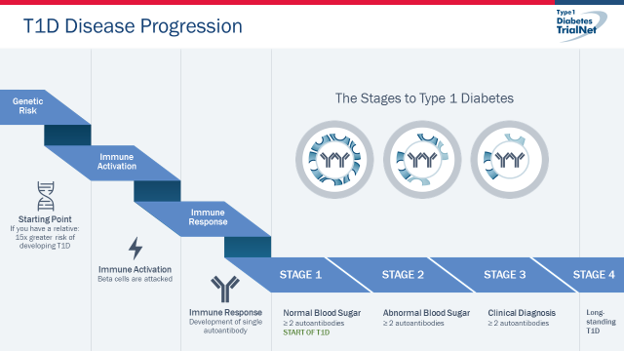

**Project Description**

The investigators carrying out this study are part of an international research group called TrialNet that is studying type 1 diabetes. Type 1 diabetes is an autoimmune disease. You are being asked to take part in this research study because you have type 1 diabetes. This means that the immune system, the part of your body that helps fight infections, mistakenly attacks cells that produce insulin in your body. The cells that produce insulin are called beta cells and are found in the pancreas. As the immune system destroys these cells, the body’s ability to produce insulin decreases and diabetes develops.

The treatment being tested (NNC0361-0041) is a type of plasmid therapy. Plasmids are pieces of DNA that are used in medical care and research as a way to deliver treatment. They do not alter your DNA. In this study, a newly made plasmid will be used to test whether the immune response which leads to type 1 diabetes can be re-trained.

This Phase 1 study will enroll approximately 48 adult participants with type 1 diabetes. If there are no safety concerns and the treatment demonstrates the expected changes in the immune response we hope to conduct a larger study for prevention of type 1 diabetes to determine whether this new therapy works in slowing or stopping type 1 diabetes in people at an earlier stage of the disease.

**The Study Drug**

The study drug is a plasmid vector designed to send signals to the immune system. The goal of plasmid immunotherapy is to help “re-educate” the immune system to stop the autoimmune response that destroys insulin secreting cells in the pancreas which leads to type 1 diabetes. Human plasmids are used in medical care and are being studied in many clinical trials for other conditions. They are not yet approved for therapeutic use in type 1 diabetes.

A plasmid is a circular piece of DNA. Plasmids do not change your DNA.

In this study the plasmid is used as a carrier of different proteins. The proteins that this plasmid carrier delivers include three cytokines and an antigen. Cytokines are chemical messengers that direct the activity of immune cells. Antigens are parts of proteins that the immune system reacts with. Working together, these four proteins should favorably change the immune attack on the insulin producing beta cells.

**How long will the study last?**

This study is starting in 2020. We expect it will take about 2 years to complete the study but it may take longer. However, your participation will be no longer than 1 year, not including the screening period prior to enrollment in the study. When the study is over, you may qualify to enroll as part of TrialNet’s LIFT (Long-Term Investigative Follow-Up in TrialNet) study

**“How the study works”**

* In this study, there are four groups of participants who will take different doses of the treatment. As the study progresses, we will be checking information from each group to decide when the next group will start therapy. Only a limited number of “slots” will be available for each group. Your study team will let you know when a group is open for enrollment and you can decide then if you are ready to continue in the study. Depending on when this occurs, you may need to undergo additional screening tests to be sure you are still eligible.

**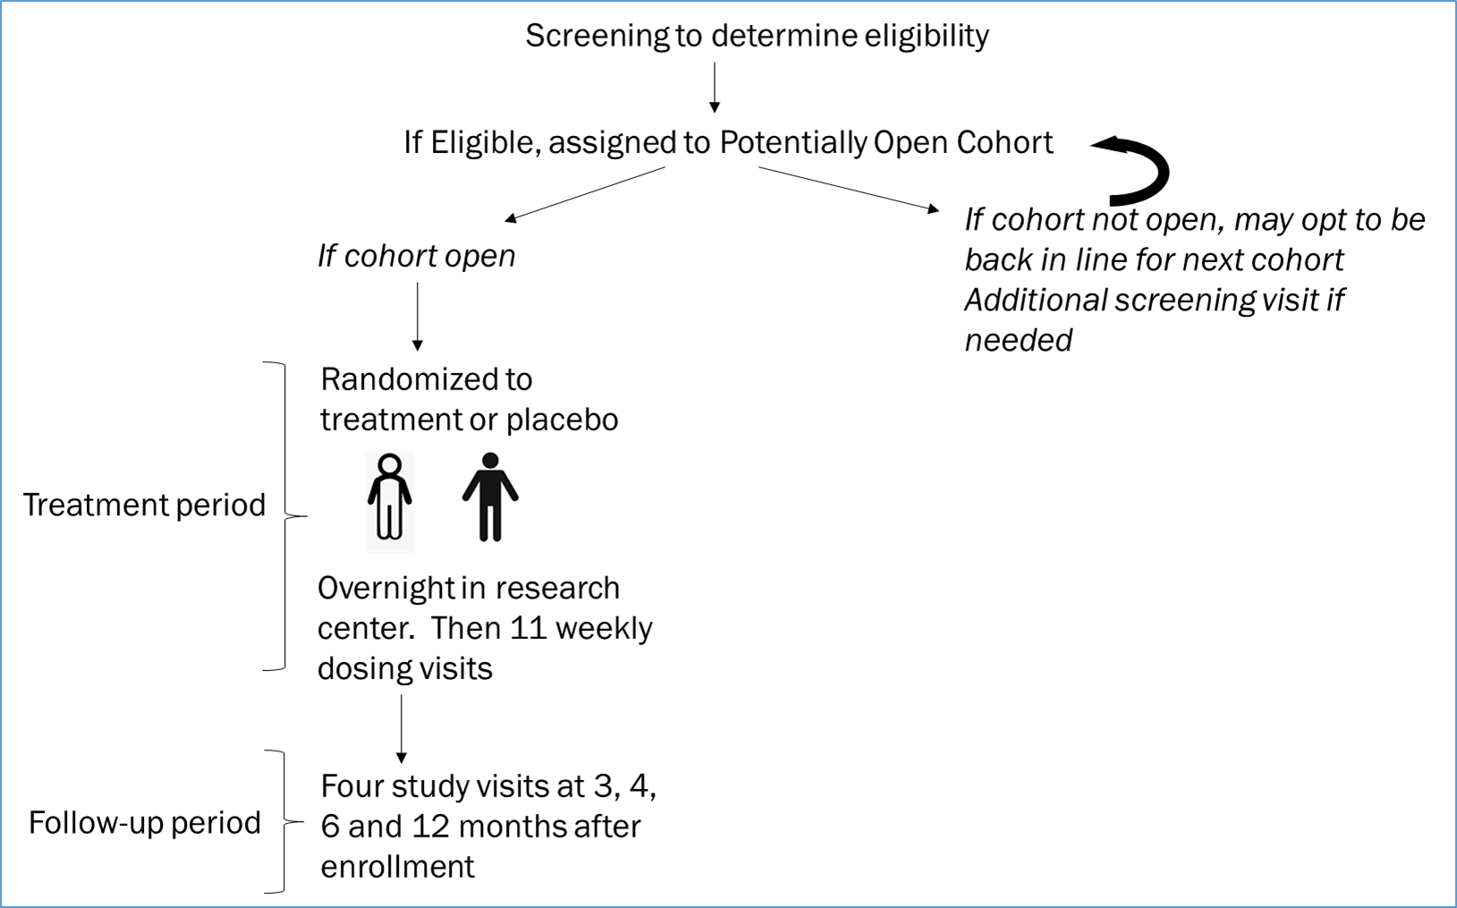**

**Dosing Groups:**

* This study uses a dose escalation design. This means that the first group will receive the lowest dose of the plasmid and each additional group will receive a higher dose. The dose of the plasmid or placebo you receive depends on when you start the study. The safety of each dosing group will be evaluated before the next dosing group starts.
* Within each dosing group, two people will be enrolled to start. If there are no safety concerns, another three people will be enrolled. If no safety problems are seen in these people, the remaining 7 individuals will be enrolled in the group. The same process will be followed for each of the dosing groups.

**Randomization:**

* Each group will have 12 participants. In each group, 9 participants will be randomized to the treatment group and 3 will be randomized to the placebo group.
* A placebo looks like medicine, but has no medicine in it so that people in the study will not know whether they are receiving the drug or placebo. You will be placed into one of these groups by chance (similar to drawing straws). Neither you nor your doctor will be able to choose the group in which you will be placed. Neither you nor your doctor will know who is getting study drug and who is getting placebo.

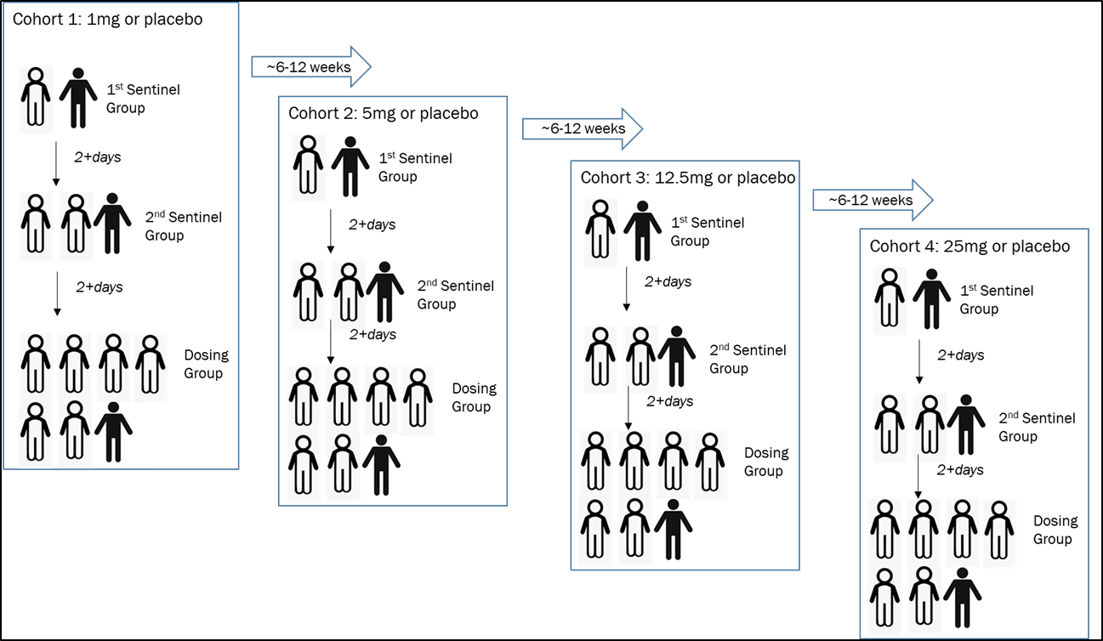

**“What do I do to join this study?”**

**Step 1: Learn about the study and give informed consent.**

* We will have you take a survey so we can see if we have explained everything clearly.
* You’ll read and sign the Informed Consent.
* Participants must live in a location with rapid access to emergency medical services.
* TrialNet is partnering with Novo Nordisk A/S to conduct this study.  In the consent form, you were provided with information about the use of your data and samples as requested under US regulations.  Novo Nordisk is located in Europe.  They are required under European regulations to provide you with a separate notice to let you know about data and sample handling.

**Step 2: Have screening tests.**

These tests are explained in this handbook and in the consent form. We will have the results in about 1 to 2 weeks. You can join the study if the results of these tests show that:

* You were diagnosed with type 1 diabetes in the last 4 years.
* You will be at least 18 years old at time of randomization in this trial.
* Results of your screening tests show you are eligible.
* You don’t have any medical conditions that might make it unsafe for you to be in this study.
* You are not pregnant and do not plan to become pregnant while participating in the study.

**Step 3: Schedule your first study visit.**

You must have your screening visit, including a Mixed Meal Tolerance Test (MMTT) before being randomized and starting study medication. The results of the screening visit will determine whether you are eligible to continue on the study.

**By volunteering for this study, you are agreeing to the following:**

* Screening tests
* Coming for 12 visits during the treatment phase which includes:
  + Overnight stay in hospital to receive first treatment dose and for observation.
  + Subsequent 11 weekly study visits during treatment phase.
* Coming in for 4 visits during the follow-up phase.
  + These visits are at months 3, 4, 6, and 12.
* Contact your study team if you have any unexpected side-effects (*see page* *2*).
* Come to all study visits within the required target date (*see page 11-15*).

**SECTION 2: Study Visits**

If you join this study, you are agreeing to:

* + Come in for study visits, which include blood tests, for the duration of your participation in the study. It is very important not to miss any study visits. If we do not collect your blood at the required time points, the study findings could be compromised.
  + Report any changes in your health or medications.
  + Stay in touch with your study team.
  + Stick to the required study visit schedule*. If you are unable to travel to the study site, we may be able make arrangements for you to have some of your blood tests done locally. Your study coordinator will explain how to do this.*

Study Visit Schedule:

**Screening (Visit -1)**

|  |  |  |  |
| --- | --- | --- | --- |
|  | **Procedures include:** | **Allow** | **Fasting** |
| **Screening**  Time:  Early morning (before 10:00 am). | Early morning (before 10:00 am).  See MMTT test preparation procedures page 16  Questions about your health, including information about your diabetes. Collection of information about insulin usage and CGM data (*if available*).  Physical Exam  2-hour MMTT  Blood tests, EKG  *Pregnancy testing as needed.* | 3 hours | Yes |

**Note: Screening procedures may take place over several days; it is possible that screening tests will need to be repeated depending on available enrollment slots when participant is screened.**

**First Treatment Visit (Visit 0)**

|  |  |
| --- | --- |
|  | **Procedures include:** |
| **DOSE 1**  Day 0 | Admitted to research center for 48 hour in-patient admission.  Randomization.  Study treatment injection.  Questions about your health with physical exam if needed. Collection of information about insulin usage and CGM data (*if available*).  Heart rate, blood pressure, respiratory rate, temperature, blood tests, EKG.  *Pregnancy testing as needed.* |
| Day 1 | Questions about your health with physical exam if needed.  Monitoring, heart rate, blood pressure, respiratory rate, temperature, blood tests, and EKG. |
| Day 2 | Questions about your health with physical exam if needed.  Heart rate, blood pressure, respiratory rate, temperature, blood tests, EKG.  Discharge from research center. |

**Out-patient Treatment Visits (Dose 2 –12)**

|  |  |  |  |  |
| --- | --- | --- | --- | --- |
|  | **Visit**  **(weeks)** | **Visit Window** | **Procedures include:** | **Allow** |
| Dose 2 | 1 | ± 1 day | Questions about your health with physical exam if needed. Collection of information about insulin usage and CGM data (*if available*).  Heart rate, blood pressure, respiratory rate, temperature, blood tests.  Study treatment injection, 4 hour monitoring.  *Pregnancy testing as needed.* | 5 hours |
| Dose 3 | 2 | ±1 day | Questions about your health with physical exam if needed. Collection of information about insulin usage and CGM data (*if available*).  Heart rate, blood pressure, respiratory rate, temperature, blood tests.  Study treatment injection, 4 hour monitoring.  *Pregnancy testing as needed.* | 5 hours |
| Dose 4 | 3 | ±1 day | Questions about your health with physical exam if needed. Collection of information about insulin usage and CGM data (*if available*).  Heart rate, blood pressure, respiratory rate, temperature.  Study treatment injection, 4 hour monitoring.  *Pregnancy testing as needed.* | 5 hours |
| Dose 5 | 4 | +/1 day | Early morning (before 10:00 am).  See MMTT test preparation procedures page 16  Questions about your health with physical exam if needed. Collection of information about insulin usage and CGM data (*if available*).  Heart rate, blood pressure, respiratory rate, temperature, blood tests.  2-hour MMTT  Study treatment injection, 4 hour monitoring.  *Pregnancy testing as needed.* | 6-7 hours |
| Dose 6 | 5 | ±1 day | Questions about your health with physical exam if needed. Collection of information about insulin usage and CGM data (*if available*).  Heart rate, blood pressure, respiratory rate, temperature.  Study treatment injection, 2 hour monitoring.  *Pregnancy testing as needed.* | 3 hours |
| Dose 7 | 6 | ±1 day | Questions about your health with physical exam if needed. Collection of information about insulin usage and CGM data (*if available*).  Heart rate, blood pressure, respiratory rate, temperature, blood tests.  Study treatment injection, 2 hour monitoring.  *Pregnancy testing as needed.* | 3 hours |
| Dose 8 | 7 | +/- 1 day | Questions about your health with physical exam if needed. Collection of information about insulin usage and CGM data (*if available*).  Heart rate, blood pressure, respiratory rate, temperature, blood tests.  Study treatment injection, 2 hour monitoring.  *Pregnancy testing as needed.* | 3 hours |
| Dose 9 | 8 | +/- 1 day | Questions about your health with physical exam if needed. Collection of information about insulin usage and CGM data (*if available*).  Heart rate, blood pressure, respiratory rate, temperature.  Study treatment injection, 2 hour monitoring.  *Pregnancy testing as needed.* | 3 hours |
| Dose 10 | 9 | ±1 day | Questions about your health with physical exam if needed. Collection of information about insulin usage and CGM data (*if available*).  Heart rate, blood pressure, respiratory rate, temperature, blood tests.  Study treatment injection, 2 hour monitoring.  *Pregnancy testing as needed.* | 3 hours |
| Dose 11 | 10 | ±1 day | Questions about your health with physical exam if needed. Collection of information about insulin usage and CGM data (*if available*).  Heart rate, blood pressure, respiratory rate, temperature.  Study treatment injection, 2 hour monitoring.  *Pregnancy testing as needed.* | 3 hours |
| Dose 12 | 11 | ±1 day | Questions about your health with physical exam if needed. Collection of information about insulin usage and CGM data (*if available*).  Heart rate, blood pressure, respiratory rate, temperature.  Study treatment injection, 2 hour monitoring.  *Pregnancy testing as needed.* | 3 hours |

**Follow-up Visits**

|  |  |  |  |
| --- | --- | --- | --- |
| **Visit** | **Visit Window** | **Procedures** | **Allow** |
| 3 months | +/- 1 days | Early morning (before 10:00 am).  See MMTT test preparation procedures page 16  Questions about your health with physical exam if needed. Collection of information about insulin usage and CGM data (*if available*).  Physical Exam, Heart rate, blood pressure, respiratory rate, temperature, blood tests, EKG.  2-hour MMTT.  *Pregnancy testing as needed.* | 3 hours |
| 4 months | +/- 3 days | Questions about your health with physical exam if needed.   Collection of information about insulin usage and CGM data (*if available*).  Heart rate, blood pressure, respiratory rate, temperature, blood tests.  *Pregnancy testing as needed.* | 1 hour |
| 6 months | +/- 14 days | Early morning (before 10:00 am).  See MMTT test preparation procedures page 16  Questions about your health with physical exam if needed. Collection of information about insulin usage and CGM data *(if available*)  Heart rate, blood pressure, respiratory rate, temperature, blood tests.  2-hour MMTT.  *Pregnancy testing as needed.* | 3 hours |
| 12 months  (1 year) | +/- 14 days | Early morning (before 10:00 am)  See MMTT test preparation procedures page 16  Questions about your health with physical exam if needed. Collection of information about insulin usage and CGM data (*if available*)  Heart rate, blood pressure, respiratory rate, temperature, blood tests.  2-hour MMTT  *Pregnancy testing as needed.* | 4 hours |

**Mixed Meal Tolerance Test (MMTT)**

***Test Prep***

We will put an IV line in a vein in your hand or arm. We will take all the blood samples from this line. You can have a numbing cream before the IV line is placed.

***The Test***

* We will draw blood samples at the beginning of the test.
* You will drink about a cup of a very sweet drink. You have to drink it all in 5 minutes. Some people may feel sick to their stomachs (nauseated) when they drink this.
* We will draw blood samples for 2 hours after you drink the glucose.
* You will need to sit quietly or rest in bed during the test.

**“How do I prepare for my study visits which require an MMTT?”**

For study visits that include a Mixed Meal Tolerance Test (MMTT):

**Call us if you’re taking any prescription or over-the-counter medicines that you haven’t already told us about.**

Some medicines may change the test results.

**Be sure to eat plenty of carbohydrate.**

Eat at least 150 grams of carbohydrate (starches and sugars) a day for at least three days before the test. Most adults eat 150 grams or more in a usual day, so this will probably not mean a new diet for you. Eating more than 150 grams of carbohydrate is OK. Foods with carbohydrate include:

Grains: breads, pasta, crackers, cereals (hot and cold)

Beans

Starchy vegetables: potatoes, peas, corn

Fruit: fresh, canned, dried, juices

Milk (whole, 2%, 1%, non-fat, chocolate), yogurt

Sweets: candy, cookies, cakes, pies, regular sodas

Each of these has about 15 grams of carbohydrate:

1 slice of bread

6 crackers

1/2 cup pasta

1/3 cup rice

1 cup low-fat milk

1 medium apple

Meats and non-starchy vegetables (leafy greens, broccoli) have little or no carbohydrate. You can have these foods in the amounts that you normally eat.

**Drink plenty of water the day before and the day of the test.**

It will be easier for us to do your test.

**Have no food or drink other than water for 10 hours before your test.**

This includes:

* No coffee or tea
* No alcohol
* No diet sodas or sugar-free gum. Even though these have no calories, the flavor can prompt your body to make insulin, and this may change the test results.
* Don’t use tobacco (smoking or chewing) or nicotine replacement products for 10 hours before your test.
* Don’t exercise for 10 hours before your test.
* Get a good night’s sleep before the test.
* Don’t schedule the test for the morning after you work a night shift.

**Other Blood Tests (Immune/mechanistic samples):** We will be collecting blood samples, including genetic samples at many of your visits. These samples will also be used to see the effect of study treatment (NNC0361-0041) on your immune system, to better understand what causes type 1 diabetes and how individuals respond to treatments, and to get ideas about new treatments in the future. Blood samples may also be used to develop and evaluate new tests and to make sure our tests are accurate. ***You will not routinely be provided with test results from these studies.***

**Continuous Glucose Monitoring (CGM):**

If you wear a Continuous Glucose Monitor (CGM) for your clinical care, we will periodically review your blood glucose results from the CGM.

**Risks and Discomforts:**

Tests involved in this research project may have some of the known risks listed below. There may be other risks associated with the study treatment that are unknown.

The study treatment injection may cause skin problems such as bruising, bleeding, redness, pain or irritation and possible scarring due to a local reaction. These problems usually go way after a few days.

You may experience body aches, fever, or shortness of breath shortly after being given the study treatment injection. This could be due to an immune system reacting to the new therapy.

The study treatment may cause allergic reactions. These reactions may be mild or severe. Signs of mild allergic reactions include rash, redness, hives and itching, wheezing. Signs of a severe allergic reaction may include swelling of your throat and face, breathing problems, fast heart-beat, pale and cold skin, feeling dizzy or weak. Severe allergic reactions could lead to death if not treated. If you have any signs of a serious allergic reaction, get emergency help.

Although unlikely, it is possible that the treatment could accelerate the loss of remaining beta cells responsible for insulin secretion due to immune activation.

We will watch you closely for all these events. There is a safety monitoring board that will be reviewing the study carefully and the study will be discontinued if there are any safety concerns.

**Birth control and pregnancy**It is not known whether this therapy can damage unborn babies. If you can become pregnant, you will need to use an effective form of birth control during the treatment phase until after the last follow-up visit which is approximately 1 year from initial dosing. If you can become pregnant, you will need to provide a urine sample for pregnancy testing regularly during this study. If you become pregnant, you must tell the study doctor right away. Your study doctor will stop study treatment. You will not be required to come for study visits during your pregnancy However, information about you, your pregnancy and your baby will still need to be collected. This is so that we can watch for anything unusual.

Men with female partner(s) should also use effective contraception during the treatment phase and for 3 months after the last study injection (*unless partner cannot become pregnant).*

**Intravenous Needle (IV) and Blood Drawing**

While on the study, you may have side effects from having your blood taken or IV placed. The risks of side effects from these procedures are very small. There is sometimes soreness and/or a bruise at the site where the needle goes through the skin. Once in a while, people faint. It is rare, but some people may get an infection, a small blood clot, swelling of the vein and the area around it or bleeding where the needle goes through the skin.

**Mixed Meal Tolerance Test (MMTT):**

The MMTT requires that you drink a product called BOOST which contains milk and soy ingredients. People with severe allergies to these could have a reaction. If you have a known allergy to either of these ingredients, please let us know. It is possible we may need to advise you not to participate in the trial.

**Immunizations**

The effect of this therapy on vaccinations is unknown. To be safe, we do not want you to have received “live” vaccinations during the treatment period. If you need any “live” vaccinations, you should get them more than 6 weeks before enrolling in the study and should avoid having live vaccines for 3 months after the treatment phase. You must be up to date on all recommended vaccines before you enroll in this study. Other than flu shot (influenza vaccine) if you need any other killed (inactive) vaccines you must have them within 4 weeks of starting the study. We recommend that you get an influenza vaccine at least two weeks before starting study treatment, and during flu season.

Due to the potential severity of COVID-19 infection, it is recommended that all eligible participants get the vaccine when it becomes available. If you are able to get the vaccine, you will need to have all required shots at least two weeks before starting study treatment. If planning to get the COVID-19 vaccine, you need to inform your study team to determine when you can start the study treatment.

If you are able to receive the COVID-19 vaccine during the treatment phase, you must wait 3 days from your most recent study drug injection. In this case you will not receive further study treatment, but we will ask you to come for additional study visits for follow-up.

You may also have the Covid-19 vaccine 3 days after completing study treatment without any change in your study participation.

**Infections and COVID-19 risk**

This therapy is not expected to affect the overall immune system. Thus, it is expected that the therapy will not have a higher risk of getting infections including COVID-19. However, going to site visits if an outbreak is ongoing in your state may increase your risk of getting infected. To minimize the risk as much as possible, your study team will review recommended safe practices for travelling for study visits your area. You should contact your study doctor if you develop any infections, bruising, abnormal bleeding, or if you are not feeling well at any time.

**Genetic Testing**

We will not generally provide the results of your genetic testing to you or anyone else. Although we will try very hard to keep any information about your genetic testing private, there is a very small possibility that someone else could learn about your testing.

**Call Us Right Away…**

\* If you have any questions or concerns about the study.

\* If you’re not feeling well, especially in first two weeks.

\* If you develop any infections, any flu-like symptoms, or are not feeling well at any time.

\* If you don’t want to be in the study any longer.

\* If you plan to receive a COVID-19 vaccine.

- You are always free to stop being in the study. Your future medical care will not be affected in any way.

- Please keep coming for blood tests even if you stop getting the infusions or injections. These will give us very important information about the therapy and type 1 diabetes.

**In Case of Emergency: Call 9-1-1**

- In the event of a life-threatening emergency, ALWAYS CALL 9-1-1.

- Get medical attention right away rather than calling your study team.

During this study, a group of experts who are not doing the actual study will look at the information being collected. If these experts feel that it’s not safe to continue the study, the study will be changed or stopped.