DR. KOSSLER’S PATIENT QUESTIONNAIRE

Name: ______________________________________ DOB: __________ Age: _____ M / F Date:__________
Occupation: _________________________________ Employer: ____________________________________
Referred By: ________________________________ Primary Care Physician: _________________________

What is the reason for your visit? (Check below or list)
____ Droopy Eyelids (Ptosis)/Excess skin over lids ____ Thyroid Eye Disease/Grave’s Disease
____ Eyelids Turned In or Out (Entropion)/(Ectropion) ____ Proptosis (Eye Bulging)/Orbital Mass
____ Eyelid/Facial Weakness (Bells Palsy/Poor Closure) ____ Trauma to Eyelid or Orbit
____ Eyelid or Facial lesion/Lump/Bump ____ Tearing/Discharge/Tear duct Problem
____ Cosmetic Consultation (Aesthetic Surgery to Eyelids, Eyebrows, Botox, or Dermal Fillers)
____ Other, please explain: __________________________________________________________________
How long has your concern been present? ______________________________________________________

How often do you notice it? (Intermittent, daily, chronic): __________________________________________

What treatments have you had before? ________________________________________________________

Does anything make this better or worse? (If YES, explain) __________________________________________

Do you have any of the following? (Check all that apply)
___Blurry Vision ___Decreased Vision ___Decreased Peripheral Vision ___Double Vision ___Dry Eye
___Eyelid Swelling ___Eye Pain ___Eye Redness ___Eyelid Redness ___Heaviness of Upper Eyelids
___Pain with Eye Movement ___Tearing ___Bulging Eyes ___Change in eye appearance
Other: ____________________________________________________________________________________

Ocular History
Do you have any eye diseases? NO / YES, if so, explain: _____________________________________________
__________________________________________________________________________________________
Please list all previous ocular or eyelid surgeries & dates: __________________________________________
___________________________________ _____________________________________ ________________________________________
Is there anything else we should know about your eyes? ___________________________________________

Thank you for visiting the Oculofacial Plastic Surgery Service at Stanford. It is a pleasure to take care of you. Please fill out our questionnaire and let us know what brings you in today. You will be cared for by several members of our Oculofacial Plastics Team to prepare you for your visit. This may include a full eye exam, photography & additional testing prior to your visit. Please see my bio below. I look forward to meeting you today!

Biography
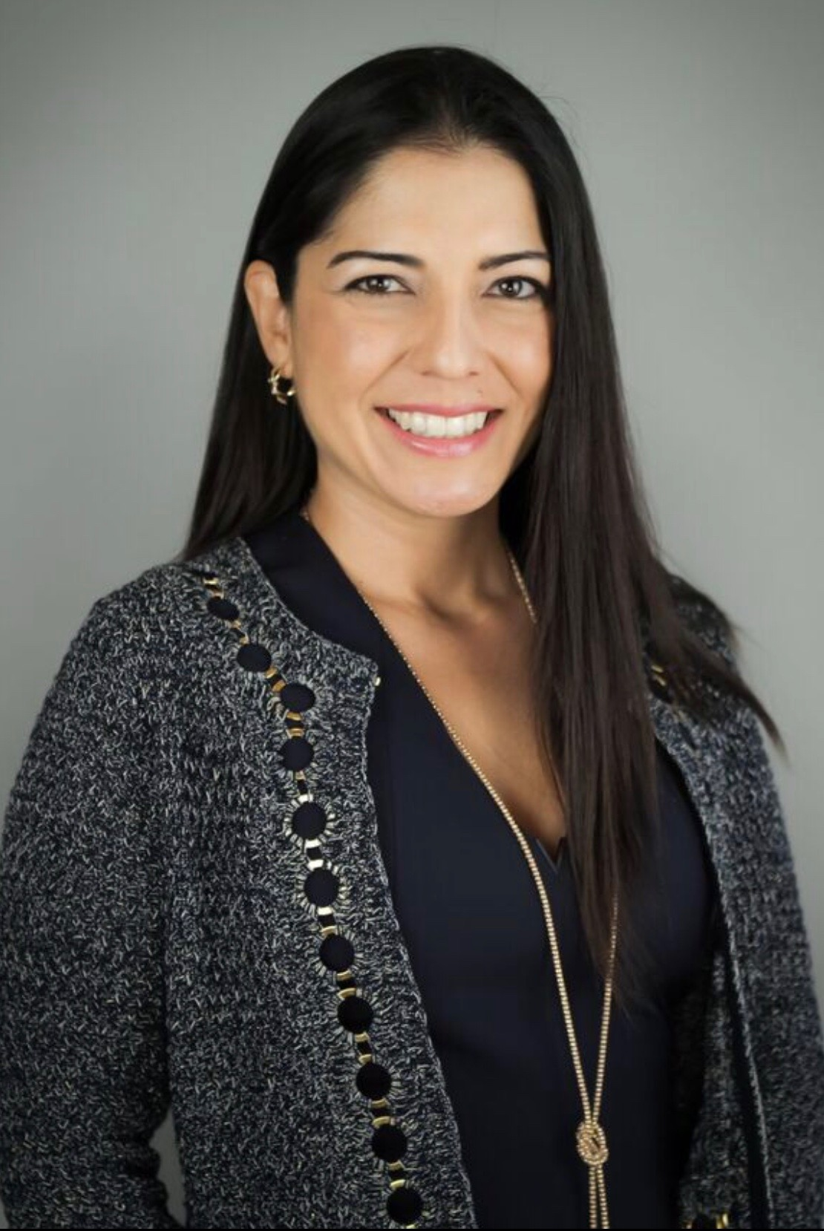
Andrea Lora Kossler, MD, is Assistant Professor of Ophthalmology at Stanford University School of Medicine and Director of the Oculofacial Plastic, Reconstructive Surgery and Orbital Oncology Service at the Byers Eye Institute. Andrea is Co-Director of the Thyroid Eye Disease Center at Stanford Hospital Center and Director of the Stanford Aesthetic Eye Surgery Center. Dr. Kossler specializes in plastic and reconstructive surgery of the face and eyes and treats adults and children with oculoplastic conditions. Dr. Kossler’s research interests include thyroid eye disease, orbital oncology, and neurostimulation for ocular surface disease.
Dr. Kossler earned her medical degree from Georgetown University School of Medicine where she graduated summa cum laude and valedictorian of her class. She completed her residency in Ophthalmology at the number one ranked Bascom Palmer Eye Institute at the University of Miami. She continued at the University of Miami to complete a fellowship in Oculofacial Plastic and Reconstructive Surgery & Orbital Oncology. Dr. Kossler is trained in ophthalmic microsurgery and oculofacial plastic surgery to provide the best possible aesthetic & functional outcomes for the face, eyelids, forehead, orbit (tissue around the eye) and lacrimal (tear duct) system, while preserving and often enhancing visual function.
Andrea L. Kossler, M.D
Director, Oculofacial Plastic Surgery
& Orbital Oncology
Assistant Professor of Ophthalmology
Stanford University School of Medicine

Byers Eye Institute at Stanford
Oculoplastics Appointments:
(650) 723-6995
Aesthetic Appointments:
(650) 498-6995

Clinical Focus
Blepharoplasty (Upper & Lower Lid Surgery) Thyroid Eye Disease
Ptosis (Droopy Eyelid) Surgery Orbital Oncology & Surgery
Mohs Reconstruction and Eyelid Cancer Surgery Pediatric Oculoplastic Surgery
Brow and Forehead Surgery (Brow lift) Lacrimal and Tear Duct Surgery
Cosmetic Eyelid Surgery (Eyelid lift, eyelid contour) Facial Nerve Palsy Surgery
Wrinkle Treatments (Botox, Xeomin, Dermal Fillers) Anophthalmic Socket Surgery

