**Otitis Media Flip (children >12 months)**

______________________________________________________________________

**Subjective**

* Current pain, drainage from ears, recent URI, fever, decreased fluid intake, listlessness. Pulling on ears or vomiting in a child not yet old enough to verbalize.
* History of recent or recurrent ear infections, recent antibiotics, teething or extended exposure to water. Consult provider if recurring ear infections, purulent conjunctivitis or recent antibiotic use (within last 30 days).
* Document history of allergies to antibiotics or other medications
* Document ill contacts (friends/family members/co-workers)

**Objective**

* Describe general condition of child, i.e. no acute distress (NAD) or playful or alert
* Document vital signs
* Note condition of the external auditory canal (EAC) and compare the drums in each ear
* Note movement of the auricle and tragus may be painful in otitis externa
* Document if nose has mucoid nasal discharge.
* Neck should be supple
* Fontanel should be flat but not sunken
* Respirations should be noted as unlabored, even if breathing is rapid secondary to fever

**icd-10 codes**

* Otitis media NOS, 382.9 **OR** Otitis media, acute with rupture of ear drum, 382.01

**Treatment**

* Refer to chart from Uptodate (below) to determine if observation or treatment is indicated. Observation can include providing a prescription for antibiotics to use if symptoms do not improve or worsen.

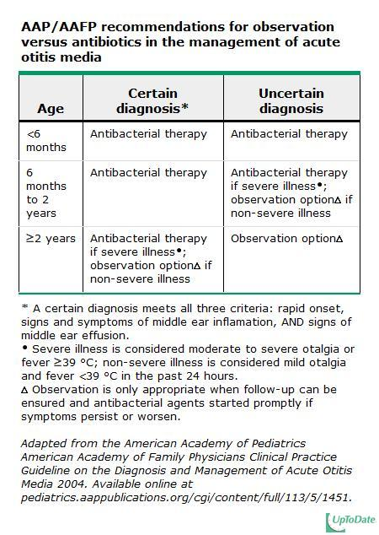

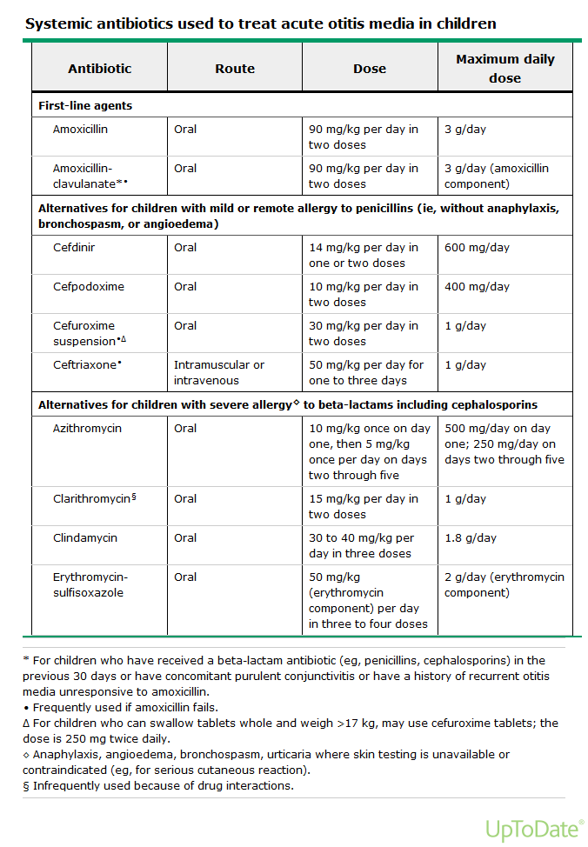

* Always include symptomatic treatment for pain or fever with acetaminophen or ibuprofen as appropriate for age/weight.

**Education**

* Babies should be off the bottle by age 1 year, avoid exposure to second hand smoke.
* Feed infants in semi-upright position, not completely horizontal.
* Otitis media can progress to mastoiditis, a serious condition needing hospitalization.
* All children less than 2 years old need a follow up appointment in 3-4 weeks.
* If no improvement in 24 hours after onset of treatment, parent needs to call back for an appointment.
* Remind parents that over the counter preparations for cold symptoms should not be given to children under 2 years old.
* Warm compresses for comfort.

**Co-Visit**

* Present to provider after examination but BEFORE documentation.
* Make sure all of the above is documented after consultation with provider.

***Call back for appointment with provider if:***

* Persistent fever
* New drainage from ear or increased swelling in region of ear/mastoid
* Not improving with antibiotics after 24 hours
* Decreased PO intake, listlessness, vomiting

**Document all of above in Medical Record and send visit to PCP for completion.**



### FIGURE 11-16: Healthy Tympanic Membrane

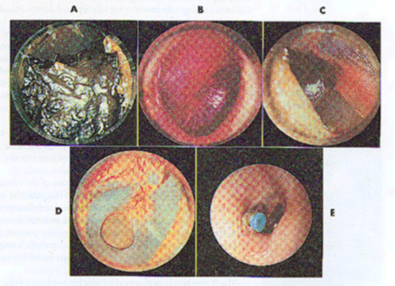

### FIGURE 10-15: A: Tympanic membrane partially obscured by cerumen. B: Bulging tympanic membrane with loss of bony landmarks. C: Perforated tympanic membrane. D: Perforated tympanic membrane. E: Tympanostomy tube protruding from the right tympanic membrane.

*Adapted from La Clinica, Boulder, CO—January 2016*