Conjunctivitis Flip

Subjective
  - Presence, history and duration of watery, mucoid or purulent discharge from the eye, crusting of the eyelids in the morning, redness, and irritation of eyes.
  - Symptoms of allergies (i.e. runny nose, itchy watery eyes, sneezing)
  - Symptoms of upper respiratory infection (i.e. runny nose, cough, fever, sore throat)
- Document ill contacts (friends/family members/co-workers)
- Document allergies to antibiotics and other medications
- Absence of eye pain, photophobia, significant vision changes or history of eye trauma

SIGNS AND SYMPTOMS WHICH REQUIRE THE IMMEDIATE ATTENTION OF A PROVIDER
- Profuse, purulent discharge to the point where the amount of discharge is “striking”
- Eye is tender to palpation
- Generalized edema of the affected lid
- Visual changes
- Pre-auricular adenopathy
- Periorbital edema
- Foreign body sensation

Objective
Acute conjunctivitis is usually a benign, self-limiting condition or one that is easily treated. There are three different etiologies for conjunctivitis: viral, bacterial, and allergic. Although most studies suggest that the majority of cases are bacterial, clinical experience suggests that most conjunctivitis is largely viral. Below are some pointers for being able to distinguish between the types:

- Bacterial

  - Usually unilateral in presentation
  - Thick, purulent, yellow, green or white discharge
  - Discharge located at lid margins and corners of eye and tends to re-appear within minutes of wiping
  - More common in children than adults
  - Redness or erythema
  - Patient will likely report that one or both eyes was “stuck shut” upon waking. (AM crusting) *This finding alone is not specific to bacterial conjunctivitis.

- Viral

  - Usually bilateral in presentation
  - Scant, watery or mucoserous discharge
  - Discharge not always immediately apparent; often clinician has to pull down lower lid to observe exudate
  - History of other URI symptoms (cough, sore throat, nasal congestion)
  - Patient may report “sandy, gritty or burning” feeling in one or both eyes
  - Report of AM crusting (eye “stuck shut”)
  - Erythema

- Allergic

  - Usually bilateral in presentation
  - Bilateral erythema often observed
  - History of seasonal allergies
  - Tearing or watery discharge
  - **Itching (this is the cardinal sign of allergic conjunctivitis)

If none of the above signs and symptoms of optic emergency are present, document the presence or absence of erythema and itching; type of discharge or drainage; associated symptoms; absence of conjunctival swelling or edema. Present patient to provider.

icd-10 codes: Conjunctivitis H10.9

Treatment (for bacterial conjunctivitis)

- Erythromycin Ophthalmic Ointment ½ inch inside lower lid QID x 5-7 days. Warn patient or parent that ointment may blur vision for up to 20 minutes.
OR
- Trimethoprim-Polymyxin 1-2 drops QID x 5-7 days
- Ointment is preferred over drops for children, those with poor compliance, and those in whom it is difficult to administer eye medications.
- Patients with bacterial conjunctivitis should expect improvement in discharge, redness, and irritation after 1-2 days.

education

- for Viral and therefore self-limiting conjunctivits):
If patient has other viral or allergy symptoms, they probably do not need treatment. Explain to patient viral vs bacterial illness and that as with other viral episodes, symptoms may persist for 10-14 days.

- Advise warm, moist compresses for crusts, hand washing to prevent spread.
- Provide reassurance that conjunctivitis is usually self limiting with no permanent effects.
- Mild, ophthalmologist- tested face wash or baby wash can be used to wash face and eyes.
- In addition, topical lubricants such as Dry Eyes can be suggested for allergic etiologies.
- Write an excuse for day care or school if needed.

Co-Visit
- Present to provider after examination but BEFORE documentation.
- Make sure all of the above is documented after consultation with provider.

Call back for appointment with provider if:
- If symptoms worsen or if they do not improve in 7 days.
- Call back for visual changes or eye pain.

Bacterial Conjunctivitis
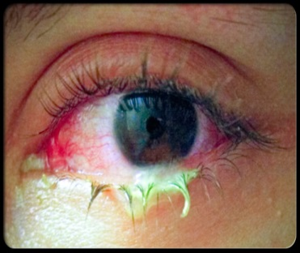

Bacterial Conjunctivitis
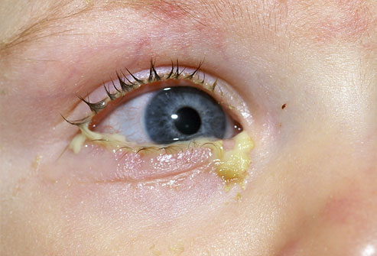

Viral or Allergic Conjunctivitis
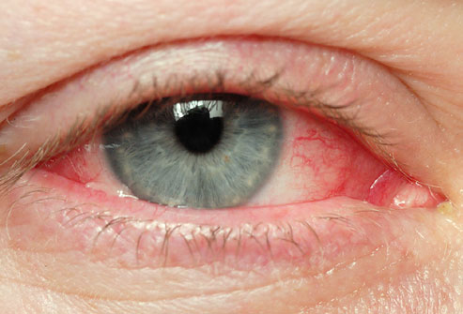

Document all of above in Medical Record and send visit to PCP for completion.

Adapted from La Clinica, Boulder, CO—January 2016

