The Autism Parent Education Program
Mindfulness Skills for Parents

SPONSORED by the
Stanford Autism Center at Lucille Packard Children’s Hospital

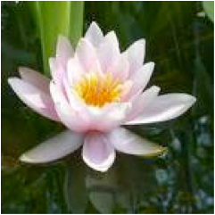

This education program offers instruction in mindfulness practices including meditation and its application for reducing stress and improving self-esteem and quality of life. The program includes didactic presentations, guided meditations and time for dialogue and sharing around how mindfulness can address specific challenges of parenting a child/adolescent/adult with an autism spectrum disorder. In between classes participants are encouraged to cultivate daily meditation practice as well as applying mindfulness to parenting and other daily activities.

Topics we will be exploring include:
What is mindfulness? How can it help me and my child?
How can we better manage our own difficult emotions as parents?
How can we move from coping to living more meaningful lives?
How do we stay present and responsive to our children while planning for the future?

Eight Tuesday Mornings, 9:30 – 11:30AM
April 12th – May 31th 2016
Plus Saturday Morning Class, 9:00AM – 1:00PM, May 21th
Fee: $100 (Limited Scholarships Available)
To register, please email Beth Archibald at earchiba@stanford.edu or
call 650-498-7376

Place:
The Stanford Psychiatry Building
401 Quarry Rd., Stanford CA 94305

Instructor by Linda Lotspeich, MD, MEd
If you have questions about the class email: earchiba@stanford.edu

