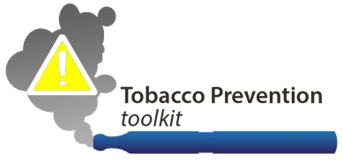
[School Name]
INSERT YOUR SCHOOL LOGO HERE
[Street Address, City, ST ZIP Code] | [Phone Number] | [Email Address]

August 10, 2016

Dear [Insert Name of PTA President]

We wanted to let you know about our relatively new school policy prohibiting the use of all tobacco products, including electronic cigarettes (also known as e-cigs, vapes, vaporizers), on or near [School or District Name].

Our school policies are based on sound research showing that almost 9 out of 10 adult smokers began as adolescents, and that adolescents are significantly more likely than adults to become addicted to nicotine. As you know, tobacco use can lead to numerous diseases, and premature death. Thus, our goal is to reduce and hopefully eliminate youth smoking.

Our school tobacco policy is as follows: [Insert Policy Here]

Will you please help us spread the word to parents/caregivers and students about this new policy? Maybe announce it at school PTA-sponsored events, help us make flyers, and so on?

We really appreciate all the support we can get, as this is such an important public health issue!
Together, we can help make all students healthier.

All the best,
[SIGNATURES AS APPROPRIATE]

