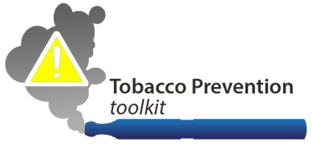
[School Name]
INSERT YOUR SCHOOL LOGO HERE
[Street Address, City, ST ZIP Code] | [Phone Number] | [Email Address]

August 10, 2016

Dear Parents/Caregivers and other members of our school community:

We wanted to let you know about our school policies prohibiting the use of all tobacco products, including electronic cigarettes (also known as e-cigs, vapes, vaporizers), on or near [Insert School or District Name]

Our school policies are based on sound research showing that almost 9 out of 10 adult smokers began as adolescents, and that adolescents are significantly more likely than adults to become addicted to nicotine. As you know, tobacco use can lead to numerous diseases, and premature death. Thus, our goal is to reduce and hopefully eliminate youth smoking.

Our school tobacco policy is as follows: [Insert Relevant Policy Details Here

We at [School Name Here]hope that you will discuss this policy with your
sons/daughters, and enforce our tobacco-free messages at home as well.

Best wishes,

