E-Cigarette and Vape Pen Module
Unit 6 Quiz

- The amount of nicotine in a JUUL pod is equivalent to:

a. 1 cigarette b. 1.5 to 2 packs of cigarettes
c. Half a pack of cigarettes d. 5 packs of cigarettes

- Which of the following statements about JUULs and PHIX is TRUE?

a. Some contain nicotine b. All contain nicotine
c. None contain nicotine d. There are no flavors

- An e-cigarette/vape product with a 5% strength of nicotine is _________.

a. very low in nicotine b. low in nicotine
c. high in nicotine d. very high in nicotine

- Which organs in the human body does nicotine affect?

a. Stomach b. Heart
c. Lungs d. All of the above

- JUUL Labs reports 7 ingredients in their pod e-juice. Independent scientists found how many chemicals in their pod e-juice?

a. 7 b. 59
c. 19 d. They have not studied this yet

- What about this 2018 pod-based system ad makes it problematic for young people?
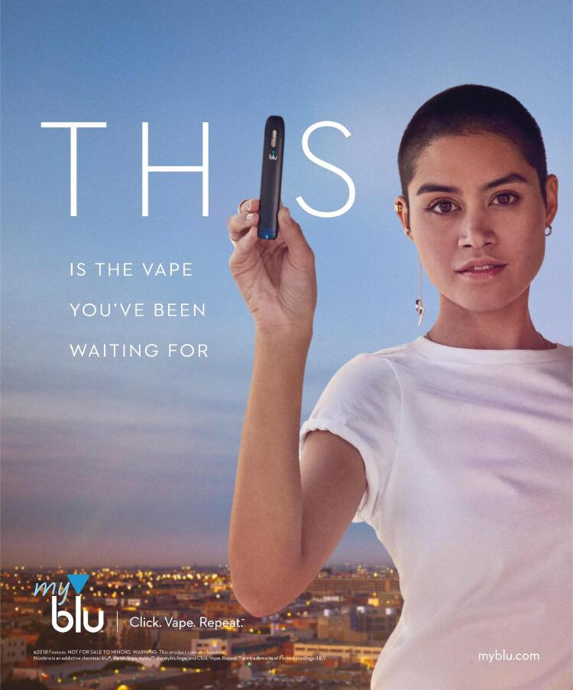
a. The young-looking model targets young people
b. The use of specific words stands out to young people
]
c. The pod-based company uses social justice imagery

d. All of the above

- How are pod-based systems marketed to young people?

a. Use of flavors and colors b. Misleading labeling of nicotine
c. Advertisements including people d. All of the above
that look like young people

- Market e-juices range from 0-25 mg of nicotine, while one JUUL pod has at least ___ mg of nicotine per pod.

a. 4.13 b. 5
c. 25 d. 41.3

- Which ingredient in many pod-based systems makes them highly addictive?

a. Benzoic acid b. Extracts and flavors
c. Glycerol d. Nicotine

- What do we NOT know about pod-based systems?

a. All the specific ingredients b. Long-term effects of using it
c. Effects of nicotine on the brain d. Both a & b

