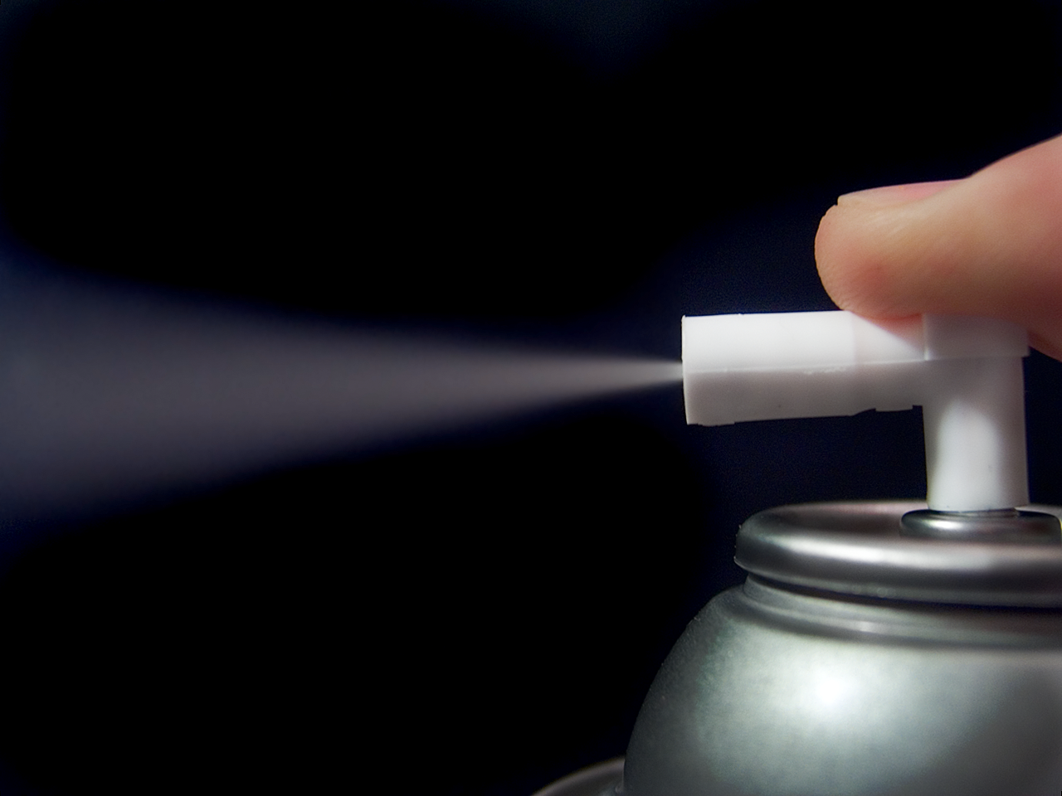

**Define: AEROSOL**

In your own words:

In your own words:

Dictionary Definition:

Examples of aerosol: