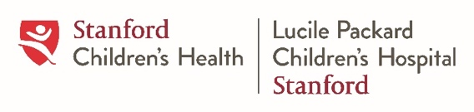
Please submit your completed 6-month progress report to Clea Sarnquist, cleas@stanford.edu and Rasika Behl rasikab@stanford.edu
Stanford Pediatrics Resident Research Grant
Progress Report
1. TITLE OF PROJECT

2. SCHOLARLY CONCENTRATION Basic Science Clinical Research Advocacy
Medical Education QI/PI Global Health
3. RESIDENT NAME: (Last, first) Email:
4. PRIMARY RESEARCH MENTOR:
Primary Mentor Name: Department/Division:
5. SCHOLARLY CONCENTRATION LEADER (Primary, if applicable):
Name:
6. IS YOUR STUDY HUMAN SUBJECTS RESEARCH?  No Yes  6a. IS YOUR STUDY IRB APPROVED?  No Yes Exempt from IRB | CO-INVESTIGATORS/AUTHORS  Name:  Name:  Name:
7. SUMMARY OF PROGRESS TO DATE (Please describe your research progress to date including sampling and recruitment efforts, data collection activities, data analysis, and dissemination, if applicable. Do not exceed 1 page.)

8. UPDATED TIMELINE AND DISSEMINATION PLAN

9. LIST OF ALL PURCHASES TO DATE (Please include date of purchase, type of purchase, cost, and how purchase was made)
Date of Purchase | Item (and item quantity) | Total Cost | How Purchase Was Made (e.g., residency office, personal credit card)

