Hematuria
Introduction
Hematuria is a common finding in children. Defined by the presence of an abnormal quantity of red blood cells (RBCs) in the urine, with hematuria being either visible to naked eye (gross) or apparent only upon urinalysis (microscopic).

American Academy of Pediatrics: Recommendations for Preventive Pediatric Health Care (2000)
Screening urinalysis at 5 years of age and once during adolescence

Warning Signs  Hematuria is worrisome when accompanied by: (will need bigger workup)  - Gross hematuria  - Hypertension  - Proteinuria  - Elevated serum creatinine | 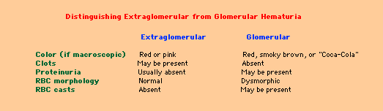
Macroscopic: Pink, red, cola colored

Microscopic: Seen only under microscope
- Dipstick – Reagent strip hydrogen peroxide catalyzes chemical reaction between hemoglobin (or myoglobin) and the chromogen tetramethylbenzidine.
- Detects 5-10 RBC/microliter (or 2-5 RBCs/HPF)
- False negatives in presence of formalin or high urinary concentration of ascorbic acid.
- False positive with alkaline urine (pH>9) or contamination with oxidizing agents used to clean the perineum.
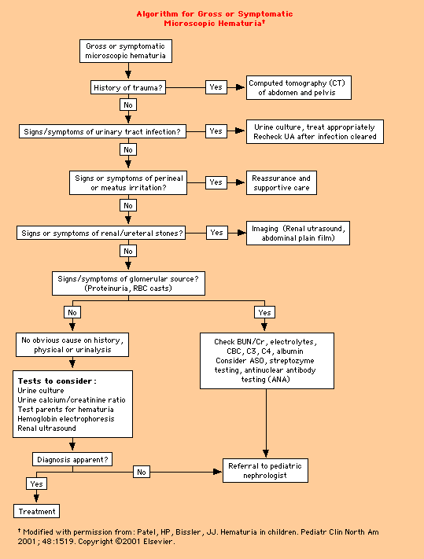

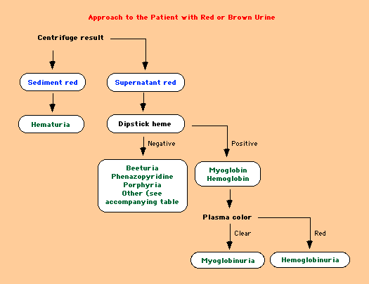 | 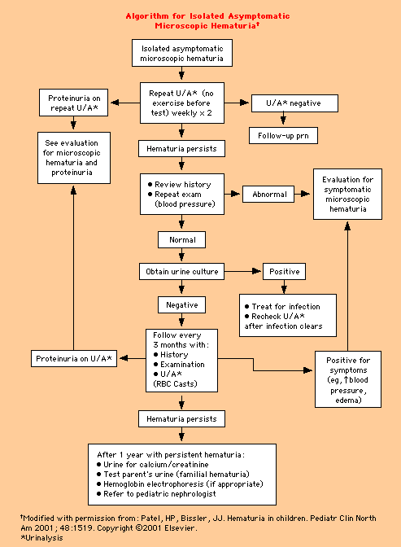

Glomerular Hematuria

Often associated with other abnormalities - red cell casts, proteinuria, edema, hypertension, and renal insufficiency.
Disorders that account for most cases of persistent isolated hematuria due to glomerular disease:
- IgA nephropathy – gross hematuria common, usu negative family history
- Hereditary nephritis (Alport syndrome) – gross hematuria common, some cases deafness
- Thin basement membrane nephropathy (benign familial hematuria) – gross hematuria uncommon (<10%)
Although mild postinfectious GN can also lead to isolated hematuria, there’s usually rapid resolution within three to six months.

IgA Nephropathy — There is no conclusive evidence to support any therapy in patients with IgA nephropathy and isolated hematuria. Although patients with IgA nephropathy may progress to renal failure, those who have only isolated hematuria (with little or no proteinuria) do very well unless they develop signs of progressive disease (such as increasing levels of proteinuria, blood pressure, or serum creatinine concentration that may initially remain within the normal range). Thus, close periodic monitoring of the urinalysis, renal function, and protein excretion is sufficient in most cases.
Thin Basement Membrane Nephropathy — Thin basement membrane nephropathy also typically has a benign course. However, a biopsy may be indicated in patients with suspected thin basement membrane nephropathy and isolated hematuria who subsequently develop hypertension or proteinuria.
Alport syndrome — Hereditary nephritis is typically associated with a family history of renal failure (primarily in males); deafness is also present in many families in which there is an X-linked dominant mode of inheritance. Confirmation of Alport syndrome by kidney or skin biopsy has important implications for the patient's prognosis and for genetic counseling. A skin biopsy is a relatively noninvasive way to establish the diagnosis of X-linked Alport syndrome. Incubation of the biopsy specimen with a monoclonal antibody directed against the alpha-5 chain of type IV collagen (which is the site of primary abnormality in hereditary nephritis) reveals no staining along the epidermal basement membrane in most males with X-linked Alport syndrome, discontinuous staining in female carriers, but normal staining in autosomal forms of Alport syndrome, thin basement membrane nephropathy and other glomerular disorders. However, normal immunostaining for the alpha-5(IV) chain in epidermal basement membrane does not exclude a diagnosis of Alport syndrome. Immunostaining of kidney biopsies for the alpha-3, alpha-4, and alpha-5 chains of type IV collagen can confirm a diagnosis of Alport syndrome and frequently distinguish between X-linked and autosomal forms of the disease.
- About 10 percent of individuals with X-linked Alport syndrome have de novo mutations, so that the absence of a family history of renal failure does not exclude the diagnosis. In children with persistent glomerular hematuria, kidney biopsy is frequently performed to establish a specific diagnosis, unless family history strongly suggests thin basement membrane nephropathy or Alport syndrome.

Adapted from UpToDate Articles “Evaluation of hematuria in children” and “Glomerular hematuria: IgA; Alport; thin basement membrane nephropathy” All figures taken from UpToDate

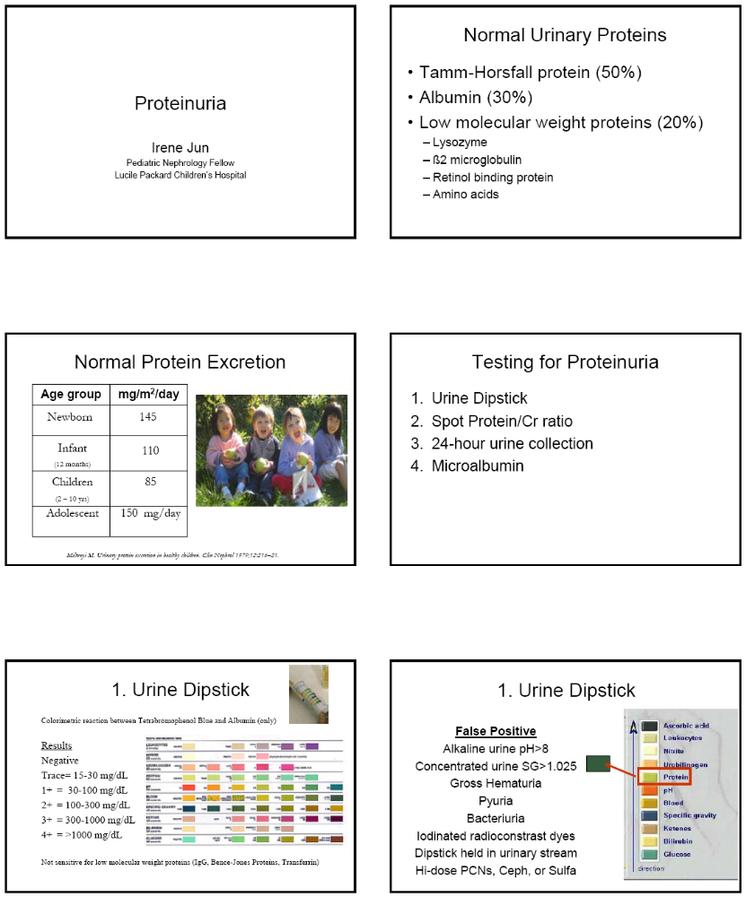
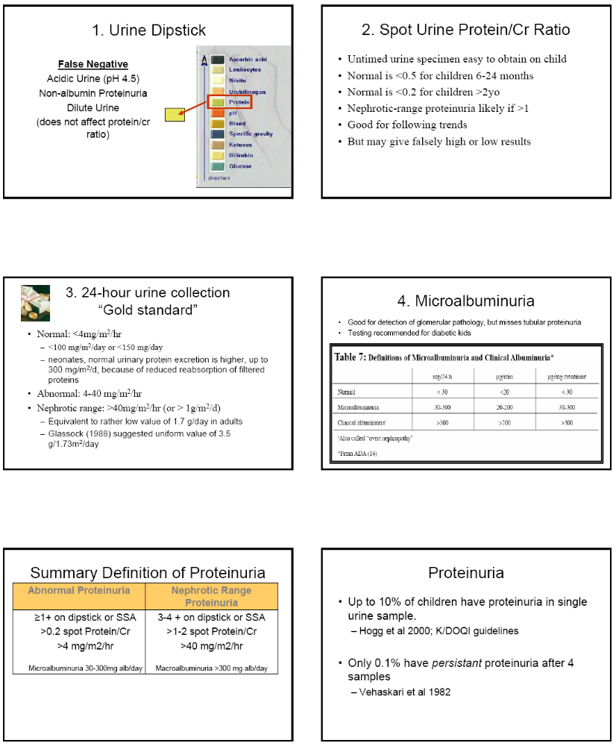
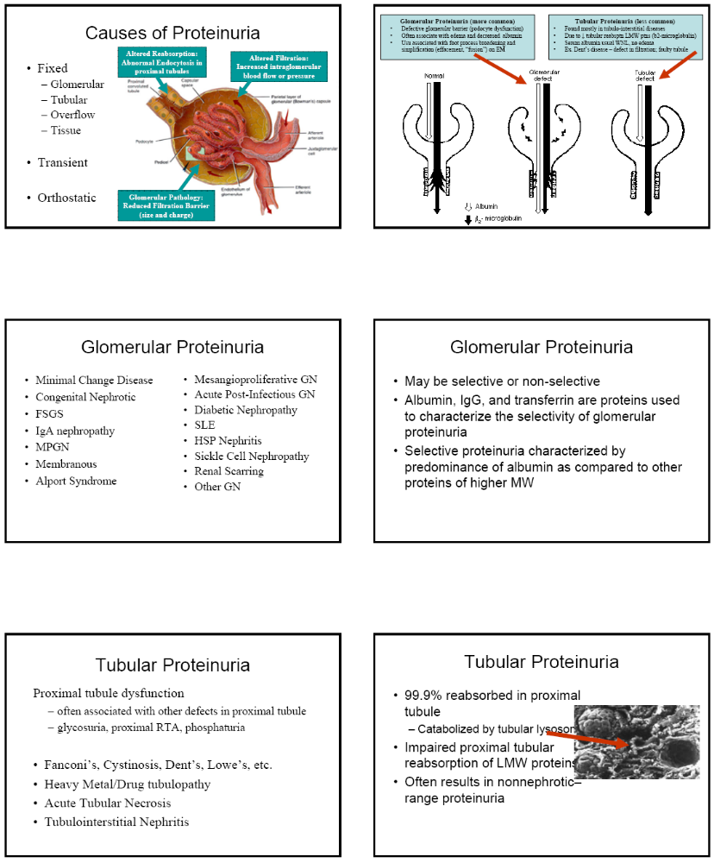

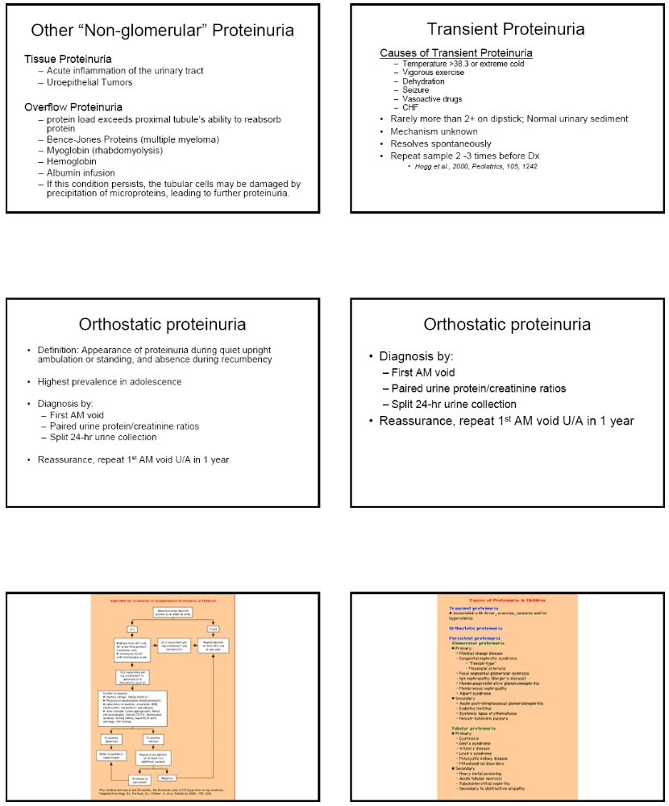

GLOMERULONEPHRITIS

Signs
Hypertension, edema, rales, gallop, rhythm, hepatomegaly, arthritis, rash

Symptoms
Dark urine, puffiness, swelling, dyspnea, tachypnea, orthopnea, joint pain/swelling/redness, rash, headaches

Evaluation
Step 1: Determine if pre-renal, intrinsic renal, or post-renal
- Calculate FENa to see if oliguric (differentiate pre-renal from ATN)
- Evaluate U/A (to look for an active sediment)
- Renal ultrasound (to rule out obstruction)
- Anti-neutrophil cytoplasmic antibodies (ANCA) if suspect Wegner's granulomatosus, Goodpasture's, PAN
- If Intrinsic Renal Disease, then differential diagnosis can be broken down into
  - Glomerular (e.g. glomerulonephritis or nephrotic syndrome or both)
  - Tubular (e.g. ATN)
  - Interstitial (e.g. acute interstitial nephritis)
  - Vascular (e.g. atheroembolic renal disease, PAN)

Step 2: If glomerular, differentiate glomerulonephritis (GN) pattern from nephrotic syndrome pattern
- Similar to the evaluation for isolated hematuria and/or isolated proteinuria.
- Urinalysis, renal ultrasound, 24 hour urine protein/creatinine or spot urine protein:creatinine ratio
- GN – see active sediment on UA (protein, RBCs → dysmorphic and/or casts), proteinuria, HTN, edema
- Nephrotic - see bland sediment on U/A (mostly heavy protein), heavy proteinuria (> 3.5 g/day), edema, hyperlipidemia, hypoalbuminemia
- Membranoproliferative GN (MPGN) - can present as nephrotic syndrome, GN or both.

Step 3: Use the serum complement levels to look help differentiate causes of GN.
- Causes of glomerulonephritis with normal serum complement level:

Systemic Diseases Renal Diseases
Polyarteritis nodosa IgA nephropathy
Hypersensitivity vasculitis Rapidly progressive GN
Wegener's granulomatosus Anti-glomerular basement membrane disease
Henoch-Schonlein purpura Immune complex disease
Goodpasture's syndrome
Visceral abscess

- Causes of glomerulonephritis with low serum complement level:

Systemic Diseases Renal Diseases
SLE Post-Infectious GN
Subacute bacterial endocarditis Membranoproliferative GN
Shunt nephritis
Cryoglobulinemia

Nephrotic Syndrome

Definition  - Proteinuria  - Hypoalbuminemia  - Edema  - Hyperlipidemia | 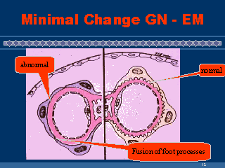

Demographics
- Annual Incidence: 2-3/100,000 children
- Prevalence: 16/100,000
- Typical idiopathic nephrotic syndrome of childhood ~ 2-8 yo
- Children: male to female ratio is 2:1

Urinalysis with micro:
- Nephrotic range proteinuria – mostly albuminuria

Urine Dipstick: 4+  Spot Urine Pr/Cr : >1  24 Hr Urine: >40 mg/m²/hr | (Normal is none)  (Normal is <0.5 if 6-24 mo; or < 0.2 if > 2yo)  (Normal <4 mg/m2/hr)

- 20% have microscopic hematuria
- Hyaline casts, oval fat bodies, no granular casts

Protein Losses
- Albumin → Edema
- IgG, Complement factors B & D → Infection
- Anti-Thrombin III → Risk thrombi
- Transferrin → Iron loss, anemia
- Vitamin D Binding Protein → Low serum Ca++ levels
- Thyroid Binding Protein → Hypothyroidism

Supportive Treatment
- Salt and fluid restriction
- Insensible losses = 400mL/m²/day or 30-45mL/100kcal energy expended
- Albumin (and lasix) for symptomatic patients
- Gravity
- Antibiotics if signs of infection

Mainstay of Therapy: Steroids
- 60 mg/m2/day or 2 mg/kg/day divided BID (max 60-80mg) for 6wks
- Then 40 mg/m2/day or 1 mg/kg/day (max 40mg) QOD x next 6 wks
- Taper off last 2 weeks
- Make sure to put on H2-blocker to prevent GI side effects
- Landmark Study- “Short vs standard prednisone therapy for initial treatment of idiopathic nephrotic syndrome in children.” Arbeitsgemeinschaft fur Padiatrische Nephrologie. Lancet 1988; 1:380.

Response to Steroids
- Steroid-Sensitive
  - Usually diurese and lose proteinuria within a week
- Steroid-Resistant
  - Failure to respond within 1-2 months
- Steroid-Dependent
  - 2 consecutive relapses during steroid therapy – usually during the taper – or immediately upon end of therapy
  - Frequent elapses are those with ≥ 2 relapses within the first 6 months after initial response of ≥ 4 relapses within any 12 month period

25% Albumin Infusions
- 25% Albumin 0.5 gm/kg over 8 hrs w/lasix (0.5 to 1 mg/kg) 4 hrs into infusion and at end of infusion
- Reevaluate pt after each infusion to see if more albumin would be beneficial.
- If patient stable and BPs permissive, then may increase 25% albumin to 1 mg/kg over the next 8 hrs
- Albumin infusions buy time until steroids kick in.
- Ultimate Goal albumin somewhere >3, but it is hard to maintain this level in a nephrotic pt.

Other Possible Therapies
- Calcineurin Inhibitors (CSA, Prograf)
- Levamisole
- Cyclophosphamide
- Chlorambucil
- Mycophenolate mofetil

Home Monitoring: Albustix (urine dipsticks only for albumin)
- QD during initial treatment
- QD for few weeks after discontinuing steroids
- 1-2 times per week thereafter
- With onset of illnesses

Clinical Course
- 30% have only one “attack”
- 10-20% relapse after several months
- 40-50% multiple relapses

Indications for Biopsy
- Lack of response to steroids
- Long course of mild isolated proteinuria
- Macroscopic hematuria
- Marked hypertension
- Renal insufficiency
- Low Complements
- Signs/Symptoms of Collagen Vascular Disease
- <12 months or >11 years
- Not indicated for first episode between 1-8 years
Hemolytic Uremic Syndrome
Adapted from Up-to-Date

I. Definition: HUS is one of the main causes of acute renal failure in children and defined by the clinical triad:
- Microangiopathic hemolytic anemia
- Thrombocytopenia
- Acute renal failure

Typical HUS (90%) | Atypical
- Often prodromal episode of bloody diarrhea  - Associated with strains of E. coli that produce Shiga toxin  - Aka Diarrhea-associated HUS, D+ HUS, Shiga toxin-assoc HUS | - Absence of diarrhea or Shiga toxin-producing E. coli infxn  - Aka Nondiarrhea-associated HUS, or D- HUS  - Unlike typical disease, atypical HUS is more likely to recur, have a severe clinical course (esp. renal insufficiency, HTN), and be associated with a positive family history

II. Epidemiology
Typical HUS represents 90 % of cases of HUS observed in children. It principally affects children under the age of five years. The annual incidence of the disease in North America and Western Europe is 2-3/100,000 children less than five years of age. Typical HUS occurs most commonly in the summer months and in rural versus urban populations.

III. Prevention
- Attempts to prevent progression from the bloody diarrheal phase (acute infectious phase) of postdiarrheal HUS to the clinical manifestations of HUS have been unsuccessful.
- Antibiotics, antimotility agents, and narcotics have been associated with an ↑ incidence of progression, so should not be given to children with confirmed/suspected E. coli 0157:H7 or shiga toxin associated infxns.

IV. Complications and Management:

A. Microangiopathic hemolytic anemia — Characterized by following:  Hemoglobin levels that are usually less than 8 g/dL  Negative Coombs' tests  Peripheral blood smear: schistocytes and helmet cells  Other hemolysis signs: ↑bilirubin, ↓haptoglobin, ↑LDH  Children with HUS can become profoundly and rapidly anemic. To avoid cardiovascular and pulmonary compromise, pRBCs should be transfused when the hemoglobin level is <6 g/dL. The goal is not to restore the hemoglobin level to normal as the increased volume may cause heart failure, pulmonary edema, and hypertension. Because of these concerns, clinically indicated transfusions should be given slowly and cautiously with frequent monitoring of the patient's vital signs. Although hemolysis may recur over a several-week period, there is no correlation between severity of anemia and severity of renal disease. | 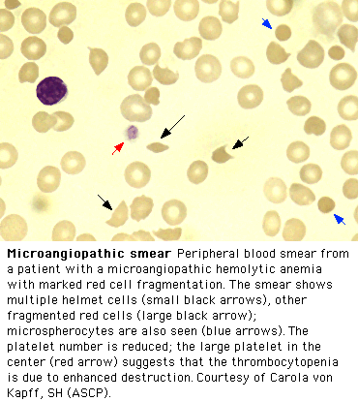
B. Thrombocytopenia — Thrombocytopenia is characterized by a platelet count usually around 40,000/mm³. Despite this, there is usually no purpura or active bleeding. As with hemolytic anemia, the degree of thrombocytopenia is unrelated to the severity of renal dysfunction. Platelet transfusion is rarely administered because of concerns that new or expanding thrombi may be initiated by the consumption of infused platelets. In addition, clinical significant bleeding is infrequent as the platelet count rarely falls below 10,000/mm³. Platelet transfusion is reserved for patients with HUS who have significant clinical bleeding or if an invasive procedure is required.

C. Fluid — The fluid status of the patient with HUS must be carefully assessed to guide fluid management. There are competing processes that can lead to either decreased (vomiting, decreased oral intake, and diarrhea) or increased (oliguria or anuria) intravascular volume. In some cases, fluid expansion may be indicated to counteract renal hypoperfusion in volume deleted patients. In contrast, fluid restriction may be needed in patients with increased intravascular volume and oliguria/anuria. Initial weight gain may not be an accurate marker for intravascular volume since hypoalbuminemia and capillary leakage may cause an edematous state with increased total body water but a decreased intravascular volume.

Fluid management is therefore based upon the fluid status of the patient and renal function. Patients with decreased intravascular volume are repleted to an euvolemic state. Those with increased volume and diminished urine output are fluid restricted but may require dialysis treatment especially if there is cardiac and pulmonary compromise. Once the patient is in an euvolemic state, administration of fluids should be given as insensible losses plus urine output until renal function returns to normal.

Frequent monitoring of fluid balance, weight, and vital signs is imperative. At the first sign of hypertension or cardiopulmonary overload, fluids should be restricted. Diuretics rarely avert anuria but a trial of furosemide may be attempted to induce a diuresis, particularly in patients with cardiopulmonary compromise. Diuretics should not be continued in the child who fails to respond. Dialysis therapy is required if fluid restriction and/or diuretic therapy fail to improve the compromised cardiorespiratory status of the patient in a timely manner.

D. Acute renal failure — The severity of renal involvement ranges from hematuria and proteinuria to severe renal failure and oligoanuria, which occur in one-half of cases. In patients with HUS who develop renal insufficiency or renal failure, nephrotoxic medications should be stopped and dosing of drugs excreted by the kidney must also be readjusted.

Dialysis: Indications for dialysis in children with HUS are similar to those other forms of acute renal failure:
Signs and symptoms of uremia
Azotemia (BUN greater than 80 to 100 mg/dL [29 to 36 mmol/L])
Severe fluid overload (cardiopulmonary compromise and/or hypertension) that is refractory to medical therapy
Severe electrolyte abnormalities (e.g., hyperkalemia and acidosis) refractory to supportive medical therapy
Need for nutritional support in a child with oliguria or anuria
E. Hypertension — The etiology of HTN includes overexpansion of intravascular volume and ischemia-induced activation of the renin-angiotensin system. Management is directed towards correcting the fluid, and the use of antihypertensive agents.
F. Neurologic dysfunction — Serious complications of the central nervous system, such as seizures and strokes, are predictors of poor outcome. In any patient with HUS who presents with serious neurologic dysfunction (eg, seizure and coma), radiological imaging should be performed to assess for CNS infarction. Seizures may also be secondary to severe hypertension. Studies in the related disorder thrombotic thrombocytopenic purpura that also have severe neurologic dysfunction have shown plasma exchange improves clinical outcome. Although unproven in patients with HUS, plasma exchange has been used in patients with severe CNS involvement (eg, stroke).
G. Other organ involvement — Although not as common as renal and neurologic complications, patients may develop colitis, cardiac dysfunction, and pancreatitis. In addition, respiratory complications secondary to increased intravascular volume may occur. Management for these potential complications includes the following:
- Colitis — Severe colitis may progress to necrosis and in some cases intestinal perforation. Management includes serial abdominal examinations, stool guaiac testing of the stool, and TPN. Surgical intervention may be required.
- Cardiac dysfunction — Cardiac dysfunction can be due to cardiac ischemia, and fluid overload. Pericarditis may be associated with uremia. Appropriate therapy may include inotropic agents, fluid restriction, and/or dialysis.
- Pancreatitis — Clinically significant pancreatitis can occur and may require the use of insulin for hyperglycemia.
- Pulmonary complications — Pulmonary edema and effusions may result from fluid overload. Management may include fluid restriction, diuretics, dialysis, and/or ventilatory support.
H. Other therapies— Multiple modalities and/or agents have been utilized that are directed against the underlying or presumed pathogenic mechanisms of Shiga-toxin associated HUS. These include antithrombotic agents, plasma exchange and/or plasma infusion, tissue-type plasminogen activator, and oral Shiga toxin-binding agent. Of these modalities, only plasma exchange appears to be currently acceptable for patients with severe CNS involvement.
V. Prognosis
The prognosis for recovery of renal function is generally favorable. Spontaneous resolution typically begins within one to two weeks, and the mortality rate is now under five percent. However, another five percent of patients may have a stroke or develop end-stage renal disease.

Children who do not do well during the acute episode often have one or more of the following risk factors:
- Initial WBC> 20,000. Leukocytosis reflects neutrophil activation resulting from toxin-induced release from monocytes of the neutrophil chemoattractant Il-8; these neutrophils may then contribute to tissue damage.
- Initial anuria lasting > eight days.
- Renal histology showing a glomerular microangiopathy affecting > 50 % of glomeruli, an arterial microangiopathy, and/or cortical necrosis.
Long-term outcome — The prognosis for recovery of renal function is generally favorable. Spontaneous resolution typically begins within one to two weeks after the disease onset. The glomerular filtration rate returns to normal in many of these patients, although renal blood flow may be persistently reduced by 10 to 20 percent, suggesting that there has been some permanent subclinical nephron loss.
However, 5 to 25 percent have permanent and serious renal sequelae. Long-term follow-up often reveals evidence of irreversible injury during the initial episode. These include an increased incidence of the following:
- Hypertension
- Mild proteinuria (usually less than 1000 mg)
- Subclinical decline in GFR (even though the plasma creatinine remains in normal range).
Of note, recurrence of HUS after renal transplantation is rare in children with typical disease (zero to 10 percent).
VI. Follow-Up — Yearly evaluation of patients with typical HUS is recommended to monitor for signs of hypertension, proteinuria, and renal insufficiency. Thus, each visit should include blood pressure measurement, and laboratory evaluation of renal function including urinalysis and serum creatinine.
Henoch Schonlein Purpura

Definition: Henoch-Schönlein purpura is an IgA-mediated, autoimmune, nonthrombocytopenic hypersensitivity vasculitis affecting small blood vessels. A tetrad of symptoms includes purpuric rash occurring on the lower extremities, abdominal pain or renal involvement, and arthritis.

Incidence: 14 cases per 100,000 people.

Epidemiology: Occurs most frequently in the spring and fall. 75% occur between 2-11 year old, with mean age 5-6 years old. Children younger than 2 yo have milder disease, whereas renal involvement is more likely to be severe in older children.

Pathogenenesis: Tissue deposition of IgA-containing immune complexes.

Clinical Manifestations
- Cutaneous purpura (100%): Typically on lower extremities and buttocks, but may also involve upper extremities, face and trunk. Non-blanching urticarial wheals, erythematous maculopapules and larger, palpable ecchymosis-like lesions. Petechiae and target lesions may be present as well
- Arthritis (82%): The ankles and knees are most frequently affected; however, the elbows, hands and feet may also be involved. Transient and leave no permanent deformity.
- GI symptoms: Abdominal pain (63%), GI bleeding (33%). Severe cases may proceed to intussusception, hemorrhage, and shock.
- Renal Disease (40%): Usu mild disease w/asymptomatic hematuria and proteinuria with normal or only slightly ↑ creatinine. May develop nephrotic syndrome, HTN, and acute renal failure.

Diagnosis – Clinical diagnosis where characteristic tetrad is virtually pathognomonic of HSP in children. There is not a specific laboratory test for the disorder, although an elevated serum IgA level is suggestive. CBC will show normal or elevated WBC and platelet count, and possible eosinophilia. ESR count may be elevated. Electrolytes may be affected secondary to gastrointestinal involvement. Urinalysis may show hematuria. A stool guaiac test may be positive. Skin biopsy may show a leukocytoclastic vasculitis.

Treatment
There is no specific treatment for Henoch-Schönlein purpura.
- Bed rest and supportive care, such as assuring adequate hydration.
- Nonsteroidal anti-inflammatory drugs can relieve joint and soft tissue discomfort.
- Corticosteroids have some use in patients with severe abdominal pain. However, corticosteroids are not recommended for treatment of rash, joint pain or renal disease alone.
- For severe nephritis: IV methylprednisolone (30 mg/kg/dose x 3 days) followed by PO corticosteroids plus an immunosuppressive agent (either azathioprine or cyclophosphamide).

Prognosis
In the absence of renal disease and central nervous system involvement, the prognosis for patients with Henoch-Schönlein purpura is excellent. The illness lasts four to six weeks in most patients. One half of patients may have a recurrence. Long-term follow-up is necessary for patients with renal disease. The renal disease may not arise for several years. Renal biopsy may be performed to establish the diagnosis and determine the prognosis. The primary long-term complication is renal disease, which develops in 5 percent of patients. Prognosis overall is excellent.

Renal Tubular Acidosis
What is Renal Tubular Acidosis?
- Group of syndromes of renal tubular dysfunction characterized by either impaired bicarbonate absorption or hydrogen ion secretion out of proportion to GFR.
- Without proper treatment, chronic acidity of blood leads to growth retardation, kidney stones, bone disease, and progressive renal failure.
- Hyperchloremic metabolic acidosis with a normal serum anion gap
Anion Gap = Na+– (Cl–+ HCO3–)
- Note: The other major cause of a normal AG acidosis (but non renal related) is diarrhea

Finding | Type I RTA | Type 2 RTA | Type 4 RTA | GI Loss
Normal anion-gap acidosis | Yes | Yes | Yes | Yes
Primary Defect | Impaired distal acidification | ↓ Proximal bicarb reabsorption | ↓ Aldosterone secretion or effect | --
Urine pH | > 5.5 | < 5.5 | < 5.5 | 5 to 6
Fractional Excretion Bicarb | < 5 | > 15 | < 10 | < 10
Serum K | Low | Low | High | Low
Serum Bicarbonate | Variable, may be < 10 | Usually 12-20 | >17 meq/L
Fanconi Syndrome | No | Yes | No | No
Stones/Nephrocalcinosis | Yes | No | No | No

Type I Distal Renal Tubular Acidosis
- Pathophysiology - Distal Tubule fails to excrete ammonium
- Causes
  - Inherited disorder
  - Acquired causes
    - Systemic Lupus Erythematosus
    - Sickle Cell Anemia
    - Nephrocalcinosis related disorders (Hyperparathyroidism, Medullary sponge)
    - Medications and Toxins (Amphotericin B, Lithium, Toluene)
- Signs - Musculoskeletal weakness, Recurrent Nephrolithiasis
- Labs
  - Arterial Blood Gas (ABG) - Non-Anion Gap Metabolic Acidosis
  - Urine pH - Elevated >5.5 despite Metabolic Acidosis
  - Serum Potassium - Low or normal
  - Urine Anion Gap = Urine [Na + K - Cl]
    - Estimates urine ammonium excretion, as most of difference between chloride and sodium plus potassium concentrations is comprised of NH4+
    - POSITIVE value, because defect in distal acidification results in low urine NH4+
  - Fractional Excretion of Bicarbonate
    - FE-HCO3 <5%: Distal RTA
    - FE-HCO3 >15%: Proximal RTA (Assumes serum bicarbonate >20 meq/L)
- Management: Bicarbonate Supplementation
  - Dose: 1-2 meq/kg/day
  - Goal: Serum bicarbonate > 22 meq/L
  - Corrects Hypokalemia

Type II Proximal Renal Tubular Acidosis
- Pathophysiology - Proximal Tubule defect of bicarbonate reabsorption
- Causes
  - Most commonly in Children: As part of Fanconi’s Syndrome, Cystinosis
  - Others: Medications (Acetazolamide), Medullary cystic disease, Multiple Myeloma, Wilson’s Disease, Nephrotic Syndrome, Renal Transplantation
- Signs (Presentation) – FTT, Growth retardation, Vomiting, Dehydration, Lethargy
- Labs
  - Arterial Blood Gas - Mild to moderate non-Anion Gap Metabolic Acidosis
  - Serum bicarbonate decreased - Usually not lower than 15 meq/L
  - Urine pH - Exceeds 5.5 except in severe Metabolic Acidosis
  - Fractional Excretion of Bicarbonate
    - FE-HCO3 exceeds 15% if serum bicarbonate >20 meq/L
    - FE-HCO3 <5% in Distal RTA
- Radiology: XRay - Children: Rickets / Adults: Osteopenia
- Management
  - High dose Bicarbonate Supplementation (10-25 meq/kg/day)
  - Observe for Hypokalemia
  - Treat Osteomalacia in adults –Vitamin D supplementation, Calcium Supplementation
  - Treat Rickets in children - Vitamin D Supplementation, Sodium Phosphate

Type 3 (Rare) Renal Tubular Acidosis
- Initially used to describe a transiently severe form of type 1 RTA in infants
- AR syndrome (carbonic anhydrase II deficiency) with features of both Type 1 and Type 2 RTA
- Complications: Osteopetrosis, cerebral calcification, MR.

Type 4 Hyperkalemic Renal Tubular Acidosis
- Causes
  - Aldosterone deficiency
    - Syndrome Hyporeninemic Hypoaldosteronism
    - Addison's Disease
    - Heparin
    - Potassium sparing Diuretics (e.g. Spironolactone)
  - Collecting duct dysfunction from Renal insufficiency
    - Diabetic Nephropathy
    - Interstitial Nephritis
    - Obstructive uropathy
    - Renal Transplantation
- Labs
  - Arterial Blood Gas (ABG) - Metabolic Acidosis
  - Chemistry panel - Hyperkalemia
  - Urinalysis - Urine pH <5.5 with severe Metabolic Acidosis
  - Creatinine Clearance decreased (<45 ml/min)
- Management
  - Cause: Aldosterone or mineralocorticoid deficiency → Fludrocortisone
  - Cause: CRI → Dietary K restriction, Loop Diuretics, Bicarbonate (1-2 meq/kg/day)
References: http://www.fpnotebook.com/REN6.htm
Up-To-Date Renal Tubular Acidosis

