The Normal Kidney
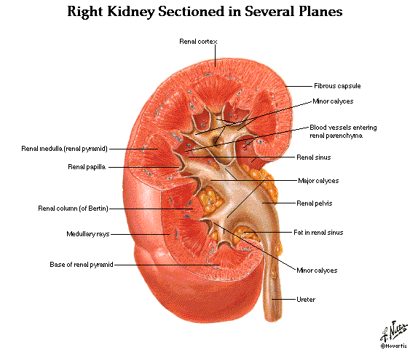 | Kidney Size by Age
 | 0-1 wk  1-4 mo  8-12 mo  1-2 yrs  2-3 yrs  3-4 yrs  4-5 yrs  5-6 yrs  6-7 yrs  7-8 yrs  8-9 yrs  9-10 yrs  10-11 yrs  11-12 yrs  12-13 yrs  13-14 yrs  14-15 yrs  15-16 yrs  16-17 yrs  17-18 yrs  18-19 yrs | 4.48 cm  5.28  6.15  6.65  7.36  7.36  7.87  8.09  7.83  8.33  8.90  9.20  9.17  9.60  10.42  9.29  10.05  10.93  10.04  10.53  10.81

Weight: 150 gram each
Structure: The cut surface is made of Cortex, Medulla, Renal Pyramids (papillae), Major/Minor Calyces, and Pelvis that empties into the Ureter. The kidney is divided into 12 lobes, each consisting of a pyramid, of Medullary and Cortical Tissue. The Basic Unit of Kidney Structure is the NEPHRON made up of Glomerulus surrounded by Bowman’s Capsule, and the renal tubules.

Functions:
- Regulates total body water
- Regulates blood pressure (renin-angiotensin-aldosterone)
- Regulates acid-base status
- Regulates electrolytes, calcium and phosphorus
- Hydroxylates Vitamin D
- Produces Erythropoietin
- Removes nitrogenous wastes
- Drug metabolism and removal

Laboratory Values:

Urine Analysis

Specific gravity: 1.001 – 1.035

pH : 4.6 – 8.0
- Creatinine: 0.6 – 1.3 mg/dl
- Normal Creatinine clearance is 75 – 125 ml/min, decreases with age.
- Negative for bilirubin, blood, acetone, glucose, protein, nitrite (bacteria), and Leukocyte esterase.

RBCs count 0-5/HPF

WBCs count 0-4/HPF.
- Epithelial Cells: Occasional
- Hyaline Casts: Occasional.
- Crystals: Disease, Medications.
- BUN: 7- 18 mg/dl. When elevated called AZOTEMIA
Structure of the Kidney and Urinary System
A. Gross  - Outer cortex – glomeruli and convoluted tubules  - Inner medulla – collecting ducts, Henle’s loops, osmotic gradient  - Collecting system: calices, pelvis, ureter  - Bladder and urethra | 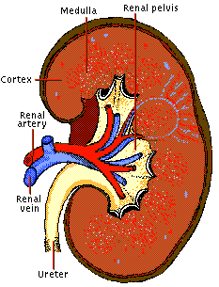
B. Microscopic  - Nephron: glomerulus and its tubule. Each nephron is an independent unit of function. Approx. 1 million nephrons in each kidney.  - Glomerulus: compact tuft of capillary loops surrounded by Bowman’s capsule. Ultrafiltration apparatus: cells and protein are held within blood while small solutes/water pass into tubules  - Tubule: divided into segments – proximal, distal, Loop of Henle. Absorption (water, sodium, glucose, etc), secretion (K⁺, H⁺), formation of osmotic gradient (Loop of Henle, distal tubule).  - Collecting ducts: concentration of urine under control of ADH | 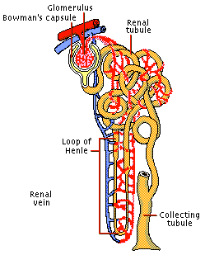
C. Blood supply  - Renal artery: 25% of cardiac output to glomerulus  - Interlobar arteries → arcuate arteries → interlobular arteries → afferent arterioles → glomerulus → efferent artery → peritubular plexus (superficial and middle cortex)→ vasa recta (juxtamedullary cortex) | 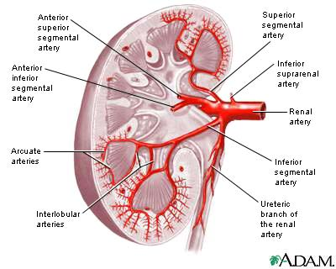
Glomerular Filtration Rate and Creatinine Clearance

Glomerular Filtration Rate
The GFR is equal to the sum of the filtration rates in all of the functioning nephrons, so estimation of the GFR gives a rough measure of the number of functioning nephrons. Thus a reduction in GFR implies worsening renal function. A “glomerular substance” is one which is: (1) freely filtered at the glomerulus, (2) neither reabsorbed nor secreted.

Creatinine clearance
• Creatinine clearance overestimates GFR in a variety of circumstances, because of tubular secretion
• Nonetheless Creatinine is very close to being a glomerular substance
• The basic formula for clearance of a substance is CrCl (ml/min) = UV/P
- Ux: urine concentration of X
- V: urine volume/time
- Plasma concentration of X

Fortunately we have easy formulas to calculate the GFR:

Children: Use the Schwartz Equation

Schwartz Equation (Ped Clinics of America, 1987: 34:571)
CLcr = k x H/Scr
Where: H = height (cm); Scr = serum creatinine (mg/dL); k = constant
Age | k value
Low birth weight babies, <1 yr old | 0.33
Term (average gestational age) babies, <1 yr old | 0.45
Children (1 - 12) and adolescent girls | 0.55
Adolescent boys (13 - 17 yrs) | 0.70
.

Adults and Children > 12 yo: Use the Cockroft-Gault Equation

The Cockroft-Gault Equation (Nephron 1976; 16:31)
CLcr (male) = IBW (140 - Age) / (72 x Scr)
CLcr (female)= 0.85 x IBW (140 - Age)/(72 x Scr)
Where: A = age in yrs; IBW = Ideal Body Weight in Kg

Ideal Body Weight(kg): Non-Metric  IBW (male) = 50 + 2.3 (H - 60)  IBW (female) = 45.5 + 2.3 (H - 60)  H = height in inches | Ideal Body Weight (kg) : Metric  IBW (male) = 0.9 H - 88  IBW (female) = 0.9 H - 92  H = height in centimeters

As a quick rule of thumb, Creatinine and GFR have a relatively reciprocal relationship:

Creatinine (mg/dL) GFR (mL/min)
1 100
2 50
4 25
8 12.5
Also, note that normal GFR values vary with age and sex:
Children achieve adult values for mean GFR at approximately two years of age

. 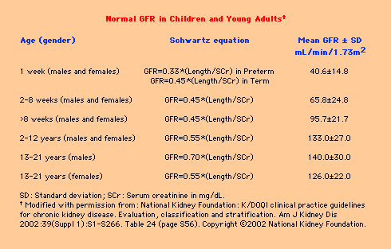

Definition of Chronic Renal Failure
Within the pediatric nephrology community, chronic renal failure typically has been characterized by an estimated GFR of less than 75 mL/min per 1.73 m2.

In contrast, the K/DOQI workgroup defined CKD in adults and children older than 2 years of age as:
- Kidney damage for 3 months, as defined by structural or functional abnormalities of the kidney, with or without a decreased GFR, manifested by either pathological abnormalities; or markers of kidney damage, including abnormalities in the composition of blood or urine, or abnormalities in imaging tests OR
- GFR < 60 mL/min per 1.73 m2 for 3 months, with or without kidney damage.

Stages of chronic kidney disease
Patients who experience a gradual decline in kidney function because of CKD are initially asymptomatic. Although the early symptoms of uremia are nonspecific in nature, their presence indicates that kidney function has decreased significantly.

CKD has been classically staged as renal failure that is:
Mild (GFR of 50 to 80 percent of normal)
Moderate (GFR of 25 to 50 percent of normal)
Severe (GFR of less than 25 percent of normal)
End-stage (ESRD) (GFR of less than 10 percent of normal).

The observation that many of the complications of CKD can be prevented or delayed through early detection and treatment prompted the K/DOQI workgroup to develop a formal staging system for stratification of CKD based on the level of kidney function, independent of the primary renal diagnosis:
Stage 1 disease is defined by a normal GFR ( 90 mL/min per 1.73 m2)
Stage 2 disease is a GFR between 60 to 89 mL/min per 1.73 m2
Stage 3 disease is a GFR between 30 and 59 mL/min per 1.73 m2
Stage 4 disease is a GFR between 15 and 29 mL/min per 1.73 m2
Stage 5 disease is a GFR of less than 15 mL/min per 1.73 m2 or ESRD.

UpToDate: Overview of the management of chronic kidney disease in children

Blood Urea Nitrogen and Serum Creatinine
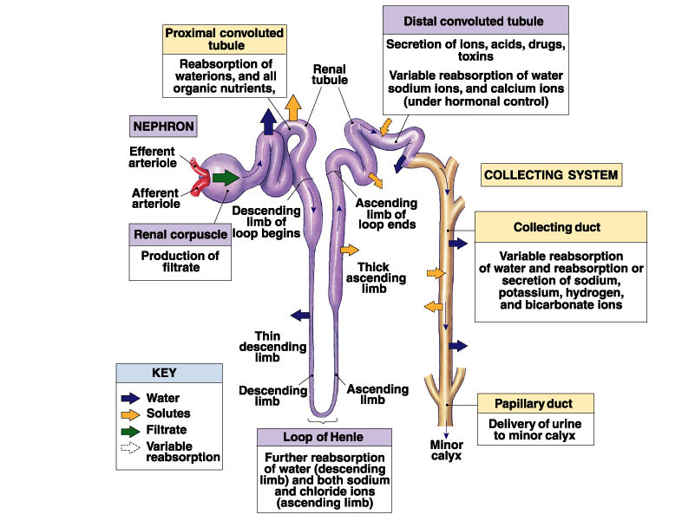

 | Blood Urea Nitrogen | Serum Creatinine
Source | Protein (exogenous or endogenous) derived from breakdown of proteins delivered to the liver | Nonenzymatic hydrolysis of creatine released from skeletal muscle
Constancy | Variable | More stable (unless ↓↓ skeletal muscle mass)
Renal Handling | • Small, uncharged molecule that is not protein bound – so completely filtered at glomerulus  BUT  • Significant tubular reabsorption which limits the value of BUN as marker for GFR | Completely filtered; some tubular secretion
Value as GFR Marker | Modest | Good in steady state
Correlation with Uremic Symptoms | Good | Poor

BUN:Creatinine Ratio (Normal = 10:1)
Increased Ratio > 10:1 Decreased Ratio < 10:1
• Increased protein intake • Starvation
• Catabolic state Advanced liver disease
Fever Postdialysis state
Sepsis Drugs that impair tubular secretion
Trauma Cimetidine
Corticosteroids Trimethoprim
Tissue necrosis • Rhabdomyolysis
Tetracylines
• Diminished urine flow
Hypocomplementemia in Glomerular Diseases

Memorize this
What are 5 classic renal diseases associated with hypocomplementemia?
- Post Strep GN
- MPGN
- SLE
- Cryoglobulinemia
- Shunt Nephritis

Hypocomplementemia Pathogenesis
- Due to increased consumption via complement activation by immune deposits
- Other factors may include:
  - Hereditary complement deficiency
  - Presence of circulating factors that promote complement activation.

Importance of Complements
- Complement activation normally plays an important role in clearing immune complexes (in part via attachment to C3b receptors on erythrocytes)

Differential Diagnosis
- Hypocomplementemia can also occur with some non-immune complex-mediated renal diseases, resulting in a clinical picture that may mimic a primary glomerulonephritis
  - Atheroembolic renal disease - complement pathway activated by exposed atheromata.
  - HUS and TTP -complement may be activated by endothelial damage or bacterial toxins.
  - Severe sepsis, acute pancreatitis, and advanced liver disease

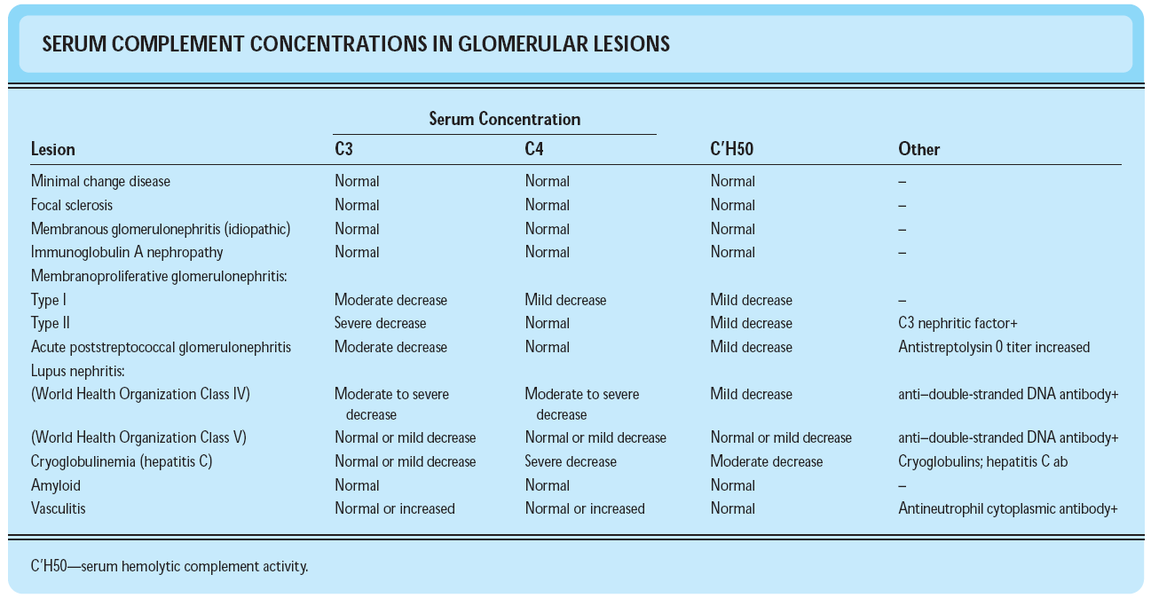
Arthur H. Cohen and Richard J. Glassock Atlas of Diseases of the Kidney: The Primary Glomerulopathies

