PEDIATRICS EQUIPMENT DISPOSAL REQUEST

This form is to help your Department Property Administrator initiate a disposal request. Once filled out, please:

Return to rlockett@stanford.edu

Requestor’s Name: Division:

Your Phone: Location: (Bldg/Rm): Date of Form:

**PTA (MANDATORY):**

Capital equipment will have one of the following tags below:

**Newer tag styles:**

  
  
**Prior tag styles:**  
  
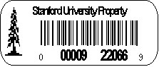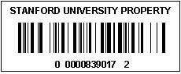

If item is **Capital Equipment, please use Form A**, otherwise use form B

**Form A**

**Capital Equipment Form**

|  |  |  |  |  |  |
| --- | --- | --- | --- | --- | --- |
| **Tag Number** | **Description** | **Manufacturer** | **Serial Number** | **Location of Item** | **Hazardous Material (Y/N)** |
|  |  |  |  |  |  |
|  |  |  |  |  |  |
|  |  |  |  |  |  |
|  |  |  |  |  |  |

**Form B**

**Untagged/Non Capital Equipment**

|  |  |  |  |  |  |
| --- | --- | --- | --- | --- | --- |
| **Description** | **Manufacturer** | **Serial Number** | **Location Of Item** | **Hazardous Material (Y/N)** | **Working Condition**  **(Y/N)** |
|  |  |  |  |  |  |
|  |  |  |  |  |  |
|  |  |  |  |  |  |
|  |  |  |  |  |  |