Menlo Corporate Center
4100 Bohannon Drive
Menlo Park, CA 94025
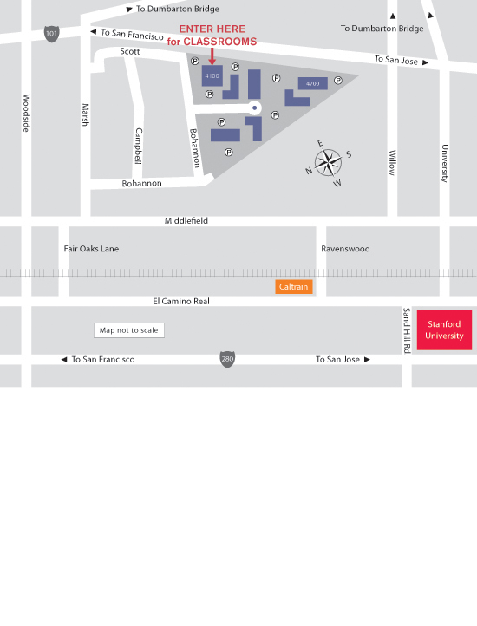
From Highway 280 Northbound or Southbound
Take the Sand Hill Road exit East. Turn left on El Camino Real. Turn right on Ravenswood Ave. Turn left on Middlefield Road. Turn right on Marsh Road. Turn right on Bohannon Drive.
From Highway 101 Southbound
Take the Marsh Road (exit 406) West. Turn left on Scott Drive and turn left to stay on Scott Drive. This will turn into Bohannon Drive.
From Highway 101 Northbound
Exit Marsh Road (exit 406). Turn left and cross over the freeway, following the sign that says Atherton. Turn left on Scott Drive and turn left to stay on Scott Drive. This will turn into Bohannon Drive.

