Pumpkin Spice Smoothie
Recipe from American Heart Association

This Simple Cooking with Heart recipe is the taste of American pumpkin pie in a glass, with fewer calories.
Ingredients:
1/2 cup canned pumpkin, (not pie filling)  1/3 cup plain Greek yogurt  1/3 cup Low-fat milk  2 Tbsp. rolled oats  2 tsp honey  1/2 tsp. Greek Yogurt  1/2 cup pumpkin pie spice  3-4 Ice cubes | 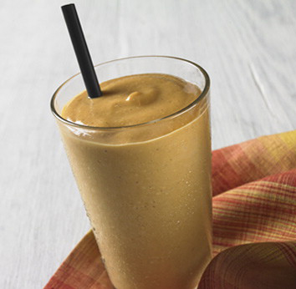

Video
View this video on YouTube

Directions
- Into a blender, add pumpkin, yogurt, milk, oats, honey, pumpkin pie spice, and ice cubes.
- Blend until smooth and frothy, about 1 minute. Pour into a glass and serve.

Additional Tips
Cooking Tip: Keeping the can of pumpkin in the fridge before using isn’t necessary, but helps make a colder smoothie.
Keep it Healthy: Make sure to buy 100% pure pumpkin and not pumpkin pie filling or mix, which looks similar but can have added sugar.
Tip: Plain nonfat Greek yogurt, which has more of a tangy taste as well as more protein, can be substituted for the light plain yogurt.
Leftover ingredients?
Search for the ingredient below and use the remaining amount in those recipes!

Nutritional Info
Nutritional Analysis
Calories Per Serving | 199
Total Fat | 1.5 g
Saturated Fat | 0.3 g
Trans Fat | 0.0 g
Polyunsaturated Fat | 0.2 g
Monounsaturated Fat | 0.3 g
Cholesterol | 3.3 mg
Sodium | 106 mg
Carbohydrates | 38 g
Fiber | 6 g
Sugars | 26 g
Protein | 11 g

Dietary Exchanges
1 fat-free milk, 1 vegetable, 1 other carbohydrate
Price Per Serving
$1.63
Recipe copyright © 2015 American Heart Association. This recipe is brought to you by the American Heart Association's Simple Cooking with Heart ® Program. For more simple, quick and affordable recipes, visit heart.org/simplecooking.

