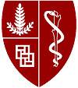

**Assistant, Associate Professor, or Professor**

**Division of General Medical Disciplines**

**Department of Medicine/Cardiovascular Institute**

The Department of Medicine and the Cardiovascular Institute at the Stanford University School of Medicine seek a clinical investigator to join the Department as Assistant Professor or Associate Professor or Professor in the University Tenure Line (UTL) or the Medical Center line (MCL). We are seeking dynamic individuals to bring intellectual leadership and rigorous scholarship to our exciting program. The successful candidate will have significant support for developing his or her independent research.

We expect the successful applicant to have a medical degree with board certification in internal medicine or a PhD with strong clinical research experience. We are particularly interested in candidates with a combination of training and experience in clinical or health services research related to cardiovascular disease and its risks, although cardiovascular clinical training not required. The successful candidate should have an established track record of scholarly achievement.

The predominant criterion for appointment in the University Tenure Line is a major commitment to research and teaching. The major criteria for appointment for faculty in the Medical Center Line shall be excellence in the overall mix of clinical care or programmatic development, clinical teaching, scholarly activity that advances clinical medicine, and institutional service appropriate to the programmatic need the individual is expected to fulfill. Faculty rank will be determined by the qualifications and experience of the successful candidate.

Stanford University is an equal opportunity employer and is committed to increasing the diversity of its faculty. It welcomes nominations of and applications from women, members of minority groups, protected veterans and individuals with disabilities, as well as from others who would bring additional dimensions to the university’s research, teaching and clinical missions.

Interested candidates should submit their curriculum vitae, a brief letter outlining their interests and the names of three references here: <http://facultyapplication.stanford.edu/>

Please note that your references will not be contacted until we have your consent.

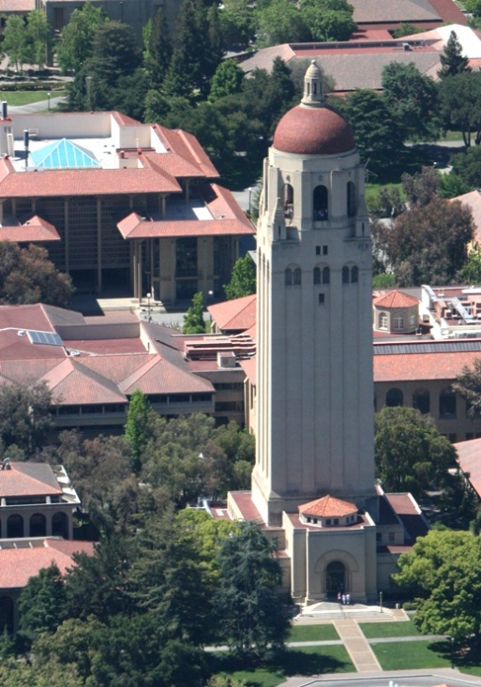

*Stanford University is an equal opportunity employer and is committed to increasing the diversity of its faculty. It welcomes nominations of and applications from women, members of minority groups, protected veterans and individuals with disabilities, as well as from others who would bring additional dimensions to the university’s research, teaching and clinical missions.*

**Hoover Tower – Stanford University**