Log in to 25 Live: https://25live.collegenet.com/stanford/#home_my25live[0]
Click the Event Wizard tab:
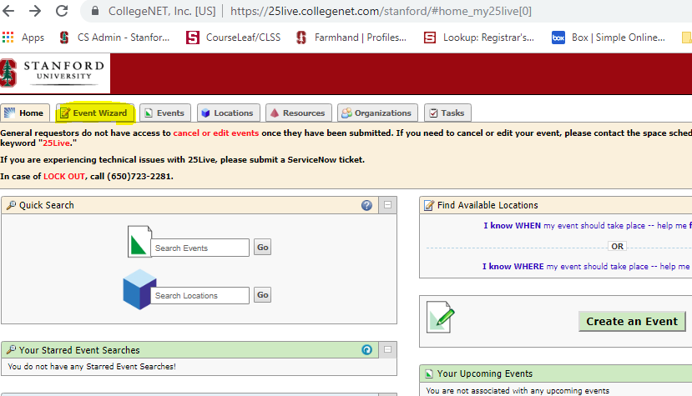
Enter Event Name, Event Type and Primary Organization for this Event
- Information is irrelevant for checking availability but fields must be entered
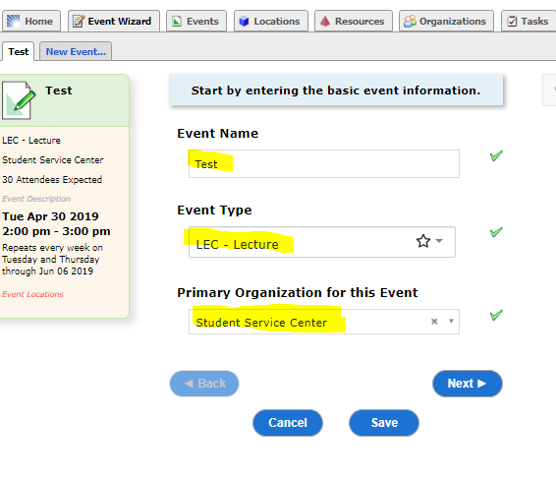
Click Next
Enter appropriate head count
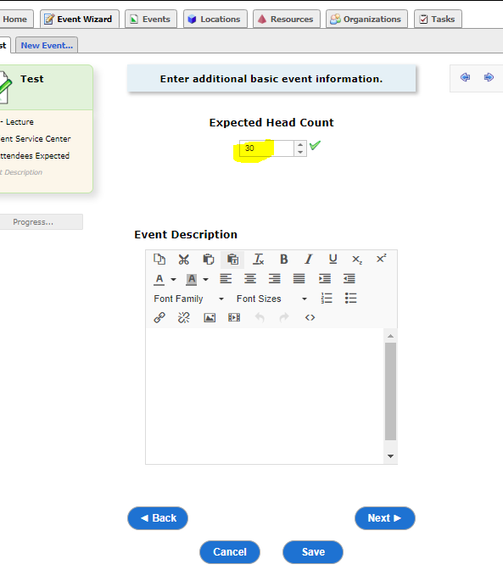
Click Next
Click Yes for repeating events
Enter first class time
Click No for Additional Time questions
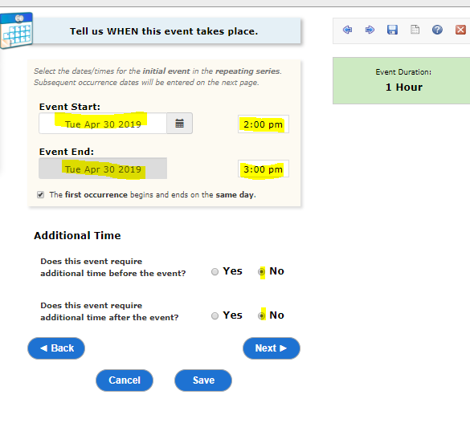
Click Next
Click Weekly Repeats
Select class schedule
Click Repeats through and enter date of last class for the quarter
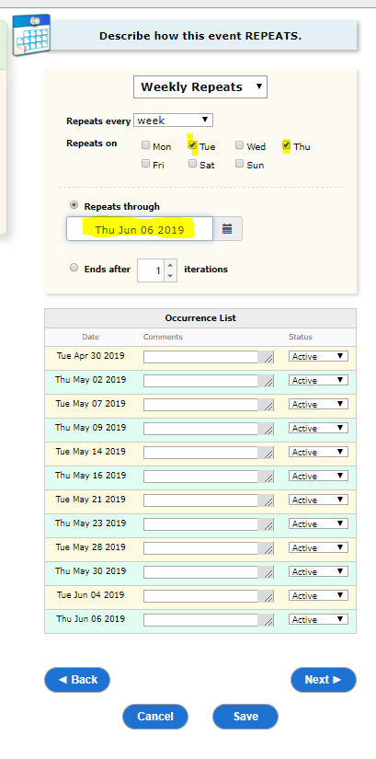
Click Next
Click Advanced Search…
Select Registrar Scheduled from the Categories drop down
Adjust Capacity scale
Click Search
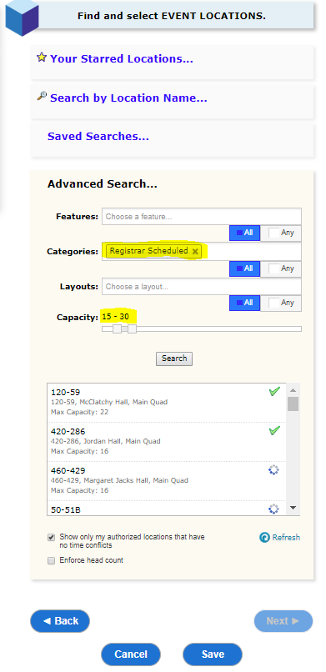
Available rooms will remain
- Enter preference in CPS CLSS – requests are not submitted through 25 Live

