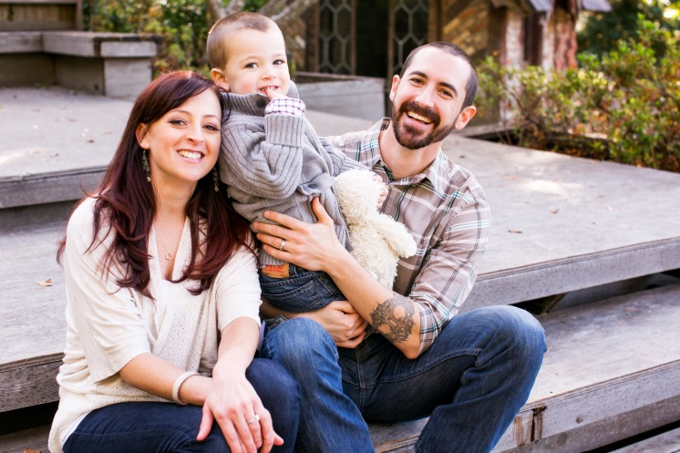
Meet The McGowans
At the time my husband and I were ready to start a family we had never heard of cystic fibrosis and had no known history of the disease in either family. Once we got pregnant, during a routine first-trimester blood screen I was diagnosed as a carrier for CF and subsequently, my husband was diagnosed as a carrier a few weeks later. We were referred to a genetics counselor at Stanford, who helped us identify resources where we could learn about the disease. We opted to perform a CVS procedure in October 2009 to test our unborn baby and he was indeed affected by CF. This was our first born so it was devastating to say the least.
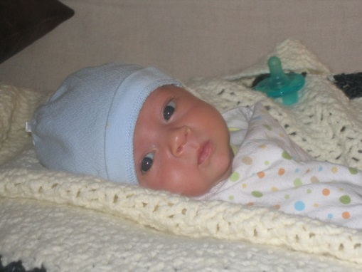
We spoke more with our genetics counselor about what life with CF was like. Our biggest concern was what our son’s quality of life would be. Would he be allowed to do “normal” kid things like play sports and go to school? After taking some time to cope with the grief of the diagnosis and do our homework, we were ready to face it head-on and not look back. We would give him the best care we could because it would give him the best chance to live a very long and normal life. My husband met with Jackie a few months before Pat was born and she gave him a very honest and positive picture of what we could expect for our son. She was warm and caring but answered all of our questions and addressed all of our concerns no matter how ignorant because we were still learning about CF. She left us with some literature and gave us samples of the medication that Patrick would use so we could practice with them. It sounds silly but the little things like getting comfortable pouring enzymes allowed us to focus on the big stuff. We leaned on our friends and family for emotional support and by the time Patrick was born in January 2010, we were still scared but positive; we felt armed with more knowledge than we knew what to do with.

Jackie Zirbes became Pat’s first CF care provider at LPCH and we hit it off with her right away. His first visit was when Pat was 10 days old, where he had lost weight every day since being born. Pat has two copies of the most common CF mutation, dF508, so he was severely pancreatic insufficient. We began enzymes immediately and noticed a dramatic turnaround in his appearance and weight gain. It wasn’t until the following visit a few weeks later that they introduced us to airway clearance (ACT) – a nebulizer and manual percussions. I am thankful that the clinic added his treatments in a stepwise fashion, allowing us to get comfortable with one aspect of his care before beginning the next. We met with the respiratory therapist, who demonstrated the nebulizer, showed us how to break it down, clean and sterilize it. She also showed us how to perform CPT on a tiny infant, one of the scariest and intimidating things we’ve ever had to learn. Starting percussions on an infant was probably the most difficult hurdle we faced with CF.
A newborn has no concept of preventive medicine, so for 30 minutes twice a day we endured the sad cries of our baby. There are days where we wanted to stop, to give him a break, to not hear him get upset, but that went against what Boyd and I agreed to – to do everything that was expected of us to deliver the best possible care to Pat. We strive to do our best in keeping him as healthy as possible. Over time, Pat got used to his treatments, we found ways to keep him distracted with toys or music, and eventually the TV, and we didn’t look back. He would still have a bad week or two every few months but we’d tradeoff who would do his CPT so it was less hard on us emotionally. When he was 1 year old we were able to transition to a vest and because we stayed consistent during the rough times, Pat now looks forward to his treatments, as that is his only opportunity to watch a favorite TV show or movie.
During the first 6 months of Pat’s life we went to CF clinic every 3-5 weeks for progress checks. We stayed on our normal regime of inhaled medication (albuterol and mucomyst) and occasionally added in an antibiotic if he cultured a bug. When we began solids, Julie was instrumental in helping us with how to “boost” the calorie and fat content of his food and ways to promote healthy eating habits (Pat has never been a great eater). She also taught us how to adjust his enzyme dosage based on what he ate. The newborn care team is an extremely useful resource for new parents dealing with CF. We had A LOT of questions during our visits, and everyone on the team was incredibly patient and understanding in taking the time to make sure we felt comfortable. We never felt rushed and they always went the extra mile to give us as much info as possible. Once Pat’s weight stabilized and he seemed to be thriving, we were able to lengthen our visits to every 3 months.
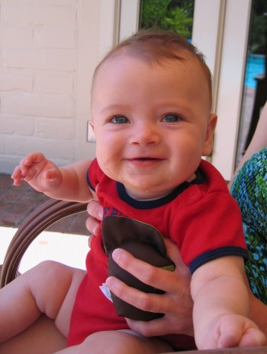
After Pat turned two last year, we transitioned into the pediatric clinic. Jackie was great in suggesting a few pulmonologists she thought would be a good fit for our family and made sure that we felt comfortable before making the transition. To date, Pat has stayed on pretty much the same course of medications and treatments. For his digestive system requirements, Pat eats a high fat/calorie diet, takes Creon 6000 enzymes, Prevacid, salt, miralax, aquADEKs multivitamin and D-Vi-Sol (an extra vitamin D supplement). We use two medications in his nebulizer: albuterol and hypertonic saline (we switched from mucomyst due to the current shortage).
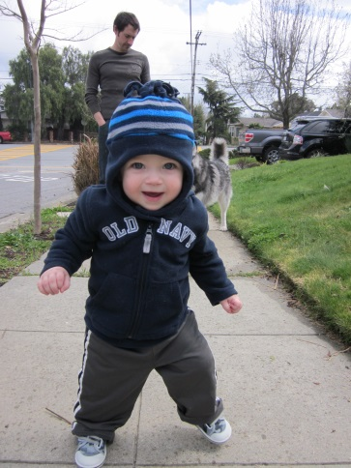
To be honest and frank, the strict regimen of medications and his CPT schedule was a lot to handle as new parents, but we learned to do it because we had to. As partners in this, we focused on each other’s strengths and used those strengths to our benefit in Pat’s care. I have a background in biology, which has helped us understand WHY his medications are so important. I also tend to be the planner/scheduler, whereas my husband is very disciplined and excelled at delivering Pat’s inhaled therapy (it’s their male bonding time). Because we have found a way to work together in ways where each of us is at our best, we have been able to provide Patrick the care we promised him when he was diagnosed.
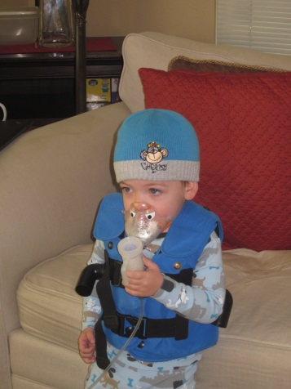

Pat recently celebrated his 3rd birthday and he is a typical boy – nothing slows him down. He attends daycare full-time, plays in the park, rides bicycles, takes swim lessons, travels on airplanes to see family/friends and loves walking his two dogs, which is everything we hoped for back in 2009 when we didn’t know much about CF. We focus on being conscious of germs without letting that rule his life. There are days when we still feel sad for Pat that he has CF and so much else to deal with than the average kid but those days are much less frequent now. We dove into the CF world full force so this is all we know. Scheduling and organizing 2 (or 3 if he’s sick) treatments per day in addition to Pat’s dietary needs definitely takes creativity, but for us skipping is simply not an option and even though we have a strict schedule and a few ground rules for containing germs, it doesn’t stop us from doing what we love and ensuring that Pat has a normal life.

