PHARYNGITIS PROTOCOL (including Rapid Strep Testing)
______________________________________________________________________

SUBJECTIVE
- Complaint of sore throat, with or without dysphagia/odynophagia
- Abdominal pain and/or vomiting
- Headache
- Fever
- Absence of cough (generally, but not always)
- Possible chills or body aches
- Document ill contacts (friends/family members/co-workers)
- Document allergies to antibiotics and other medications

OBJECTIVE
- The McIsaac modification of the Centor Scoring Tool is used to determine the likelihood of group A streptococcal infection in people presenting with pharyngitis. Based upon 5 clinical criteria, it indicates the probability of a streptococcal infection before any testing is done (“pretest probability”):

Criteria for Modified Centor Scoring Tool | Points Awarded
History of temperature > 38º F or > 100.4 º F | 1
Absence of cough | 1
Swollen, Tender Anterior Cervical Nodes | 1
Tonsillar Swelling or Exudate | 1
Age  3-14 years  15-44 years  ≥ 45 years | 1  0  -1

Modified Centor Score, Strep Probability, and Management

Centor Score | Probability of Strep | Management
0 | 1-2.5 % | No antibiotic or testing needed
1 | 5-10 %
2 | 11-17% | Rx antibiotic based upon rapid strep result
3 | 28-35%
4 or 5 | 52% | Rx antibiotic based upon rapid strep result *

*May treat without rapid strep test after consulting with provider.

- Run Rapid Strep: CPT code 87880 and document results in Nursing Documentation.
- If Centor scale >2, document numerical score in Comments section when reporting rapid strep results.
- If <1, document score in Comments section of physical exam.
- If rapid strep test is positive, treat with antibiotic as noted below.
- If rapid strep test is negative, send throat culture if patient is < 18 years of age. If 18 or older, no throat culture is needed.

ICD-10 CODES
- Pharyngitis J02.9

TREATMENT
- Children ≤ 27 kg (60 lbs)
  - penicillin V 250 mg PO BID ×10 days or
  - Amoxicillin 50mg/kg once daily x 10 days (for children >3 months and < 40kg). [Max dose of 1000mg. ]
    - If over 5 years old use 250mg TID in either chewable or liquid forms or
  - penicillin G benzathine (Bicillin® L-A) 0.6 million units IM (useful if provider in office and patient has difficult swallowing or you are worried about poor adherence to the treatment plan; observe for 30 minutes after injection for possible anaphylaxis)
- Children >27 kg and Adults
  - penicillin V 500 mg PO BID ×10 days or
  - amoxicillin 1000 mg once daily for 10 days or
  - penicillin G benzathine (Bicillin® L-A) 1.2 million units IM (useful if provider in office and patient has difficult swallowing or you are worried about poor adherence to the treatment plan; observe for 30 minutes after injection for possible anaphylaxis)
- If allergic to penicillin:
  - Children <27kg: erythromycin ethylsuccinate (EES, EryPed®) PO 40mg/kg/day divided BID ×10d
  - Adults & adolescents >27kg: erythromycin base (Ery-Tab®—250 mg, 333 mg or 500 mg—or PCE®—333 mg or 500 mg) or stearate (Erythrocin®—250 mg or 500 mg) PO, 1 gm/day, divided into 2-4 doses
OR
- Children < 27kg: azithromycin 12mg/kg PO once daily for five days.
- Adults and adolescents >27kg: azithromycin 500mg tablet PO on day one followed by 250mg tablet daily on days two through five.

- Can also use guideline below, from UpToDate For some patients with insurance, azithromycin course can result in greater adherence to the treatment plan.

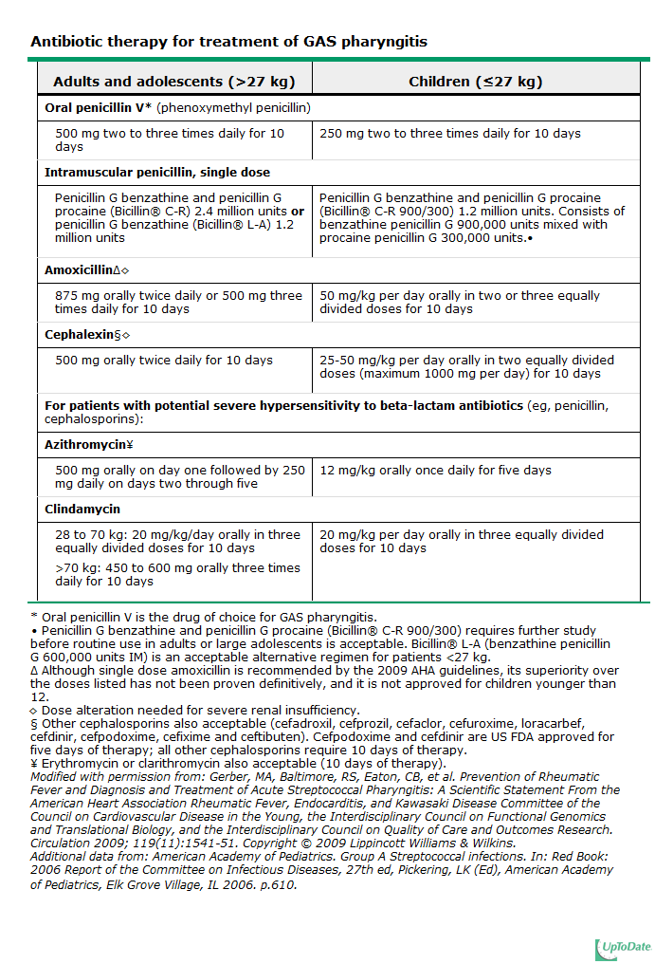

PATIENT EDUCATION
- If antibiotic prescribed, complete the full course, even if symptoms have improved.
- No school or work until on antibiotics for at least 24 hours.
- Push fluids (tea, water, sports drinks, juice). Adults should be encouraged to take 2-3L per day especially when febrile.
- Pain/fever reliever (e.g., ibuprofen or acetominophen, dosed for age)
- Gargle with saline. To prepare saline at home use 1 tsp of non-iodized salt mixed with 1 cup water.
- Lozenges
- Rest
- Discard, wash in dishwasher, or boil toothbrush after 48 hours of antibiotic treatment
- If any family members/contacts of patient with confirmed strep throat develop sore throat (with or without fever) within 2 weeks, encourage they call as you may treat them presumptively

CO-VISIT
- Present to provider after examination but BEFORE documentation.
- Make sure all of the above is documented after consultation with provider.

Call back for appointment with provider if:
- Temperature >104° F or does not improve after 24 hours of medication.
- Signs (rash, swelling) or symptoms (difficulty breathing) of allergy to antibiotics
- Notify provider if not improving after 2 full days of antibiotics

Document all of Above in Medical Record and SEND VISIT TO PCP FOR COMPLETION.

