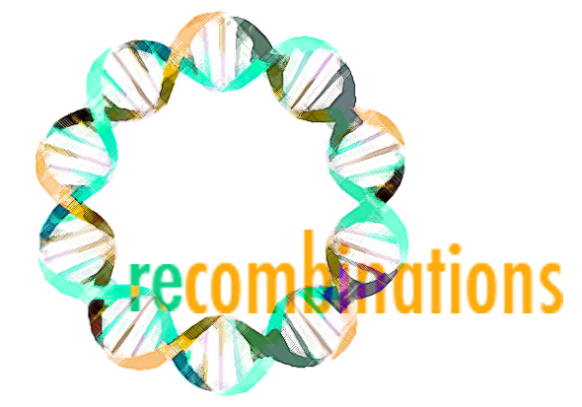

fall 2013
Continue the conversation: intersections of the arts, humanities & social sciences with medicine and bioscience at Stanford
Monday October 7, 5:30p – 7p
LKSC Ground Floor (basement)
Operating Room as Theater, Simulation Theater as Operating Room
David Gaba, MD, Associate Dean, Immersive and Simulation-based Learning
Professor of Anesthesiology, Stanford School of Medicine

Monday October 28, 5:30p – 7p
Sweet Hall, Third Floor
Integrating the Arts and Sciences in New Paths of Undergraduate Study
(Honors in the Arts, The Senior Reflection, Integrated Inquiry)
Kevin DiPirro, MFA, MA, writer, playwright, lecturer, Program in Writing and Rhetoric, Stanford
Panelists: Stephen Murphy-Shigematsu EdD, Jonah Willihnganz PhD, and Andrew Todhunter MFA

Monday November 18, 5:30p – 7p
LKSC Room 102
Medicine, Magic and Meaning
Ricardo T. Rosenkranz, MD, Assistant Professor in Clinical Pediatrics
Northwestern University Feinberg School of Medicine
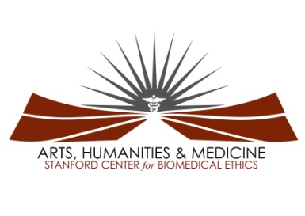
Open to Stanford students, faculty and staff

Arts, Humanities and Medicine Program,
Stanford Center for Biomedical Ethics
Contact: AHMProgram@stanford.edu

